Insomnia NMA

Prepared by Virginia Chiocchia on 7th August, refers to a single outcome analysis (Number of dropouts for adverse events) in a frequentist setting

## Description of the network

Below is a description for the network formed by studies examining the outcome Number of Dropouts due to Adverse Events

Number of included interventions:

## [1] 15

Number of included studies:

## [1] 16

The following treatments were excluded as they were disconnected to the main network:

* MAT
* LAT
* MAT+LAT
* massage
* therapeutic touch
* control/no intervention
* mimic therapeutic touch
* Mindfulness Based Stress Reduction Program
* waitlist
* sleep hygiene
* lormetazepam + sleep hygiene
* BBT I
* self-monitoring control
* auricular acupuncture
* control?
* acupressure
* sham acupressure
* artificial juice
* tart cherry juice
* midazolam
* oxazepam

The multiarm study Dement 1991 was also excluded because data was only available for one comparison. Study Klimm 1987 was also excluded because disconnected to the rest of the network.

The plot below shows the available data  
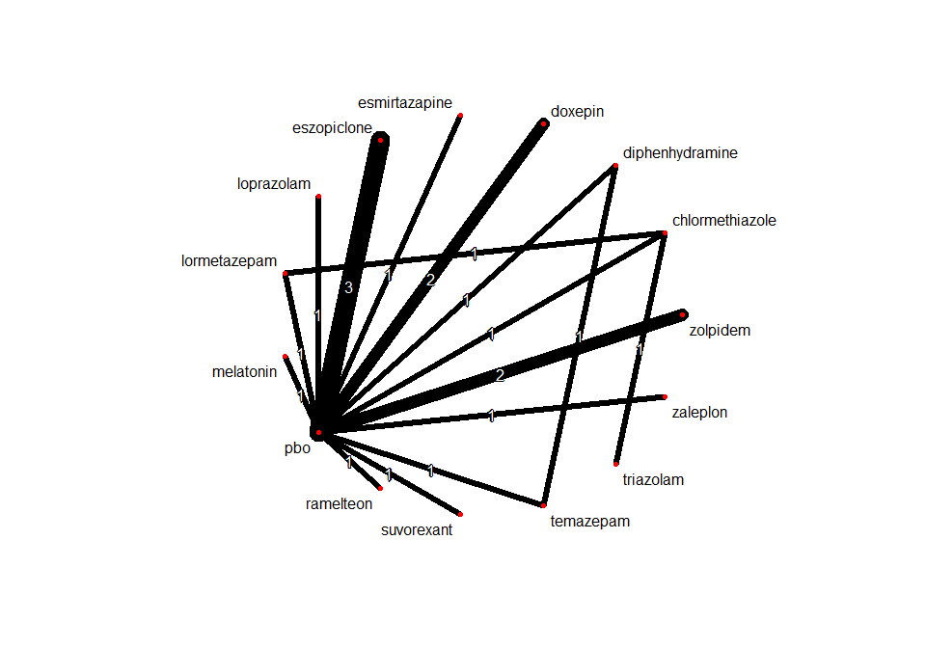

## Frequentist network meta-analysis

Below are the relative treatment effects from the NMA model.

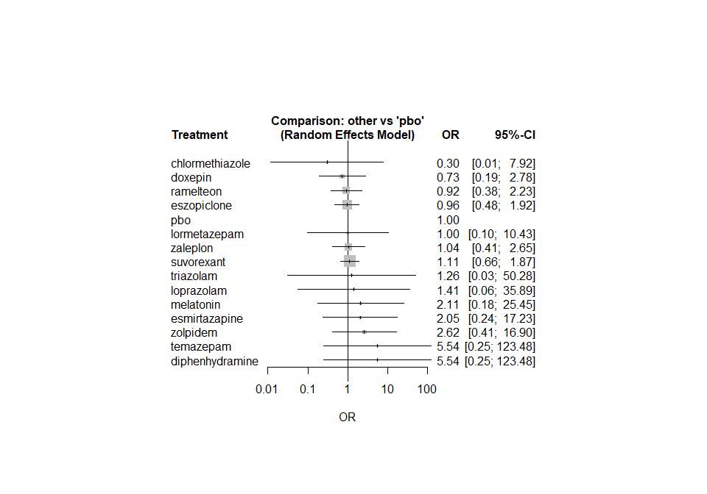

The heterogeneity standard deviation is estimated at

## tau= 0.073

and I-square (total) is

## I2= 1 %

### Sensitivity analyses and meta-regressions

We run a sensitivity analyses excluding the crossover studies

