Insomnia NMA

Prepared by Virginia Chiocchia on 16th August, refers to a single outcome analysis (Falls) in a frequentist setting

## Description of the network

Below is a description for the network formed by studies examining the outcome Falls.

Number of included interventions:

## [1] 4

Number of included studies:

## [1] 3

The following treatments were excluded as they were disconnected to the main network:

* chlormethiazole
* triazolam
* oxazepam
* midazolam

The multiarm study Glass 2008 was also excluded because data was not available for all comparisons.

The plot below shows the available data  
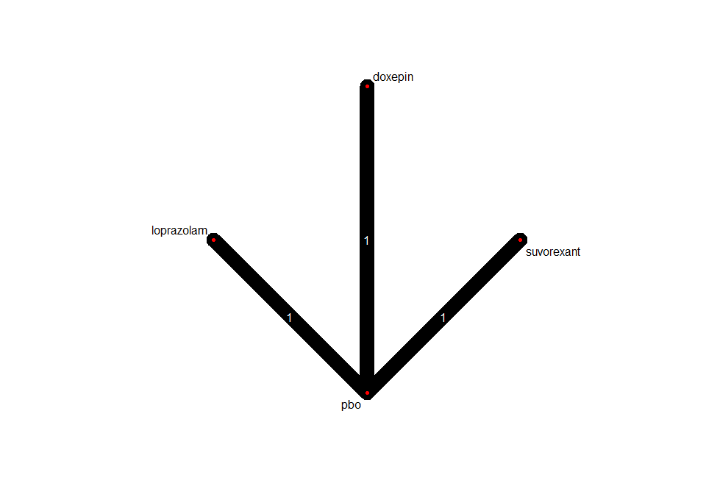

## Frequentist network meta-analysis

Below are the relative treatment effects from the NMA model.

