Insomnia NMA

Prepared by Virginia Chiocchia on 16th August, refers to a single outcome analysis (Impaired daytime-functioning) in a frequentist setting

## Description of the network

Below is a description for the network formed by studies examining the outcome Impaired daytime-functioning

Number of included interventions:

## [1] 5

Number of included studies:

## [1] 3

The following treatments were excluded as they were disconnected to the main network:

* chlormethiazole
* triazolam

The plot below shows the available data  
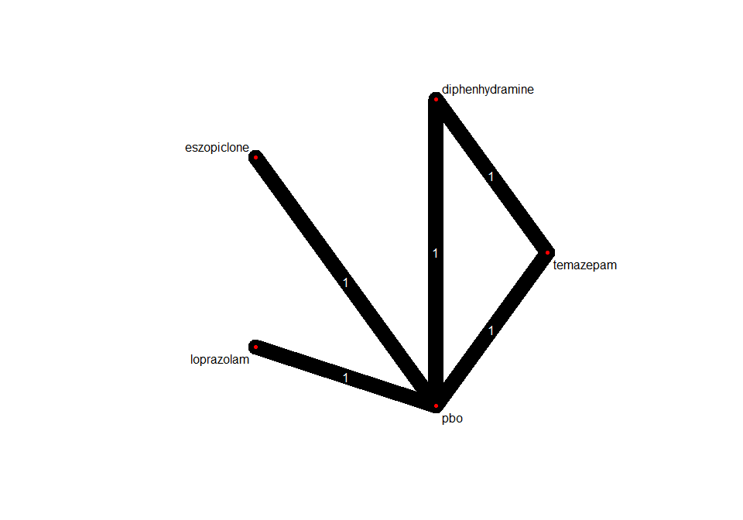

## Frequentist network meta-analysis

Below are the relative treatment effects from the NMA model.

