Insomnia NMA

Prepared by Virginia Chiocchia on 7th August, refers to a single outcome analysis (Paradoxical drug reactions/Anxiety) in a frequentist setting

## Description of the network

This network formed by studies examining the outcome Paradoxical Drug Reactions is composed by two sub-networks.

### Sub-network 1

Below is a description for the sub-network including the following interventions

## [1] "diphenhydramine" "eszopiclone" "pbo" "temazepam"

Number of included interventions:

## [1] 4

Number of included studies:

## [1] 3

The following treatments were excluded as they were disconnected to the main network:

* MAT
* LAT
* MAT+LAT
* massage
* therapeutic touch
* control/no intervention
* mimic therapeutic touch
* Mindfulness Based Stress Reduction Program
* waitlist
* sleep hygiene
* lormetazepam + sleep hygiene
* BBT I
* self-monitoring control
* auricular acupuncture
* control?
* acupressure
* sham acupressure
* artificial juice
* tart cherry juice
* midazolam
* oxazepam

The plot below shows the available data  
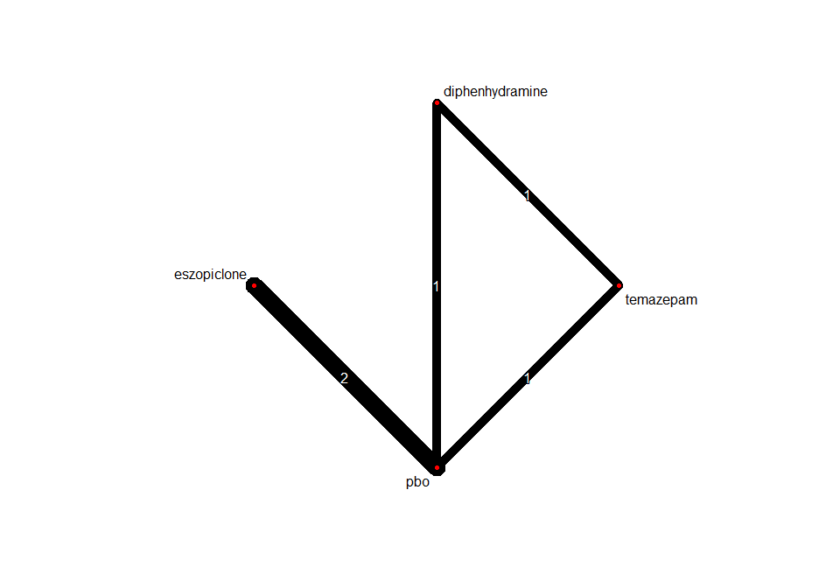

## Frequentist network meta-analysis

Below are the relative treatment effects from the NMA model.

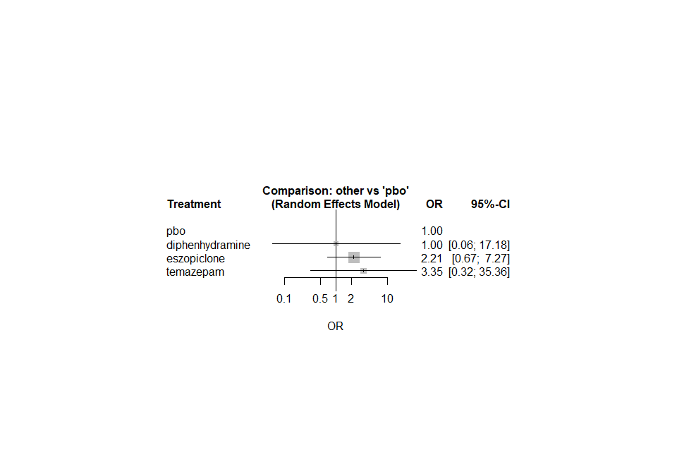

The heterogeneity standard deviation is estimated at

## tau= 0

and I-square (total) is

## I2= 0 %

### Sub-network 2

Below is a description for the sub-network including the following interventions

## [1] "chlormethiazole" "nitrazepam" "triazolam"

Number of included interventions:

## [1] 3

Number of included studies:

## [1] 2

The plot below shows the available data

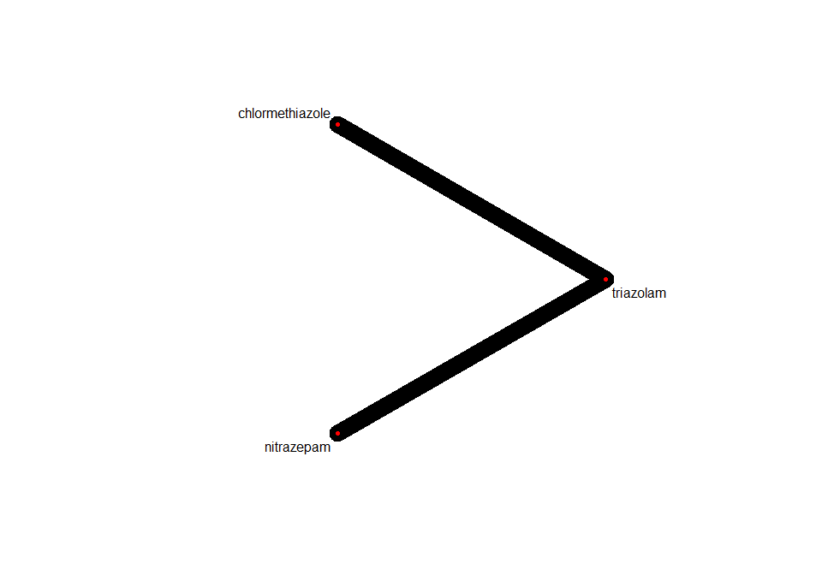

Below are the relative treatment effects from the NMA model.

