Insomnia NMA

Prepared by Virginia Chiocchia on 7th August, refers to a single outcome analysis (Number of participants with adverse events) in a frequentist setting

## Description of the network

Below is a description for the network formed by studies examining the outcome Number of Participants with Adverse Events

Number of included interventions:

## [1] 16

Number of included studies:

## [1] 18

The following treatments were excluded as they were disconnected to the main network:

* MAT
* LAT
* MAT+LAT
* massage
* therapeutic touch
* control/no intervention
* mimic therapeutic touch
* Mindfulness Based Stress Reduction Program
* waitlist
* sleep hygiene
* lormetazepam + sleep hygiene
* BBT I
* self-monitoring control
* auricular acupuncture
* control?
* acupressure
* sham acupressure
* artificial juice
* tart cherry juice
* midazolam
* oxazepam

The plot below shows the available data  
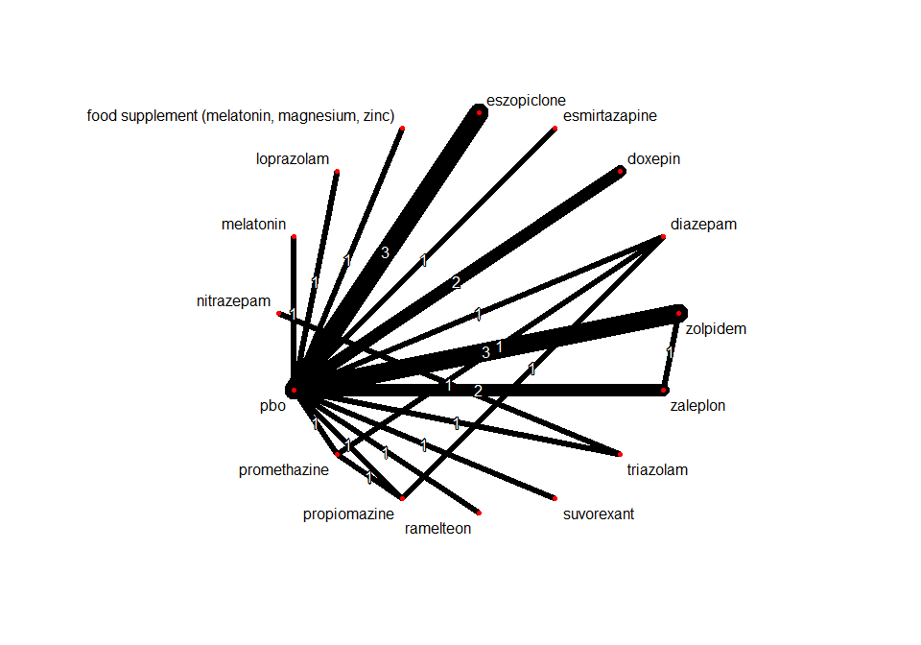

## Frequentist network meta-analysis

Below are the relative treatment effects from the NMA model.

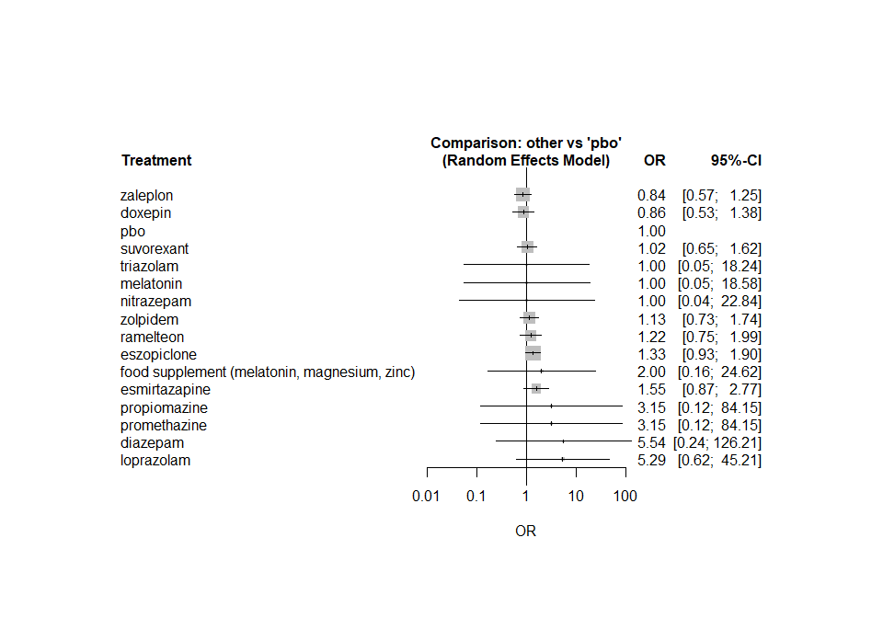

The heterogeneity standard deviation is estimated at

## tau= 0.202

and I-square (total) is

## I2= 36 %

### Sensitivity analyses and meta-regressions

We run a sensitivity analyses excluding the crossover studies

