Insomnia NMA

Prepared by Virginia Chiocchia on 7th August, refers to a single outcome analysis (Total sleep time by polysomnography) in a frequentist setting

## Description of the network

Below is a description for the network formed by studies examining the outcome Total sleep time by polysomnography.

Number of included interventions:

## [1] 4

Number of included studies:

## [1] 4

The following treatments were excluded as they were disconnected to the main network:

* MAT
* LAT
* MAT+LAT
* BBT I
* self-monitoring control

The crossover study Garfinkel 1995 was also excluded because no p-value was available for this outcome.

The plot below shows the available data  
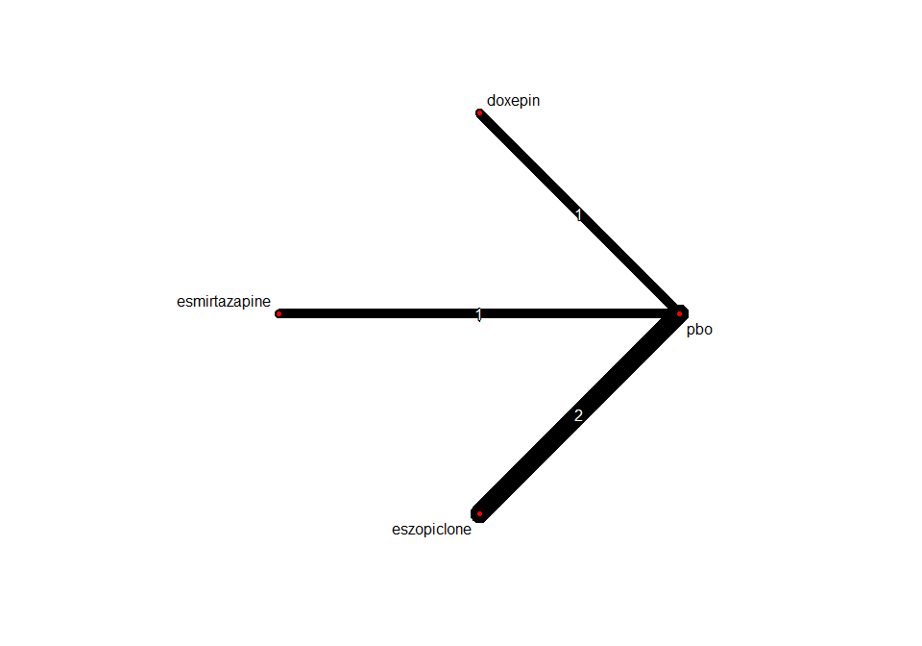

## Frequentist network meta-analysis

Below are the relative treatment effects from the NMA model.

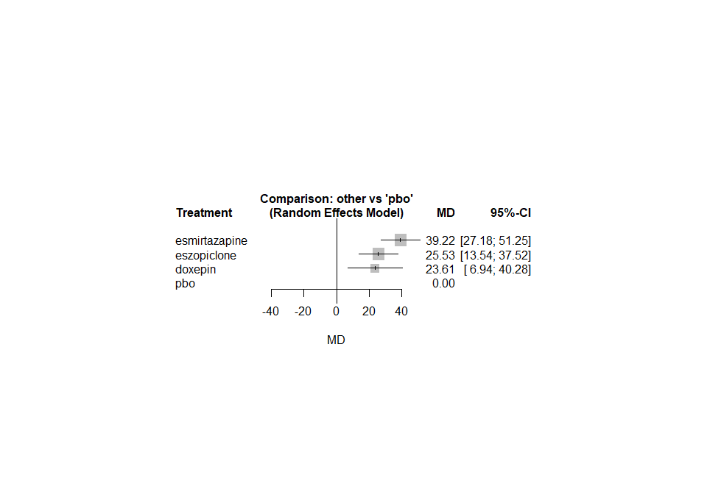

The heterogeneity standard deviation is estimated at

## tau= 4.294

and I-square (total) is

## I2= 16 %