Insomnia NMA

Prepared by Virginia Chiocchia on 7th August, refers to a single outcome analysis (Patient subjective wellbeing/Quality of life) in a frequentist setting

## Description of the network

Below is a description for the network formed by studies examining the outcome Quality of Life. The following treatments were excluded as they were disconnected to the two main networks:

* MAT
* LAT
* MAT+LAT
* acupressure
* sham acupressure

Number of included interventions:

## [1] 3

Number of included studies:

## [1] 3

The plot below shows the available data  
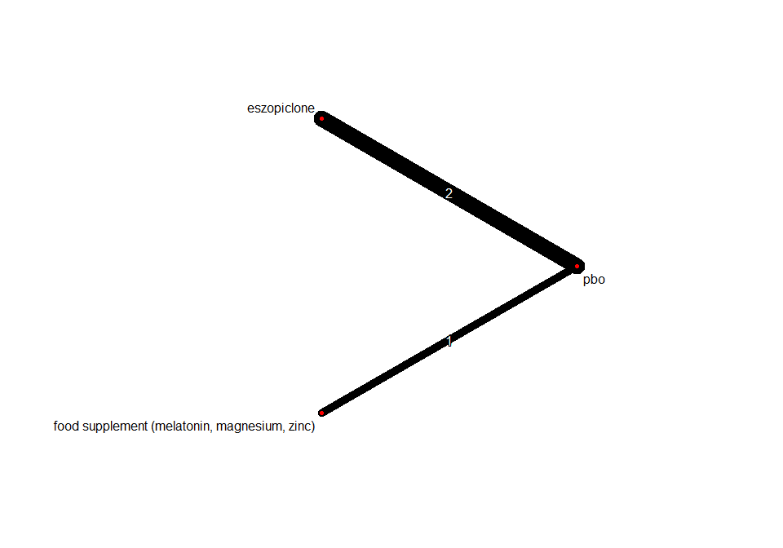

## Frequentist network meta-analysis

Below are the relative treatment effects from the NMA model.

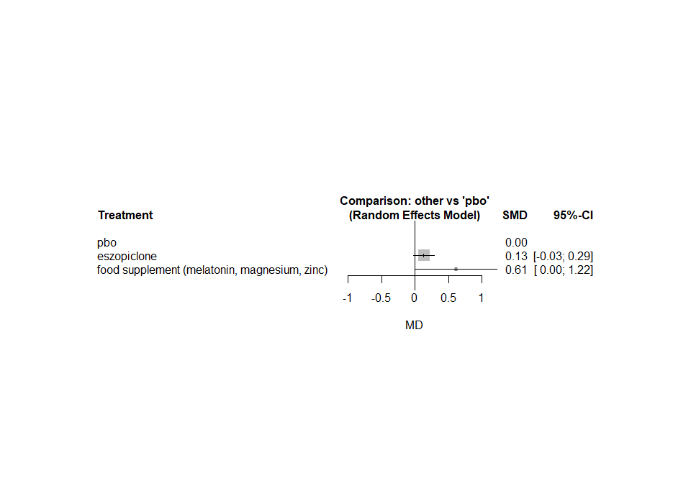

The heterogeneity standard deviation is estimated at

## tau= 0

and I-square (total) is

## I2= 0 %