Insomnia NMA

Prepared by Virginia Chiocchia on 7th August, refers to a single outcome analysis (Sleep Onset Latency) in a frequentist setting

## Description of the network

Below is a description for the network formed by studies examining the outcome Sleep Onset Latency.

Number of included interventions:

## [1] 14

Number of included studies:

## [1] 13

The following treatments were excluded as they were disconnected to the main network:

* MAT
* LAT
* MAT+LAT
* BBT I
* self-monitoring control
* flunitrazepam
* nitrazepam
* artificial juice
* tart cherry juice

The plot below shows the available data  
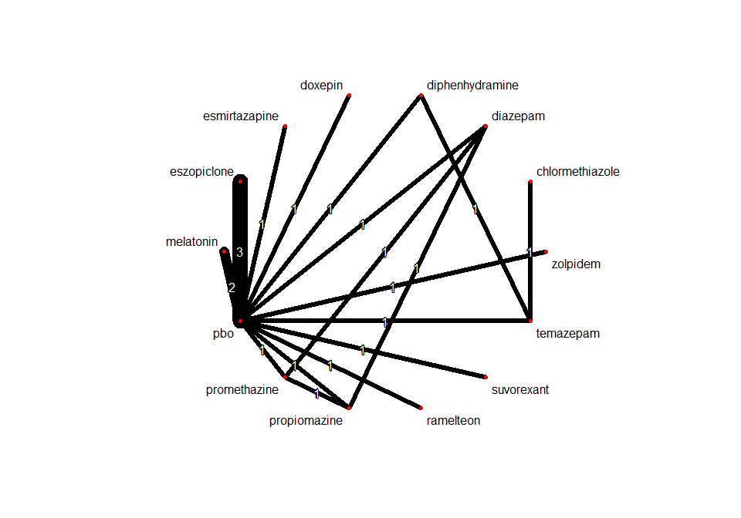

## Frequentist network meta-analysis

Below are the relative treatment effects from the NMA model.

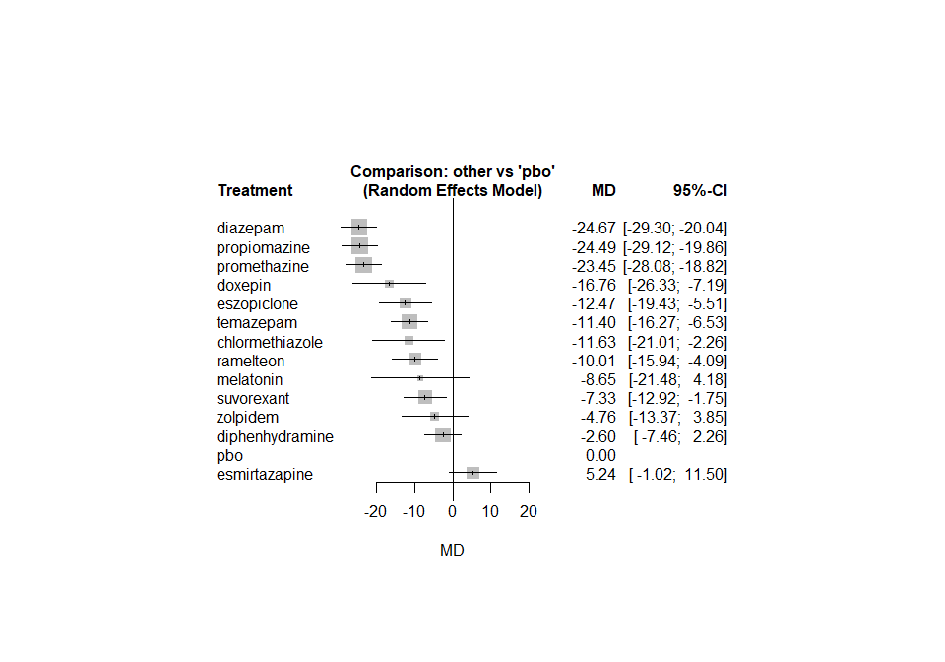

The heterogeneity standard deviation is estimated at

## tau= 0

and I-square (total) is

## I2= 0 %

### Sensitivity analyses and meta-regressions

We run a sensitivity analyses excluding the crossover studies

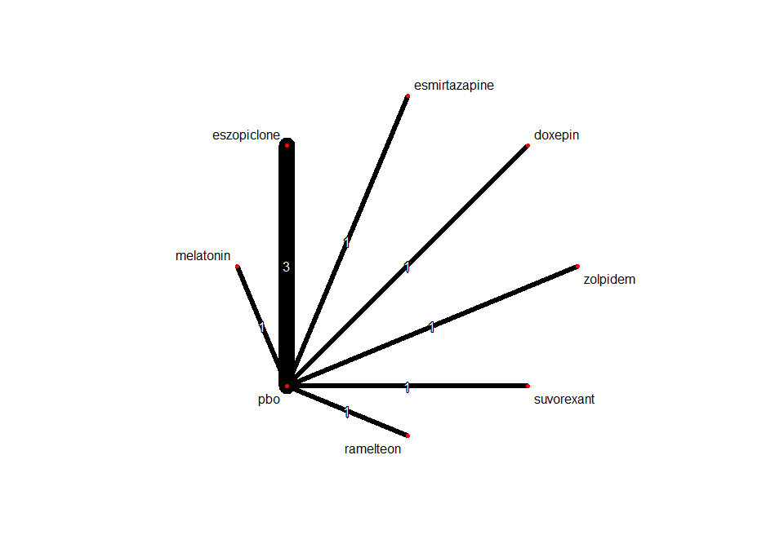

One study, comparing chlormethiazole versus temazepam, was also excluded from this sensitivity analysis because disconnected to the rest of the network

