Insomnia NMA

Prepared by Virginia Chiocchia on 26th July, refers to a single outcome analysis (Sleep Quality) in a frequentist setting

## Description of the network

This network formed by studies examining the outcome Sleep Quality is composed by two sub-networks. The following treatments were excluded as they were disconnected to the two main sub-networks:

* MAT
* LAT
* MAT+LAT
* therapeutic touch
* control/no intervention
* mimic therapeutic touch
* Mindfulness Based Stress Reduction Program
* waitlist
* sleep hygiene
* lormetazepam + sleep hygiene
* BBT I
* self-monitoring control
* auricular acupuncture
* control?
* acupressure
* sham acupressure
* artificial juice
* tart cherry juice

### Sub-network 1

Below is a description for the sub-network including the following interventions

## [1] "acetaminophen"   
## [2] "diphenhydramine"   
## [3] "doxepin"   
## [4] "esmirtazapine"   
## [5] "eszopiclone"   
## [6] "food supplement (melatonin, magnesium, zinc)"  
## [7] "melatonin"   
## [8] "pbo"   
## [9] "propiomazine"   
## [10] "temazepam"   
## [11] "zaleplon"   
## [12] "zolpidem"

Number of included interventions:

## [1] 12

Number of included studies:

## [1] 14

The plot below shows the available data

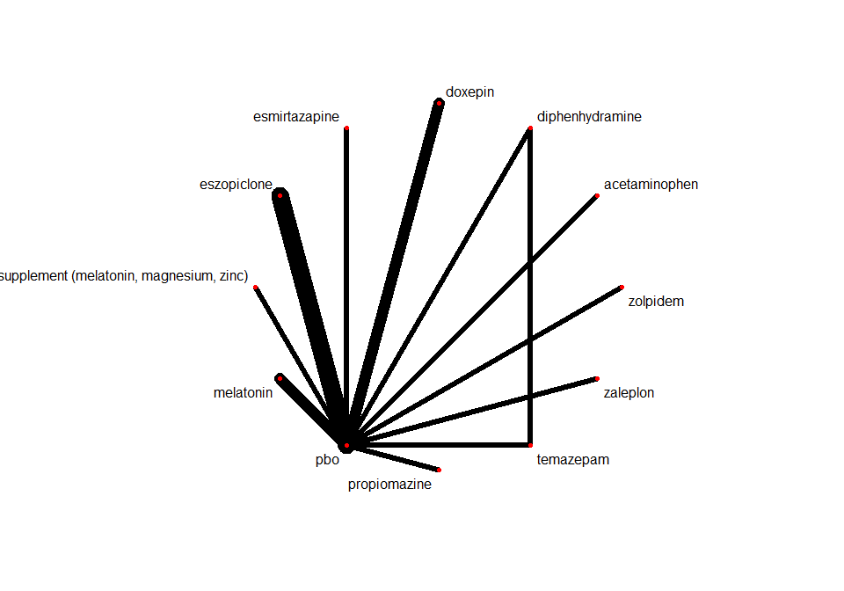

Below are the relative treatment effects from the NMA model.

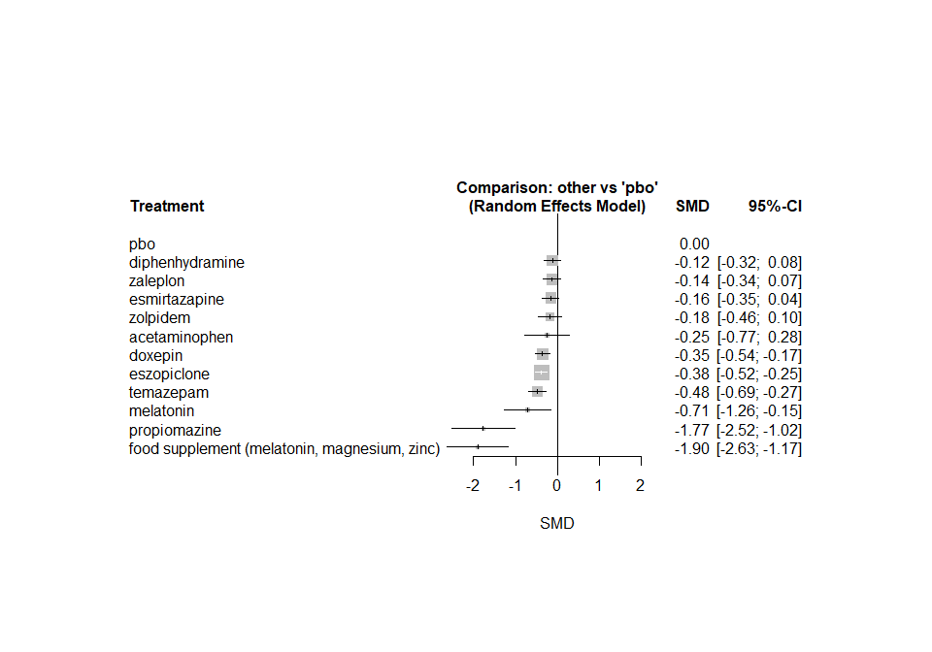

The P-scores (equivalent to the SUCRAs) are shown below

## P-score  
## food supplement (melatonin, magnesium, zinc) 0.9627  
## propiomazine 0.9446  
## melatonin 0.7525  
## temazepam 0.6856  
## eszopiclone 0.5878  
## doxepin 0.5482  
## acetaminophen 0.3944  
## zolpidem 0.3107  
## esmirtazapine 0.2801  
## zaleplon 0.2519  
## diphenhydramine 0.2298  
## pbo 0.0519

The heterogeneity standard deviation is estimated at

## tau= 0

and I-square (total) is

## I2= 0 %

### Sub-network 2

Below is a description for the sub-network including the following interventions

## [1] "chlormethiazole" "loprazolam" "nitrazepam" "triazolam"   
## [5] "zopiclone"

Number of included interventions:

## [1] 5

Number of included studies:

## [1] 4

The plot below shows the available data

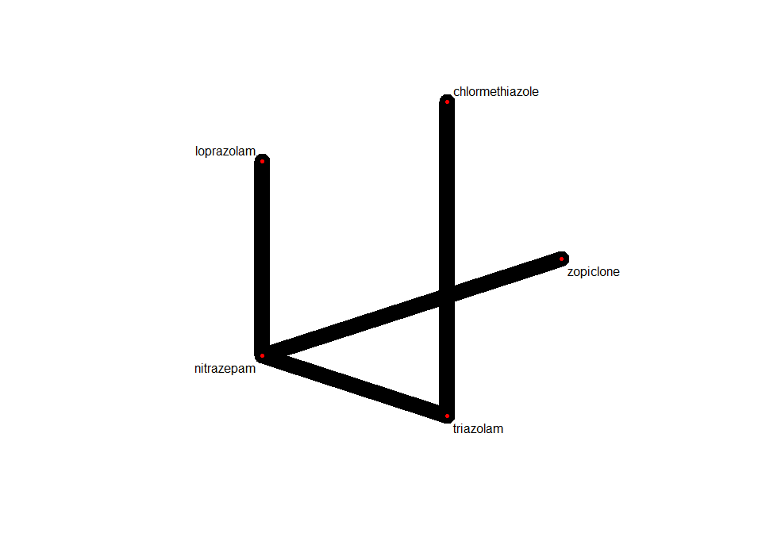

Below are the relative treatment effects from the NMA model.

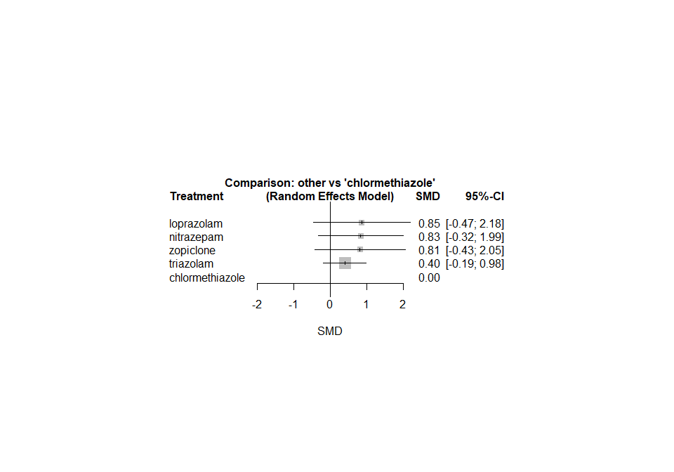

The P-scores (equivalent to the SUCRAs) are shown below

## P-score  
## chlormethiazole 0.9063  
## triazolam 0.6100  
## zopiclone 0.3521  
## nitrazepam 0.3161  
## loprazolam 0.3155

The heterogeneity standard deviation is estimated at

## tau= NA

and I-square (total) is

## I2= 0 %

### Sensitivity analyses and meta-regressions

We run a sensitivity analyses on the first sub-network excluding the crossover studies.

