Insomnia NMA

Prepared by Virginia Chiocchia on 9th October, refers to sensitivity analyses for a single outcome (Sleep Quality) in a frequentist setting

## Description of the network - sensitivity analysis (by drug group)

The following treatments were excluded as they were disconnected to the two main network:

* MAT
* LAT
* MAT+LAT
* therapeutic touch
* control/no intervention
* mimic therapeutic touch
* Mindfulness Based Stress Reduction Program
* waitlist
* sleep hygiene
* lormetazepam + sleep hygiene
* BBT I
* self-monitoring control
* auricular acupuncture
* control?
* acupressure
* sham acupressure
* artificial juice
* tart cherry juice

Below is a description for the network formed by studies examining the outcome Sleep Quality analysed by drug groups.

## [1] "acetaminophen"   
## [2] "antidepressant"   
## [3] "antihistamine"   
## [4] "benzo"   
## [5] "chlormethiazole"   
## [6] "food supplement"   
## [7] "melatonin and melatoninergic agonists"  
## [8] "pbo"   
## [9] "z-drug"

Number of included interventions:

## [1] 9

Number of included studies:

## [1] 16

The plot below shows the available data

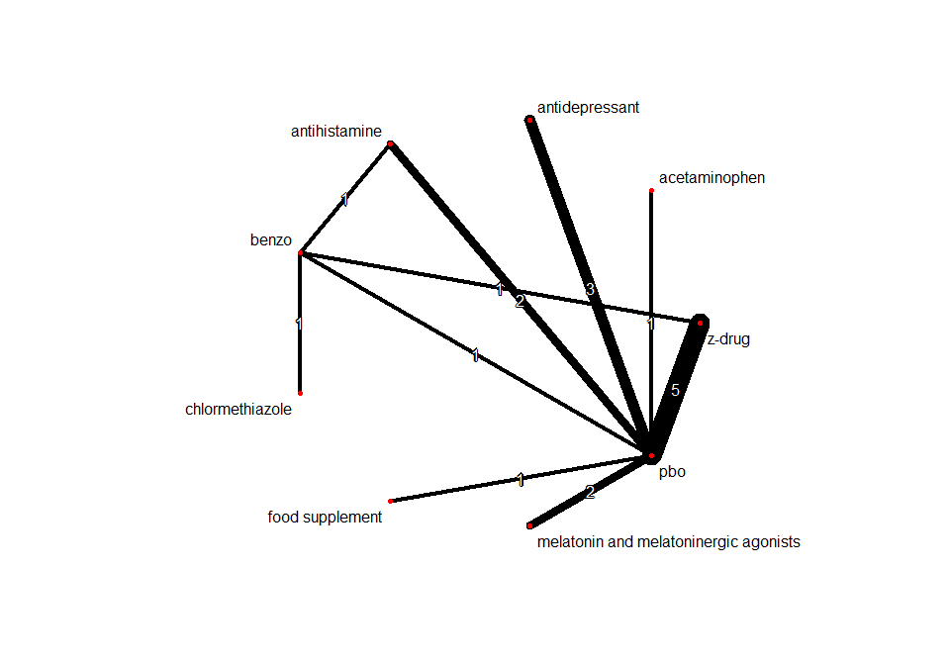

Below are the relative treatment effects from the NMA model.

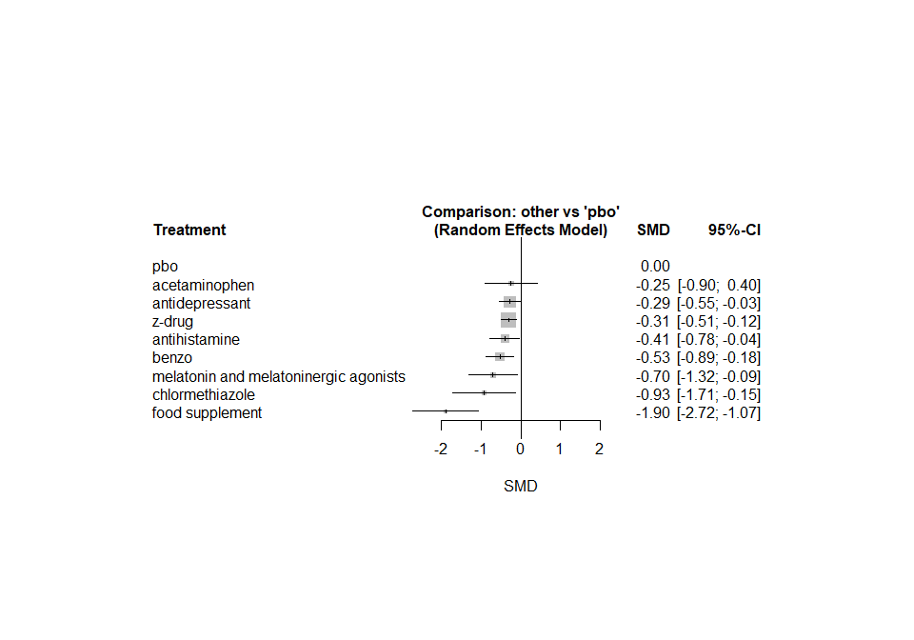

The heterogeneity standard deviation is estimated at

## tau= 0.194

and I-square (total) is

## I2= 66 %