Insomnia NMA draft

Prepared by Virginia Chiocchia on 23rd July, refers to a single outcome analysis (Total Sleep Time) in a frequentist setting

Make sure you have the needed libraries from R-Cran and Github: devtools NMAJags R2jags netmeta meta metafor readxl

First read your data. Modify the path and data name in DATA <- read_excel("~/_mydrive/Schizophrenia/Schizo.xlsx“, na =”NA") to make sure it works for you. But I urge you to keep the name DATA

#Description of the network

Below is a description for the network formed by studies examining the outcome Total Sleep Time.

Below are the total number of participants in each of the included interventions

## acetaminophen   
## 28   
## acupressure   
## 62   
## artificial juice   
## 16   
## auricular acupuncture   
## 22   
## BBT I   
## 32   
## chlormethiazole   
## 67   
## control   
## 44   
## diazepam   
## 20   
## diphenhydramine   
## 20   
## doxepin   
## 289   
## esmirtazapine   
## 402   
## eszopiclone   
## 481   
## flunitrazepam   
## 18   
## flurazepam   
## 17   
## food supplement (melatonin, magnesium, zinc)   
## 22   
## hand bath after 5 minutes, then 20 minutes hand massage   
## 0   
## LAT   
## 46   
## loprazolam   
## 81   
## lormetazepam   
## 22   
## lormetazepam + sleep hygiene   
## 15   
## massage   
## 15   
## MAT   
## 50   
## MAT+LAT   
## 51   
## melatonin   
## 132   
## midazolam   
## 30   
## mimic therapeutic touch/placebo   
## 8   
## Mindfulness Based Stress Reduction Program   
## 30   
## nitrazepam   
## 124   
## no intervention   
## 0   
## oxazepam   
## 31   
## pbo   
## 1961   
## placebo   
## 140   
## promethazine   
## 20   
## propiomazine   
## 41   
## quazepam   
## 16   
## ramelteon   
## 555   
## sham acupressure   
## 31   
## sham acupressure/control   
## 31   
## sleep hygiene   
## 15   
## suvorexant   
## 521   
## tart cherry juice   
## 16   
## temazepam   
## 40   
## therapeutic touch   
## 10   
## triazolam   
## 84   
## waitlist   
## 60   
## zaleplon   
## 615   
## zolpidem   
## 410   
## zopiclone   
## 37

Number of interventions:

## [1] 48

Number of studies:

## [1] 47

The plot below shows the available data

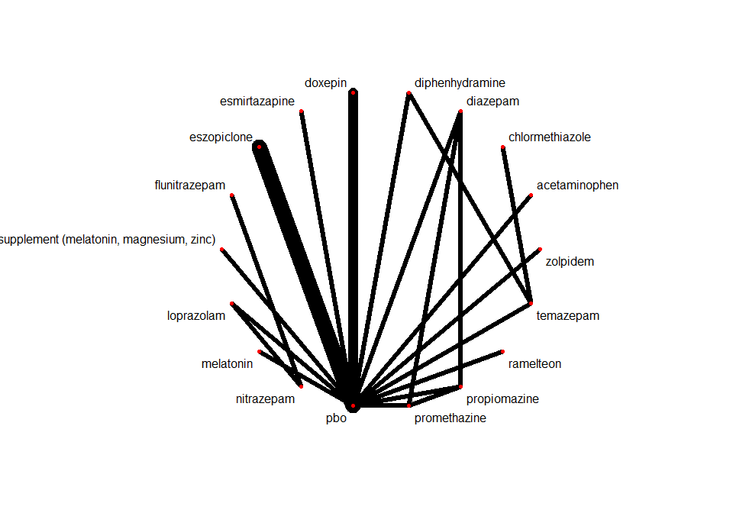

#Frequentist network meta-analysis

Below are the relative treatment effects from the NMA model.

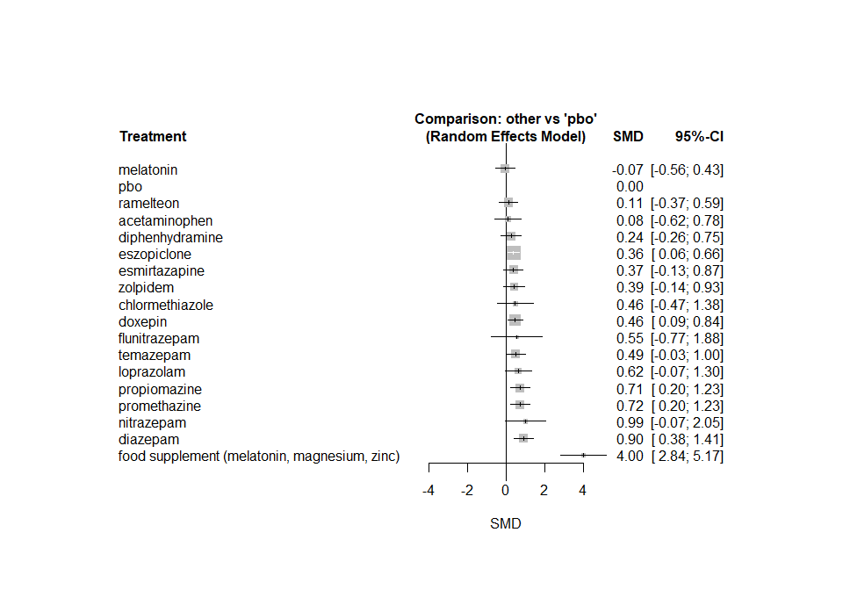

The P-scores (equivalent to the SUCRAs) are shown below

## P-score  
## food supplement (melatonin, magnesium, zinc) 1.0000  
## diazepam 0.8035  
## nitrazepam 0.7767  
## promethazine 0.6889  
## propiomazine 0.6870  
## loprazolam 0.6062  
## temazepam 0.5329  
## flunitrazepam 0.5234  
## doxepin 0.5123  
## chlormethiazole 0.4941  
## zolpidem 0.4543  
## esmirtazapine 0.4365  
## eszopiclone 0.4281  
## diphenhydramine 0.3289  
## acetaminophen 0.2381  
## ramelteon 0.2348  
## pbo 0.1274  
## melatonin 0.1268

The heterogeneity standard deviation is estimated at

## tau= 0.234

and I-square (total) is

## I2= 1 %

#Sensitivity analyses and meta-regressions

We run a sensitivity analyses excluding the crossover studies

