Insomnia NMA

Prepared by Virginia Chiocchia on 3rd October, refers to sensitivity analysis for a single outcome (Total Sleep Time) in a frequentist setting

## Description of the network - sensitivity analysis 1 (include Psychogeriatric patients)

Below is a description for the network formed by studies examining the outcome Total Sleep Time also in Psychogeriatric patients.

Number of included interventions:

## [1] 18

Number of included studies:

## [1] 17

The following treatments were excluded as they were disconnected to the main network:

* MAT
* LAT
* MAT+LAT
* sleep hygiene
* lormetazepam + sleep hygiene
* BBT I
* self-monitoring control
* midazolam
* oxazepam
* artificial juice
* tart cherry juice

The plot below shows the available data  
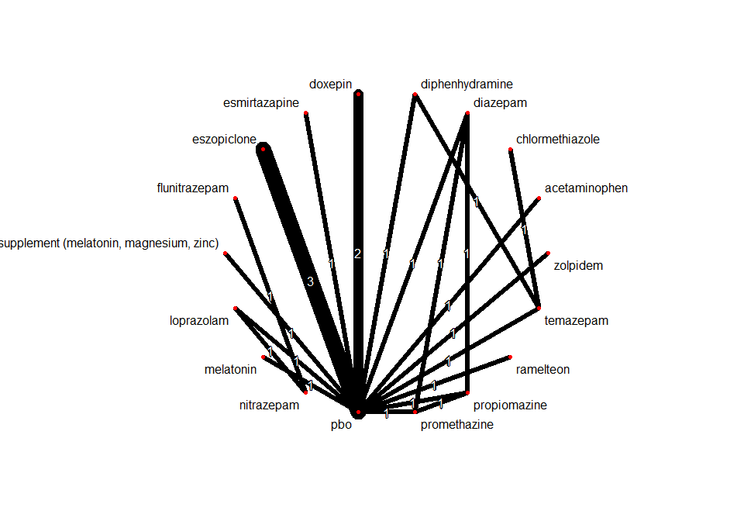

## Frequentist network meta-analysis

Below are the relative treatment effects from the NMA model.

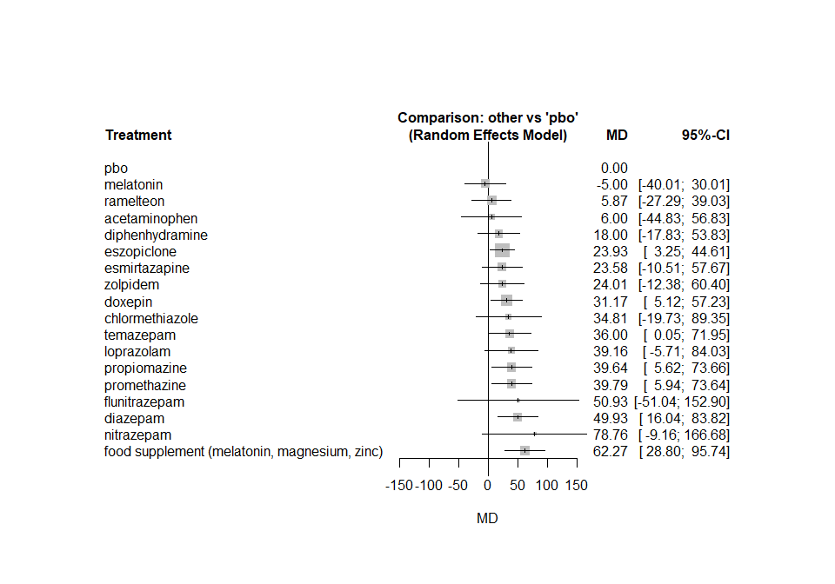

The heterogeneity standard deviation is estimated at

## tau= 16.435

and I-square (total) is

## I2= 80 %