Insomnia NMA

Prepared by Virginia Chiocchia on 4th October, refers to sensitivity analyses for a single outcome (Total Sleep Time) in a frequentist setting

## Description of the network - sensitivity analysis 1 (include Psychogeriatric patients)

Below is a description for the network formed by studies examining the outcome Total Sleep Time also in Psychogeriatric patients.

Number of included interventions:

## [1] 18

Number of included studies:

## [1] 17

The following treatments were excluded as they were disconnected to the main network:

* MAT
* LAT
* MAT+LAT
* sleep hygiene
* lormetazepam + sleep hygiene
* BBT I
* self-monitoring control
* midazolam
* oxazepam
* artificial juice
* tart cherry juice

The plot below shows the available data  
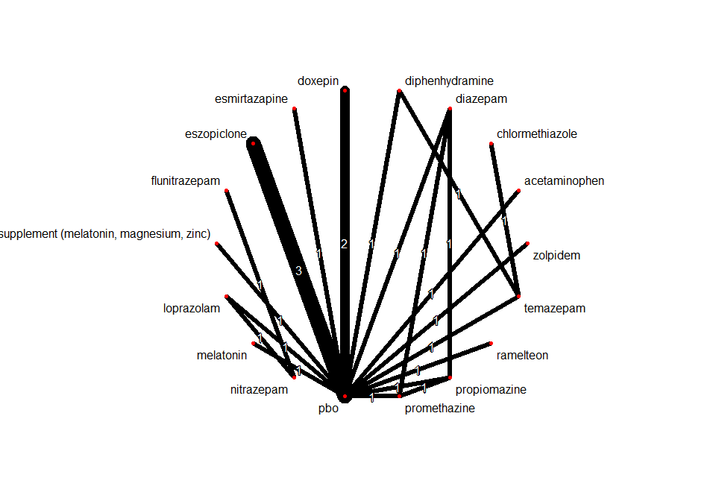

## Frequentist network meta-analysis

Below are the relative treatment effects from the NMA model.

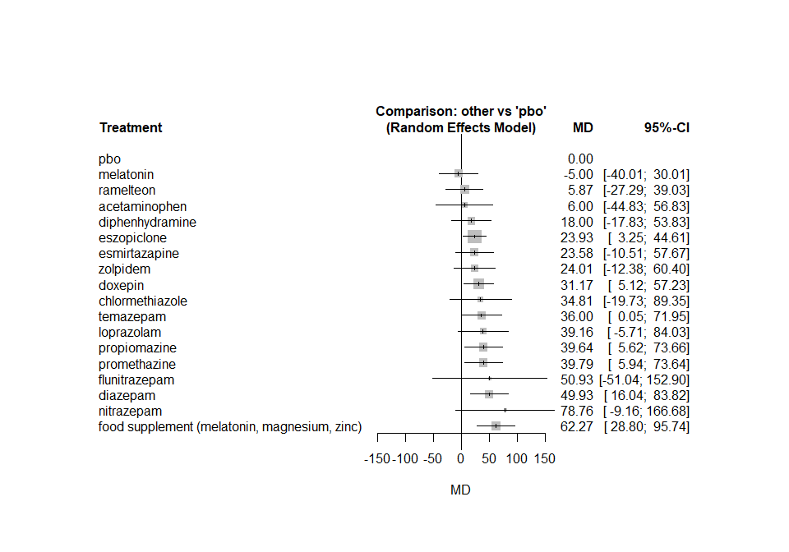

The heterogeneity standard deviation is estimated at

## tau= 16.435

and I-square (total) is

## I2= 80 %

## Description of the network - sensitivity analysis 2 (by drug group)

Below is a description for the network formed by studies examining the outcome Total Sleep Time analysed by drug groups.

Number of included drug groups:

## [1] 9

Number of included studies:

## [1] 15

The following treatments were excluded as they were disconnected to the main network:

* MAT
* LAT
* MAT+LAT
* sleep hygiene
* lormetazepam + sleep hygiene
* BBT I
* self-monitoring control
* artificial juice
* tart cherry juice

Other studies have also been excluded prior to the sensitivity analysis if they were comparing two interventions of the same “drug group”.

The plot below shows the available data  
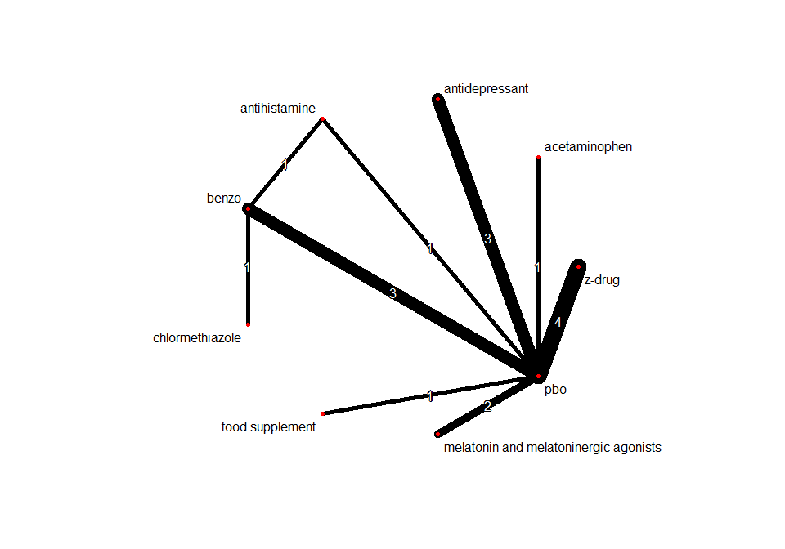

## Frequentist network meta-analysis

Below are the relative treatment effects from the NMA model.

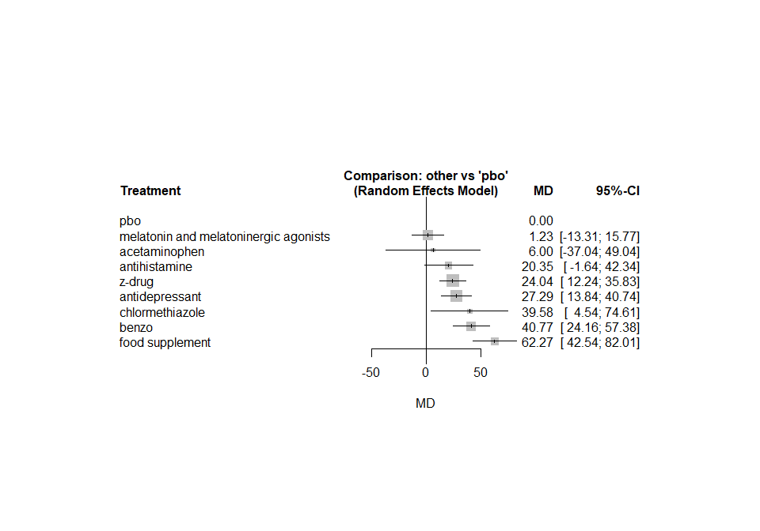

The heterogeneity standard deviation is estimated at

## tau= 8.937

and I-square (total) is

## I2= 55 %