Insomnia NMA

Prepared by Virginia Chiocchia on 28th July, refers to a single outcome analysis (Total Sleep Time) in a frequentist setting

## Description of the network

Below is a description for the network formed by studies examining the outcome Total Sleep Time.

Number of included interventions:

## [1] 17

Number of included studies:

## [1] 16

The following treatments were excluded as they were disconnected to the two main network:

* MAT
* LAT
* MAT+LAT
* sleep hygiene
* lormetazepam + sleep hygiene
* BBT I
* self-monitoring control
* midazolam
* oxazepam
* artificial juice
* tart cherry juice

The plot below shows the available data  
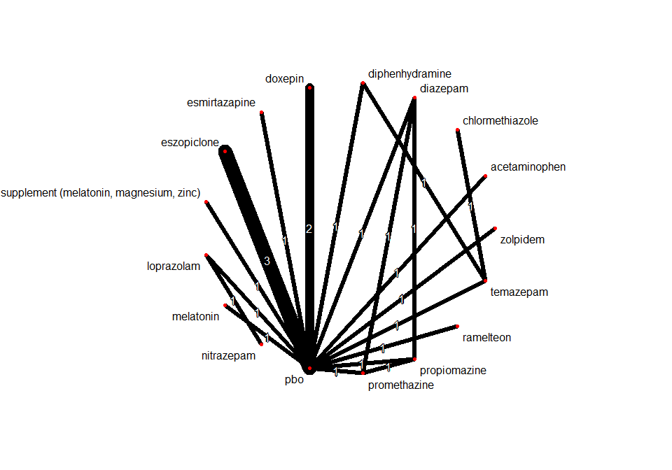

## Frequentist network meta-analysis

Below are the relative treatment effects from the NMA model.

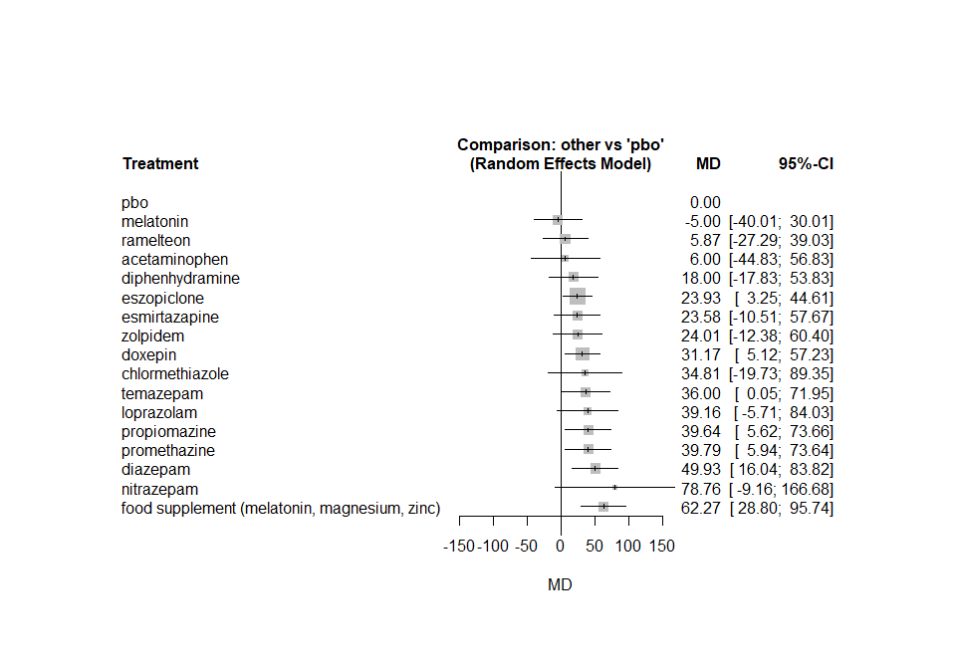

The heterogeneity standard deviation is estimated at

## tau= 16.435

and I-square (total) is

## I2= 80 %

### Sensitivity analyses and meta-regressions

We run a sensitivity analyses excluding the crossover studies

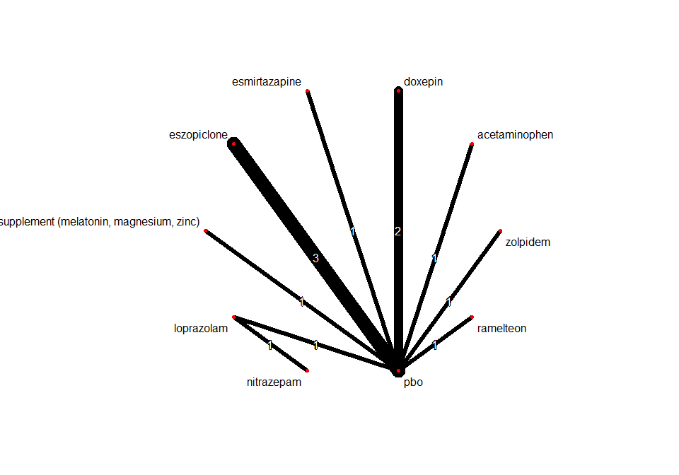

One study, comparing chlormethiazole versus temazepam, was also excluded from this sensitivity analysis because disconnected to the rest of the network

