Insomnia NMA

Prepared by Virginia Chiocchia on 7th August, refers to a single outcome analysis (Nocturnal time awake after sleep onset) in a frequentist setting

## Description of the network

Below is a description for the network formed by studies examining the outcome Time awake after Sleep Onset.

Number of included interventions:

## [1] 7

Number of included studies:

## [1] 9

The following treatments were excluded as they were disconnected to the main network:

* MAT
* LAT
* MAT+LAT
* BBT I
* self-monitoring control
* artificial juice
* tart cherry juice

The plot below shows the available data  
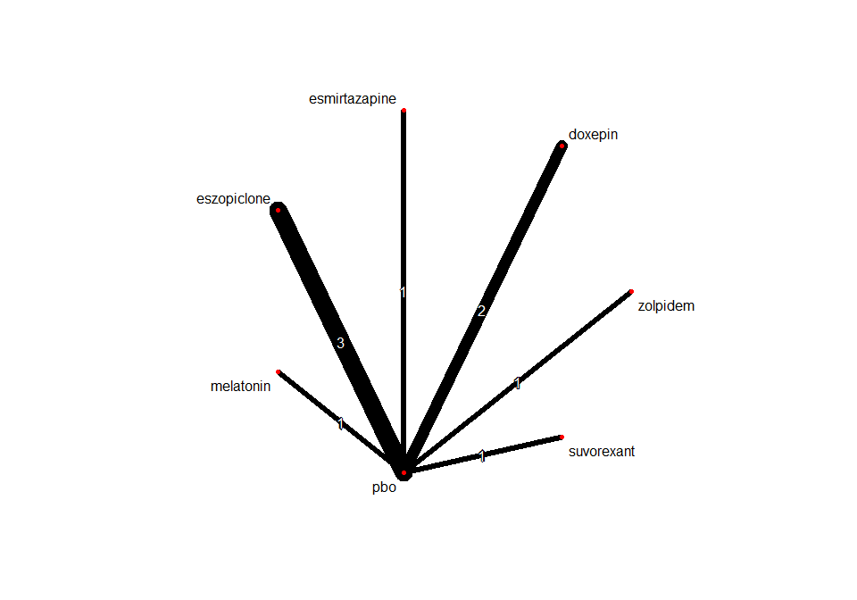

## Frequentist network meta-analysis

Below are the relative treatment effects from the NMA model.

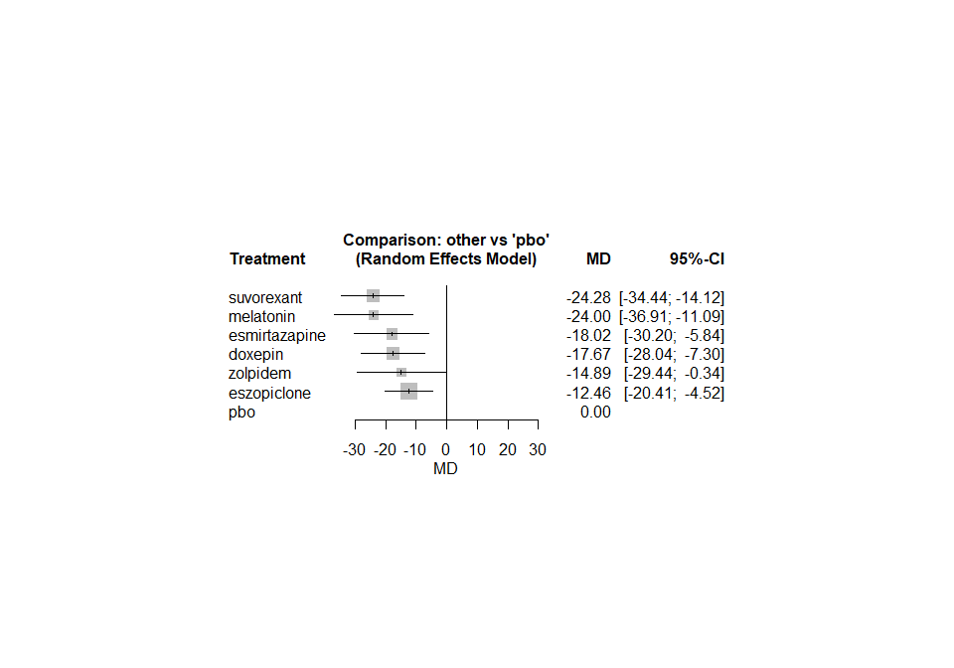

The heterogeneity standard deviation is estimated at

## tau= 3.765

and I-square (total) is

## I2= 27 %

### Sensitivity analyses and meta-regressions

We run a sensitivity analyses excluding the crossover studies

