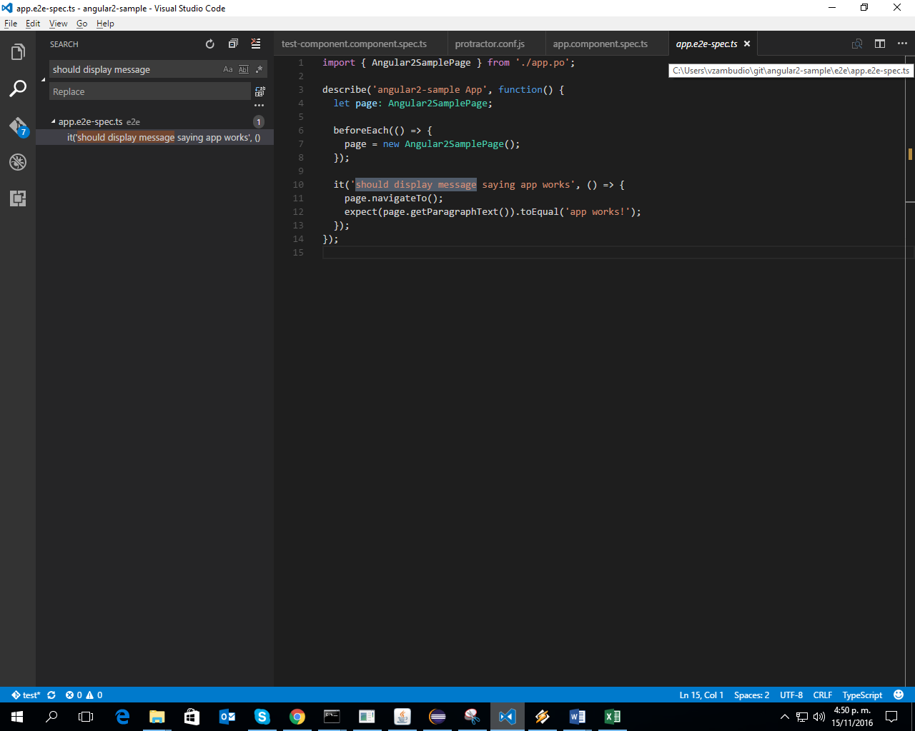
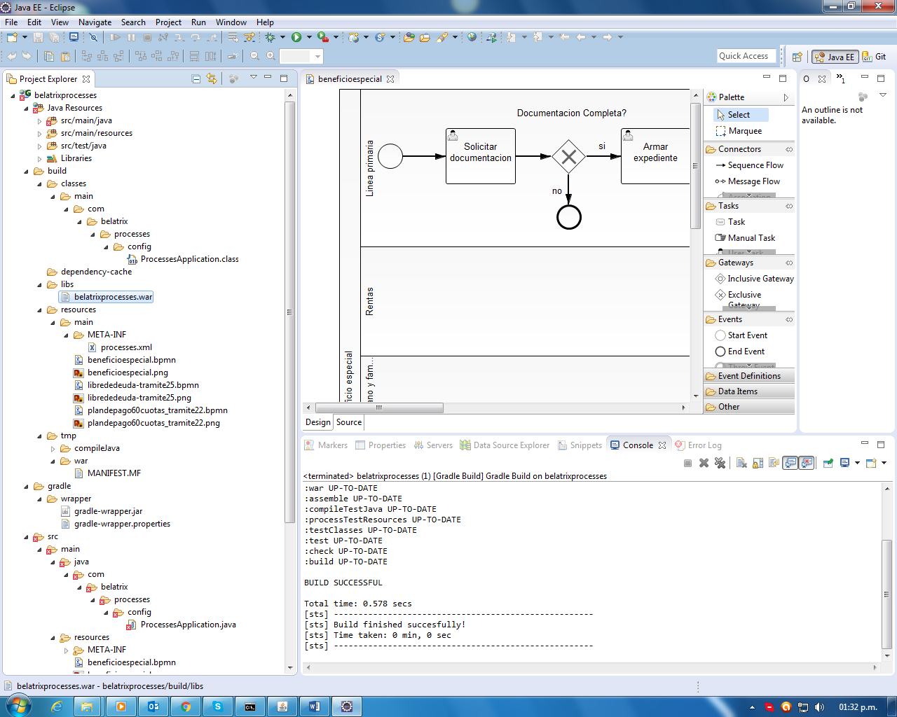
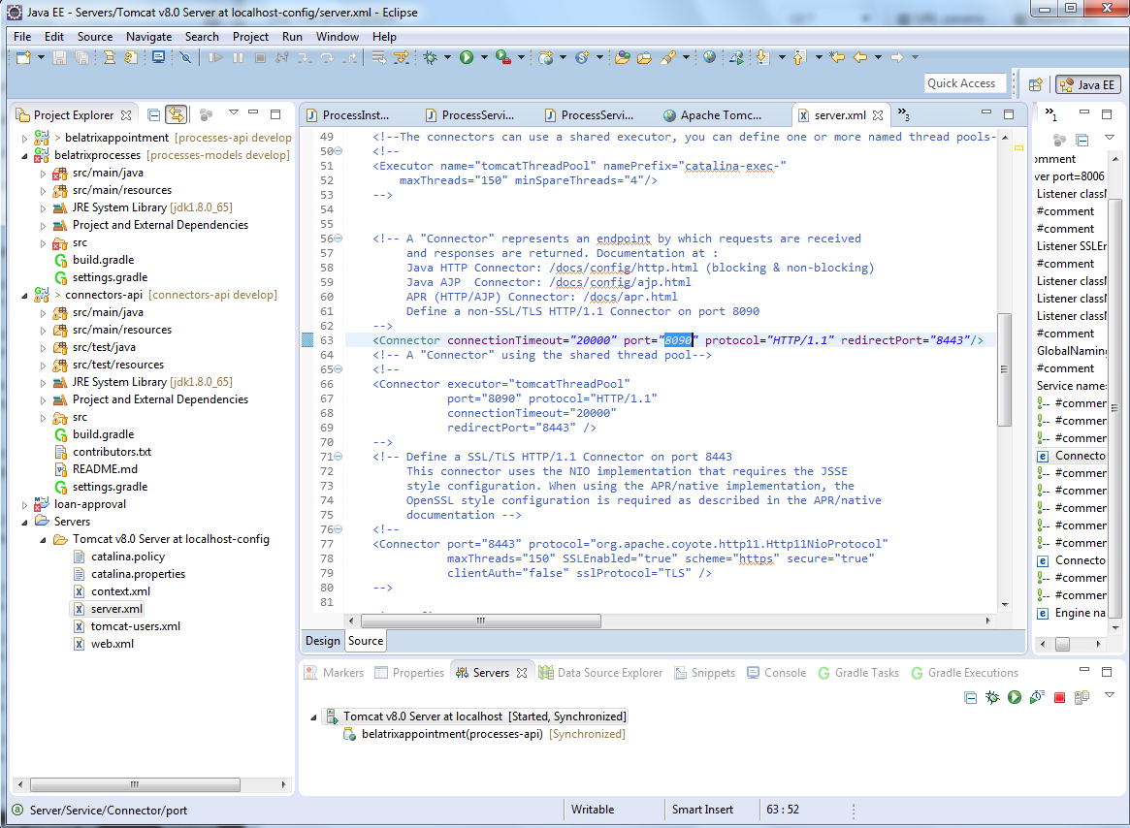
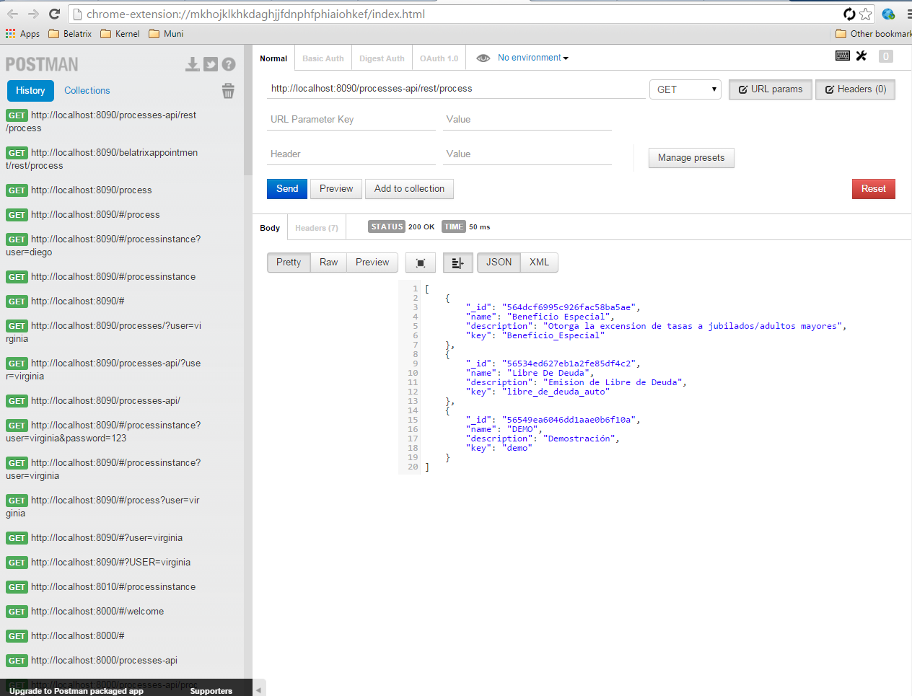
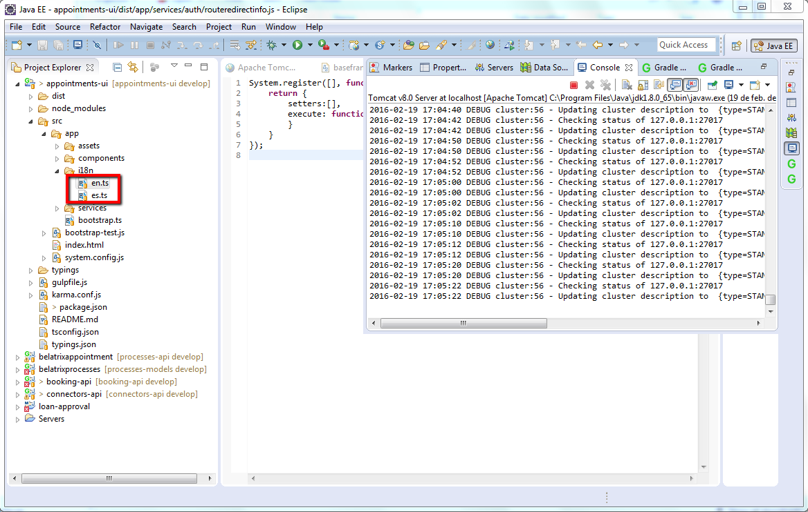
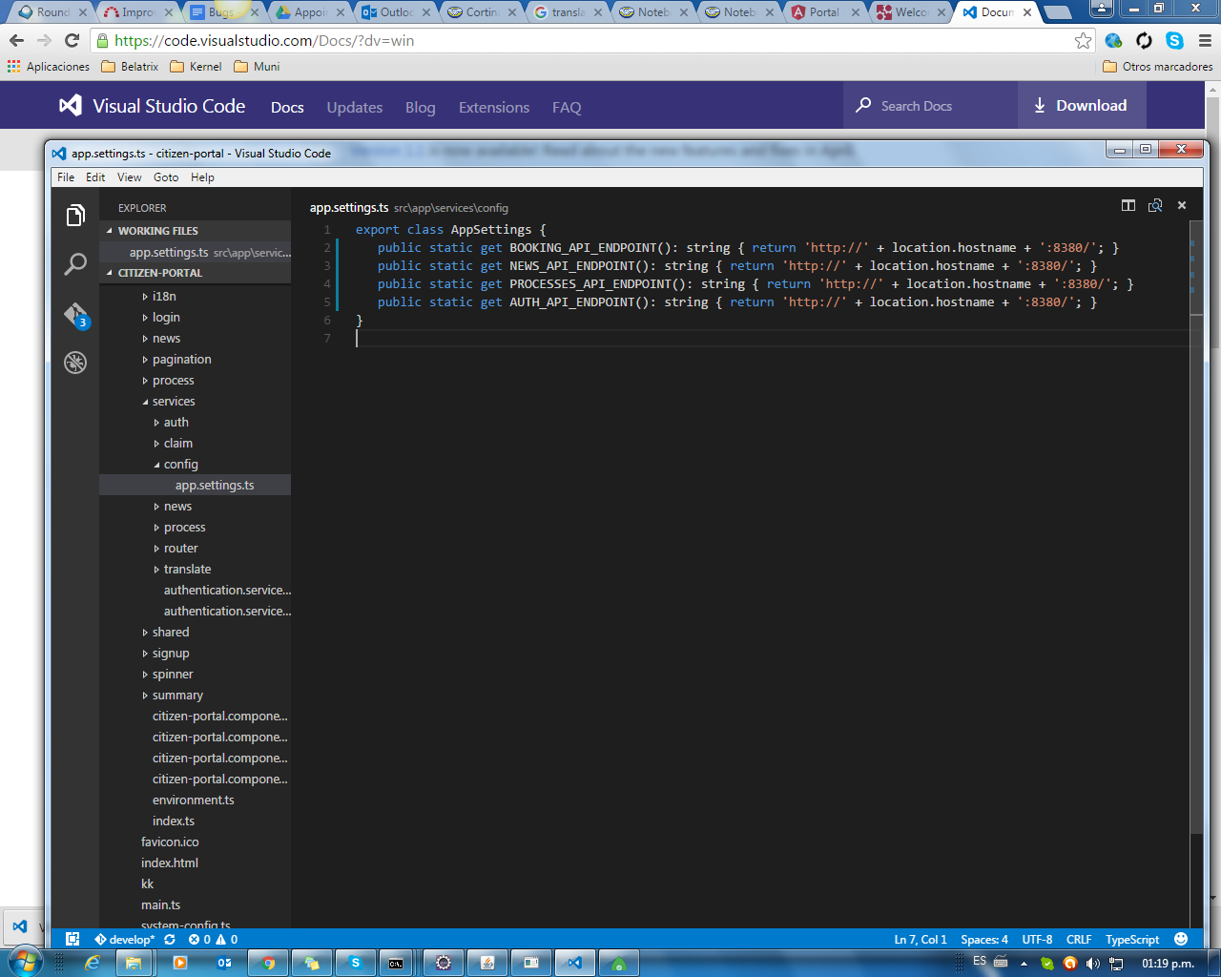
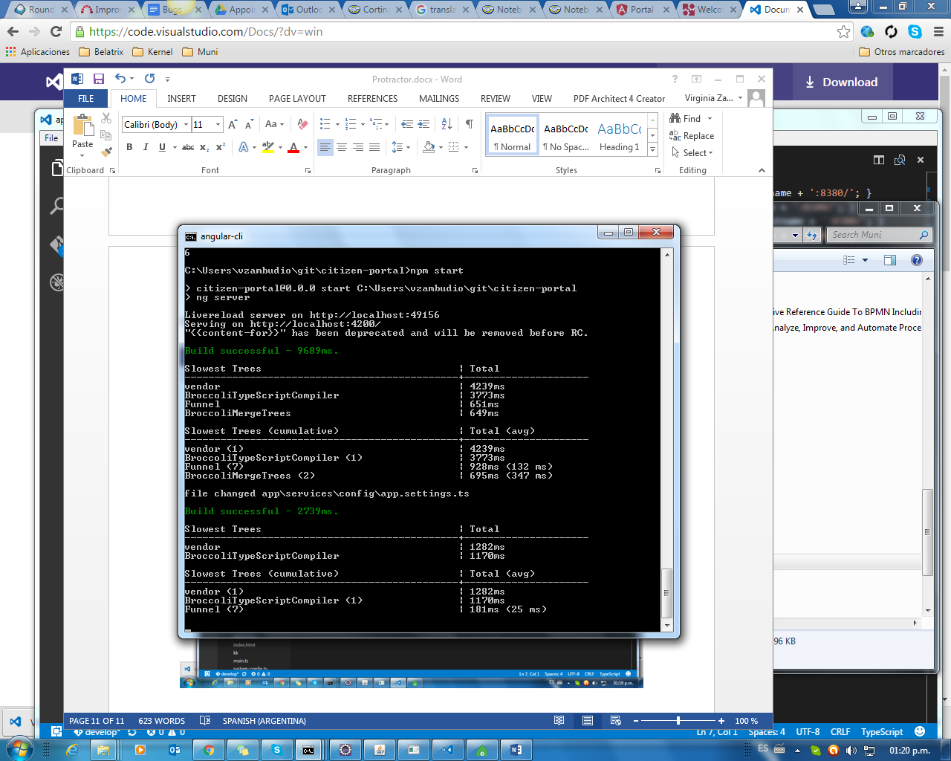
Verify node is installed:

Node –version

http://www.protractortest.org/

http://www.protractortest.org/#/toc

Setup
Use npm to install Protractor globally with:
npm install -g protractor
This will install two command line tools, protractor and webdriver-manager. Try running protractor --version to make sure it's working.
The webdriver-manager is a helper tool to easily get an instance of a Selenium Server running. Use it to download the necessary binaries with:
webdriver-manager update
Now start up a server with:
webdriver-manager start
This will start up a Selenium Server and will output a bunch of info logs. Your Protractor test will send requests to this server to control a local browser. You can see information about the status of the server at http://localhost:4444/wd/hub.

todo-spec.js:
describe('angularjs homepage todo list', function() {
it('should add a todo', function() {
browser.get('https://angularjs.org');

element(by.model('todoList.todoText')).sendKeys('write first protractor test');
element(by.css('[value="add"]')).click();

var todoList = element.all(by.repeater('todo in todoList.todos'));
expect(todoList.count()).toEqual(3);
expect(todoList.get(2).getText()).toEqual('write first protractor test');

// You wrote your first test, cross it off the list
todoList.get(2).element(by.css('input')).click();
var completedAmount = element.all(by.css('.done-true'));
expect(completedAmount.count()).toEqual(2);
});
});
conf.js:
exports.config = {
seleniumAddress: 'http://localhost:4444/wd/hub',
specs: ['todo-spec.js']
};
run the test with:
protractor conf.js

suites:
http://stackoverflow.com/questions/24232511/how-can-i-set-up-common-functions-that-are-available-for-my-test-suites-with-pro

ANGULAR 2
Conf.js
exports.config = {
baseUrl: 'http://http://localhost:3000/',
specs: ['spec.js'],
directConnect: true,
exclude: [],
multiCapabilities: [{
browserName: 'chrome'
}],
allScriptsTimeout: 110000,
getPageTimeout: 100000,
framework: 'jasmine2',
jasmineNodeOpts: {
isVerbose: false,
showColors: true,
includeStackTrace: false,
defaultTimeoutInterval: 400000
},

/**
* ng2 related configuration
*
* useAllAngular2AppRoots: tells Protractor to wait for any angular2 apps on the page instead of just the one matching
* `rootEl`
*
*/
useAllAngular2AppRoots: true
};

Spec.js
describe('Protractor Demo App', function() {
var itemList=element.all(by.css('.heroes>li'));

it('should open home', function() {
browser.get('http://localhost:3000');
});

it('should have a title', function() {
expect(browser.getTitle()).toEqual('Angular 2 QuickStart');
});

it('should open Mis Tramites', function() {
itemList.get(1).click();
expect(itemList.get(1).getText()).toContain('12 Narco');
});

});

Angular 2 Projects:
https://github.com/szikszail/protractor-ng-newsletter-tutorial

Search + Contains:
There are multiple ways to do it, e.g. with a CSS selector:
// starts-with
element(by.css("div[id^=test]"));

// ends-with
element(by.css("div[id$=test]"));

// contains
element(by.css("div[id*=test]"));
Or, with an XPath (no ends-with here):
// starts-with
element(by.xpath("//div[starts-with(@id, 'test')]"));

// contains
element(by.xpath("//div[contains(@id, 'test')]"));

An expected Text:
var educationPage = element(by.tagName("body")).getText();
expect(educationPage).toContain("Education");

Verify current URL:
expect(browser.getCurrentUrl()).toEqual('http://localhost:8000/#/welcome');
//Delete all cookies
browser.driver.manage().deleteAllCookies();

Wait for URL:
var urlChanged = function(url) {
return function () {
return browser.getCurrentUrl().then(function(actualUrl) {
return url != actualUrl;
});
};
};

it('should click on sign in', function() {

element(by.linkText('Ingresar')).click();
browser.wait(urlChanged("http://localhost:8000/#/login"),1000);

});

Wait element preset: expect(pageLogin.username.isPresent()).toBeTruthy();
How to disable waiting for Angular to navigate to a page doesn’t use Angular: https://github.com/angular/protractor/blob/master/docs/timeouts.md
If you need to navigate to a page which does not use Angular, you can turn off waiting for Angular by setting
browser.ignoreSynchronization = true. For example:

browser.get('page-containing-angular');
navigateToVanillaPage.click();
browser.ignoreSynchronization = true;
otherButton.click();
navigateToAngularPage.click();
browser.ignoreSynchronization = false;

Log messages: console.log(ptor.findElement(protractor.By.id('view-container')).getText());

Debug:
https://github.com/angular/protractor/blob/master/docs/debugging.md cmd: protractor debug conf.js
Negative comparison:
expect(false).not.toBe(true);

Pending specs:
describe("Pending specs", function() {
¶
Any spec declared with xit is marked as pending.
it("can be declared by calling 'pending' in the spec body", function() {
expect(true).toBe(false);
pending();
});
});

URL protractor project: https://github.com/CarmenPopoviciu/angular2-go-protractor
PDF con commandos: https://cli.angular.io/reference.pdf

Angular 2
Clonar proyecto
npm install
Abrir proyecto desde visual code
Para crear un componente:
Ir a la carpeta raíz del proyecto y escribir ng g component nombreComponente
Correr las pruebas unitarias: ng test
Para correrolo con protractor:
Instalar protactor: npm install -g protractor
Correr pruebas ui: ng e2e
Para reportar bugs npm bugs nombreProyecto
El archivo de los tests es: app.2e2-spec.ts

down vote | There is a major difference between isDisplayed() and isPresent().  isDisplayed() - Your element is present on the page but it is displayed.  isPresent() - Your element is present in entire DOM of the page. Probably it can be hidden or not disabled, but present.
Botones:

<button ng-click="myFunction()" ng-show="flag">
Submit
</button>
element(by.css('[ng-click="myFunction()"]'))
element(by.buttonText("Submit"));

Encontrar el primer elemento de una lista:
var el = element.all(by.css('body .ui-button, body .ui-datepicker-buttonpane > button')).first();

