**Starter Book Report**

**Given the provided data, what are three conclusions we can draw about Kickstarter campaigns?**

**Figure A.** **Categories**

Generally, the Kickstarter projects are 53% likely to be successful, 8 % to fail or 37% are cancelled. If we look at the outcomes of the successful projects as separate categories, theatre (38%), music (25%) and technology (15%) have the highest success while journalism (0%), food (2%) and photography (4%) had the lowest success. To note is that technology projects had the highest cancellation rate (51%), and only 53% of the projects were successful. This information would be important for the backers as they set goals and make a decision on which categories to support.

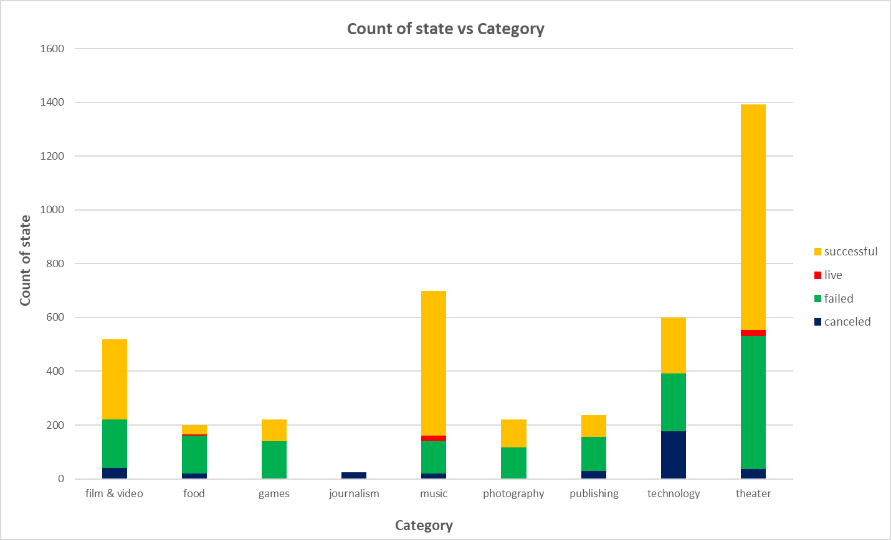

**Figure A**

**Figure B.** **Subcategories**

Looking at the completed subcategories projects (successful or unsuccessful), plays had the highest counts. We had projects that were 100% success rate: classic music, documentary, electronic music, hardware, metal, non-fiction, pop, radio and podcast, rock, shorts, small-batch, tabletop games and television. The subcategories, which had a 100%, fail were animation, children books, drama, faith, fiction, jazz, mobile games, nature, people, places, video games and restaurants.

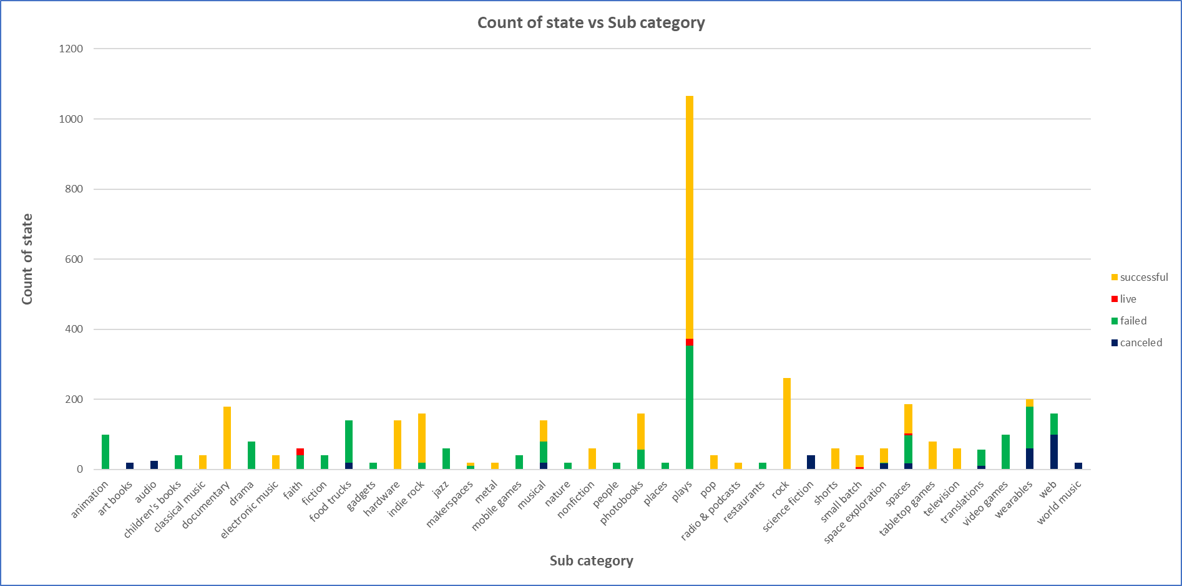

**Figure B**

**Figure C. Dates**

Between February and March, there was a decrease in the successful projects, which later picked up in April and the highest success rate was achieved in May. A wider gap between the rate of successful and failed projects was observed between January and June. After May, there was an accelerated decrease in success rate, through to September, with a narrow gap between Successful and failed projects in September and an intersection in December where failed count surpasses successfully for the first time. It would be worth full to look into any correlation between the percentage funds for highest and lowest success count and establish if there is any correlation.

Hence, the best time to launch a campaign is in May as the results showed a higher success rate in this month. The campaigns are not successful in the Month of December – January may be a result of the Christmas and new year holidays.

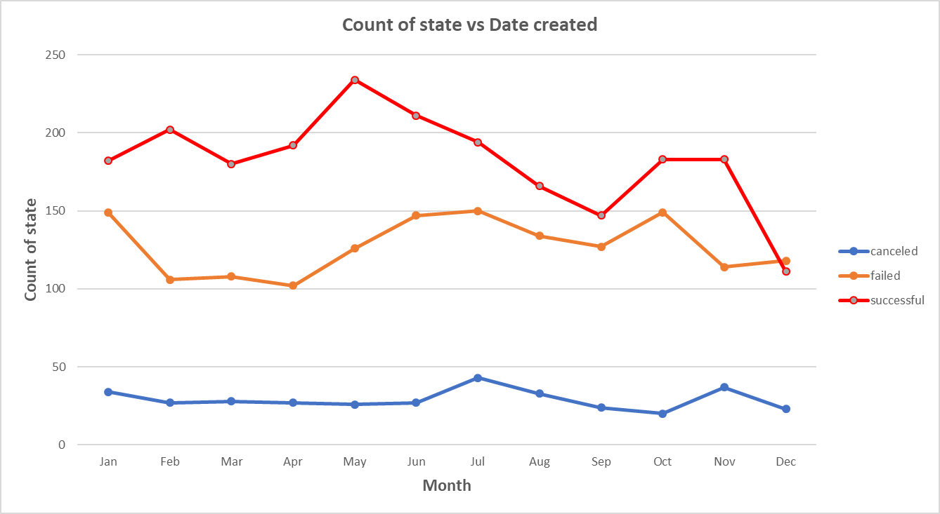

**Figure C**

**What are some limitations of this dataset?**

-Some categories have a small dataset, so these results may not be statistically correct.

-There are no references on why the campaigns failed; e.g was it due to dates, goals?

-What advertisement tools are used for successful or failed campaigns? Were they the same or were some better than others?

**What are some other possible tables and/or graphs that we could create?**

* A table or graph showing the analysis of the data by state and establishing which state have Kick-starters with the highest rate of success and which ones have the lowest rate of success.
* A graph showing the trend based on date created conversion and date ended conversion and maybe establish what separate the duration of successful and unsuccessful projects

**Bonus questions**



**Use your data to determine whether the mean or the median summarises the data more meaningfully.**

The median summarises both successful and failed data set meaningfully, with 96.5 for the unsuccessful and 74 for successful.

**Use your data to determine if there is more variability with successful or unsuccessful campaigns. Does this make sense? Why or why not?**

The variability is much higher for the pool of successful campaigns. I think this makes sense because of the huge range of backers in successful campaigns.