dash board IME

grupo 1

2023-11-03

## R Markdown

This is an R Markdown document. Markdown is a simple formatting syntax for authoring HTML, PDF, and MS Word documents. For more details on using R Markdown see <http://rmarkdown.rstudio.com>.

When you click the **Knit** button a document will be generated that includes both content as well as the output of any embedded R code chunks within the document. You can embed an R code chunk like this:

summary(cars)

## speed dist   
## Min. : 4.0 Min. : 2.00   
## 1st Qu.:12.0 1st Qu.: 26.00   
## Median :15.0 Median : 36.00   
## Mean :15.4 Mean : 42.98   
## 3rd Qu.:19.0 3rd Qu.: 56.00   
## Max. :25.0 Max. :120.00

## Including Plots

You can also embed plots, for example:

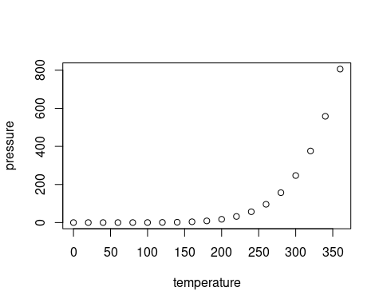

Note that the echo = FALSE parameter was added to the code chunk to prevent printing of the R code that generated the plot.

# Especializacion_obras_civiles

Entregas clase gestiometria

## GERENCIA

## OFICINA TECNICA

## COMPRAS

## GESTION DE CALIDAD

## RRHH

## OBRA

## ADMNISTRACION

# creacion de tablas

| Right | Left | Default | Center |
| --- | --- | --- | --- |
| 12 | 12 | 12 | 12 |
| 123 | 123 | 123 | 123 |
| 1 | 1 | 1 | 1 |
| 33 | 12 |  | 5 |

#importar datos de excel

library(readr)  
BSC_proveedores <- read_csv("https://themys.sid.uncu.edu.ar/r-cran/BSC_proveedores.csv")

## New names:  
## Rows: 150 Columns: 6  
## ── Column specification  
## ──────────────────────────────────────────────────────── Delimiter: "," chr  
## (1): Empresa dbl (5): ...1, Tecnologia, Normas, Capital, Equipo  
## ℹ Use `spec()` to retrieve the full column specification for this data. ℹ  
## Specify the column types or set `show_col_types = FALSE` to quiet this message.  
## • `` -> `...1`

BSC_proveedores

## # A tibble: 150 × 6  
## ...1 Tecnologia Normas Capital Equipo Empresa  
## <dbl> <dbl> <dbl> <dbl> <dbl> <chr>   
## 1 1 5.1 3.5 1.4 0.2 Tenaris  
## 2 2 4.9 3 1.4 0.2 Tenaris  
## 3 3 4.7 3.2 1.3 0.2 Tenaris  
## 4 4 4.6 3.1 1.5 0.2 Tenaris  
## 5 5 5 3.6 1.4 0.2 Tenaris  
## 6 6 5.4 3.9 1.7 0.4 Tenaris  
## 7 7 4.6 3.4 1.4 0.3 Tenaris  
## 8 8 5 3.4 1.5 0.2 Tenaris  
## 9 9 4.4 2.9 1.4 0.2 Tenaris  
## 10 10 4.9 3.1 1.5 0.1 Tenaris  
## # ℹ 140 more rows

hist(BSC_proveedores$Tecnologia)

