* ***Project Scope Document -***

VERY LARGE SPACE TELESCOPE ELAB

Authors: Angelo Rosa, Giulia Giamberini, Roberto Magrini

Date: 30.11.2024

Version: 0.1

Circulation: Internal, Project Partners, Public

1. **Project Goals and Requirements**

Objectives for the VLST-Elab project (each following the **SMART** approach)

1. **Develop data elaboration software for the VLST data**

The primary objective of the VLST-Elab project is to develop and deploy an elaboration software with the task of assembling together and elaborating the VLST’s data payloads, returning filtered and validated data and high-resolution images. The software will be compatible with NASA’s existing VLST infrastructure. We aim to release the final version of the software by the 36th month and to have it fully tested on-site by the 38th month.

1. **Validate data and high-resolution image accuracy using mathematical models and ML**

The objective is to ensure the accuracy of the received data and the images produced by the VLST-Elab. This will be achieved by integrating Machine Learning (ML) models into the software, enabling it to monitor incoming data and detect eventual anomalies. The same approach will be applied to the generated images to validate their correctness. These functionalities are planned to be added in the beta version of the software, with testing completed by the 22nd month.

1. **Increase the computational resources using our infrastructure**

The objective is to provide an enhancement of the VLST-Elab computational resources using our infrastructure. To achieve this objective a facility to house all the hardware components must be built, purchased or rented. Subsequently, the hardware must be bought, assembled, connected to the network and then tested. All these operations will be conducted in parallel with software development and are expected to be completed by the 12th month.

1. **Ensure the security of our infrastructure**

The objective is to ensure the security of the data that will be elaborated using our infrastructure. The security must be maintained during data transmission from NASA’s VLST center to our facility and vice versa, as well as during data processing and storage. To achieve this objective it’ll be required the hiring and training of specialized staff.

The hiring and training process is expected to be completed, indicatively, by the 6th month, while the completion and testing of the security measures are scheduled for completion by the 14th month.

In the next section, instead, a more detailed description of the objectives of the project will be given, following the **MoSCoW** approach.

| Priority | Name | Description |
| --- | --- | --- |
| MUST HAVE | Software Development | SW: Create advanced software for processing satellite data into high-resolution images.  HW: Use distributed computing and GPU technology for efficiency.  Ensure compatibility with NASA's VLST infrastructure and current satellites. |
| Security Standards | Ensure data integrity and protection of external data on local instances. |
| Testing and Validation | Conduct in-house, earth-based, and on-site testing.  Guarantee software reliability and accuracy. |
| SHOULD HAVE | Training Objectives | Help NASA staff in understanding of software capabilities and technical required steps. |
| Infrastructure Objectives | Infrastructure should have a maintainable modularity structure for each component. |
|
| Future Partnerships | Consider improving and enlarging partnerships with other organizations in the future. |
| Maintenance Operations | Continue to maintain the software post-development |
| COULD HAVE | Advanced UI | A user-friendly UI could be present to allow NASA employees to work faster without wasting too much time on tech aspects. |
| Increase Computation Resources | Init to think about enlarging HW infrastructure for even faster data elaboration. |
| WON’T HAVE | Outside Deployment | Deployment is limited to NASA’s VLST center and will not be release to Universities or other entities |
| Open Source Collaboration | Share piece of data/software with open source community |

1. **Assumptions and constraints**

The assumptions of this project are:

* The radio telescopes have already been designed, built and launched in a stable orbit around the sun, it’s also NASA’s job to maintain the satellites and to update their firmware.
* The VLST center has already been designed and built.
* The communication methods between the VLST center and the satellites have already been defined, so orbiting satellites can send data to the VLST center and the format and quantity of that data is known.
* The communications are reliable, it’s NASA’s job to guarantee the reliability of the communications between radio telescopes and the VLST center and to implement some kind of protocol, in case of failure, that maintains the quality of the incoming data to an acceptable level.
* The VLST center hardware can support our software.

The constraints of this project are:

* The minimal quality of the output data decided with NASA requires the usage of filtering techniques and ML models to validate the output.
* Respecting the deadlines of the milestones, since this project is part of a greater project is necessary to account beforehand for possible problems during development and to deal with them quickly and efficiently.
* The high cost of building the infrastructure for increasing the computational resources means that this capability will scale over time if it is required.

1. **Project Outputs and Control Points**

The project is divided into **twelve major milestones**, which range from the **kick-off** **meeting** to **personnel hiring**, **infrastructure design**, **software development**, completion of the **Alpha** and **Beta** versions of the software, extensive **testing phases**, and the final **deployment of the software**. The project culminates in the creation and publication of the ***first processed image*** from gathered data, followed by the commencement of long-term operations.

Deliverables are scheduled at critical points, ensuring the project's progress is systematically documented and reviewed.

*List of milestones:*

| **#** | **Name** | **Date**  **(Months)** | **Description** |
| --- | --- | --- | --- |
| **1** | Kick-Off | 0 | The first meeting where the project and the necessary steps to complete it are defined. |
| **2** | Preliminary Operations | 1 | The hiring of the necessary personnel and the start of the base software development.  Start of the design of the infrastructure needed for future performance scaling. |
| **3** | Initial Project Review | 6 | At the end of this milestone we have completed the base requirements and the design of the project. Beginning of the coding of the Alpha version of the project. |
| **4** | Completion of the Infrastructure Construction | 12 | Completion of the infrastructure construction. |
| **5** | Second Project Review | 14 | Alpha version is completed and tested using In-House data. |
| **6** | Earth-Based Stress-Test and Third Project Review | 24 | Beta version of the software has been completed and tested using instruments and old data of the EHT (Event Horizon Telescope). |
| **7** | Deployment | 35 | Deployment of the Final version of the software |
| **8** | On-Site Stress-Test | 36 | The software has been thoroughly tested on-site. |
| **9** | Fourth Project Review | 40 | Review of the test results and analysis of eventual problems. |
| **10** | First Image | 44 | The first data has been gathered and elaborated, creating the first image. |
| **11** | Final Project Review | 48 | Final review of the project and publication of the first image. |
| **12** | Start of the Long-Term Operations | 49 | The long-term work begins. |

*List of deliverables:*

| **No** | **Delivery Date** | **Title** | **Dissemination level** | **Nature** |
| --- | --- | --- | --- | --- |
| #1 | 14th Month | Alpha Cycle | CO | P |
| #2 | 15th Month | Completion of the Infrastructure for Improving Computational Power | CO | P |
| #3 | 24th Month | Beta Cycle | CO | P |
| #4 | 35th Month | Release | CO | P |
| #5 | 49th Month | Beginning of the Long Term Operations | CO | P |

where:

* Delivery date: number of months after the start of the project;
* Dissemination level: public (PU), restricted to the project team (RE), or restricted to the project stakeholders (CO);
* Nature: report (R), prototype (P), demonstrator (D), or other (O).

1. **Project Work Breakdown**

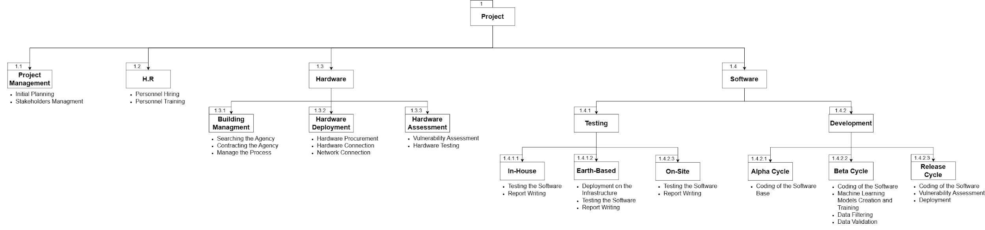

The project is organized in the following work packages.

| **WP 1. Project Management** | | |
| --- | --- | --- |
| Start Date: M 0 | End Date: M 49 | Responsible: Angelo Rosa, Giulia Giamberini, Roberto Magrini |
| Work statement | This WP includes all the necessary activities for managing the project. | |
| Tasks | Initial Planning, Stakeholder Management | |

| **WP 2. H.R** | | |
| --- | --- | --- |
| Start Date: M 1 | End Date: M 6 | Responsible: Cristian Petronici |
| Work statement | This WP includes the activities for hiring new personnel and training the new hires. | |
| Tasks | Personnel Hiring, Personnel Training | |

| **WP 3. Building Management** | | |
| --- | --- | --- |
| Start Date: M1 | End Date: M 12 | Responsible: Vito Bambolotto |
| Work statement | This WP includes all the necessary activities to build the facility that will house the hardware for the computational power increase. | |
| Tasks | Searching for an Agency, Contracting the Agency, Follow the Process | |

| **WP 4. Hardware Deployment** | | |
| --- | --- | --- |
| Start Date: M1 | End Date: M 14 | Responsible: Fatmir Qunaij |
| Work statement | This WP will include all the necessary steps to procure, deploy, and connect the hardware. | |
| Tasks | Hardware Procurement, Hardware Connection, Network Connection | |

| **WP 5. Hardware Assessment** | | |
| --- | --- | --- |
| Start Date: M14 | End Date: M 15 | Responsible: Antonietta Fusaro |
| Work statement | This WP will include all the necessary steps to test the hardware and its connections and to assess its security. | |
| Tasks | Vulnerability Assessment, Hardware Testing | |

| **WP 6. In-House** | | |
| --- | --- | --- |
| Start Date: M6 | End Date: M 14 | Responsible: Alfonso Del Sole |
| Work statement | This WP will include all the necessary steps and activities necessary to test the Alpha version of VLST-Elab using in-house data. | |
| Tasks | Test Data Gathering, Testing the Software, Report Writing, Test’s Result Exposition | |

| **WP 7. Earth-Based** | | |
| --- | --- | --- |
| Start Date: M23 | End Date: M 24 | Responsible: Alfonso Del Sole |
| Work statement | This WP will include all the steps and activities necessary to deploy and test the Beta version of VLST-Elab on the EHT infrastructure and use its data. | |
| Tasks | Deployment on the Infrastructure, Testing the Software, Report Writing | |

| **WP 8. On-Site** | | |
| --- | --- | --- |
| Start Date: M33 | End Date: M 35 | Responsible: Alfonso Del Sole |
| Work statement | This WP will include all the steps and activities necessary to test the Final version of VLST-Elab on the VLST Center Infrastructure. | |
| Tasks | Testing the Software, Report Writing | |

| **WP 9. Alpha Cycle** | | |
| --- | --- | --- |
| Start Date: M6 | End Date: M 13 | Responsible: Ubaldo Continiello |
| Work statement | This WP will include all the activities necessary to code the Alpha version of VLST-Elab. | |
| Tasks | Coding of the Software Base, Data Gathering, Image Creation | |

| **WP 10. Beta Cycle** | | |
| --- | --- | --- |
| Start Date: M14 | End Date: M 23 | Responsible: Ubaldo Continiello |
| Work statement | This WP will include all the activities necessary to code the Beta version of VLST-Elab. | |
| Tasks | Coding of the Software, Refining of the Previous Features, Machine Learning Models Creation and Training, Data Filtering, Data Validation | |

| **WP 11. Release Cycle** | | |
| --- | --- | --- |
| Start Date: M24 | End Date: M 35 | Responsible: Ubaldo Continiello |
| Work statement | This WP will include all the activities necessary to code the Final version of VLST-Elab. | |
| Tasks | Coding of the Software, Refining of the Previous Features, Vulnerability Assessment, Deployment | |

The following Gantt chart illustrates the structure of the project and the timing of the activities:

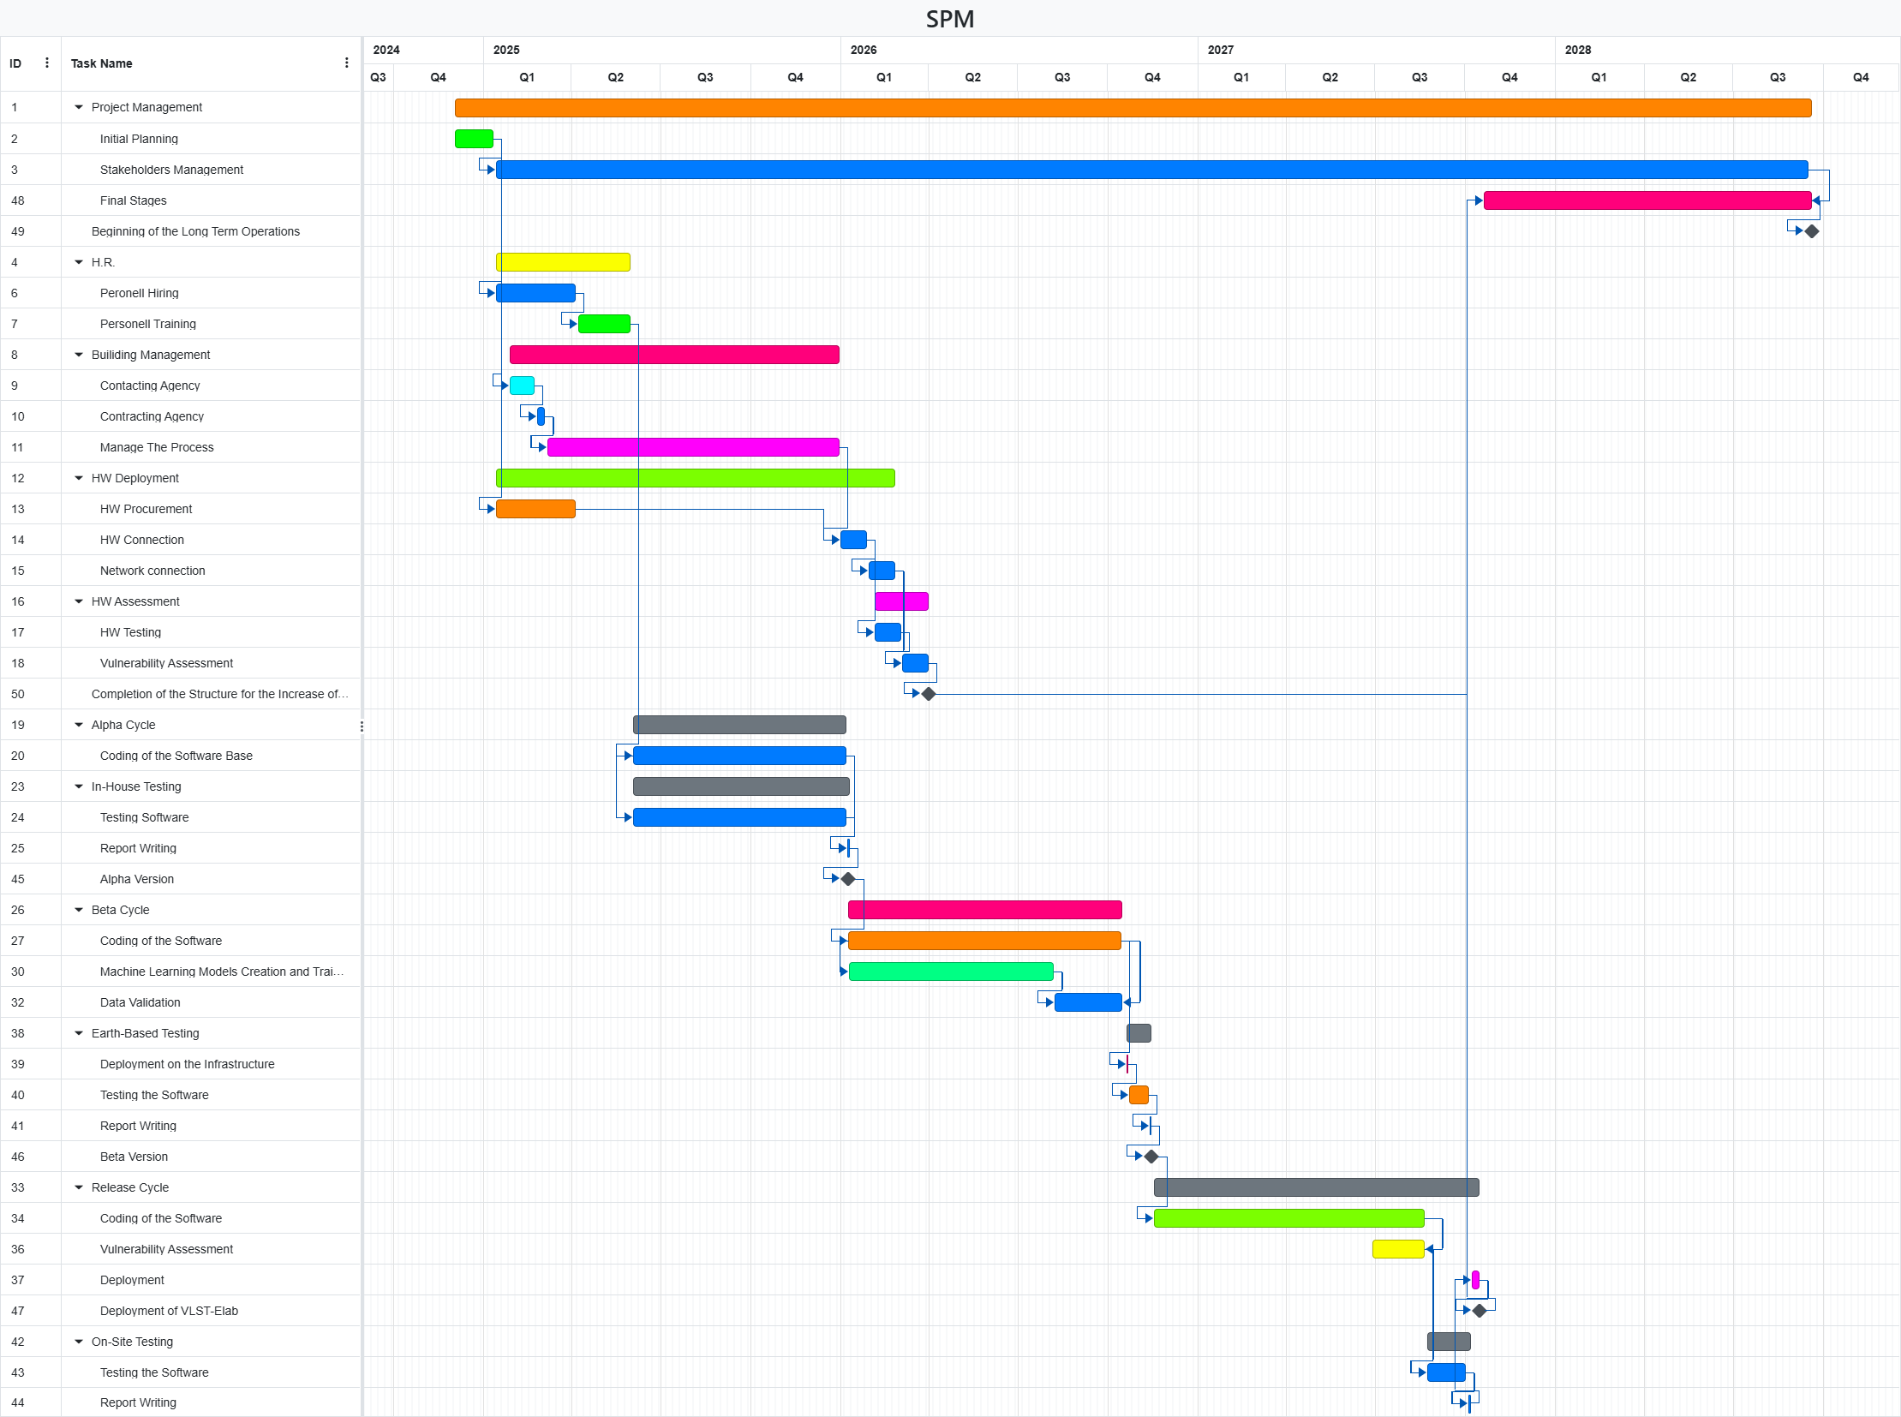

The following image illustrates the critical path analysis, highlighting multiple critical paths due to the tight interdependencies between data and coding.

*There are some critical aspects to consider. All the finish-to-finish relationships are represented by red lines, while the start-to-start relationships are shown with blue lines. Specifically, during the backward pass analysis, we encountered difficulties in determining the correct values for the latest finish times and latest start times of certain tasks.*

* *Stakeholder Management and Final Stages must both be completed at the same time. This ensures that all stakeholder requirements and communications are fully addressed by the time the project reaches its final stages;*
* *Coding Final and SW Vulnerability Assessment must both be completed at the same time. This ensures that the final code is ready and secure by the time the vulnerability assessment is completed;*
* *Coding SW Alpha and Testing SW 1 can start simultaneously. This allows for early testing of the software as soon as the coding phase begins, ensuring that any issues are identified and addressed promptly;*
* *Coding SW Beta and ML Creation can start simultaneously. This allows for the development of machine learning models in parallel with the coding of the software, facilitating integration and testing of ML components within the software* *development lifecycle.*
* 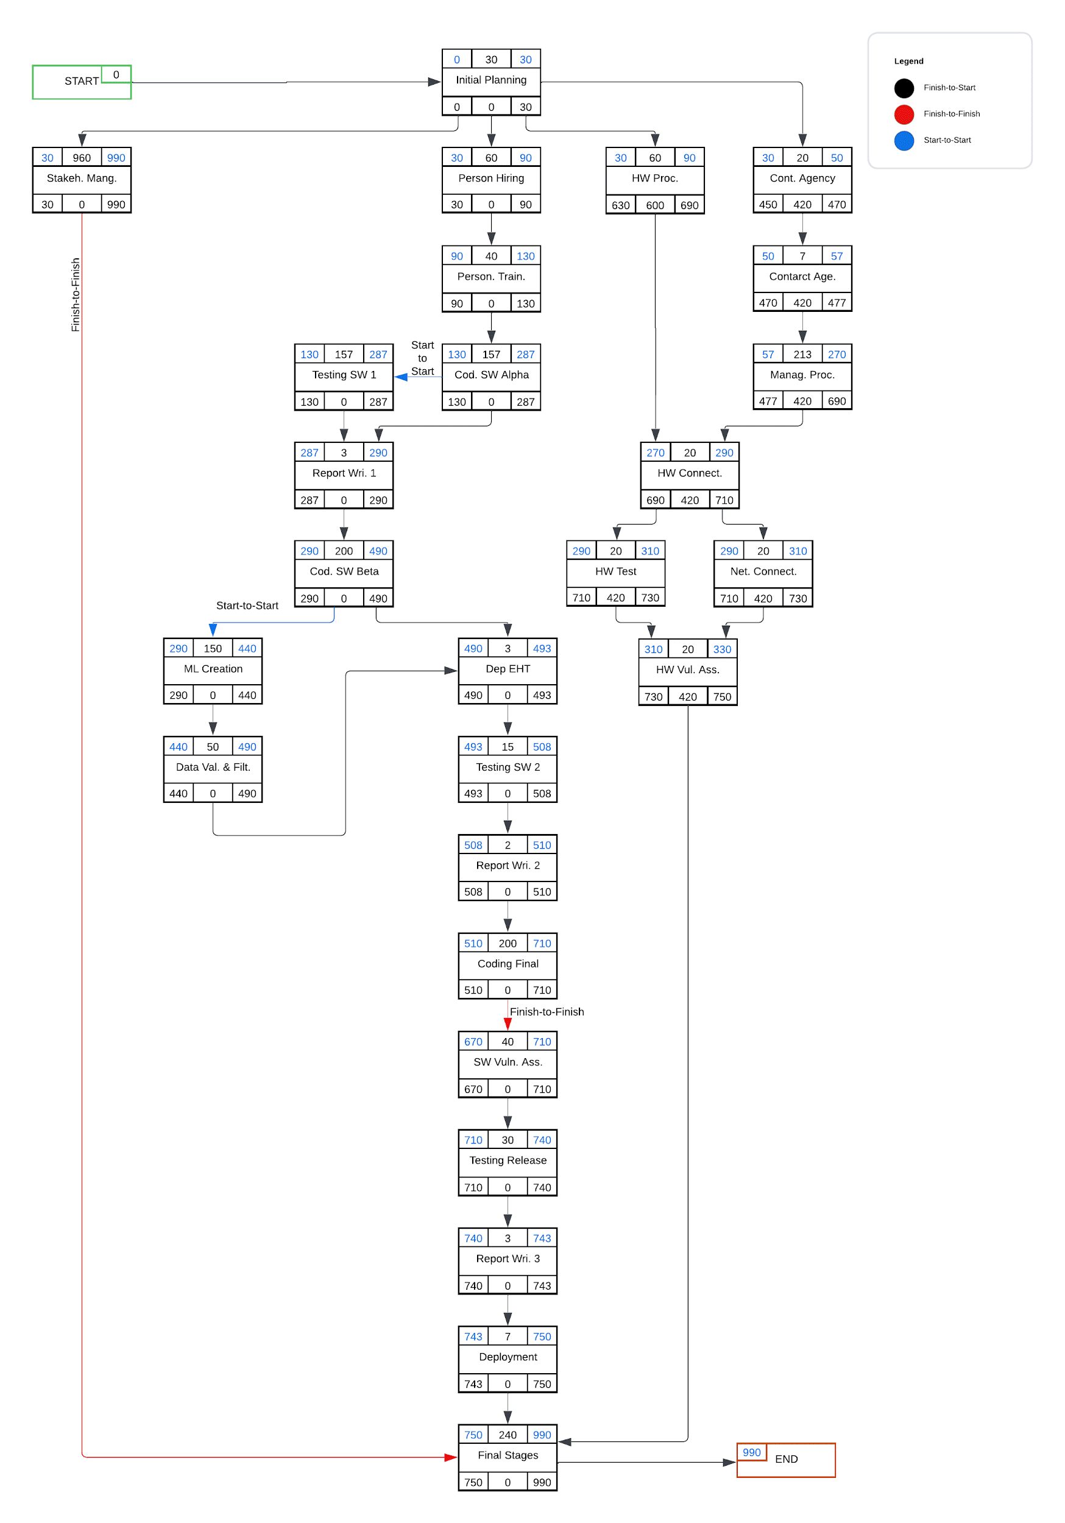

1. **Project Roster**

Following the CoCoMo template, given our needs, the template has suggested that we need at least 115 (114,86) team members. We have decided that, to reach our goals in time, we need to divide the personnel as follows:

Stakeholder contacts:

* NASA stakeholder → email: [john.doe@nasa.gov](mailto:john.doe@nasa.gov)
* Physics → ToBeIdentified from NASA
* VLST-project NASA responsible:

Internal personnel:

* Project Managers:
* Angelo Rosa [email: [angelo.rosa@vlst-elab.com](mailto:angelo.rosa@vlst-elab.com)]
* Giulia Giamberini [email: [giulia.giamberini@vlst-elab.com](mailto:giulia.giamberini@vlst-elab.com)]
* Roberto Magrini [email: [roberto.magrini@vlst-elab.com](mailto:roberto.magrini@vlst-elab.com)]
* Human Relations:
* Cristian Petronici [email: [cristian.petronici@vlst-elab.com](mailto:cristian.petronici@vlst-elab.com)]
* Members: 9
* Building Management:
* Vito Bambolotto [email: [vito.bambolotto@vlst-elab.com](mailto:vito.bambolotto@vlst-elab.com)]
* Additional Members: 9
* Hardware Deployment:
* Fatmir Qunaij [email: [fatmir.qunaij@vlst-elab.com](mailto:fatmir.qunaij@vlst-elab.com)]
* Additional Members: 10
* Hardware Assessment:
* Antonietta Fusaro [email: [anotnietta.fusaro@vlst-elab.com](mailto:anotnietta.fusaro@vlst-elab.com)]
* Additional Members: 10
* In-House Testing, Earth-Based Testing, On-Site Testing:
* Alfonso Del Sole [email: [alfonso.delsole@vlst-elab.com](mailto:alfonso.delsole@vlst-elab.com)]
* Additional Members: 14
* Alpha Cycle, Beta Cycle, Release Cycle:
* Ubaldo Continiello [email: [ubaldo.continiello@vlst-elab.com](mailto:uby.continiello@vlst-elab.com)]
* Additional Members: 69

The testers will be paid only for the months used for testing and not annually and the people working on the building of the facility and the Hardware Assessment will be contracted for the duration of their work. That'll be a one-year contract for the building management employees and only two months of contract for the hardware assessment employees. Having made this premises the annual obligatory expenses will be **2.894.000**$ per year, while occasional expenses will be **665.000**$ for building management and **490.000**$ for the testing.

**1-13 Month**: SW Employee Salaries + Building Management outgoings

**31-37 Month**: SW Employee Salaries + Testing personnel salaries

| **Time** | **Coming Investment** | **Outgoings** | **Cumulative Remaining** |
| --- | --- | --- | --- |
| 1-6 month | 5.000.000 $ | Salaries 1.447.000 $ + 665.000 $ | 2.888.000,00 $ |
| 7-13 month | 1.785.714,29 $ | Salaries 1.447.000 $ + 665.000 $ | 2.561.714,29 $ |
| 14-19 month | 1.785.714,29 $ | Salaries 1.447.000 $ | 2.900.428,58 $ |
| 20-25 month | 1.785.714,29 $ | Salaries 1.447.000 $ | 3.239.142,87 $ |
| 26-31 month | 1.785.714,29 $ | Salaries 1.447.000 $ | 3.577.857,16 $ |
| 31 - 37 month | 1.785.714,29 $ | Salaries 1.447.000 $ + 490.000 $ | 3.426.571,45 $ |
| 38 - 43 month | 1.785.714,29 $ | Salaries 1.447.000 $ | 3.765.285,74 $ |
| 44 - 48 month | 1.785.714,29 $ | Salaries 1.447.000 $ | 4.104.000,03 $ |

|  | **Remaining** | **Discount factor** | **Present value** |
| --- | --- | --- | --- |
| **1-6 month** | $2.888.000,00 | 1,00 | $2.888.000,00 |
| **7-13 month** | $ -326.285,71 | 0,95 | $ -309.971,43 |
| **14-19 month** | $338.714,29 | 0,91 | $ 308.230,00 |
| **20-25 month** | $338.714,29 | 0,87 | $ 294.681,43 |
| **26-31 month** | $338.714,29 | 0,83 | $ 281.132,86 |
| **31 - 37 month** | $-151.285,71 | 0,79 | $ -119.515,71 |
| **38 - 43 month** | $338.714,29 | 0,75 | $ 254.035,72 |
| **44 - 48 month** | $338.714,29 | 0,72 | $ 243.874,29 |
|  | **TOT remain** |  | **TOT present value** |
|  | $4.104.000,03 |  | $3.804.467,07 |

considering the evaluation of the $discount factor = \frac{1}{(1+i)^{n}}$ where *i* is the percentage of inflation and *n* is the year (or half year, depending on the semester).

This will let us recalculate some financial parameters such as Annual Profit and ROI

The following are the new proposed ones:

**Annual profit**: $(\$17.500.000,00 - \$13.396.000)/4 = \$$ 1.026.000

**ROI: $\$1.026.000 / \$13.396.000= 0.07659= 7.659\%$**

Of course, to this estimation, we must consider that at the end of the deployment, the software will be paid. These values are calculated only on the investment for development.

1. **Similar Solutions**

At the moment, no competitor to our solution exists.