**Website Usability Report for**

**Gym and Nutrition (Dot-com)**

<http://gymandnutrition.com>



Prepared for:

National College of Ireland

Mayor Street, Dublin 1, Ireland

Module: Usability Design

Prepared by:

Navjot S. Virk

[Virksaabnavjot@gmail.com](mailto:Virksaabnavjot@gmail.com)

March, 2017



Table of Contents

1 Overview and the purpose of the Report 2

Goals and Objective of Gym and Nutrition Dot-Com 3

Figure 1: Current Version of GN Website 3

Site Overview 3

Site Logo (Small) 3

Site Logo (Main Logo) 3

How Gymandnutrition.com achieve its goals? 4

Figure 2: Screenshot of the community forum where people find useful content 5

Figure 3: Website provides easy Login/Register on each page. 5

Figure 4: Easy Registration Form 5

Figure 5: Websites income source (Advertisement) 6

Introduction to Usability 6

2 Competitive websites (no more than 3) 7

Bodybuilding.com 7

Figure 6: Website of Competitor (Bodybuilding.com) 8

3 Site requirements 9

4 User requirements 9

5 Site design & navigation 9

6 Heuristic Evaluation 9

7 Conclusion & Recommendations 9

8 References 10

# Overview and the purpose of the Report

The purpose of the report is to provide a complete analysis of the GN (Gym and Nutrition) website (<http://www.gymandnutrition.com)> of the current version of the website. In order to learn weather users could gain understanding of the website structure and be able to perform common tasks with ease. Through, the course of the report, several analytical methods were utilised to determine whether the current version of the website successfully fulfils the business goals and objectives of the Gym and Nutrition.

## Goals and Objective of Gym and Nutrition Dot-Com

Attracting and keeping engaged thousands of fitness enthusiasts, and provide a powerful community for people to ask questions and be able to contribute to fitness community.

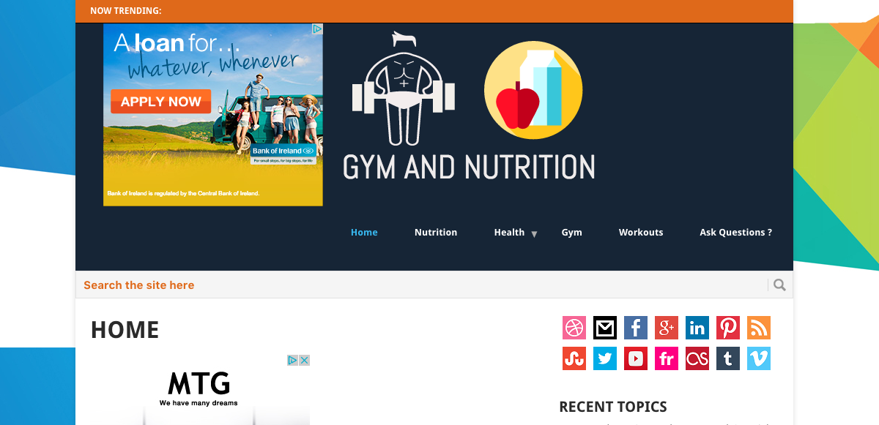

### Figure 1: Current Version of GN Website

## Site Overview



Site Logo (Small) – GN representing Gym and Nutrition along with Apple and milk representing fitness.



Site Logo (Main Logo) – Simple but meaning full logo with a Bodybuilder symbolising - “gym” and Apple & Milk symbolising – “nutrition”.

Let’s take an extensive look at the higher level view of the whole GN Website. And its layout and how it works (it’s usability). When, a user visits GN Website they are most probably looking for useful content either on gym or nutrition or both.

GN (Gym and Nutrition) is a community forum, along with blog to help people stay fit and live a better life.

## How Gymandnutrition.com achieve its goals?

GN website is fairly newly established website and new content is being posted on daily basis, the content available on website currently focuses on fat loss and nutrition based content of whole foods. The aim of GN, is to provide an easy to use and interact with platform to people looking for ways to improve their health. To achieve its aim GN provides an easy to use forum software on their website, using which new users can easily register with the site within 15 seconds and start asking their health, gym and nutrition related questions and also contribute towards the community through answering other people’s questions.

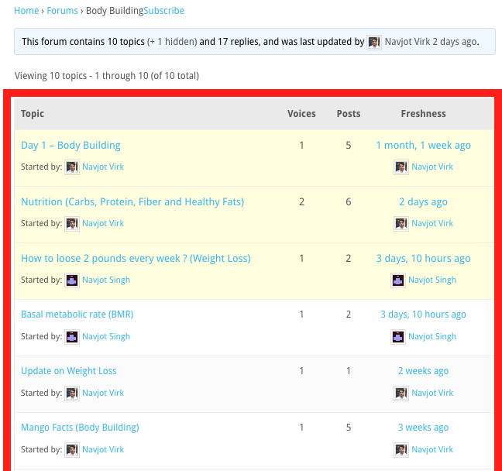

### Figure 2: Screenshot of the community forum where people find useful content

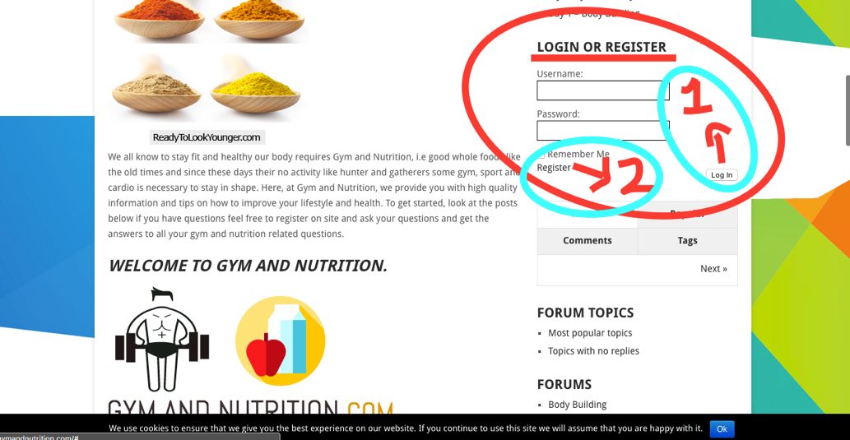

### Figure 3: Website provides easy Login/Register on each page.

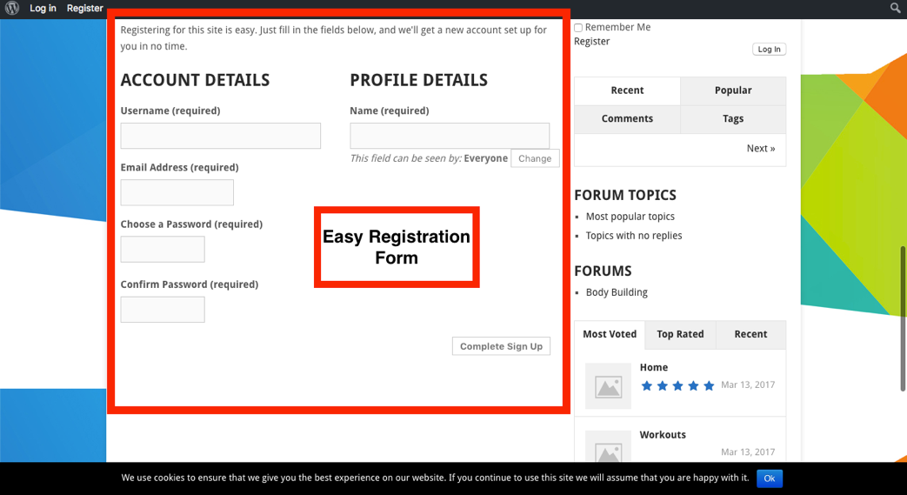

### Figure 4: Easy Registration Form

GN team also seems to be dedicated to providing quality answer to their users and also provide useful blog with quality fitness related content. GN, currently does not sell any products or services on their websites but may do so in future as we know every one of us want to be fit and fitness industry attract a lot of people and there is a high demand of fitness related content/services (digital) and products. Currently, the source of income for the website is through AdSense advertisement and some affiliate marketing.

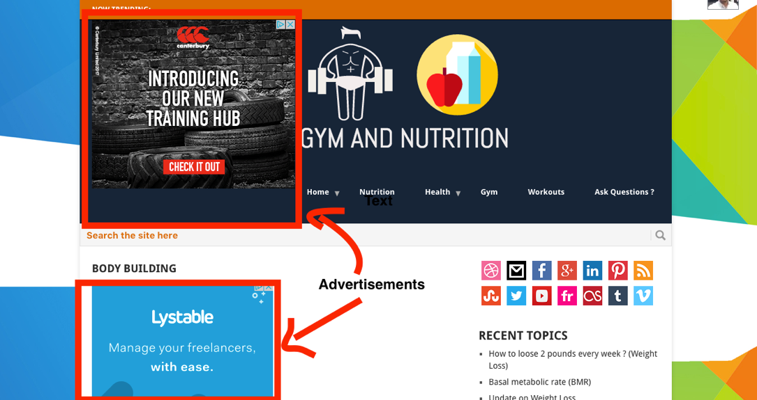

### Figure 5: Websites income source (Advertisement)

## Introduction to Usability

For an organisation to reach its audience, website is an important gateway. Website helps organisation to deliver/showcase its information, products and services to its users. As such, website should exactly reflect user needs/requirements it’s designed for?

The irony is the website development and design is often focused on making the website look good and neglect the usability aspect, and designers designing the website according to their thinking and view of the problem, technology and business objectives) instead of focusing on user needs.

In recent, times people have started focusing on usability when under pressure from competitors in race to be the best or by paying attention to customer complaints and improving the solution.

Defining the usability of the website may be confusing to many people and discussions are ongoing. To a degree usability depends on the target user and purpose of the website.

In general, a usable website is the one that is easy to learn, navigable, consistent, provide accessibility and availability, clarity, relevancy, guidance, credibility and learnability and allow quick recovery from errors that is provide an opportunity for the customer to redo/undo.

These days the internet is huge and we are able to find just anything, which interns means lots of options for users and Web users are very picky and desire great experience – if they don’t like the design or not able to find something for a second they get frustrated and quickly exit the site and are not likely to return. For business and content sites if the website is very hard to use and find the services and content it may cost the business the clients or potential content subscribers. Hence, loss of revenue.

Challenges related to Usability design for people trying to incorporate usability into their websites –

* Increased user expectations due to huge size internet is difficult to satisfy.
* When assessing a site, a user hasn’t invested like in a software package and other options are available
* Widely different user experience to users due to different hardware, network and software platforms available of the same website.
* There is always something to be improved.
* New development in technology, in short time washes away the efforts made previous technology and force business to invest in new technology to stay competitive.

# Competitive websites (no more than 3)

Fitness industry is huge and we all dream about the perfect body. Hence, fitness industry is very attractive and lucrative market. Gymandnutrition.com focuses on gym and nutrition content and has large number of competitors competing for the same audience.

Below are 3 credible competitors’ to GN website –

## Bodybuilding.com

Website: <https://bodybuilding.com>



Logo (Very simple and stylish, Sky blue background and white coloured letter “B” - short for body building).

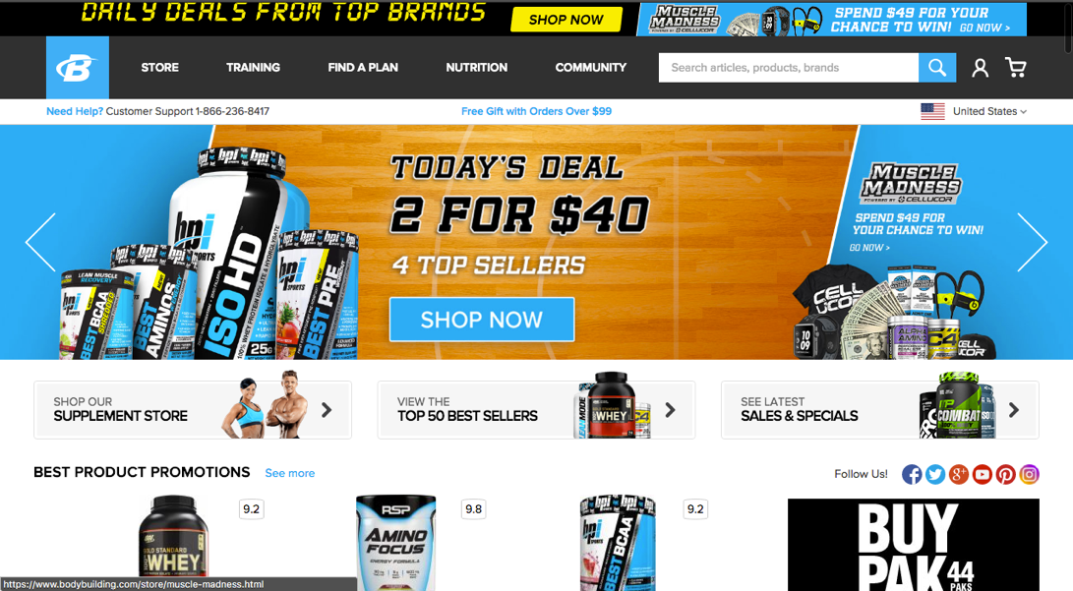

### Figure 6: Website of Competitor (Bodybuilding.com)

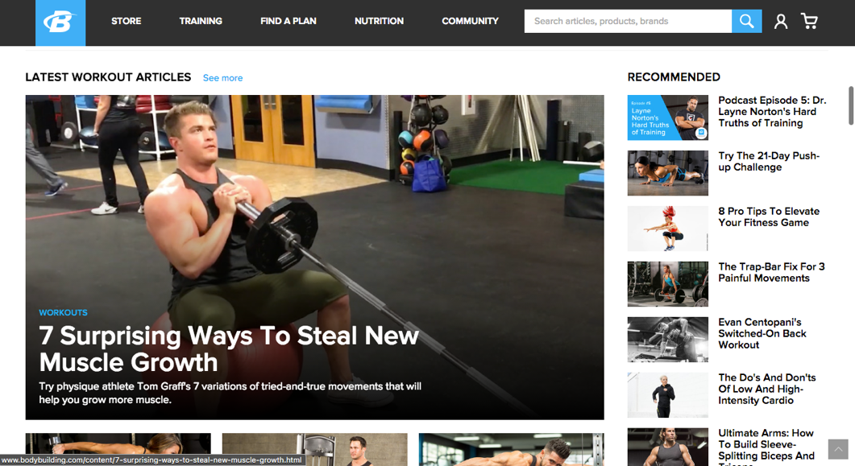

#### Figure 6.1: Bodybuilding.com Content Layout

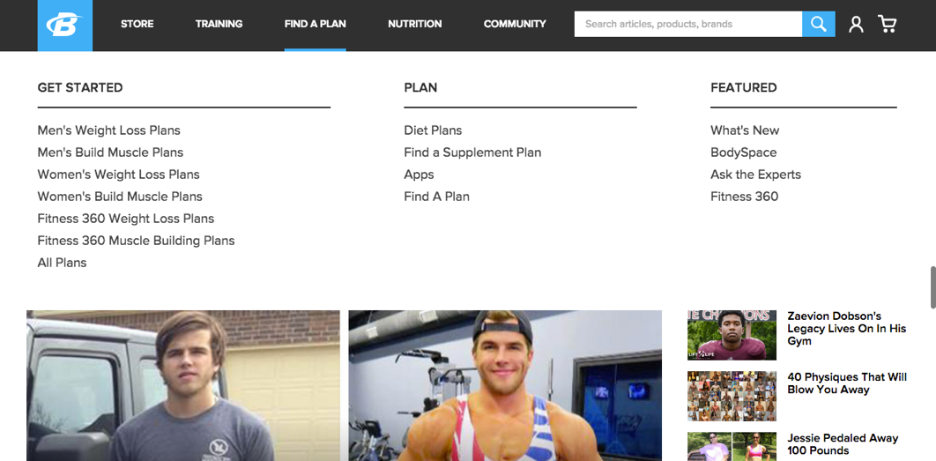

#### Figure 6.2: Bodybuilding.com Menu when hovered over

**Bodybuilding.com (BB)** is a big player in fitness industry their website has a clean design with a good menu design which expands on hovering over and provides all useful links under a topic.

**Strengths:**

BB also provide quality content on gym and nutrition and is a direct competitor to Gymandnutrition.com, GN website can compete BB by providing unique and focused, collaborated and right content users are looking for constantly people are looking for alternatives and here is where newly launched GN website can improvise and build large user base.

The website is: clear, credible, accessible, provide relevant content and services.

**Weaknesses:**

BB Website has a flashy little ad on the top of its homepage which can be annoying to some users and in general pages on BB website includes a lot of images & video content and takes about 20 seconds or more to completely load the page.

GN Website can utilize these weaknesses of it competitor.

# Site requirements

# User requirements

**Scenarios (no more than 2)**

# Site design & navigation

**Information architecture**

**Mobile usability (optional)**

# Heuristic Evaluation

# Conclusion & Recommendations

# References

~~Notes and Requirements~~

~~Carry out investigation into the usability of an existing website. (3 Thousand Words)~~