***Jump Hero***

*Simple 2D platformer*

I wanted to make a simple game, so a platformer came into my mind. This game is nothing much but I think you will at least acknowledge it’s “simplicity”. So, the goal of this game is to get to the blue tile on the other side of the map. There are 6 maps:

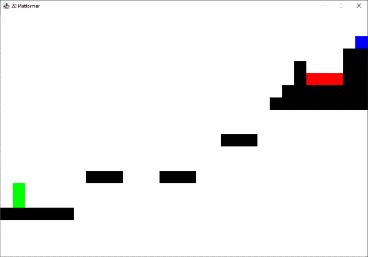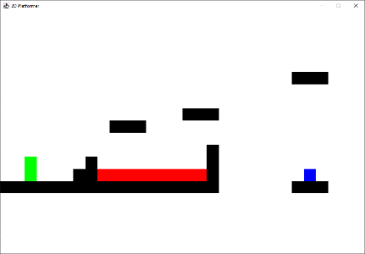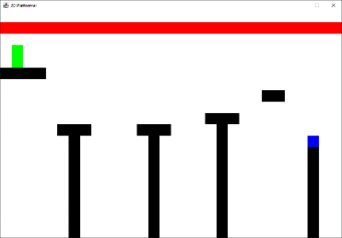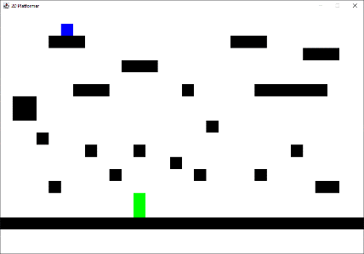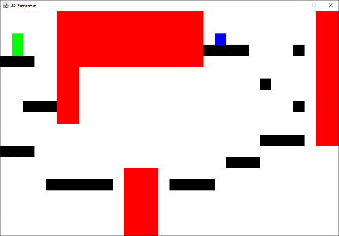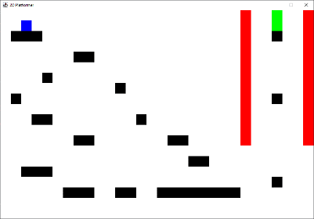

Which randomly get selected for you to play. The controls are as follows:

A = move left, D = move right, W = jump, R = reset to starting position

When you reach the blue tile the game closes but you can try to play it again and you should have a new map to play, until of course you play through them all. The player will respawn if he goes out of bounds, falls down completely or touches the red tiles. All images can be found in the doc directory of this project, for further inspection.

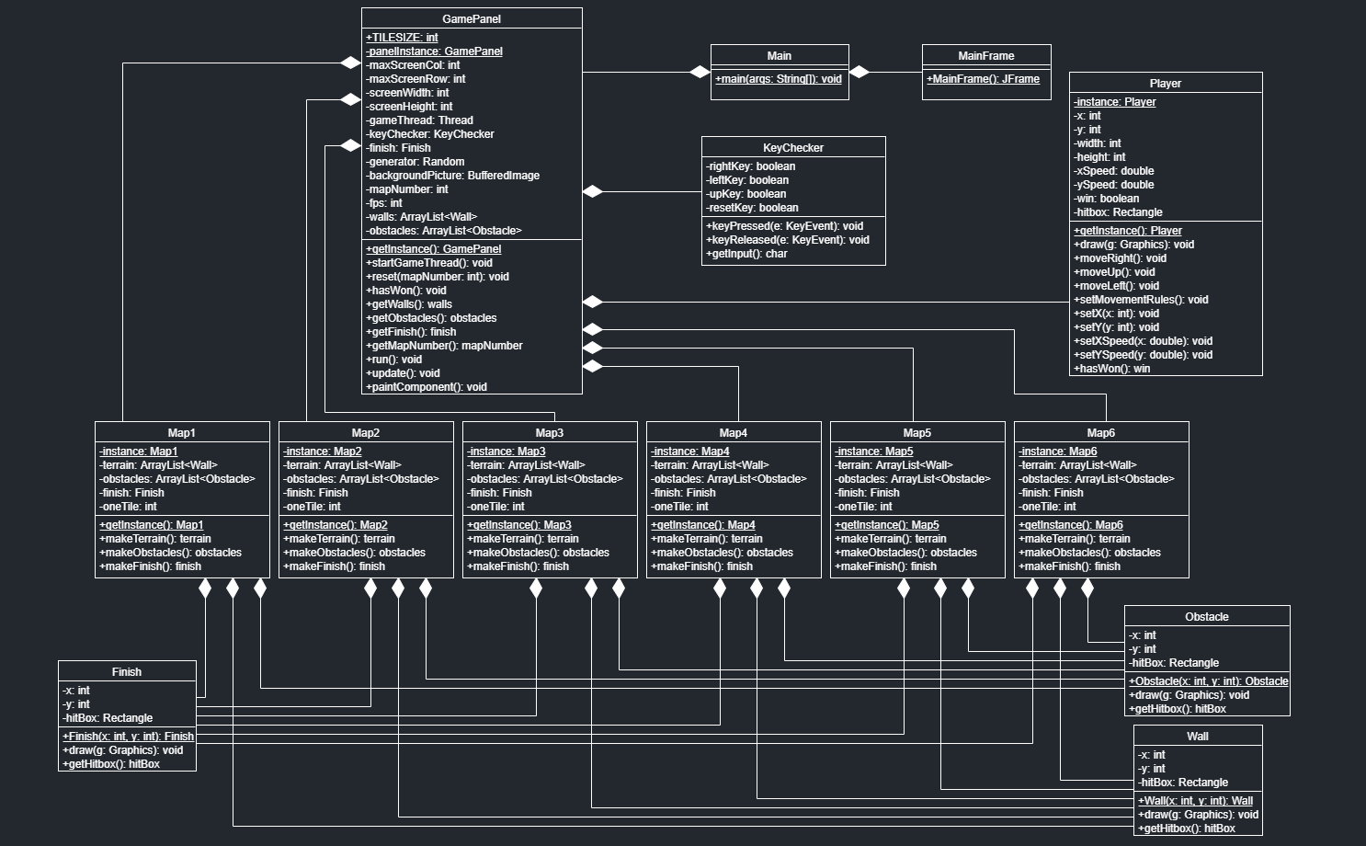UML diagram is here: