**GDD - MiniGameTest**



GDD Template Written by: Tal Hananel

**Installation**

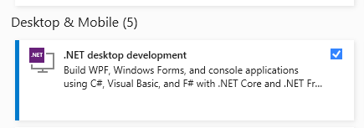Install Visual studio 2019 and make sure you install .Net desktop development (to use windows forms inside visual studio).

Then run the program located: 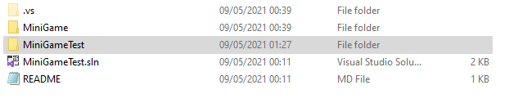

To install the game on your computer:

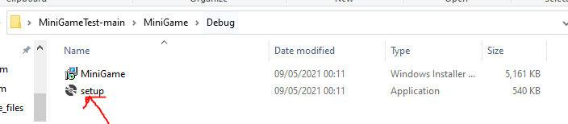

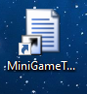It will create a shortcut named MiniGameTest

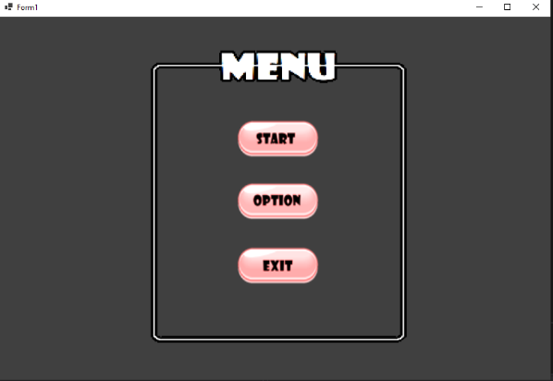  
**Game description**

Menu screen:

The menus screen have 3 buttons

Start: Will start the game.

Options: Will show the Instructions of the game in another form

Exit: Close the application

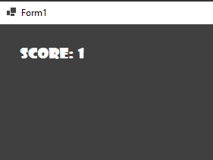

Timer:

Timer: for each second the player

Is on the game he will recive +1

Score + whenever the player touches the green Square

He will recive extra 5 points.

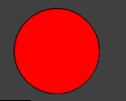Enemy Character Abilities

● Circle: going randomly on the screen, if the player touches the circle the game will be over and the player will see the total score screen

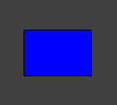

● Rectangle: The rectangle will try to get to the player mouse position, and if the player touches the rectangle, the game will be over and the player will see the total screen window

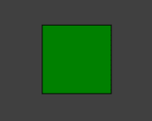

● Square: The player objective is to touch the square shape, when he does that the square will teleport to a random position on the form and the player will receive +5 points to his total score.

**Characters**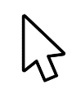

● Mouse cursor

Enemies

● Circle and rectangle

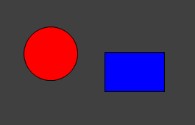

Objective

● Square

**Code:**

Shape class: contain all the information’s of all the shapes and there attributes.

Form1 class: contain all the connections between the Form1[Desing] window and the code.

**Class Shape:**

Each shape have a Init which will detarmain the object speed size and position.

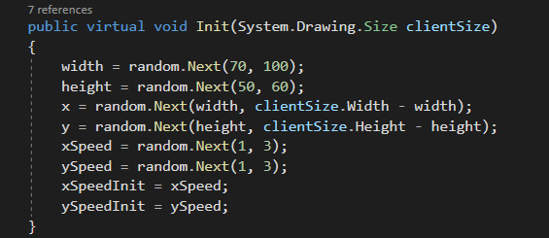

Each shape have UpdateSpeed: when the player collect more points each shape become more faster.

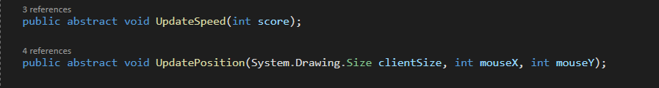

Each shape have a paint Shape function witch will draw the object

And a isHitTarget witch will determine if the player touches the shape on the screen.

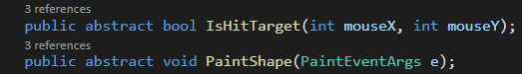

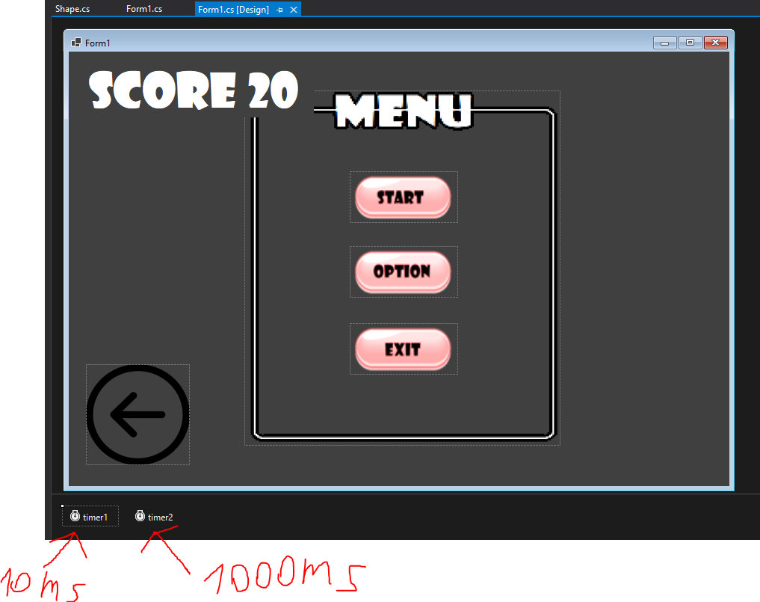

There are 2 timers on the game.

Timer1: update the drawing of the objects in the game.

Timer2: Count the seconds of the game

