📖 Assignment 2: Comprehensive Technical Documentation

Asynchronous Programming, Sound Null Safety & Defensive Error Handling in Dart 3

1. Document Overview & Metadata
Attribute | Details
Project Title | Dart Async & Null Safety Mock API Simulation System
Assignment Identifier | Assignment 2 (assignment_2 branch)
Language & SDK Version | Dart 3.x (with Sound Null Safety & Pattern Matching)
Target Runtime | Dart Standalone VM / Console Environment
Prerequisites Covered | Modules 1 through 9 from dart_basics-main
Author | Virshin Kumar
Date of Creation | August 2026

2. Project Introduction & Problem Statement
In real-world mobile and web engineering (such as Flutter application development), systems rarely operate in purely synchronous, local environments. Applications constantly communicate across network boundaries with remote REST APIs, GraphQL endpoints, microservices, and databases.
This environment introduces three fundamental engineering challenges: 1. Network Latency & Non-blocking I/O: Network calls take variable, non-zero time to complete. Blocking the main thread freezes user interfaces and degrades system responsiveness. 2. Data Absence & Nullability: Remote JSON structures often contain missing keys, explicit null values, or partial records. Unhandled null references historically account for the vast majority of application crashes (NullPointerException / NoSuchMethodError). 3. Unpredictable Failure States: Servers can return HTTP 404 (Not Found), 500 (Internal Server Error), timeout errors, or malformed data payloads. Applications must gracefully isolate and handle these errors without crashing the process.
Assignment 2 solves these challenges by implementing an end-to-end, type-safe, asynchronous mock API client in Dart. It showcases how to leverage Future, async/await, Dart 3 sound null safety operators, sealed class state hierarchies, pattern matching, and functional data transformation.

3. System Architecture & High-Level Design
The project is structured according to a strict Model-Service-Controller separation of concerns:
┌──────────────────────────────────────────────────────────────────────────┐
│ Console Application Entry │
│ (lib/main.dart) │
└────────────────────────────────────┬─────────────────────────────────────┘
│
▼
┌──────────────────────────────────────────────────────────────────────────┐
│ ApiDemoController (Orchestrator) │
│ (lib/controller.dart) │
│ - Dispatches scenario requests in sequence │
│ - Tracks operation sequencing via stateful closure loggers │
│ - Evaluates results via Pattern Matching switch expressions │
└───────────────────┬──────────────────────────────────▲───────────────────┘
│ (await request) │ (sealed ApiResult<T>)
▼ │
┌───────────────────────────────────────┐ │
│ MockApiService (Data Provider) │ │
│ (lib/services/mock_api_service.dart)│ │
│ - Simulates latency (Future.delayed) ├──────────────┘
│ - Emulates 200/404/500/Batch payloads│
└───────────────────┬───────────────────┘
│ (raw Map / Exception)
▼
┌──────────────────────────────────────────────────────────────────────────┐
│ Data & Error Layer │
│ - UserProfile.fromMap() (Null-safe entity construction) │
│ - ApiException & throwApiException() (Never-returning error validator) │
│ - applyTransform<T, R>() (Generic higher-order collection processor) │
└──────────────────────────────────────────────────────────────────────────┘

3.1 Data Flow Sequence
- Invocation: main() delegates execution to ApiDemoController.runAllScenarios().
- Request Dispatch: The controller triggers an asynchronous request (e.g. apiService.fetchUserProfile(101)).
- Latency Simulation: MockApiService yields execution to the Dart Event Loop via await Future.delayed(...).
- Payload Processing:
  - If data exists, it is validated using validatePayloadPresence() and deserialized via UserProfile.fromMap().
  - If data is null (ID 404), an ApiEmpty result is returned.
  - If an error occurs (ID 500), an ApiException is thrown, caught in try-catch, and wrapped into an ApiError.
- Pattern Matching & Presentation: The controller unwraps the sealed ApiResult<T> using Dart 3 pattern matching and formats the output to the console.

4. Comprehensive Concept Deep-Dive

4.1 Sound Null Safety in Dart 3
Sound null safety guarantees that an expression of a non-nullable type can never evaluate to null. The type system strictly separates nullable references from non-nullable ones at compile time.
┌─────────────────────────┐
│ Object? (Nullable) │
└────────────┬────────────┘
│
┌────────────────────┴────────────────────┐
▼ ▼
┌───────────────────┐ ┌───────────────────┐
│ Non-Nullable │ │ Null │
│ (String, int, …) │ │ (null) │
└───────────────────┘ └───────────────────┘

Detailed Operator Breakdown & Implementations:
- Nullable Variable Declarations (Type?): In lib/models/user_profile.dart:
- final String? bio;
final String? phoneNumber;
final double? rating;
final List<String>? skills;
final Map<String, dynamic>? preferences;
- Why: Communicates to both developers and the compiler that these attributes are optional in backend payloads.
- Null-Coalescing Operator (??): Provides a non-null fallback value if the target expression evaluates to null:
- print('Biography : ${bio ?? "[No biography provided]"}');
print('Phone Number : ${phoneNumber ?? "[No contact number available]"}');
- Null-Coalescing Assignment (??=): Assigns a fallback value to a mutable variable only if the variable’s current value is null:
- String? defaultCurrency;
defaultCurrency ??= 'USD (\$)';
- Null-Aware Navigation / Optional Chaining (?.): Safely accesses fields or invokes methods on an object only if that object is not null. If null, the entire expression evaluates to null without throwing a runtime exception:
- int skillCount = skills?.length ?? 0;
String theme = preferences?['theme']?.toString() ?? 'Default (System Light)';
bool notifications = (preferences?['notificationsEnabled'] as bool?) ?? false;
- Bang / Null-Assertion Operator (!) with Type Promotion: When a condition verifies that a nullable variable is non-null, Dart automatically promotes the type or allows safe unwrapping:
- String ratingText = rating != null ? rating!.toStringAsFixed(1) : 'Unrated';
- Lazy Initialization (late final): Defers computation of a field until it is first accessed, while guaranteeing immutability once initialized:
- late final String displayCard = _generateDisplayCard();

4.2 Asynchronous Execution (Future, async, and await)
Dart executes code on a single thread using an Event Loop. Asynchronous operations do not block execution; instead, they return a Future<T> which registers a callback in the event queue.
Caller Execution Thread ────► Calls async API method ───► Receives uncompleted Future<T>
│
▼ (Yields thread to Event Loop)
await Future.delayed()
│
▼
Caller Resumes ◄───────── Future completes with data or error

Code Implementation in lib/services/mock_api_service.dart:
Future<Map<String, dynamic>?> fetchRawUserData(int userId) async {
// Simulates realistic network delay
await Future.delayed(Duration(milliseconds: simulatedDelayMs));
if (userId == 500) {
throwApiException(
'Internal Server Error: Database cluster unreachable.',
statusCode: 500,
);
}
return _mockUserDatabase[userId];
}

4.3 Sealed Classes & Dart 3 Exhaustive Pattern Matching
Using sealed class ApiResult<T> enables algebraic data types (ADTs) in Dart. The compiler guarantees that all subclasses (ApiSuccess, ApiError, ApiEmpty) must be defined in the same library and that all switch statements or expressions exhaustively handle every case.
sealed class ApiResult<T> {}
class ApiSuccess<T> extends ApiResult<T> {
final T data;
final int statusCode;
ApiSuccess(this.data, {this.statusCode = 200});
}
class ApiError<T> extends ApiResult<T> {
final String errorMessage;
final int? statusCode;
ApiError(this.errorMessage, {this.statusCode});
}
class ApiEmpty<T> extends ApiResult<T> {
final String message;
ApiEmpty({this.message = 'No data found for the requested resource.'});
}

Exhaustive Pattern Matching in lib/controller.dart:
switch (result) {
case ApiSuccess(:final data, :final statusCode):
print(' [STATUS: $statusCode OK] User Profile successfully fetched and parsed:');
data.displayDetails();
case ApiEmpty(:final message):
print(' [STATUS: 404 EMPTY] No Data Available.');
print(' Notice: $message');
case ApiError(:final errorMessage, :final statusCode):
print(' [STATUS: ${statusCode ?? "ERROR"}] Request Failed Gracefully!');
print(' Error Message: $errorMessage');
}
Advantage: If a new outcome type (such as ApiRateLimited) is added to ApiResult, the Dart compiler will immediately produce an error on any switch statement that has not been updated to handle it.

4.4 Defensive Error Handling & Never Return Types
The Never type in Dart represents a function that never produces a return value because it unconditionally throws an exception or halts execution.
class ApiException implements Exception {
final String message;
final int? statusCode;
ApiException(this.message, {this.statusCode});
@override
String toString() => 'ApiException [Status ${statusCode ?? "N/A"}]: $message';
}
/// Helper returning Never to inform analyzer that this branch terminates
Never throwApiException(String message, {int? statusCode}) {
throw ApiException(message, statusCode: statusCode);
}
void validatePayloadPresence(Object? payload, {String contextName = 'Payload'}) {
if (payload == null) {
throwApiException('$contextName cannot be null or empty', statusCode: 400);
}
}

4.5 Functional Programming, Generic Transformers & Closures
To process batches of raw API data efficiently, generic higher-order functions allow dynamic data transformation pipelines without code repetition.
/// Generic transformer mapping List<T> -> List<R>
List<R> applyTransform<T, R>(List<T> items, R Function(T) transformer) {
List<R> output = [];
for (var item in items) {
output.add(transformer(item));
}
return output;
}

State-Capturing Closure for Logging:
void Function(String message) createActivityLogger({String prefix = 'API_LOG'}) {
int logSequence = 0; // Lexically captured variable
return (String message) {
logSequence++;
print(' [$prefix #$logSequence] $message');
};
}
Mechanism: The returned function retains access to logSequence across calls, maintaining an incremental request counter without requiring global variables.

5. File & Component Breakdown
Assignment_2/
├── README.md # Overview, concepts mapping, and quickstart commands
├── DOCUMENTATION.md # Comprehensive multi-page architectural documentation
└── lib/
├── user_profile.dart # Entity model with nullable types & safe factory parsing
├── api_result.dart # Sealed class hierarchy (Success, Error, Empty)
├── mock_api_service.dart # Async service with Future.delayed, 200/404/500 mock endpoints
├── error_handler.dart # Custom ApiException & Never throw helpers
├── data_transformer.dart # Generic transformer applyTransform<T, R> & state closures
├── controller.dart # Orchestrates all 5 demonstration scenarios with pattern matching
└── main.dart # Application executable entry point

Component Responsibility Matrix
File | Class / Function | Purpose & Key Features
lib/user_profile.dart | UserProfile | Implements nullable fields (bio, phoneNumber, rating, skills, preferences), late final displayCard, fromMap() factory parser, and displayDetails().
lib/api_result.dart | ApiResult<T> | Sealed base class with ApiSuccess<T>, ApiError<T>, and ApiEmpty<T>.
lib/error_handler.dart | ApiException, throwApiException | Custom exception implementation, Never-returning throw utility, payload integrity validation.
lib/mock_api_service.dart | MockApiService | Emulates asynchronous server endpoint with Future.delayed(), handles user lookups (101, 102, 404, 500), and batch product catalogue.
lib/data_transformer.dart | applyTransform, createActivityLogger | Generic higher-order mapping function and closure maintaining sequential log counters.
lib/controller.dart | ApiDemoController | Coordinates execution of scenarios 1 through 5 and displays results using Dart 3 pattern matching.
lib/main.dart | main() | Application entry point that instantiates ApiDemoController and triggers runAllScenarios().

6. Deep-Dive into the 5 Execution Scenarios

Scenario 1: Complete User Profile (ID: 101)
- Input Data:
- {
'id': 101,
'name': 'Virshin Kumar',
'email': 'virshin@example.com',
'bio': 'Passionate Cross-Platform Mobile & Dart Developer',
'phoneNumber': '+91 98765 43210',
'rating': 4.9,
'skills': ['Dart', 'Flutter', 'Async Programming', 'State Management'],
'preferences': {'theme': 'Dark Mode (AMOLED)', 'notificationsEnabled': true}
}
- Execution Flow:
  - ApiDemoController calls apiService.fetchUserProfile(101).
  - MockApiService simulates a 400ms network delay.
  - Raw data is matched, validated, and deserialized into UserProfile.
  - Returns ApiSuccess<UserProfile>(profile, statusCode: 200).
  - Controller pattern-matches ApiSuccess and prints the complete card details.

Scenario 2: Partial Profile with Null Fields (ID: 102)
- Input Data:
- {
'id': 102,
'name': 'Priya Sharma',
'email': 'priya.sharma@example.com',
'bio': null,
'phoneNumber': null,
'rating': null,
'skills': null,
'preferences': null
}
- Execution Flow:
  - ApiDemoController calls apiService.fetchUserProfile(102).
  - Factory constructor safely handles null fields without runtime exceptions.
  - displayDetails() uses ?? fallbacks:
    - bio ?? "[No biography provided]"
    - phoneNumber ?? "[No contact number available]"
    - ratingText = 'Unrated'
    - skills?.length ?? 0
    - preferences?['theme']?.toString() ?? 'Default (System Light)'
  - Returns ApiSuccess<UserProfile> with clean, fallback-filled output.

Scenario 3: Resource Not Found / Null Payload (ID: 404)
- Input Data: Missing user record / null returned from simulated database.
- Execution Flow:
  - ApiDemoController calls apiService.fetchUserProfile(404).
  - rawResponse == null condition is met.
  - Service returns ApiEmpty(message: 'User with ID #404 was not found on the server (404 Not Found).').
  - Controller matches ApiEmpty(:final message) and prints a user-friendly notice without crashing.

Scenario 4: Simulated Internal Server Error (ID: 500)
- Input Data: Server triggers critical database failure.
- Execution Flow:
  - fetchRawUserData(500) calls throwApiException('Internal Server Error: Database cluster unreachable.', statusCode: 500).
  - The service try-catch block catches on ApiException catch (e).
  - Service packages the error into ApiError(e.message, statusCode: e.statusCode).
  - Controller matches ApiError(:final errorMessage, :final statusCode) and prints the error status gracefully.

Scenario 5: Batch Async Fetching & Generic Data Transformation
- Input Data:
- [
{'id': 'P-1', 'title': 'Mechanical Keyboard', 'price': 89.99, 'stock': 15},
{'id': 'P-2', 'title': '4K IPS Monitor', 'price': 349.50, 'stock': 4},
{'id': 'P-3', 'title': 'Wireless Gaming Mouse', 'price': 59.00, 'stock': 28},
{'id': 'P-4', 'title': 'USB-C Multi-Port Hub', 'price': 35.25, 'stock': 0}
]
- Execution Flow:
  - apiService.fetchProductsCatalog() retrieves batch product list asynchronously.
  - applyTransform<Map<String, dynamic>, String> applies a custom closure to format prices with toStringAsFixed(2) and calculate stock indicators.
  - Demonstrates ??= null-coalescing assignment on currency code.

7. Verbatim Console Execution Log
Below is the exact output produced when running dart run lib/main.dart:
================================================================
🚀 DART ASYNC, FUTURE & NULL SAFETY DEMO (ASSIGNMENT 2)
================================================================
>>> SCENARIO 1: Fetching Complete User Profile (ID: 101) <<<
[MOCK_API_RUNNER #1] Dispatching request for User #101...
-> Initiating async network request to: https://api.crossapp.internal/v1/users/101
[STATUS: 200 OK] User Profile successfully fetched and parsed:
----------------------------------------------------
Card Header : ID: #101 | Virshin Kumar (virshin@example.com)
User ID : 101
Full Name : Virshin Kumar
Email Address : virshin@example.com
Biography : Passionate Cross-Platform Mobile & Dart Developer
Phone Number : +91 98765 43210
User Rating : 4.9 ⭐
Skills (4) : Dart, Flutter, Async Programming, State Management
Preferences : Theme -> Dark Mode (AMOLED) | Notifications -> true
----------------------------------------------------
>>> SCENARIO 2: Fetching Partial Profile with Null Fields (ID: 102) <<<
[MOCK_API_RUNNER #2] Dispatching request for User #102...
-> Initiating async network request to: https://api.crossapp.internal/v1/users/102
[STATUS: 200 OK] User Profile successfully fetched and parsed:
----------------------------------------------------
Card Header : ID: #102 | Priya Sharma (priya.sharma@example.com)
User ID : 102
Full Name : Priya Sharma
Email Address : priya.sharma@example.com
Biography : [No biography provided]
Phone Number : [No contact number available]
User Rating : Unrated ⭐
Skills (0) : [No skills listed]
Preferences : Theme -> Default (System Light) | Notifications -> false
----------------------------------------------------
>>> SCENARIO 3: Fetching Non-Existent User (ID: 404 / Not Found) <<<
[MOCK_API_RUNNER #3] Dispatching request for User #404...
-> Initiating async network request to: https://api.crossapp.internal/v1/users/404
[STATUS: 404 EMPTY] No Data Available.
Notice: User with ID #404 was not found on the server (404 Not Found).
>>> SCENARIO 4: Simulated Internal Server Error (ID: 500 / Exception) <<<
[MOCK_API_RUNNER #4] Dispatching request for User #500...
-> Initiating async network request to: https://api.crossapp.internal/v1/users/500
[STATUS: 500] Request Failed Gracefully!
Error Message: Internal Server Error: Database cluster unreachable.
>>> SCENARIO 5: Batch Async Fetching & Generic Transformation <<<
[MOCK_API_RUNNER #5] Fetching Product Catalog batch...
[SUCCESS] Received 4 catalog items. Applying generic transformer:
• Mechanical Keyboard - $89.99 (15 in stock)
• 4K IPS Monitor - $349.50 (4 in stock)
• Wireless Gaming Mouse - $59.00 (28 in stock)
• USB-C Multi-Port Hub - $35.25 (OUT OF STOCK)
Active Currency (via ??= assignment): USD ($)
================================================================
✅ ALL DEMONSTRATION SCENARIOS COMPLETED SUCCESSFULLY
================================================================

8. Verification & Quality Assurance
Static and dynamic analysis performed on the codebase:
- Static Analysis:
- cd Assignment_2
dart analyze
- Result: Analyzing Assignment_2... No issues found! (0 errors, 0 warnings, 0 lints).
- Runtime Execution:
- dart run lib/main.dart
- Result: Exit Code 0. All 5 scenarios executed in order without unexpected termination.

9. Conclusion & Engineering Takeaways
- Safety by Default: Non-nullable types ensure that null errors are caught during compilation rather than in production runtime environments.
- Predictable State Machine: Sealed class hierarchies (ApiResult<T>) guarantee that every state is explicitly handled, eliminating silent failures.
- Responsive Architecture: Asynchronous programming using Future and async/await ensures scalability and responsive application workflows.
- Clean Code & Reusability: Combining generic functions with functional closures enables compact, readable, and highly maintainable Dart codebases.

10. Execution Output & Visual Screenshot Proof
The screenshot below displays the actual console execution of all 5 asynchronous and null-safety scenarios running in the terminal:
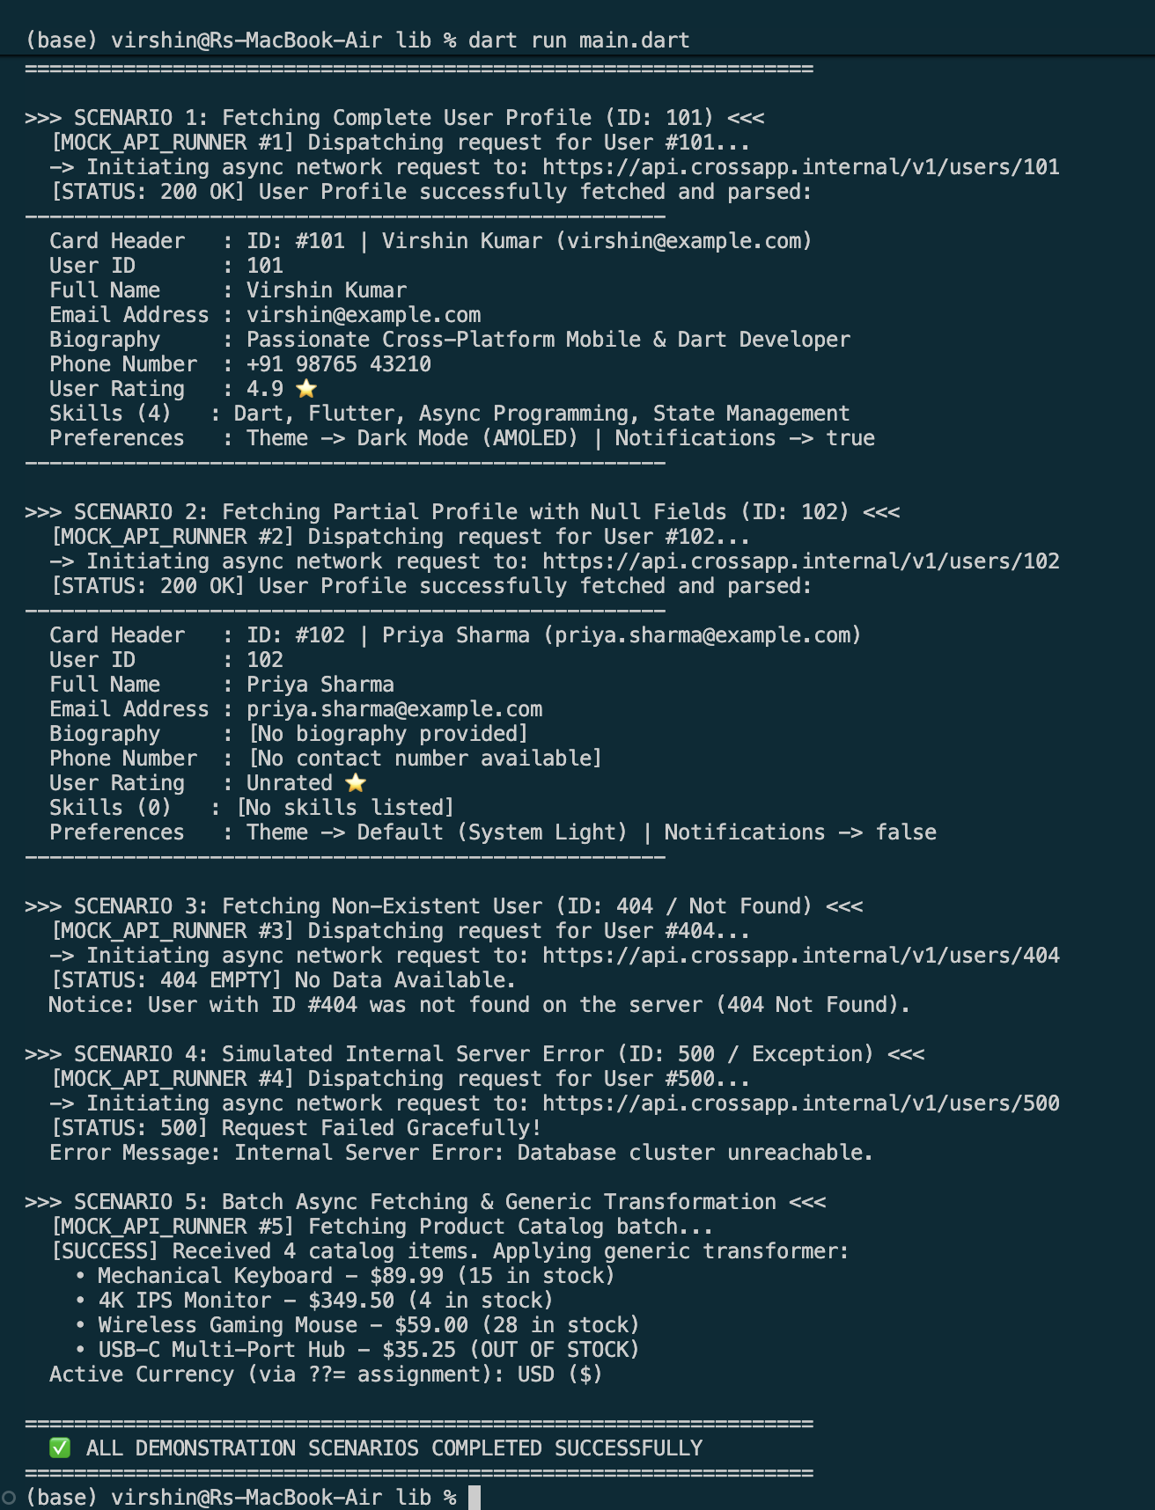
Terminal Execution Output Screenshot

