Comprehensive Technical Documentation
Modular Library Management System in Dart

Project Title: Modular Object-Oriented Library Management System
Language: Dart (v3.x+)
Framework / Runtime: Dart SDK / Flutter
Assignment Track: Dart Fundamentals, Data Structures & Object-Oriented Programming

Table of Contents
- [Executive Summary & Problem Statement](#1-executive-summary--problem-statement)
- [Core Learning Objectives & Concepts](#2-core-learning-objectives--concepts)
- [System Architecture & Design Patterns](#3-system-architecture--design-patterns)
- [UML Class Diagram & Relationships](#4-uml-class-diagram--relationships)
- [In-Depth File-by-File Technical Breakdown](#5-in-depth-file-by-file-technical-breakdown)
- [5.1 Base Item Abstract Class (item.dart)](#51-base-item-abstract-class-itemdart)
- [5.2 Book Derived Class (book.dart)](#52-book-derived-class-bookdart)
- [5.3 Magazine Derived Class (magazine.dart)](#53-magazine-derived-class-magazinedart)
- [5.4 Library Member Entity (member.dart)](#54-library-member-entity-memberdart)
- [5.5 Library Orchestration Service (library.dart)](#55-library-orchestration-service-librarydart)
- [5.6 Financial Utility (fee_calculator.dart)](#56-financial-utility-fee_calculatordart)
- [5.7 Execution Drivers (console.dart & main.dart)](#57-execution-drivers-consoledart--maindart)
- [Data Structures, Control Flow & Loops Analysis](#6-data-structures-control-flow--loops-analysis)
- [Edge Cases, Validation & Error Handling](#7-edge-cases-validation--error-handling)
- [Execution Trace & Scenario Walkthrough](#8-execution-trace--scenario-walkthrough)
- [Complete Console Output](#9-complete-console-output)
- [Future Scope & Scalability](#10-future-scope--scalability)
- [Screenshots](#11-screenshots)

1. Executive Summary & Problem Statement
Modern software engineering relies heavily on modularity, maintainability, and clean separation of concerns. The objective of this assignment is to design and implement a console-based Library Management System in Dart that models real-world catalog operations, member interactions, and financial overdue penalties.
Instead of writing a monolithic script, the system is engineered across a modular multi-file structure. It demonstrates fundamental software engineering principles including:
- Object-Oriented Programming (OOP): Inheritance, polymorphism, encapsulation, and abstraction.
- Data Integrity: Enforcing loan rules, verifying catalog availability, and linking checked-out items to unique member profiles.
- Defensive Programming: Validating edge cases such as duplicate checkouts, missing IDs, and invalid return attempts.

2. Core Learning Objectives & Concepts
Concept | Dart Implementation | Purpose in this Project
Variables & Types | String, int, double, bool, List<T>, Map<K, V> | Strongly typed representation of entities, counters, and fee amounts.
Class Abstraction | abstract class Item | Defines a common interface and shared attributes without direct instantiation.
Inheritance | class Book extends Item, class Magazine extends Item | Eliminates redundant code and establishes an "is-a" polymorphic hierarchy.
Method Overriding | @override void displayInfo() | Allows specialized child classes to format their unique output while respecting parent contracts.
Encapsulation | Modular classes with focused responsibilities | Prevents tight coupling and keeps state transitions clean.
Functions & Parameters | Named parameters ({required ...}), default arguments (dailyRate = 2.50) | Enhances readability and prevents argument ordering bugs.
Iteration & Loops | for, for-in, while | Demonstrates multiple traversal techniques for inventory display, searching, and status updates.

3. System Architecture & Design Patterns
The codebase is organized into distinct layers to promote maintainability:
┌─────────────────────────────────────────────────────────────┐
│ Presentation Layer │
│ main.dart / console.dart │
│ (Program Entry, Scenario Simulation) │
└──────────────────────────────┬──────────────────────────────┘
│
┌──────────────────────────────▼──────────────────────────────┐
│ Service Layer │
│ library.dart │
│ (Inventory Management, Borrow/Return Logic, Search) │
└──────────────────────────────┬──────────────────────────────┘
│
┌───────────────┴───────────────┐
│ │
┌──────────────▼──────────────┐ ┌──────────────▼──────────────┐
│ Domain Models │ │ Utility Modules │
│ item.dart, book.dart, │ │ fee_calculator.dart │
│ magazine.dart, member.dart │ │ (Mathematical Computations)│
└─────────────────────────────┘ └─────────────────────────────┘
Key Design Principles Applied:
- Single Responsibility Principle (SRP): Each class does one thing well. Item handles data, Member maintains borrowing state, Library orchestrates business logic, and fee_calculator performs financial computations.
- Open/Closed Principle (OCP): New item types (e.g., DVD, AudioBook, Journal) can be introduced by extending Item without modifying existing borrowing or inventory logic.
- Liskov Substitution Principle (LSP): Any method expecting an Item can seamlessly process a Book or a Magazine polymorphically.

4. UML Class Diagram & Relationships
classDiagram
class Item {
<<abstract>>
+String id
+String title
+bool isBorrowed
+displayInfo()* void
}
class Book {
+String author
+int pages
+String genre
+displayInfo() void
}
class Magazine {
+int issueNumber
+String publishMonth
+displayInfo() void
}
class Member {
+String memberId
+String name
+List~Item~ borrowedItems
+showBorrowedItems() void
}
class Library {
+String libraryName
+List~Item~ items
+Map~String, Member~ members
+addItem(Item item) void
+registerMember(Member member) void
+displayInventory() void
+borrowItem(String itemId, String memberId) bool
+returnItem(String itemId, String memberId) bool
+searchItems(String keyword) List~Item~
}
Item <|-- Book : Inherits
Item <|-- Magazine : Inherits
Library o-- Item : Aggregates
Library o-- Member : Aggregates
Member --> Item : References (Loans)

5. In-Depth File-by-File Technical Breakdown
5.1 Base Item Abstract Class (`item.dart`)
- Role: Root entity of the catalog hierarchy.
- Attributes:
- id (String): Unique identifier code (e.g., 'B101').
- title (String): Title of the asset.
- isBorrowed (bool): Availability status flag (false indicates available).
- Abstract Contract:
- void displayInfo(): Enforces that every physical or digital media item must define how its attributes are presented.
abstract class Item {
String id;
String title;
bool isBorrowed;
Item({
required this.id,
required this.title,
this.isBorrowed = false,
});
void displayInfo();
}

5.2 Book Derived Class (`book.dart`)
- Role: Models books in the library.
- Additional Attributes:
- author (String): Author's full name.
- pages (int): Page count.
- genre (String): Category (e.g., Programming, Software Engineering).
- Inheritance Mechanics: Utilizes super.id, super.title, and super.isBorrowed to forward values to the base class constructor.
- Polymorphic Method: Implements @override void displayInfo() to format and print title, author, genre, and current status.

5.3 Magazine Derived Class (`magazine.dart`)
- Role: Models periodical magazine publications.
- Additional Attributes:
- issueNumber (int): Edition sequence number.
- publishMonth (String): Month and year of issue (e.g., 'August 2026').
- Polymorphic Method: Implements @override void displayInfo() tailored specifically to magazine issue metadata.

5.4 Library Member Entity (`member.dart`)
- Role: Represents a registered library patron.
- Attributes:
- memberId (String): Unique identifier code for the patron.
- name (String): Full name.
- borrowedItems (List<Item>): Dynamic list storing all items currently on loan to this member.
- Methods:
- showBorrowedItems(): Iterates through borrowedItems using a for-in loop, printing each title and ID. Handles empty loan lists cleanly.

5.5 Library Orchestration Service (`library.dart`)
- Role: Central domain service that manages collections, state transitions, and business rules.
- State Fields:
- List<Item> items: Dynamic list holding all inventory items.
- Map<String, Member> members: Key-value dictionary enabling $O(1)$ fast lookups by member ID.
- Operations:
- addItem(Item item): Appends an item to the collection.
- registerMember(Member member): Inserts a member into the lookup table.
- displayInventory(): Traverses the inventory using an index-based for loop and invokes displayInfo() on each item.
- borrowItem({required String itemId, required String memberId}):
- Validates that the member exists in members.
- Searches for the item using a while loop over items.
- Verifies that isBorrowed is false.
- Mutates item.isBorrowed = true and appends the item to member.borrowedItems.
- returnItem({required String itemId, required String memberId}):
- Verifies the member's profile.
- Iterates through member.borrowedItems using for-in to find the matching itemId.
- Mutates item.isBorrowed = false and removes it from member.borrowedItems.
- searchItems(String keyword): Performs a case-insensitive substring search across all item titles and returns a filtered List<Item>.

5.6 Financial Utility (`fee_calculator.dart`)
- Role: Pure standalone helper function for overdue calculations.
- Signature:
double calculateLateFee({required int daysLate, double dailyRate = 2.50}) {
if (daysLate <= 0) return 0.0;
return daysLate * dailyRate;
}
- Features: Demonstrates named parameters, default parameter values (2.50), conditional guards against negative days, and floating-point arithmetic.

5.7 Execution Drivers (`console.dart` & `main.dart`)
- `console.dart`: Houses runLibrarySystem() which builds the library environment, registers sample members, adds diverse items, and executes a full cycle of checkout, collision, search, and return operations.
- `main.dart`: Acts as the standard Dart entry point, cleanly invoking runLibrarySystem().

6. Data Structures, Control Flow & Loops Analysis
This project demonstrates deliberate, pedagogical choices of data structures and traversal loops:
1. Indexed `for` Loop (`displayInventory` in `library.dart`)
for (int i = 0; i < items.length; i++) {
items[i].displayInfo();
}
- Reason: Provides clean access to loop index numbers when enumerating catalog items.
- Complexity: $O(N)$ time complexity, where $N$ is total inventory count.
2. `while` Loop (`borrowItem` in `library.dart`)
int index = 0;
while (index < items.length) {
if (items[index].id == itemId) {
targetItem = items[index];
break;
}
index++;
}
- Reason: Demonstrates loop control with manual index pointers and early termination via break once a matching item is found.
- Complexity: Best case $O(1)$, Worst case $O(N)$.
3. `for-in` Loop (`returnItem` & `searchItems`)
for (Item item in member.borrowedItems) {
if (item.id == itemId) {
targetItem = item;
break;
}
}
- Reason: Idiomatic Dart for iterating directly over collection elements when explicit index tracking is unnecessary.
4. Hash Map Lookup (`Map<String, Member>`)
- Reason: Patrons are retrieved via members[memberId] in $O(1)$ constant time, avoiding expensive sequential scans.

7. Edge Cases, Validation & Error Handling
The application implements defensive checks for common operational edge cases:
┌─────────────────────────────────────┐
│ Checkout Attempt │
└──────────────────┬──────────────────┘
│
[Does Member Exist in Map?]
├── No ───► Print "Member not found" (Abort)
│
Yes
│
[Item Exists in List?]
├── No ───► Print "Item not found" (Abort)
│
Yes
│
[Is Item Already Borrowed?]
├── Yes ──► Print "Item already checked out" (Reject)
│
No
│
┌────────▼────────┐
│ Mark isBorrowed │
│ Add to Member │
│ Print "Success" │
└─────────────────┘
- Borrowing Already Checked-Out Items: If an item's isBorrowed flag is true, subsequent checkout attempts are blocked with an explicit error message.
- Invalid ID Lookups: Non-existent memberId or itemId queries return graceful warnings rather than throwing runtime null-pointer exceptions.
- Invalid Return Requests: If a member attempts to return an item ID they do not possess, the return process safely aborts with an informative message.
- Negative Overdue Calculation: If daysLate <= 0, calculateLateFee returns 0.0 to avoid negative fee assessments.

8. Execution Trace & Scenario Walkthrough
The test workflow executed in runLibrarySystem() follows a structured timeline:
- Catalog & Member Seeding:
- Adds Book (B101: Clean Code), Book (B102: The Pragmatic Programmer), and Magazine (M201: National Geographic).
- Registers members Alice (MEM01) and Bob (MEM02).
- Initial Inventory Display: Verifies that all three items start with Status: Available.
- Checkout Transactions:
- Alice successfully borrows B101 (Clean Code).
- Bob successfully borrows M201 (National Geographic).
- Bob attempts to borrow B101 (Clean Code) $\rightarrow$ Blocked (Collision Check Passed).
- Patron Status Inspection: Inspects Alice and Bob's active loan lists to ensure bidirectional state integrity.
- Keyword Search Query: Executes searchItems("Programmer") and verifies that B102 is returned accurately.
- Return & Overdue Penalty Assessment:
- Alice returns B101.
- calculateLateFee(daysLate: 4, dailyRate: 1.50) assesses a $\$6.00$ penalty.
- Final Inventory Audit: Verifies that B101 returns to Available status, while M201 remains Borrowed.

9. Complete Console Output
================ Central City Library INVENTORY ================
[Book] B101: "Clean Code" by Robert C. Martin (464 pages, Software Engineering) - Available
[Book] B102: "The Pragmatic Programmer" by Andrew Hunt & David Thomas (352 pages, Programming) - Available
[Magazine] M201: "National Geographic" (Issue #840, August 2026) - Available
>>> BORROWING ITEMS <<<
Success: Alice borrowed "Clean Code".
Success: Bob borrowed "National Geographic".
Item "Clean Code" is already checked out.
>>> MEMBER STATUS <<<
Borrowed items for Alice (MEM01):
- Clean Code (ID: B101)
Borrowed items for Bob (MEM02):
- National Geographic (ID: M201)
>>> SEARCHING FOR "Programmer" <<<
[Book] B102: "The Pragmatic Programmer" by Andrew Hunt & David Thomas (352 pages, Programming) - Available
>>> RETURNING ITEM & CALCULATING OVERDUE FEE <<<
Success: Alice returned "Clean Code".
Overdue fee for 4 days late: $6.0
================ Central City Library INVENTORY ================
[Book] B101: "Clean Code" by Robert C. Martin (464 pages, Software Engineering) - Available
[Book] B102: "The Pragmatic Programmer" by Andrew Hunt & David Thomas (352 pages, Programming) - Available
[Magazine] M201: "National Geographic" (Issue #840, August 2026) - Borrowed

10. Future Scope & Scalability
While this implementation fulfills all console assignment objectives, the modular architecture facilitates several natural extensions:
- Persistent Storage Layer: Integration of local file I/O (dart:io), SQLite (via sqflite), or NoSQL (via hive) to persist catalog and loan records across sessions.
- Asynchronous APIs: Refactoring operations to use Future<T> and async/await to simulate network queries and real-world backend APIs.
- Reservation & Queue System: Enabling patrons to place holds on currently borrowed items, notifying them when the item is returned.
- Flutter UI Integration: Binding these existing domain models and service methods directly to Flutter stateful widgets or a state management framework (Provider, Riverpod, or BLoC) for desktop and mobile applications.

11. Screenshots
Terminal Execution Output
The screenshot below illustrates the execution of the Library Management System running in the macOS console environment (dart run lib/main.dart):
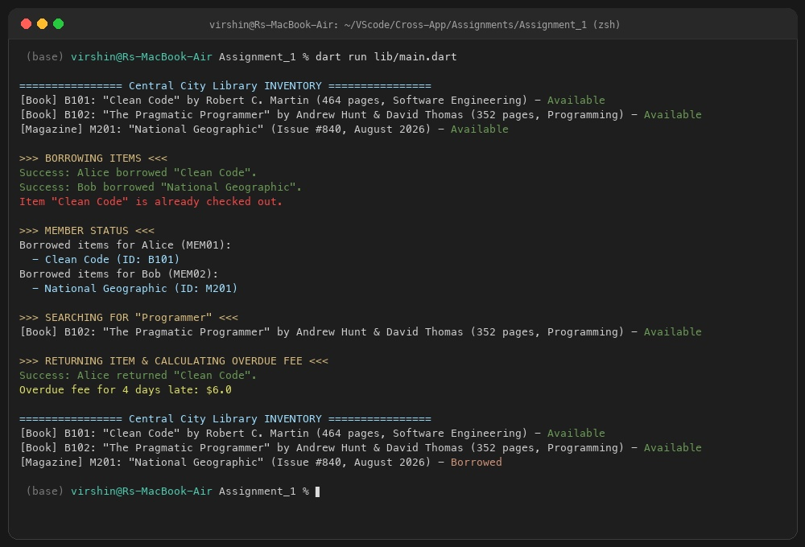

End of Documentation — Prepared for Flutter & Dart Cross-App Development Track

