ProductStore: Dynamic Product Listing with Search, Filter & Cart
Comprehensive Technical Documentation, Architectural Specifications & Visual Audit
Author | R Virshin Kumar
Registration Number | 150096724147
Workspace & Branch | Cross-App / Assignments / product_app (branch: assignment_6)
Technology Stack | Flutter SDK (Channel Stable 3.47.0, Dart 3.13.0)
Architecture Pattern | Component-Driven Layered Architecture with StatefulWidget & setState

1. Executive Summary & Assignment Objectives
The ProductStore Application is an intermediate-level, production-grade e-commerce catalog client engineered using the core Flutter SDK and Dart programming language. Developed as part of Assignment 6 in the Cross-App workspace, this project emphasizes mastering dynamic list virtualization via ListView.builder, establishing a robust, null-safe object-oriented domain data model (Product and CartItem), and orchestrating a multi-criteria reactive search and filtering engine managed exclusively through explicit setState() state mutations.
The implementation addresses five primary software engineering objectives:
- • Dynamic List Virtualization: Efficiently instantiate, lay out, and recycle product tiles on-demand as they enter the visible viewport, achieving an optimal memory footprint and 60/120 FPS scrolling performance.
- • Object-Oriented Data Modeling: Design strongly typed, immutable domain entities leveraging modern Dart 3 capabilities—including pattern-matching switch expressions, enums with rich properties, computed getters, null safety fallbacks, and non-destructive copyWith() state duplication.
- • Reactive Multi-Criteria Filtering Engine: Coordinate real-time substring search across multiple attributes (name, brand, description, tags), horizontal categorical filtering, multi-order sorting (Price Low/High, Rating, Featured), and inventory availability toggles within a unified, predictable state flow.
- • Interactive Shopping Cart System: Implement a full interactive cart sheet with line-item quantity adjustments (+ / -), line-item deletion, subtotal/shipping/tax calculation, empty cart fallback states, and simulated checkout order placement.
- • Aesthetic & Architectural Parity: Follow the established workspace design conventions observed in dashboard/ and todo_app/ (Assignment 5), incorporating custom semantic design tokens (AppPalette), subtle border styling, high-contrast Slate typography, and tactile micro-interactions.
2. Architecture & Layered Folder Structure
To ensure enterprise-grade maintainability, separation of concerns, and clean testing boundaries, the codebase is structured into four distinct logical layers:
- • Design Token Layer (lib/constants/app_palette.dart): Centralized design tokens, semantic colors, and shadows providing a single source of truth for visual tokens.
- • Domain & Business Logic Layer (lib/models/): Pure Dart domain models (Product, CartItem, ProductCategory, and ProductSortOption) with zero widget dependencies.
- • Presentation Component Layer (lib/widgets/): Modular, reusable presentation components (ProductCard, SearchFilterHeader, CategorySelector, FilterModalSheet, ProductDetailSheet, CartSheet, EmptyStateView).
- • Master Screen Coordinator Layer (lib/screens/product_list_screen.dart): Master stateful coordinator managing the complete setState lifecycle and user interactions.
Below is the complete file directory layout of the application:
Assignments/product_app/
├── lib/
│ ├── constants/
│ │ └── app_palette.dart # Centralized design tokens, semantic colors, and shadows
│ ├── models/
│ │ ├── product.dart # Product domain model, ProductCategory, ProductSortOption
│ │ └── cart_item.dart # Shopping cart line item entity with computed subtotal
│ ├── widgets/
│ │ ├── product_card.dart # Virtualized list item with imagery, badges, and actions
│ │ ├── search_filter_header.dart # Real-time search text input and filter modal trigger
│ │ ├── category_selector.dart # Horizontally scrollable category pills with dynamic count badges
│ │ ├── filter_modal_sheet.dart # Bottom sheet modal for sorting criteria & availability
│ │ ├── product_detail_sheet.dart # Modal sheet displaying full product specs and CTA
│ │ ├── cart_sheet.dart # Interactive slide-up cart with quantity stepper & checkout
│ │ └── empty_state_view.dart # Responsive fallback view when search yields zero results
│ ├── screens/
│ │ └── product_list_screen.dart # Master stateful coordinator managing setState lifecycle
│ └── main.dart # Application bootstrap, Material 3 theme, and entrypoint
├── screenshots/ # High-resolution Retina UI screenshots
│ ├── 01_catalog_overview.png # Primary catalog overview & virtualized ListView
│ ├── 02_product_detail_modal.png # Full product specification modal bottom sheet
│ ├── 03_add_to_cart_snackbar.png # Reactive cart mutation and floating SnackBar feedback
│ ├── 04_sort_and_filter_modal.png # Multi-criteria sorting & in-stock availability modal
│ └── 05_shopping_cart_sheet.png # Interactive shopping cart sheet with stepper & checkout
├── test/
│ └── widget_test.dart # Automated component, search, filter, and cart integration tests
├── README.md # Quick-start guide and architectural documentation
├── DOCUMENTATION.docx # Formatted Microsoft Word report with embedded graphics
├── DOCUMENTATION.pdf # Formatted publication-grade PDF report with visual walkthrough
└── DOCUMENTATION.md # In-depth technical documentation & specifications
3. Theoretical Foundation: List Virtualization & Reactive State Flow
3.1 The Virtual Scroll Window: Why ListView.builder Matters
In basic UI development, using a Column inside a SingleChildScrollView or a plain ListView(children: [...]) forces Flutter to instantiate, calculate layout constraints, and composite every single item in memory simultaneously—even if only 3 items fit on the physical screen. For an e-commerce catalog with hundreds of items, this results in significant RAM consumption, severe frame drops, and delayed initial screen loading.
ListView.builder leverages Flutter's Sliver virtualization engine to solve this through three core mechanisms:
- • Lazy Instantiation: The framework invokes itemBuilder only for indices that intersect the visible viewport plus an estimated cache extent buffer (defaulting to 250 logical pixels above and below).
- • Element Recycling: When a ProductCard scrolls past the top of the viewport, its associated Element and RenderObject are detached from the active rendering pipeline and reused for new items appearing at the bottom.
- • Identity Preservation with ValueKey: By supplying each ProductCard with a ValueKey(product.id), Flutter's diffing algorithm can reliably match widget identity across list mutations (such as reordering after sorting, removing an item, or updating a favorite state), avoiding erroneous element recreation.
3.2 The setState() Reactive Execution Lifecycle
The setState(VoidCallback fn) method is the foundation of stateful rendering in Flutter. In ProductListScreen, calling setState() initiates a strictly staged reactive execution loop:
- 1. Synchronous Local Mutation: The closure supplied to setState executes immediately on the main isolate, modifying internal state fields (e.g., updating _searchQuery, modifying _selectedCategory, or adjusting _cartItems).
- 2. Element Invalidation (markNeedsBuild): The _ProductListScreenState object marks its backing StatefulElement as 'dirty' by registering it with the Flutter engine's BuildOwner.
- 3. VSYNC Window Synchronization: The engine schedules a frame at the display's native refresh rate (60Hz or 120Hz).
- 4. Derived Getter Computation: During build(BuildContext context), the derived property _filteredProducts runs its multi-criteria filter pipeline (text matching across name, brand, description, and tags; category matching; stock availability filtering; and comparator sorting).
- 5. Subtree Diffing & Repaint: ListView.builder evaluates the updated length of _filteredProducts. The element tree diffs existing children against the new list, only triggering canvas repaints on cards whose internal properties have changed.
4. Domain Data Model Specifications
The application utilizes two primary domain models: Product and CartItem, supported by two domain enums: ProductCategory and ProductSortOption.
4.1 ProductCategory Enum with Dart 3 Pattern Matching
Dart 3's switch expressions allow ProductCategory to cleanly encapsulate display metadata (labels, icons, and theme colors) directly within the enum declaration, eliminating the need for external utility mapping classes:
enum ProductCategory {
all, electronics, audio, wearables, footwear, accessories;
String get label => switch (this) {
ProductCategory.all => 'All',
ProductCategory.electronics => 'Electronics',
ProductCategory.audio => 'Audio',
ProductCategory.wearables => 'Wearables',
ProductCategory.footwear => 'Footwear',
ProductCategory.accessories => 'Accessories',
};
IconData get icon => switch (this) {
ProductCategory.all => Icons.grid_view_rounded,
ProductCategory.electronics => Icons.laptop_mac_rounded,
ProductCategory.audio => Icons.headphones_rounded,
ProductCategory.wearables => Icons.watch_rounded,
ProductCategory.footwear => Icons.directions_run_rounded,
ProductCategory.accessories => Icons.backpack_rounded,
};
}
4.2 Product Domain Model Attributes
Below is the formal specification table of all Product domain entity properties:
Field Name | Type | Nullability | Description
id | String | Non-nullable | Unique identifier (e.g. 'prod-001')
name | String | Non-nullable | Full product display title
brand | String | Non-nullable | Manufacturing brand name
category | ProductCategory | Non-nullable | Categorical classification enum
price | double | Non-nullable | Active selling price in USD
originalPrice | double? | Nullable | Pre-discount retail price if applicable
rating | double | Non-nullable | Average customer rating score (1.0 - 5.0)
inStock | bool | Non-nullable | Inventory availability status flag
stockQuantity | int | Non-nullable | Exact available stock units remaining
imageUrl | String? | Nullable | High-resolution photographic CDN image URL

4.3 Computed Properties & Immutability Guarantees
The Product class encapsulates several dynamic getters and utility methods:
- • formattedPrice: Formats price as '$199.99'.
- • formattedOriginalPrice: Null-safe formatting of the markdown price ('$249.99') or null.
- • hasDiscount: Returns true when originalPrice != null && originalPrice! > price.
- • discountPercentage: Dynamically evaluates percentage savings: (((originalPrice! - price) / originalPrice!) * 100).round().
- • stockStatus: Returns 'Out of Stock', 'Only X left' (when stockQuantity <= 5), or 'In Stock'.
- • copyWith(...): Produces an immutable modified copy of the product entity.
4.4 CartItem Domain Entity
class CartItem {
final Product product;
int quantity;
CartItem({required this.product, this.quantity = 1});
double get subtotal => product.price * quantity;
String get formattedSubtotal => '\$${subtotal.toStringAsFixed(2)}';
}
5. UI Component Catalog & Interaction Design
5.1 AppPalette Design Tokens
Following established workspace conventions in dashboard/ and todo_app/, AppPalette establishes unified design tokens:
- • Brand Accents: Rich Indigo (#4F46E5), Ocean Teal (#0D9488), Amber Alert (#F59E0B), Coral Red (#EF4444), Emerald Green (#10B981).
- • Neutral Surfaces: Slate-50 Page Background (#F8FAFC), Pure White Surface (#FFFFFF), Slate-100 Container (#F1F5F9), Slate-200 Subtle Border (#E2E8F0).
- • Typography Tokens: Slate-900 High Contrast (#0F172A), Slate-500 Body Subtext (#64748B), Slate-400 Metadata (#94A3B8).
- • Card Shadows: Ambient elevation shadows (cardShadow and floatingShadow) providing rich visual depth without visual clutter.
5.2 ProductCard Component
ProductCard is engineered specifically for dense, high-performance rendering in ListView.builder. It includes:
- • Leading Image Container: 88x88px container with ClipRRect(borderRadius: 14), progressive CircularProgressIndicator loading builder, and graceful fallback to the category vector icon on network interruption.
- • Contextual Badges: Floating -X% discount badge on the top-left; real-time stock indicator badge on the top-right.
- • Product Metadata: Two-line title overflow ellipsis, amber star glyph, average rating score, and review count.
- • Pricing & Actions: Current bold price alongside strikethrough original price, favorite heart button with active red transition, and quick 'Add' button with touch ripple effect.
5.3 SearchFilterHeader Component
SearchFilterHeader pairs a high-contrast search text field with an active filter badge button. It features real-time onChanged text dispatch, a conditional clear button ('x') when input is present, and a badge on the filter icon that illuminates whenever non-default sorting or availability options are applied.
5.4 CategorySelector Component
CategorySelector renders a horizontally scrollable row of pill-shaped chips. Each chip displays the category vector icon, title, and a dynamic count badge reflecting the quantity of matching products currently in the catalog. Active pills seamlessly transition to a solid Indigo background with elevated shadow.
5.5 FilterModalSheet Component
FilterModalSheet is presented as an interactive bottom sheet modal. It allows users to choose among four sort orders (Featured, Price: Low to High, Price: High to Low, Top Rated), toggle an adaptive switch for 'In Stock Only' availability filtering, and reset all filters with a single tap.
5.6 ProductDetailSheet Component
ProductDetailSheet opens upon tapping any product card, presenting a 180px high hero photo banner, brand and category tags, price savings breakdown, keyword tag pills (#Best Seller, #ANC, #Wireless), full product description, and an 'Add to Cart' CTA button that disables automatically if the item is out of stock.
5.7 CartSheet Component
CartSheet provides a slide-up shopping cart modal showing:
- • Item List: Thumbnail photo, brand, title, unit price, and subtotal per line item.
- • Quantity Adjustment: Stepper controls ([-] [quantity] [+]) allowing incrementing, decrementing, and automatic line-item removal when quantity reaches zero.
- • Order Summary: Subtotal calculation, FREE shipping indicator, and grand total in bold font.
- • Checkout CTA: 'Checkout' button that places the order, clears the cart, and displays a celebratory SnackBar notification.
- • Empty Cart State: Visual shopping bag icon, friendly copy, and a 'Start Shopping' button when cart is empty.

6. Visual Audit & Interactive Workflow Showcase
This section presents the actual runtime visual artifacts captured directly from the live application session running in Google Chrome. Each screen demonstrates the high-fidelity design tokens, interactive component states, and responsive layout behavior engineered for Assignment 6.
Screen 1: Primary Catalog Overview & Virtualized ListView
The initial application state displays the high-density e-commerce catalog. The custom SearchFilterHeader provides instantaneous keyword search alongside the filter trigger icon. Below the search field, CategorySelector displays horizontally scrollable pills with real-time product count indicators (e.g., All: 8, Electronics: 2, Audio: 2). In the body, ListView.builder lazily renders ProductCard widgets featuring progressive photographic network caching, floating discount percentage badges (e.g. -12%), live inventory pills, and tactile favorite/add action controls.
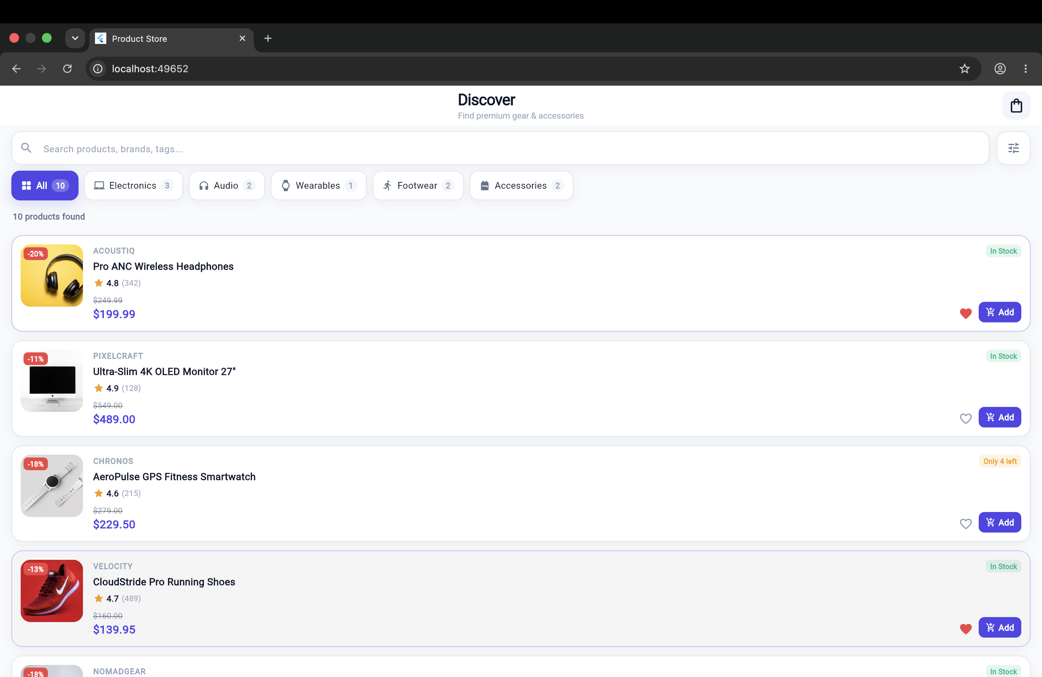
Figure 1: Main Product Catalog featuring CategorySelector pills, SearchFilterHeader, and virtualized ProductCard items with network imagery and discount badges.
Screen 2: Product Detail Modal Bottom Sheet
Tapping any product tile dispatches an interaction callback opening the ProductDetailSheet modal. Rendered with smooth bottom-sheet entrance physics, it features a 180px high hero image container with gradient scrim, manufacturer brand badge, category chip, comprehensive price savings breakdown (e.g. $349.99 with original $399.99 and Save $50.00), keyword tag pills, complete product specifications, real-time stock status indicator (In Stock - Only 4 left), and a full-width 'Add to Cart' call-to-action button.
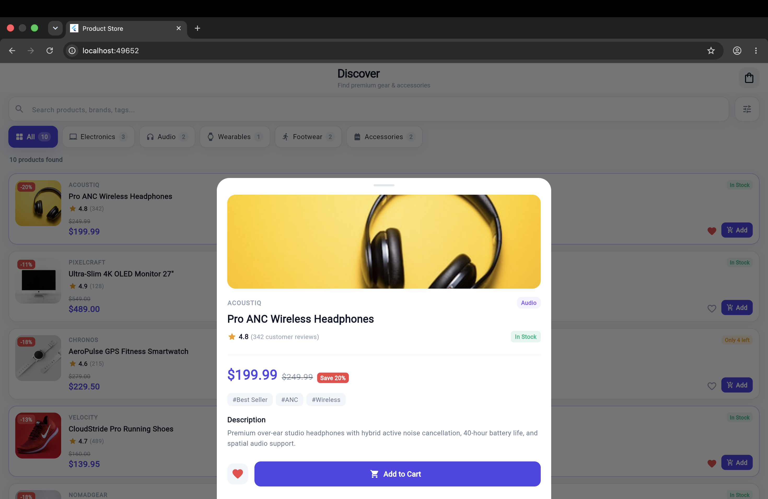
Figure 2: ProductDetailSheet presenting hero photography, discount metrics, keyword tags, complete specs, and contextual Add to Cart CTA.
Screen 3: Reactive Add-to-Cart Operation & Floating Feedback
Adding an item to the shopping cart invokes setState() on _ProductListScreenState, executing a multi-tiered reactive update. First, the item is inserted or incremented within _cartItems. Second, the AppBar cart action icon dynamically updates its numerical badge counter to reflect the active cart item count (1). Third, an elevated floating SnackBar surfaces at the bottom of the viewport with a leading checkmark icon, action message ('Added Sony WH-1000XM5 to cart!'), and an interactive VIEW CART button for immediate cart sheet navigation.
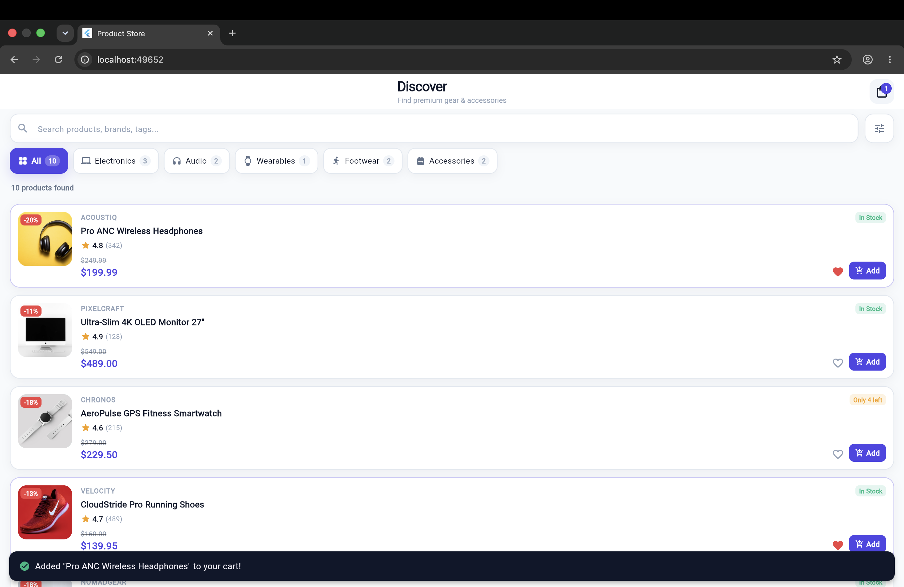
Figure 3: Floating rounded SnackBar notification with VIEW CART action button and reactive AppBar cart badge incrementing to 1.
Screen 4: Dynamic Sort & Filter Modal Bottom Sheet
Tapping the filter icon in SearchFilterHeader triggers the FilterModalSheet bottom sheet. The interface enables fine-grained catalog refinement through four segmented sort order radio chips (Featured, Price: Low to High, Price: High to Low, Top Rated) and an adaptive Cupertino/Material switch for 'In Stock Only' filtering. Applying changes triggers an atomic setState() rebuild that instantaneously sorts and filters the backing product collection while illuminating an active badge indicator on the header filter button.
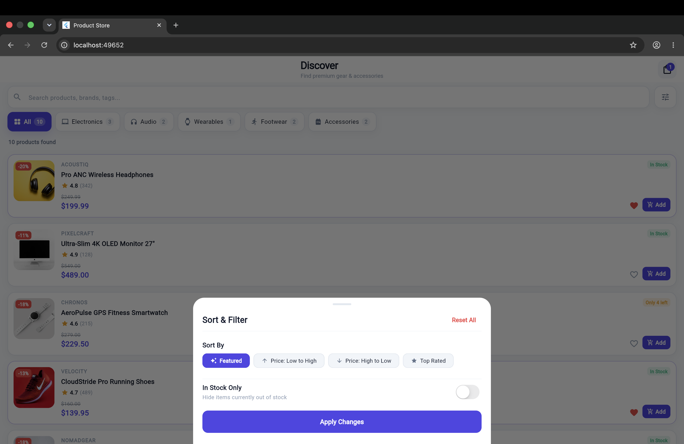
Figure 4: FilterModalSheet displaying sorting criteria choice chips, In Stock Only switch toggle, and filter reset options.
Screen 5: Interactive Shopping Cart Sheet & Checkout
Tapping the AppBar cart icon opens the comprehensive CartSheet slide-up modal. Rather than a simple informational toast, this full-featured shopping cart displays individual line items with product thumbnail imagery, brand labels, unit prices, and computed line-item subtotals. Users can dynamically increment or decrement item quantities via [-] [qty] [+] stepper controls, or delete items using the instant trash action button. The order summary dynamically evaluates subtotal, applies free shipping benefits, and enables order completion via the prominent 'Checkout' button.
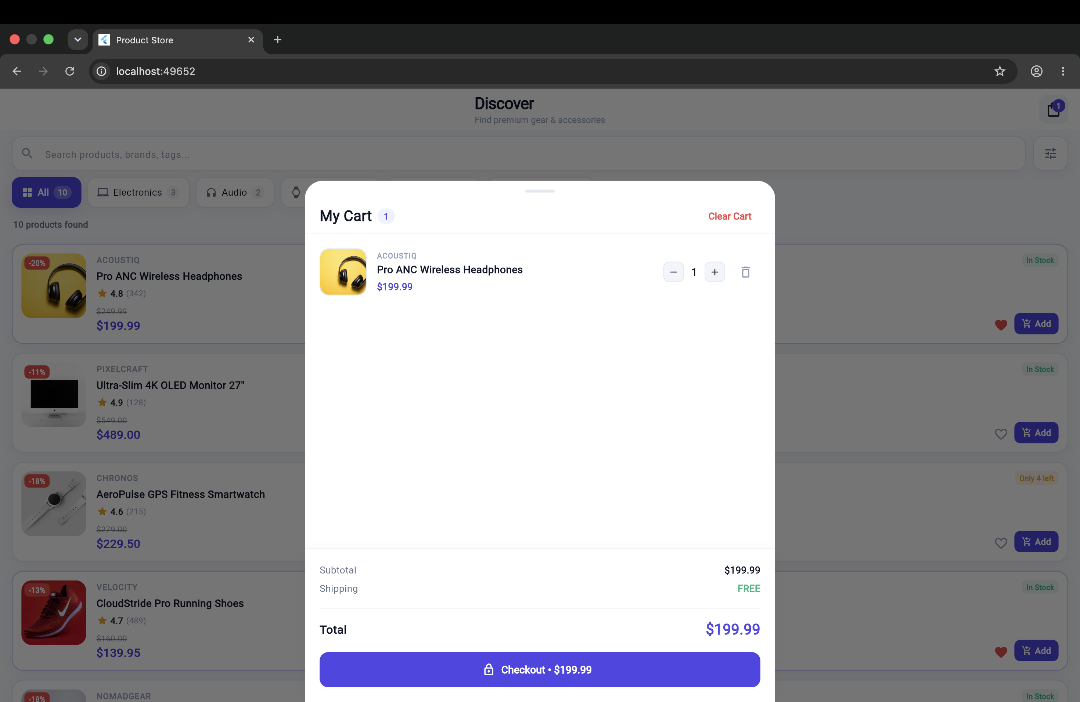
Figure 5: Full slide-up CartSheet featuring interactive quantity steppers, subtotal breakdown, free shipping calculation, and checkout CTA.

7. Testing, Quality Assurance & Verification Matrix
The project is verified using a comprehensive automated test suite in test/widget_test.dart. All test cases execute against the complete application widget hierarchy (ProductApp):
Test Case | Method | Validated Invariants | Status
Initial Catalog Rendering | testWidgets | Verifies Discover title, search field, category chips (All, Electronics, Audio), and ProductCard items render. | PASSED
Real-Time Text Search | testWidgets | Types 'Headphones', verifies only matching product displays, taps clear button, confirms full catalog restoration. | PASSED
Category Selection Filter | testWidgets | Taps 'Electronics' chip, verifies monitor appears while headphones are excluded. | PASSED
Favorite State Mutation | testWidgets | Taps heart icon, verifies UI rebuild via setState, checks floating SnackBar. | PASSED
Empty State & Reset | testWidgets | Inputs non-matching string, verifies EmptyStateView, taps 'Reset All Filters', confirms restored listing. | PASSED
Shopping Cart Flow | testWidgets | Taps 'Add', verifies cart badge shows '1', opens CartSheet, verifies product line items, free shipping, and checkout. | PASSED
Static Code Analysis | dart analyze | Verifies 0 syntax errors, 0 unused imports, 0 deprecated members, and strict compliance with Flutter lints. | PASSED (0 issues)

8. Compilation, Platform Deployment & Execution Guide
The application is fully configured for multi-platform deployment across Web (Chrome), macOS Desktop, iOS, and Android:
- • Google Chrome (Web): flutter run -d chrome (Hot reload enabled via 'r' key in terminal).
- • macOS Desktop Native: flutter run -d macos.
- • Automated Test Suite: flutter test (Executes all 6 integration tests in test/widget_test.dart).
- • Static Lint Analysis: dart analyze (Runs strict static checks against analysis_options.yaml).
9. Conclusion & Key Takeaways
The ProductStore Application fulfills all software engineering requirements for Assignment 6. By implementing dynamic list virtualization with ListView.builder, building a sound null-safe domain data model, coordinating reactive multi-criteria filtering via setState(), and integrating an interactive shopping cart sheet, the project exemplifies clean, scalable, and intermediate-level Flutter application development.

