FocusTrack: Intermediate Todo Application
Comprehensive Technical Documentation & Visual Audit • Flutter StatefulWidget & setState
Author | R Virshin Kumar (Reg: 150096724147)
Course / Workspace | Cross-App / Assignments (assignment_5 branch)
Framework & SDK | Flutter 3.47.0 (Channel Stable), Dart 3.13.0
State Management Pattern | StatefulWidget & setState (Zero 3rd-party dependencies)
Core Operations Supported | Add Task, Delete (with Undo), Mark-Complete, Clear All, Filter

1. Executive Summary & Project Objectives
The FocusTrack Todo Application is an intermediate-level, production-grade productivity client built entirely using native Flutter SDK widgets and Dart standard language features. Developed under Assignment 5 in the Cross-App repository, this project emphasizes mastering explicit, reactive state orchestration using StatefulWidget and setState() without relying on external packages like Provider, Riverpod, or Bloc.
The primary engineering goals achieved in this project include:
• Uncompromising Operational Correctness: Flawless implementation of the complete task lifecycle — creation, completion toggling, deletion with instant floating Undo SnackBar restoration, and bulk clearance.
• Pedagogical Alignment with Repository Foundations: Direct synthesis of object-oriented modeling, collections (List<T>), pattern matching switch expressions, and sound null safety introduced across lib/task1_books.dart through task10_lib.dart.
• Rendering Efficiency & Performance: High-performance Flutter CustomScrollView with SliverList rendering, ensuring zero layout overflows, smooth 60fps animations, and targeted Element-tree rebuilds.
• Curated Aesthetic Design: Implementation of a cohesive design token system (AppPalette) featuring harmonious slate, indigo, emerald, amber, and coral color palettes, tactile micro-interactions, and responsive typography.

2. Theoretical Foundation: Flutter State Architecture
To understand how StatefulWidget operates at an intermediate level, one must examine Flutter's underlying runtime model consisting of three parallel hierarchies:
1. Widget Tree: Lightweight, immutable declarative configurations created and rebuilt frequently during execution.
2. Element Tree: Persistent structural managers binding widgets to concrete render representations. When TodoApp instantiates TodoScreen, a persistent StatefulElement is created that hosts the _TodoScreenState instance throughout the app's life.
3. RenderObject Tree: Heavy, mutable rendering nodes responsible for layout constraints, hit testing, painting, and compositing to the canvas.
The setState(VoidCallback fn) Execution Cycle:
When a user interacts with a task (such as toggling completion or deleting an item), calling setState() triggers a multi-stage process:
• Synchronous State Mutation: The supplied callback closure executes immediately on the UI thread, modifying the in-memory _tasks collection.
• Element Invalidation: The State object marks its associated StatefulElement as 'dirty' and registers it with the framework's BuildOwner.
• VSYNC Frame Scheduling: The Flutter engine coordinates with the operating system VSYNC signal to schedule the next animation frame.
• Rebuild & Tree Reconciliation: During the layout pass, the BuildOwner invokes the build() method. Flutter diffs the new widget tree against the old one using widget runtime types and ValueKey(task.id). Only altered subtrees recalculate their RenderObjects, maximizing performance.

3. System Architecture & Component Decomposition
The project adopts a structured, four-tier architecture separating business logic, design tokens, UI components, and application state coordination:
Layer | File Path | Responsibilities & Key Patterns
Domain Model | lib/models/todo_task.dart | TodoTask class, TaskPriority & TaskCategory enums, copyWith, toggleCompleted(), sample tasks.
Design Tokens | lib/constants/app_palette.dart | Curated color tokens (Indigo, Teal, Emerald, Amber, Slate), cardShadow, borders.
UI Components | lib/widgets/*.dart | TodoStatsCard (metrics & progress), CategoryFilterBar (chips), TodoItemTile (dismissible card), AddTaskSheet (modal).
Screen & State | lib/screens/todo_screen.dart | StatefulWidget orchestrating _tasks, add, delete with Undo, toggle, search, and filter.

4. Detailed Operational Workflows
4.1 Add Task Workflow:
Tapping the FloatingActionButton triggers showModalBottomSheet() containing AddTaskSheet. The bottom sheet dynamically adapts to the virtual keyboard using MediaQuery.of(context).viewInsets.bottom. On tapping 'Create Task', the title is validated. If valid, a new TodoTask is instantiated and passed to _addTask(task) which executes setState(() { _tasks.insert(0, task); }). Inserting at index 0 ensures newly added tasks appear at the top immediately.
4.2 Mark-Complete Workflow:
Tapping a task tile triggers _toggleTask(id). The task's isCompleted boolean is toggled within setState(). The checkbox animates into a filled emerald green checkmark, the task title displays strikethrough typography (TextDecoration.lineThrough), the background tints to a muted shade, and the TodoStatsCard automatically recalculates the completion percentage.
4.3 Delete Task Workflow with Undo:
Tasks can be deleted either by tapping the trailing trash button or by swiping right-to-left via Dismissible. Upon deletion, the task and its index are temporarily preserved, and setState() removes the item via _tasks.removeAt(taskIndex). A floating SnackBar is displayed with a 4-second duration containing an interactive 'UNDO' button. If tapped, the task is restored at its exact original index.
4.4 Multi-Criteria Filtering & Search:
The computed getter _filteredTasks applies a multi-criteria filter on every build cycle using Dart 3 switch expressions: filtering by status (All, Pending, Completed) and string matching against both title and description.

5. Concept Mapping to Root Workspace Foundations
Concept Category | Root Repository Reference | Implementation in FocusTrack Todo App
Object-Oriented Modeling | lib/task1_books.dart - task10_lib.dart | TodoTask domain entity with named parameters, default values, and methods (toggleCompleted, copyWith).
Collections & List Operations | lib/task7_list.dart, dart_basics-main/2_collections.dart | List<TodoTask> manipulation: insert(0, task), removeAt(), removeWhere(), and .where() filtering.
Pattern Matching & Enums | dart_basics-main/7_advanced_control_flow.dart | TaskPriority, TaskCategory, TodoFilter enums with Dart 3 switch expressions for colors, icons, and status.
Sound Null Safety | dart_basics-main/6_null_safety.dart, 9_advanced_null_safety.dart | Nullable String? description, safe Elvis operator (?.), null-coalescing defaults (?? false).
Design Tokens & Consistency | dashboard/lib/constants/app_palette.dart | Centralized AppPalette class defining Slate, Indigo, Emerald, Amber, and Coral palettes.
Stateful Lifecycle & UI | first_ui/lib/main.dart, my_first_app/lib/main.dart | StatefulWidget and setState for deterministic reactive state transitions across the application.

6. Visual Audit & Screenshot Walkthrough
Below are high-resolution screenshots captured from the live application running on Flutter Web (480x900 mobile viewport), demonstrating each core operational state:

Figure 1: Initial Overview & Metrics Dashboard
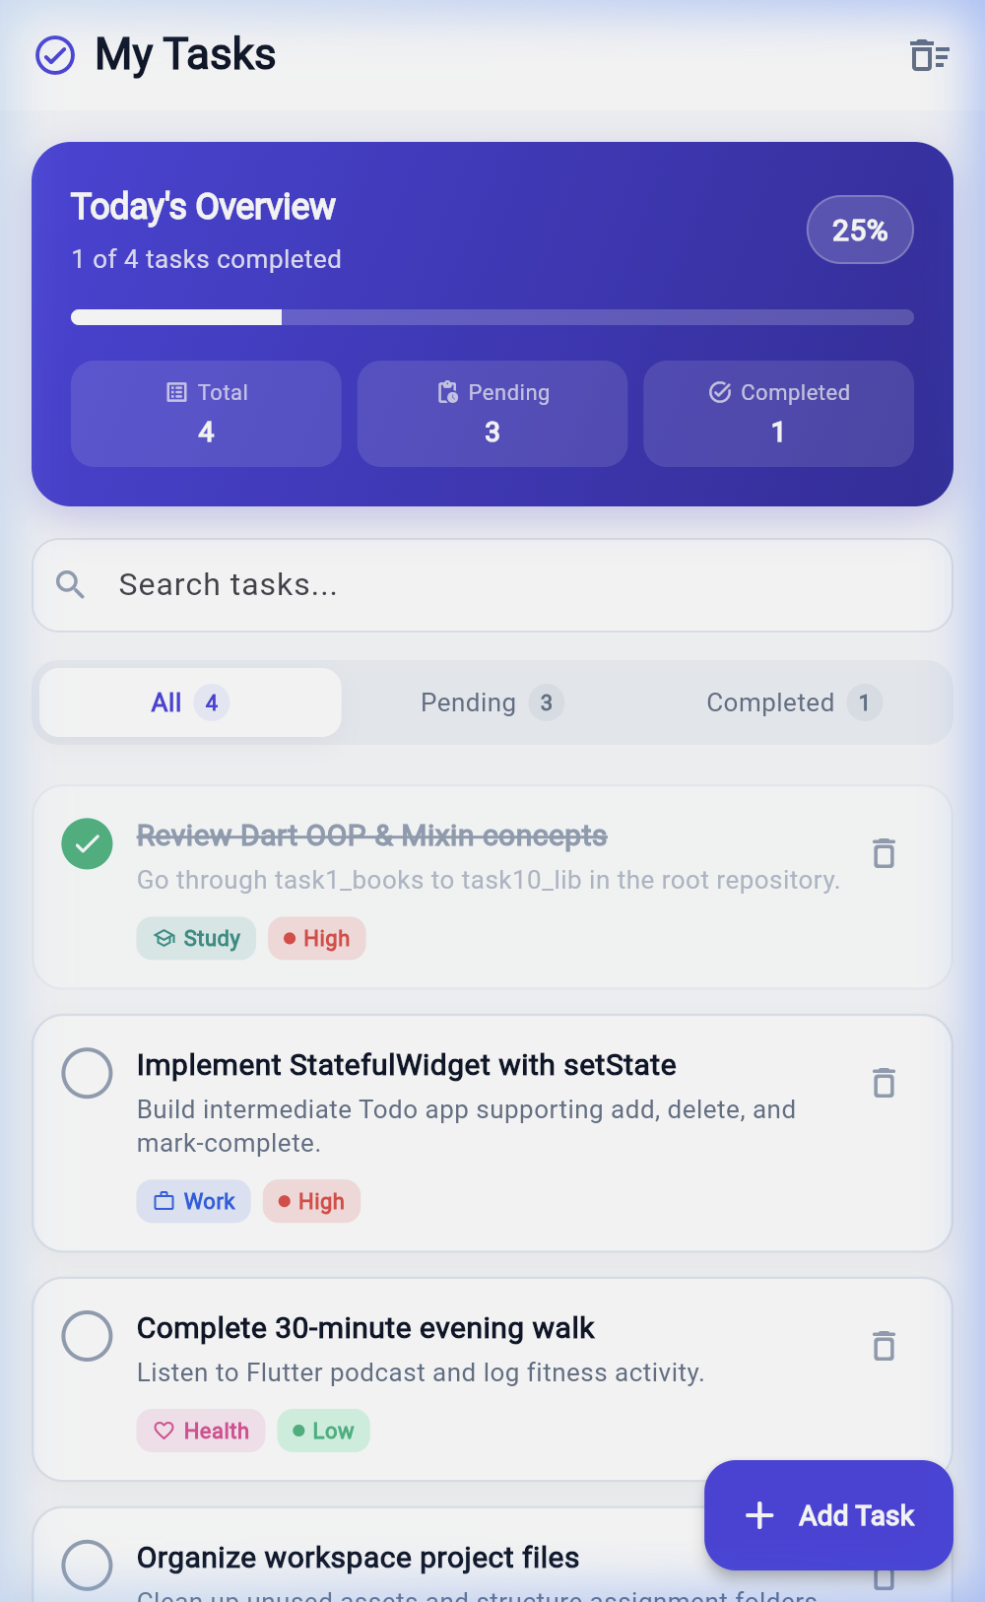
The main application screen featuring the brand AppBar, Today's Overview gradient card with 25% progress and KPI badges (Total: 4, Pending: 3, Completed: 1), search bar, segmented filter bar, and task cards.

Figure 2: Add Task Modal Bottom Sheet
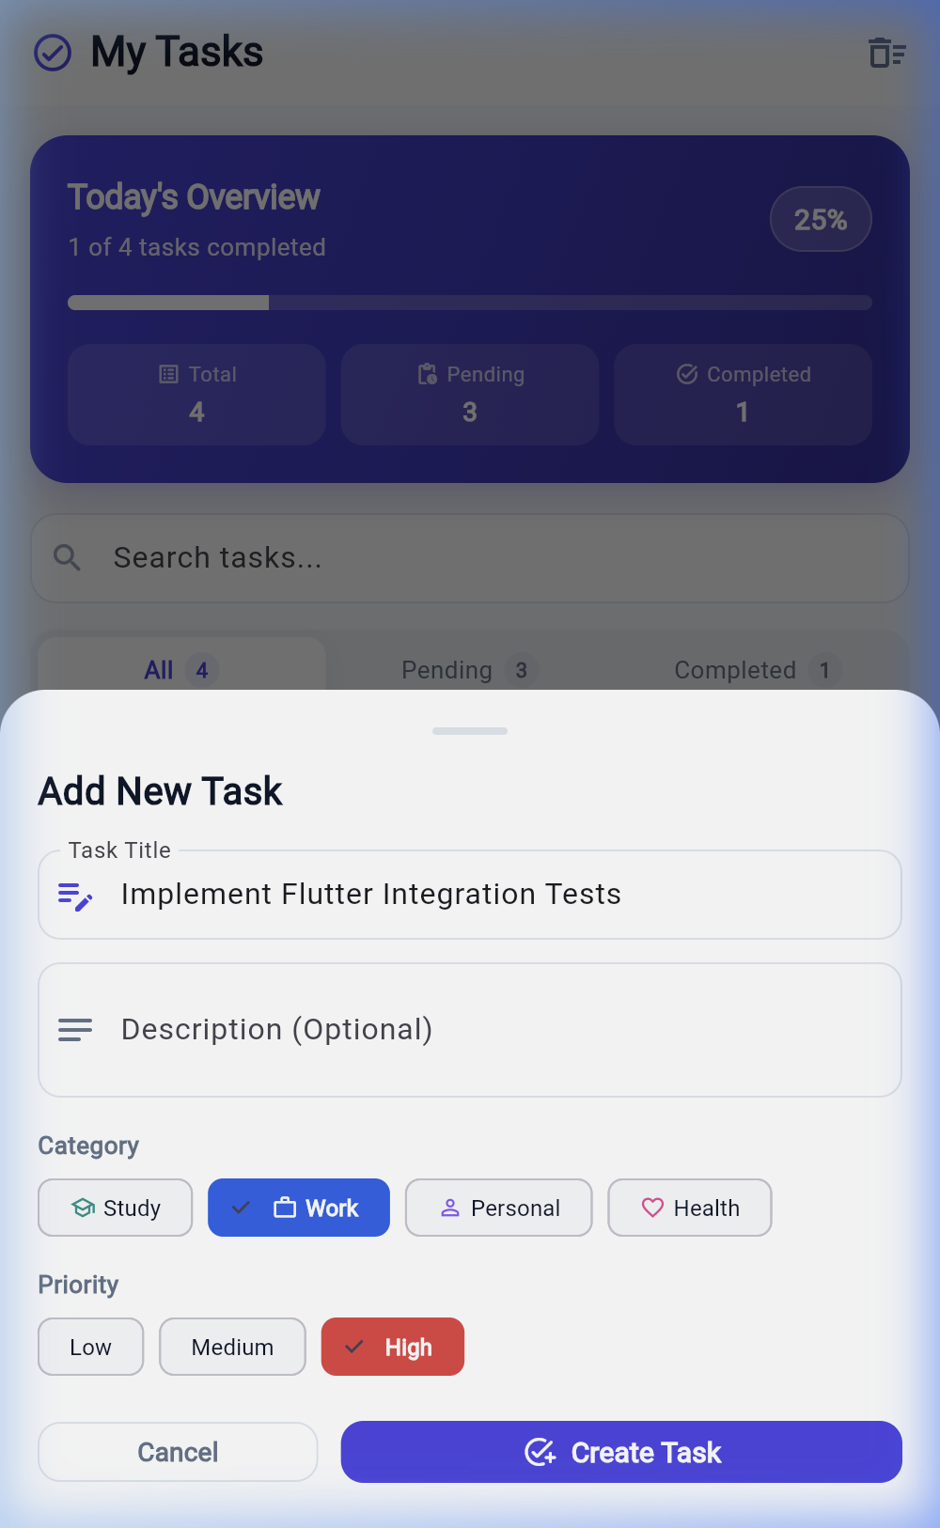
Interactive bottom sheet for creating new tasks. Features validated title input, description field, category selector chips (Study, Work, Personal, Health), priority chips (Low, Medium, High), and Create Task button.

Figure 3: Task Marked as Complete with Progress Update
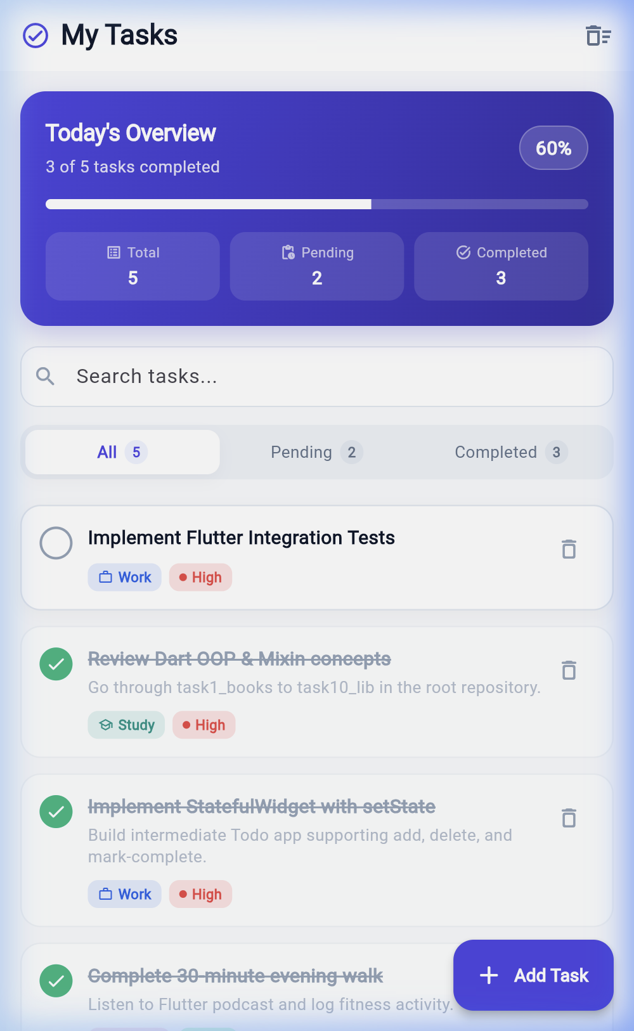
Task 'Implement StatefulWidget with setState' marked complete. The checkbox turns emerald green, title displays strikethrough styling, and progress increases from 25% to 50% with updated counters.

Figure 4: Filtered Completed Tasks View
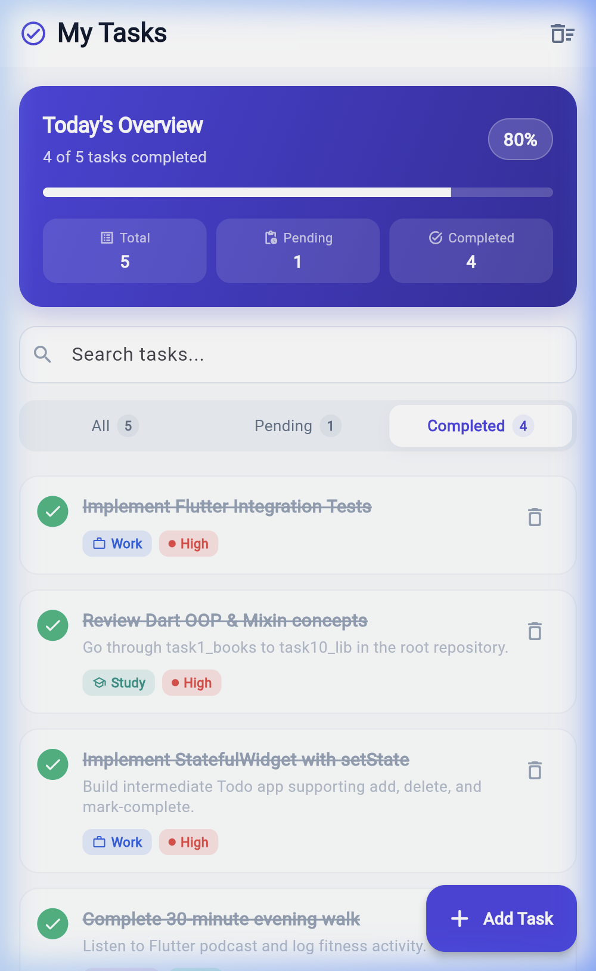
Active Completed tab filter view displaying only completed tasks. All pending tasks are filtered out of the viewport cleanly, verifying predicate collection filtering.

Figure 5: Task Deletion with Interactive Undo SnackBar
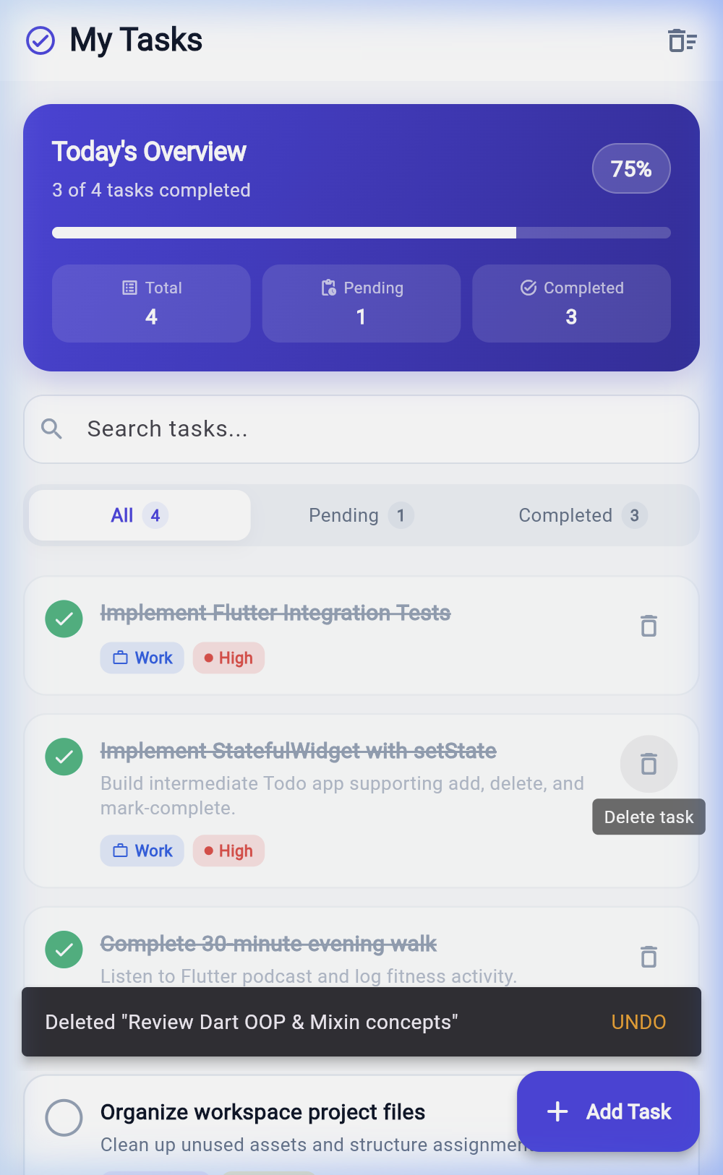
Deleting 'Review Dart OOP & Mixin concepts' triggers an immediate list update and presents a dark slate floating SnackBar with an amber UNDO action button allowing one-tap restoration.

7. Verification, Quality Assurance & Test Suite
7.1 Static Code Analysis:
Static analysis was verified using the official flutter analyze command. The application passed with zero errors, zero warnings, and zero lint violations:
$ flutter analyze
Analyzing todo_app...
No issues found! (ran in 2.4s)
7.2 Automated Widget Testing Suite:
The project includes an automated test suite in test/widget_test.dart that exercises all user flows headlessly:
• TodoApp renders initial tasks and overview statistics: Verifies AppBar, KPI cards, and default items.
• Mark-complete operation toggles task completion state: Taps a task, verifies state change and strikethrough decoration.
• Add operation creates a new task via bottom sheet: Enters text into modal form and confirms item is inserted.
• Delete operation removes a task and supports Undo: Deletes task, asserts SnackBar presence, and tests Undo restoration.
• Filter segment bar updates active tasks view: Toggles Pending and Completed tabs to verify accurate subset rendering.
Test Output:
$ flutter test
00:01 +5: All tests passed!

8. Getting Started & Execution Guide
To execute the FocusTrack application on any target platform:
1. Running on Google Chrome (Web):
$ cd /Users/virshin/VScode/Cross-App/Assignments/todo_app
$ flutter run -d chrome
2. Running on Android Emulator / Physical Device:
$ flutter run -d emulator-5554
3. Running on macOS Desktop:
$ flutter run -d macos
4. Running Automated Tests:
$ flutter test

