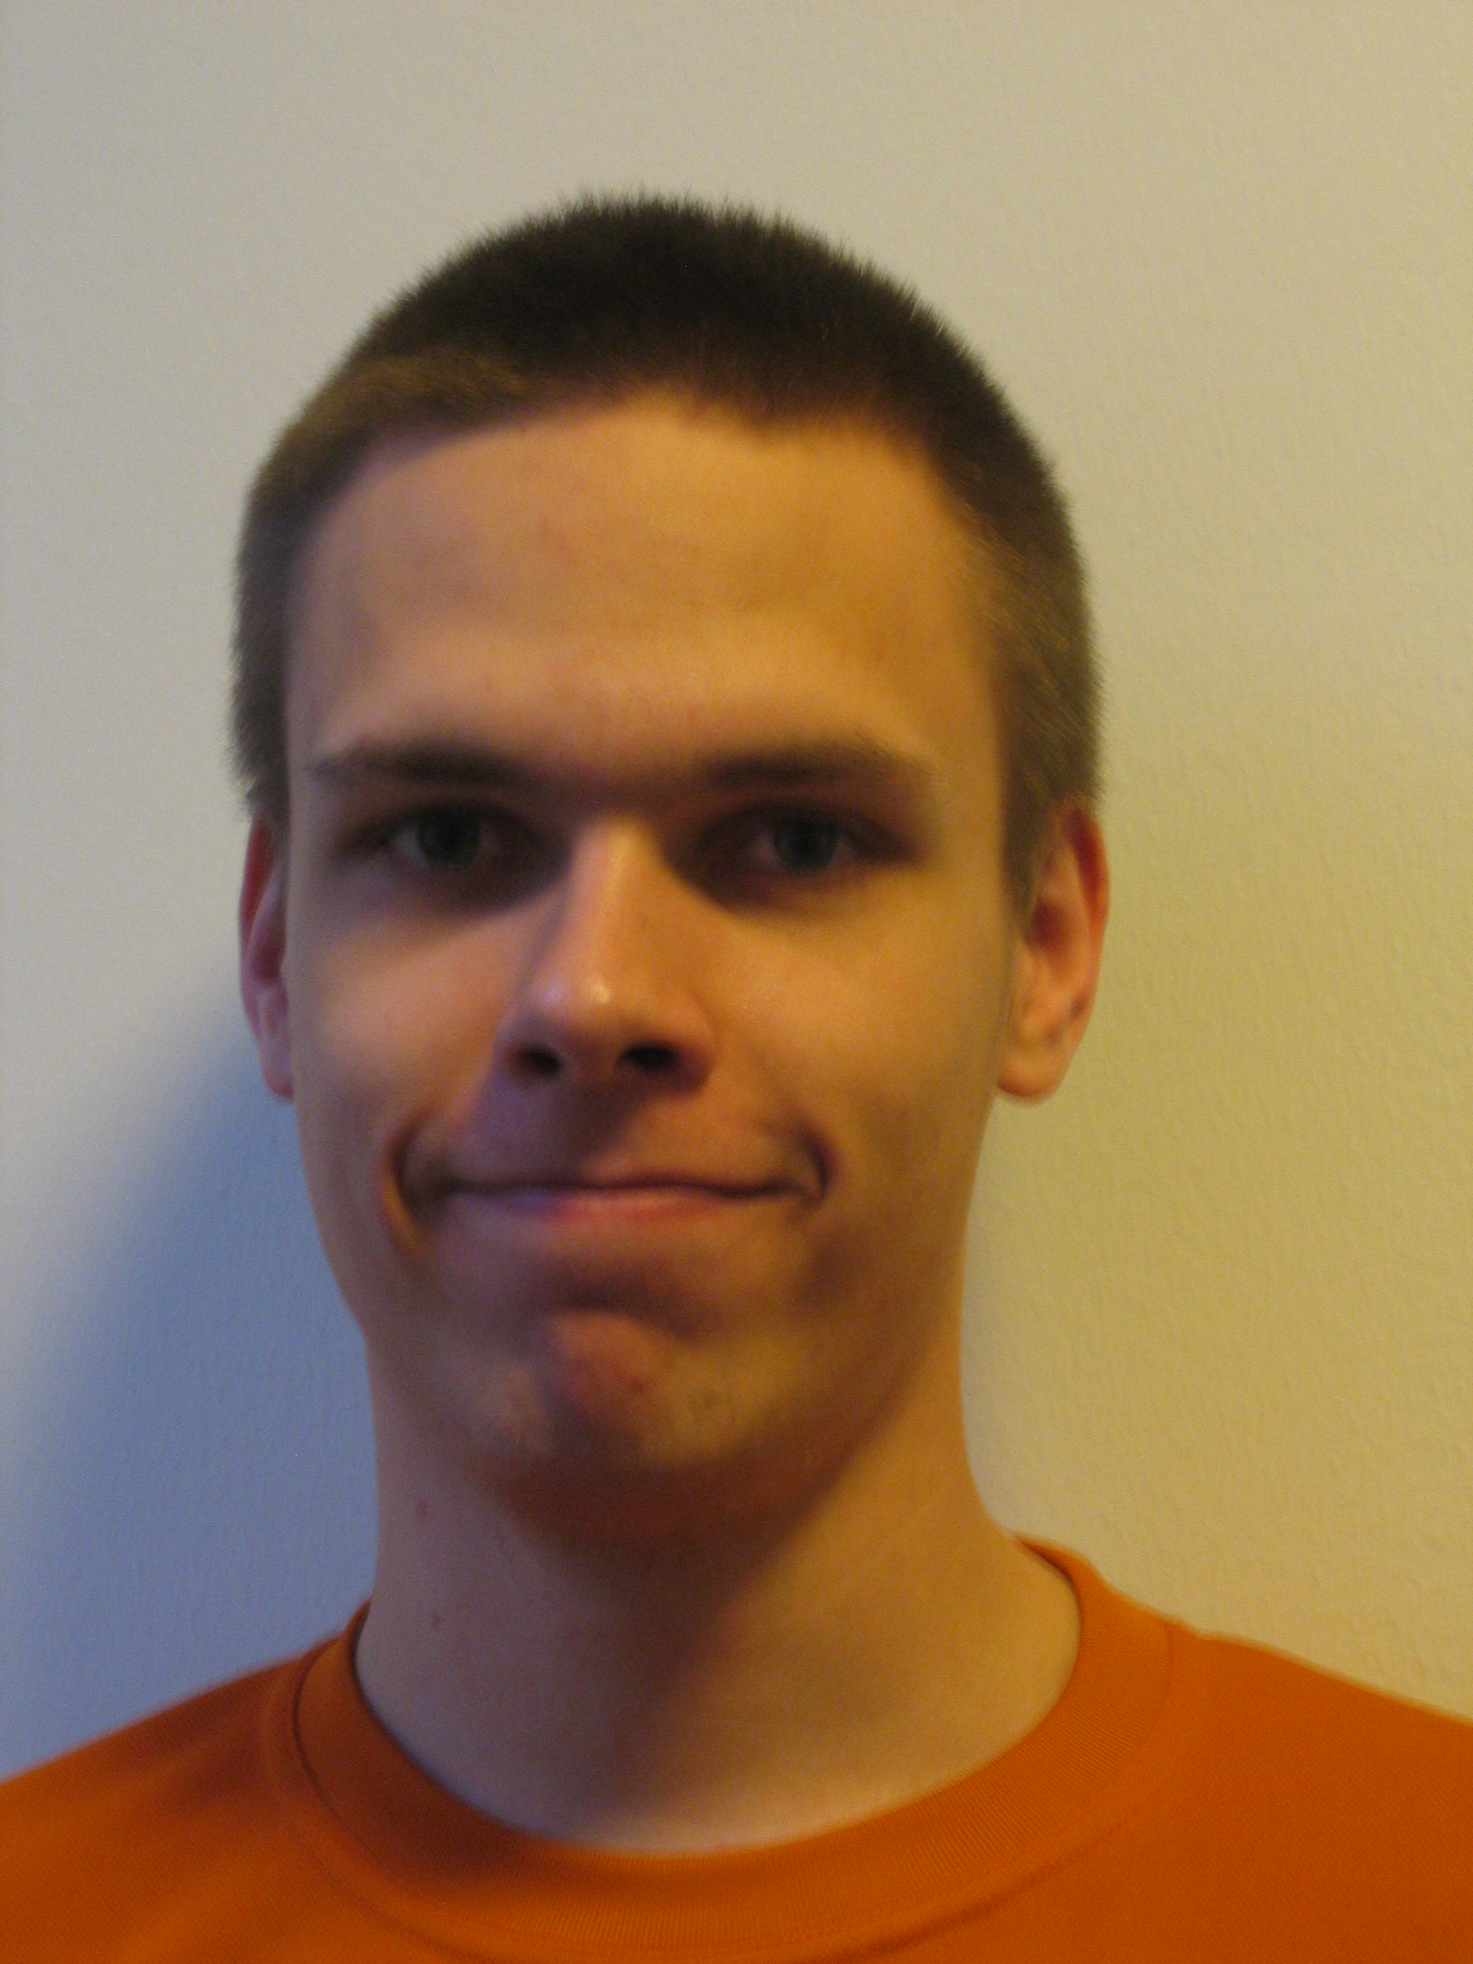
EDUCATION
2005- Student at Helsinki University of Technology
Study program: Engineering physics and mathematics, major: physics
minors: mathematics
2005 Matriculation Examination, Hyvinkään Sveitsin lukio

WORKING EXPERIENCE
1/2008- Teaching assistant in C-programming, Helsinki University of Technology, laboratory of Information and Computer Systems in Automation
Duties consist mainly of teaching at practise sessions and correcting excercises.
9/2007-12/2007 Teaching assistant in mathematics, Helsinki University of Technology, Department of Mathematics
Primarily teaching at practise sessions, additionally correcting exams.
1/2007-9/2007 Secretary General of Conscript Committee, Defense Command Finland
Five months as a conscript, thereafter three additional months as a civil servant. Assignment covers various tasks pertaining management of conscript co-operation and conferences both on national and nordic levels.
2/2005-9/2005 Farm labourer, Mari Skogberg
Various agricultural tasks and selling the farm products at an outdoor market

LANGUAGE SKILLS
suomi | mother tongue
englanti | fluent
saksa | good
ruotsi | good
venäjä | basics

OTHER EDUCATION

Class B driver's license (car, van)
First Aid degree EA1 approved by the Finnish Red Cross
Military rank: Second lieutenant in reserve

COMPUTER SKILLS
Fluent use of MS Office and Openoffice suites
Programming and markup languages: C, Java, python, (x)html, css, latex
Use and administration of MS Windows XP and GNU/Linux systems
Administration of GNU/Linux -based servers (Apache, samba, ssh etc.)

HOBBIES AND PERSONAL INTERESTS
Diving
Running
Hiking
Hunting
Computers

