ZTF Orchestrator UAT Update and Verification Guide
Build v1.8.5-rc1-c660955
Use the guided GUI to update the UAT appliance. Verify the pipeline controls in UAT and run the recovery rehearsal in Docker with networking disabled.

1 Prepare the appliance
1. Obtain ztf-update-v1.8.5-rc1-c660955.zip and the matching .zip.sha256 file. From the download folder, run this command in PowerShell.
Get-FileHash -Algorithm SHA256 -LiteralPath '.\ztf-update-v1.8.5-rc1-c660955.zip'
Expected SHA-256
ef263af72f6d758ef4d640be05ee8f0ea63bcccc2331558a2c0aad0861c4e7bb
2. Sign in to UAT as an administrator. Open /health and record the exact current image tag for rollback. Confirm the previous image and a verified backup pair are available.
3. Confirm jobs, pipelines and recovery runs are idle. Pause schedules that could start work during the update.
4. Open Administration → Appliance Ops → Updates. If space is tight, select Review Storage Before Upload. If the host update service is missing, follow the one-time bootstrap in host-service/README.md inside the verified ZIP.

2 Install through the guided GUI
1. Choose the ZIP and click Upload and Verify ZIP. Select v1.8.5-rc1-c660955 from the imported package list.
2. Click Check Readiness. Resolve any storage or active-job blockers and rerun readiness. Proceed when the result allows installation.
3. Type the following confirmation and click Back Up and Install. Readiness approval expires after 15 minutes.
INSTALL v1.8.5-rc1-c660955
4. If the browser disconnects, sign in again and review the existing operation. Confirm it succeeded and download the operation report.

3 Verify the installed build
Open /health on the UAT appliance. Expect healthy status, storage backend postgres, and the exact installed identity below.
Version tag v1.8.5-rc1-c660955
Commit c660955c862fa9bf020c50d3eb229cdb2b535214
Image ghcr.io/virtuarchitect/ztf-orchestrator:v1.8.5-rc1-c660955
Open an existing pipeline and recovery profile. Confirm their saved records are accessible.

4 Verify Native opt in and compatibility
1. Open an existing pipeline and confirm Executor for new runs shows ZTF 1.x (default). Close without saving.
2. Save the following disposable YAML in Config Files. Create a disposable pipeline named UAT Native compatibility check, add Set Prism Login Title (PE), and select that YAML.
clusters:
"192.0.2.20":
name: UAT-COMPATIBILITY-ONLY
pe_credential: uat_nonexistent_credential
prism_login_title: UAT Compatibility Check
3. Select Native (opt-in) and click Check compatibility. Expect step 1 to be flagged because the credential reference does not resolve. The compatibility check reads saved YAML and resolves references locally without contacting Prism.
4. Save and reopen the disposable pipeline. Confirm Native (opt-in) persisted. Leave Run unclicked, then delete the disposable pipeline and YAML.
This build supports Native execution for Set Prism Login Title (PE). Keep the working eight-step pipeline on ZTF 1.x. The offline tests include a compatible title configuration with mocked credentials.

5 Rehearse the step 08 retry offline
From the Windows development workstation, use Docker Desktop, the local recovery test image and the exact merged checkout. The container uses a read-only checkout and has networking disabled.
$checkout = 'C:\path\to\ZTF-Orchestrator'
git -C $checkout rev-parse HEAD
docker run --rm --network none `
-e ZTF_STORAGE_BACKEND=file `
--mount "type=bind,source=$checkout,target=/checkout,readonly" `
-w /checkout `
ztf-orchestrator:recovery-test-local `
python -m pytest -o cache_dir=/tmp/pytest-cache `
tests/test_disaster_recovery.py tests/test_native_pipeline_preview.py `
-k 'rehearse_only_step_08 or retry_eligibility or native' -q
Expected checkout commit is c660955c862fa9bf020c50d3eb229cdb2b535214. Expected test result is 4 passed, as verified on this checkout.
The rehearsal simulates successful Foundation imaging and steps 01–07, then fails step 08 registration verification. Retry is blocked before reconciliation and when health evidence is missing or expired. After recording that registration is absent in mocked PE and PC and supplying fresh health evidence, exactly one job is submitted using the original step 08 configuration. Earlier job records and the failed attempt remain in history. The run reaches Awaiting acceptance.
Leave the UAT recovery execution controls untouched during this check.

6 Roll back if needed
1. Review the existing operation report and /health. A failure before the new image starts may already have triggered restoration of the previous application.
2. If the console is reachable and database compatibility is confirmed, open Administration → Appliance Ops → Updates → Recovery: previous application image. Match the displayed version to your recorded tag.
3. Complete the compatibility confirmation. Replace the placeholder below with the exact displayed version and submit the rollback.
ROLLBACK <previous version>
4. After restart, confirm the previous image and healthy PostgreSQL in /health. Open representative pipelines and recovery profiles before resuming schedules.
5. GUI rollback restores the application image only. If the console is unavailable, compatibility is uncertain, or data needs restoring, use the approved host or VM procedure and the matching verified backup pair and receipt. Keep the application stopped during a database restore.

Illustrated walkthrough
Screenshots use simulated records in an isolated local console. Follow the numbered procedure in the guide for the actual UAT update.

Guided appliance update
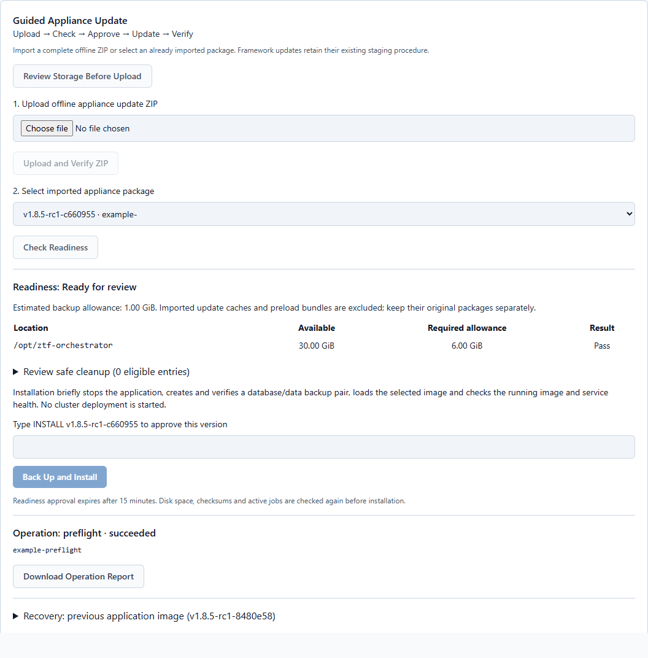
Figure 1. The imported c660955 package is selected. Simulated readiness checks passed and the approval field is visible. Installation was left unsubmitted.

Native opt-in and compatibility
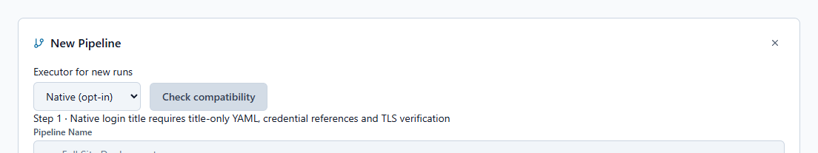
Figure 2. Native is selected for new runs. The example compatibility result flags step 1 and describes the requirements for the PE login-title action.

Mocked recovery retry and rollback

Retry only step 08
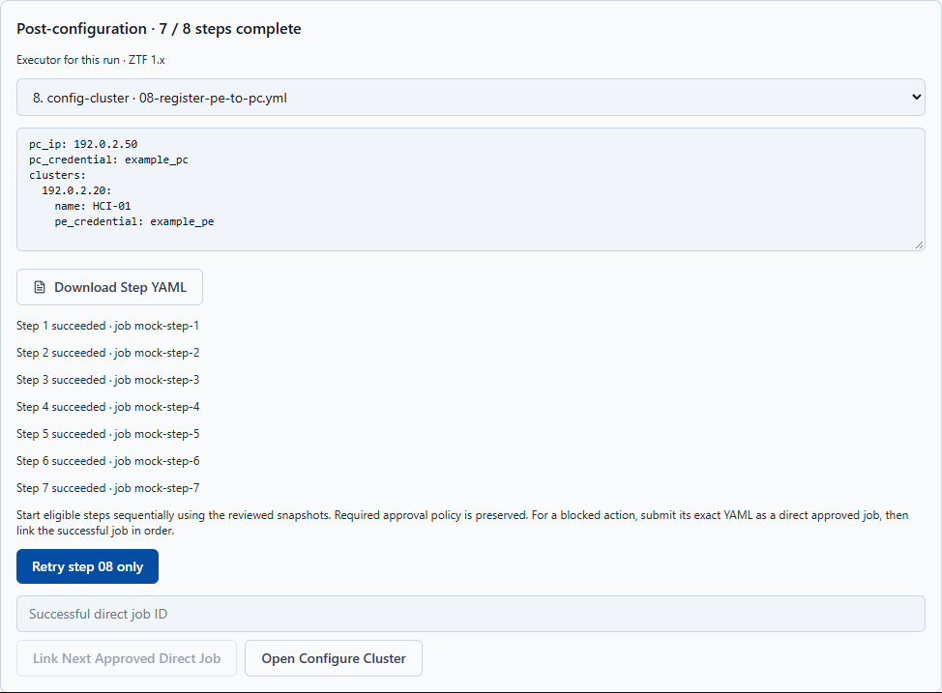
Figure 3. The simulated recovery shows seven successful steps and only the original PC registration step ready to retry. The offline test in section 5 verifies reconciliation, fresh health evidence and the single submission. The illustrated button was left unclicked.

Restore the previous application image
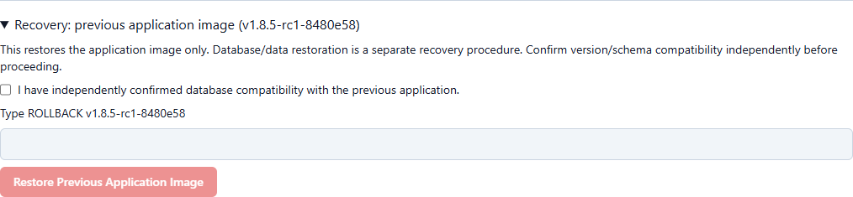
Figure 4. The rollback panel displays an example previous image and the required compatibility confirmation. Use the version displayed by your appliance. Rollback was left unsubmitted.

