Datacenter and Recovery Cluster Profile Setup
  - Link saved deployment and post configuration automation without deploying
Applies to ZTF Orchestrator v1.8.5-rc1-867fe83. Prepared 29 October 2026.

Purpose
Create a datacenter, link a saved Foundation VM configuration and post-deployment pipeline, capture a recovery profile revision and verify that the reviewed baseline persists. The outcome is a saved recovery plan. No cluster deployment or post-configuration execution is part of this procedure.

Before you begin
- Sign in as an administrator to the Orchestrator where the Disaster Recovery feature is installed.
- Have a saved Foundation VM deployment YAML for exactly one cluster and a saved post-deployment pipeline for that same cluster.
- Use secure credential references. Do not place literal passwords, secrets, tokens or private keys in the recovery YAML.
- Use your actual approved cluster identity and endpoint. The names and endpoint in this guide are generic examples.

Procedure
1 Prepare the Foundation configuration
2 Prepare the pipeline
3 Add the datacenter
4 Create the profile
5 Review the baseline
6 Verify without deploying
7 Maintain revisions

Where to stop
Finish after baseline review and persistence checks. Do not select Prepare Recovery, Prepare Rehearsal or Deploy Reviewed Recovery, and do not run the linked pipeline during setup verification. A deployed rehearsal performs real infrastructure changes.

1 Prepare the Foundation VM configuration
Open Cluster Create (Foundation VM). Save or import the deployment YAML intended for the recovery cluster.

Review the deployment intent
- Exactly one cluster is defined, with the correct cluster name and VIP.
- Physical node serial numbers identify only the intended recovery nodes.
- The Foundation VM endpoint is correct, including its protocol and port.
- Image filenames, the required AHV ISO checksum and image selections are correct.
- Host, CVM and IPMI addresses and their network settings are correct.
- Credentials use references in the existing credential store.
- Cluster formation is enabled. An imaging-only configuration is not suitable.
Save the file with a clear cluster-specific name, for example create_foundation_vm_cluster_CLUSTER01.yml. Confirm it appears in Config Files.
Use the workflow Dry Run for non-mutating validation. Review its output and resolve failures. Do not select Run Workflow.
Expected result: The saved deployment YAML is available in Config Files and passes the applicable validation checks. No deployment job is started.

Keep the endpoint consistent
The datacenter endpoint entered later must match the endpoint in this deployment YAML. Use the Foundation HTTP or HTTPS origin, such as http://foundation-dc01.example.com:8000. Do not append /gui/index.html.
Saving a recovery profile does not perform live reachability, certificate or credential tests. Complete the relevant non-mutating workflow checks separately; a saved profile alone does not establish dependency readiness.

2 Prepare the post deployment pipeline
Open Pipelines. Create or select the saved pipeline intended for this cluster. Save it without running it.

Supported recovery pipeline actions
- Configure Cluster
- Change Default Admin Password (PE)
- Create Local Users (PE)
The recovery profile accepts a saved pipeline with 1 to 30 steps. Other action types are not currently accepted by this recovery coordinator.

Example logical sequence
- Change the PE administrator password when required.
- Configure EULA, the approved Pulse setting, DNS and NTP.
- Configure storage containers and supported VM networks.
- Create PE local administrators and apply remaining supported baseline settings.
Use only actions and configuration fields supported by your installed framework. Include only the settings needed for the intended recovery baseline.

Check every referenced configuration file
- Each file targets only the recovery cluster VIP.
- Each file specifies the exact same cluster name as the Foundation deployment YAML.
- Step order is deliberate, including any credential transition after changing the PE password.
- Every referenced credential is available to the Orchestrator.
For example, name the pipeline CLUSTER01 Post Deployment. Referencing a saved pipeline does not bypass approvals or verification gates during a future execution.
Expected result: The saved pipeline is visible in Pipelines and contains only supported, cluster-specific steps. Saving it creates no execution job.

3 Add the datacenter
Open Recovery → Disaster Recovery and select Add Datacenter.
Datacenter name — DC01, or your approved datacenter name.
Foundation VM endpoint — For example http://foundation-dc01.example.com:8000. This must match the deployment YAML endpoint.
Recovery dependencies and runbook notes — Record provisioning network requirements, image locations, credential references, backup platform access and the relevant runbook reference.

Review prerequisite statuses
The form provides these prerequisite reviews:
- Provisioning network
- Approved images
- Recovery credentials
- DNS / NTP
- Backup platform access
Leave each status as Needs review until someone has actually checked that dependency. Select Reviewed only when the corresponding review is complete. These are operator reviews, not automatic connectivity probes.
Save the datacenter using the form save control.
Expected result: The datacenter is present in Disaster Recovery and is selectable when creating a recovery profile. If no datacenter exists, Create Recovery Profile is disabled.

4 Create the recovery cluster profile
Select Create Recovery Profile and complete the following fields.
Profile name — For example DC01 CLUSTER01 Recovery.
Datacenter — Select DC01 or the datacenter created above.
Cluster origin — Existing cluster to rebuild for an existing cluster, or New cluster for a new deployment intent.
Foundation VM deployment YAML — Select the saved single-cluster configuration from Step 1.
Post-configuration pipeline — Select the saved cluster-specific pipeline from Step 2.
Optional observed configuration import — Leave unselected unless you have a suitable saved observation file. The import remains separate from the desired baseline and is not live discovery.
Select Save Draft Revision.
Expected result: The profile appears with Revision 1 and a draft review status. No Foundation job starts.

5 Review the captured baseline
Select Review Profile for the saved profile. Inspect the latest revision before marking it reviewed.
- Confirm the cluster name and VIP.
- Confirm the physical node count and every exact node serial number.
- Inspect the deployment snapshot, including the Foundation endpoint, images, checksum and addressing.
- Expand each post-configuration snapshot. Confirm step order, action and captured configuration contents.
- Check all credential references, including credentials required after any password change.
- Record the displayed Baseline SHA256 fingerprint in your change or recovery planning record.

Record baseline review notes
Enter notes describing the actual review performed. For example:
Reviewed the intended node serials, cluster identity, Foundation endpoint, image references and post-configuration files. All pipeline steps target this cluster. Planning verification only; no deployment performed.
Select Mark Baseline Reviewed only after completing that review.
Expected result: The latest revision is marked reviewed and the review notes and reviewer information are retained. This records baseline review; it does not authorize imaging.

6 Verify the setup without deploying
Close the profile, refresh the page and reopen it. You can also sign out and sign in again to check persistence.
- The datacenter and recovery profile remain present.
- The correct Foundation YAML and saved pipeline are linked.
- The reviewed revision, captured contents and SHA256 fingerprint remain unchanged.
- Review notes and reviewer information remain visible.
- Jobs / Queue contains no new deployment or configuration job caused by saving or reviewing the profile.
- Recovery Runs and Rehearsals contain no new run created by these setup steps.
Expected result: A reviewed recovery baseline persists, with no deployment or pipeline execution. Stop here.

7 Maintain the profile and resolve setup issues

When saved configurations change
Editing a saved deployment YAML or pipeline can flag the profile as baseline changed. Open Review Profile → Capture New Revision, save the updated snapshot, review it and mark the new baseline reviewed. Historical revisions remain available for inspection.
Credential references are captured, but their resolved secret values are not frozen. Recheck credential availability and correctness before any future execution.

Common setup issues
Create Recovery Profile is disabled — Create a datacenter first and confirm you are signed in as an administrator.
Deployment endpoint mismatch — Make the datacenter Foundation origin and the deployment YAML endpoint consistent, including protocol and port.
Foundation configuration is incomplete or invalid — Return to the Foundation VM workflow, correct the configuration and repeat non-mutating validation.
Recovery profile rejects the pipeline — Use 1 to 30 supported steps. Every referenced file must target only the intended cluster VIP and exact cluster name.
Secret field is rejected — Replace literal secret values with the supported credential references. Do not put secrets in review notes.
Profile needs review after a change — Capture and review a new revision. An old reviewed snapshot does not automatically approve changed source files.

Final verification record
- Datacenter name and Foundation endpoint recorded.
- Single-cluster deployment YAML and saved pipeline linked.
- Cluster identity, physical targets and pipeline snapshots reviewed.
- Reviewed revision and Baseline SHA256 recorded and persistent after refresh.
- No new deployment, configuration, recovery or rehearsal execution started.
Result: a saved and reviewed recovery plan. Reachability, actual cluster health and successful physical recovery require separate validation.

Source reference
Disaster Recovery operator documentation at the version covered by this guide:
https://github.com/VirtuArchitect/ZTF-Orchestrator/blob/867fe83f6c90dff1ee785e8caf0fe2b82b969174/docs/disaster-recovery.md

Screenshot 1 Create the datacenter
Use with Step 3. Enter the datacenter name, matching Foundation VM origin and recovery notes. Leave prerequisite statuses as Needs review until the actual dependency reviews are complete.
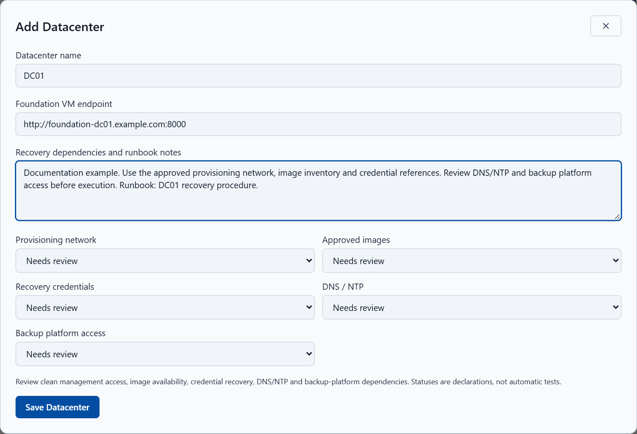
Figure 1. Add Datacenter with generic DC01 details and all five prerequisite reviews outstanding.
Screenshot provenance: actual application interface from source commit 867fe83, captured in an isolated browser session with generic simulated API records. YAML shown is an illustrative excerpt, not a complete deployment template. No live backend, Foundation VM, Prism system or production record was changed.

Screenshot 2 Link the deployment and pipeline
Use with Step 4. Select DC01, the saved single-cluster Foundation VM YAML and CLUSTER01 Post Deployment. Select Save Draft Revision to capture the linked configuration without execution.
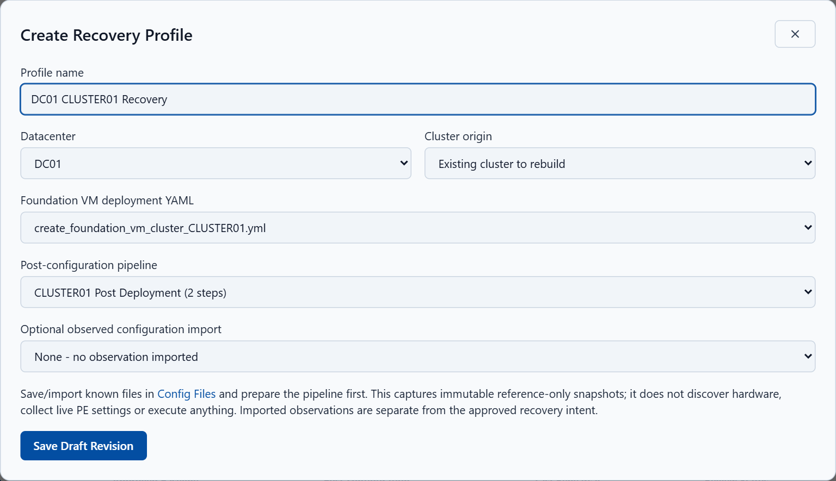
Figure 2. The recovery profile links create_foundation_vm_cluster_CLUSTER01.yml to the saved two-step post-configuration pipeline.
Screenshot provenance: actual application interface from source commit 867fe83, captured in an isolated browser session with generic simulated API records. YAML shown is an illustrative excerpt, not a complete deployment template. No live backend, Foundation VM, Prism system or production record was changed.

Screenshot 3 Review the saved baseline
Use with Steps 5 and 6. Inspect Revision 1 Reviewed, the cluster identity, physical node serials, Baseline SHA256, deployment snapshot and captured pipeline steps. Stop after review and persistence checks.
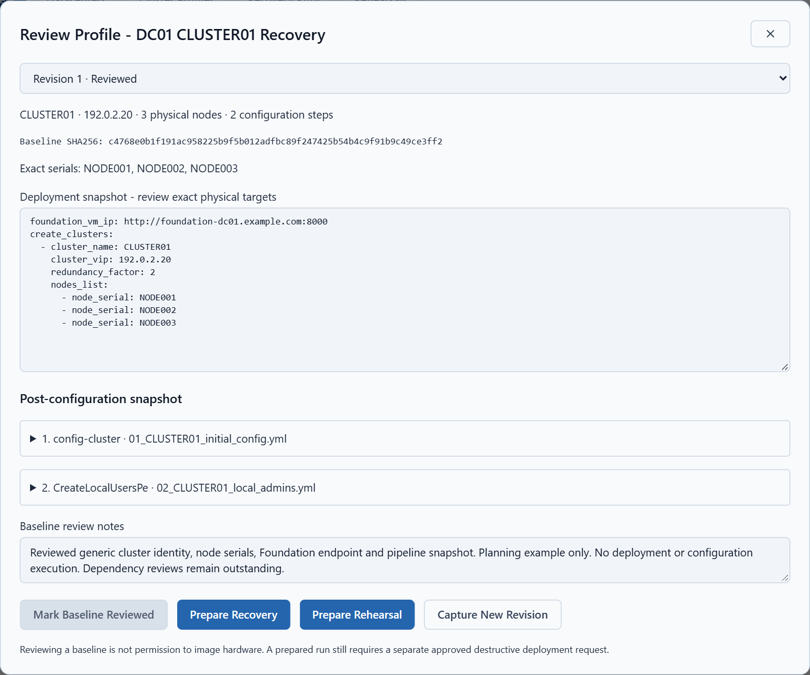
Figure 3. Reviewed baseline with planning notes. Prepare Recovery and Prepare Rehearsal are shown for orientation only; neither was selected.
Screenshot provenance: actual application interface from source commit 867fe83, captured in an isolated browser session with generic simulated API records. YAML shown is an illustrative excerpt, not a complete deployment template. No live backend, Foundation VM, Prism system or production record was changed.
Verification: the isolated capture requested only datacenter save, draft profile save and baseline review. No recovery preparation, deployment, rehearsal or pipeline execution request was made. A reviewed baseline is not proof of dependency readiness or successful recovery.

