**Test Case** **0024**

**System:** VirtuCardsClient & VirtuCardsHost

**Description:** Test that the waiting screens reflects the selected game information

**Severity:** 3

**Instructions**

**Test 1**

1. Start VirtuCardClient application
2. Click the button labeled “Sign In”
3. Enter “virtucards01@gmail.com” into the text input labeled “Enter email…”
4. Enter “Testing1” into the text input labeled “Enter password…”
5. Press the button labeled “Login”
6. A window should appear saying “Login Success”
7. Press the OK button that appears on that window
8. Start VirtuCardHost application
9. Repeat steps 2-7 but on the VirtuCardHost application, but use “virtucards02@gmail.com” as the email and use “Testing1” as the password
10. Select the “GoFish” option from the game choices dropdown
11. Press the Create Game button
12. On the VirtuCardClient application enter the 6-character room code found on the host’s screen into the field labeled “Enter Code…”
13. Press the Join Game button on the client
14. On the waiting screen on the VirtuCardClient application and on the VirtuCardHost application, observe the name of the selected game on the screen.

**Expected Result:** Both the host and the client waiting screens should display the selected game of GoFish

VirtuCard Host:

Selecting GoFish from the dropdown

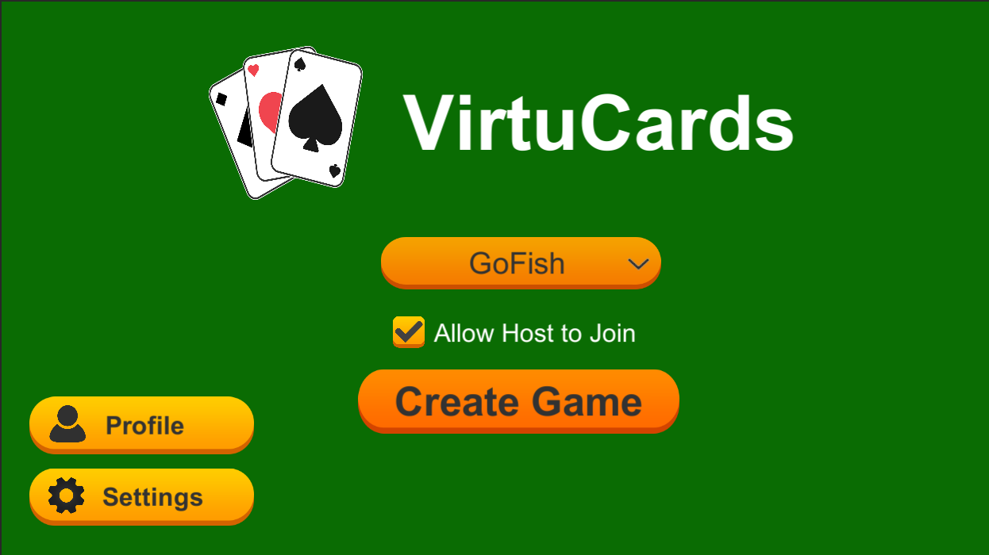

Host waiting screen

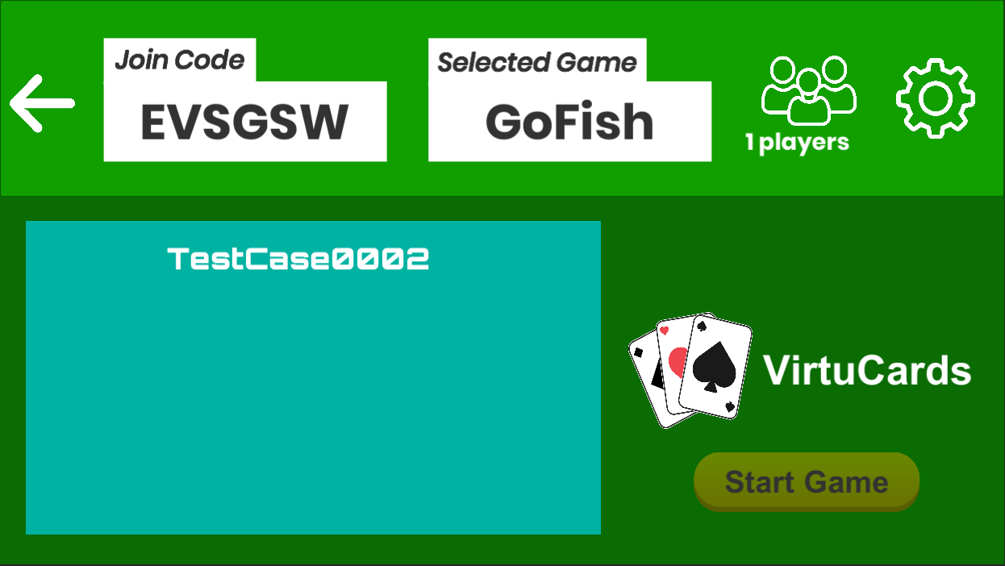

VirtuCard Client:

Client waiting screen

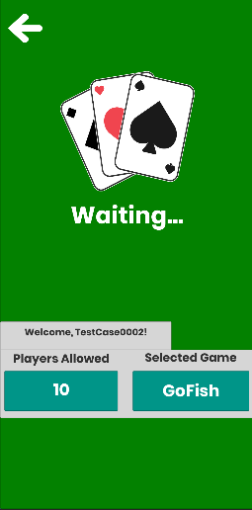

**Test 2**

1. Start VirtuCardClient application
2. Click the button labeled “Sign In”
3. Enter “virtucards01@gmail.com” into the text input labeled “Enter email…”
4. Enter “Testing1” into the text input labeled “Enter password…”
5. Press the button labeled “Login”
6. A window should appear saying “Login Success”
7. Press the OK button that appears on that window
8. Start VirtuCardHost application
9. Repeat steps 2-7 but on the VirtuCardHost application, but use “virtucards02@gmail.com” as the email and use “Testing1” as the password
10. Select the “War” option from the game choices dropdown
11. Press the Create Game button
12. On the VirtuCardClient application enter the 6-character room code found on the host’s screen into the field labeled “Enter Code…”
13. Press the Join Game button on the client
14. On the waiting screen on the VirtuCardClient application and on the VirtuCardHost application, observe the name of the selected game on the screen.

**Expected Result:** Both the host and the client waiting screens should display the selected game of War

VirtuCard Host:

Selecting War from the dropdown

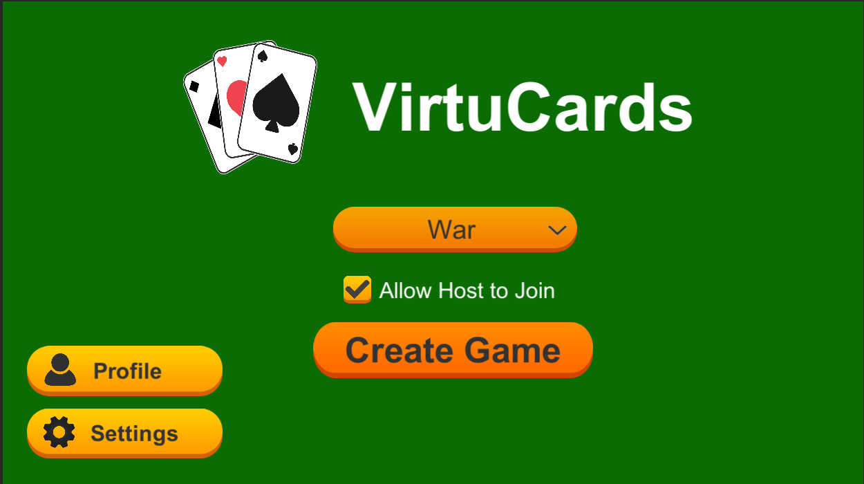

Host waiting screen

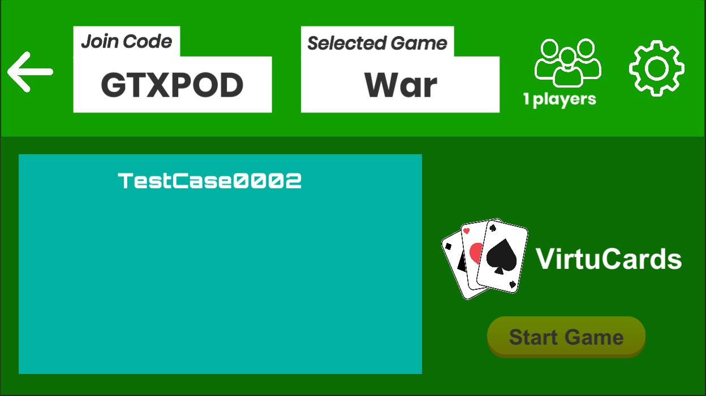

VirtuCard Client:

Client waiting screen

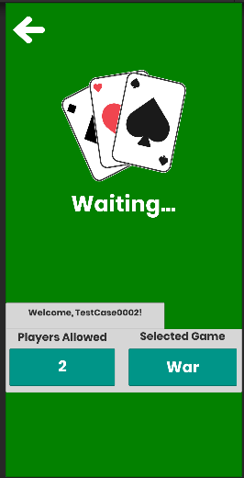

**Test 3**

1. Start VirtuCardClient application
2. Click the button labeled “Sign In”
3. Enter “virtucards01@gmail.com” into the text input labeled “Enter email…”
4. Enter “Testing1” into the text input labeled “Enter password…”
5. Press the button labeled “Login”
6. A window should appear saying “Login Success”
7. Press the OK button that appears on that window
8. Start VirtuCardHost application
9. Repeat steps 2-7 but on the VirtuCardHost application, but use “virtucards02@gmail.com” as the email and use “Testing1” as the password
10. Select the “Freeplay” option from the game choices dropdown
11. Press the Create Game button
12. On the VirtuCardClient application enter the 6-character room code found on the host’s screen into the field labeled “Enter Code…”
13. Press the Join Game button on the client
14. On the waiting screen on the VirtuCardClient application and on the VirtuCardHost application, observe the name of the selected game on the screen.

**Expected Result:** Both the host and the client waiting screens should display the selected game of Freeplay

VirtuCard Host:

Selecting Freeplay from the dropdown

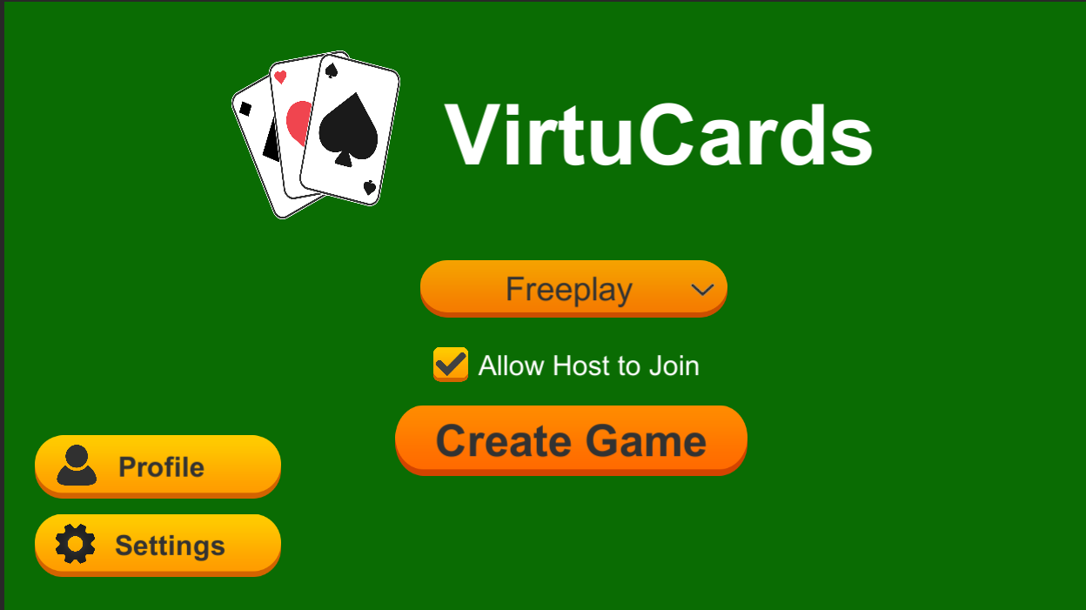

Host waiting screen

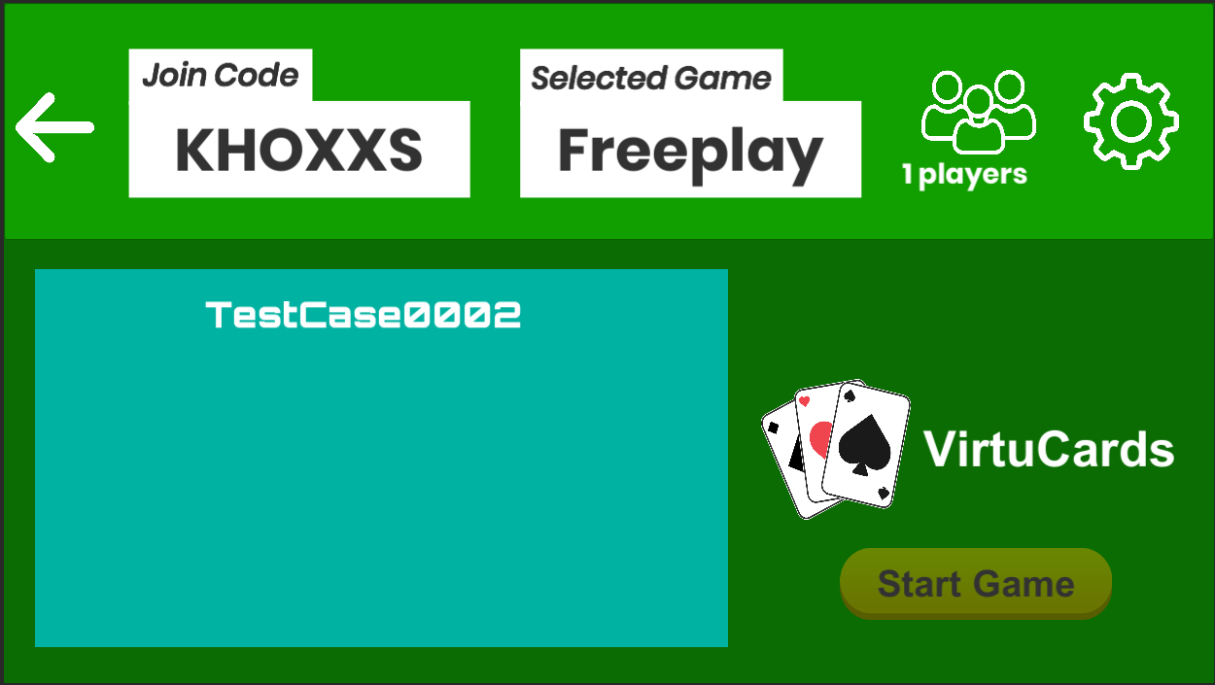

VirtuCard Client:

Client waiting screen

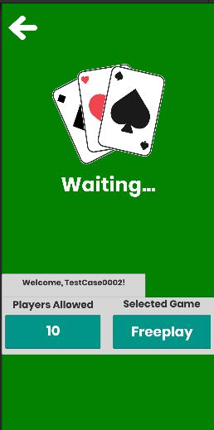

**Test 4**

1. Start VirtuCardClient application
2. Click the button labeled “Sign In”
3. Enter “virtucards01@gmail.com” into the text input labeled “Enter email…”
4. Enter “Testing1” into the text input labeled “Enter password…”
5. Press the button labeled “Login”
6. A window should appear saying “Login Success”
7. Press the OK button that appears on that window
8. Start VirtuCardHost application
9. Repeat steps 2-7 but on the VirtuCardHost application, but use “virtucards02@gmail.com” as the email and use “Testing1” as the password
10. Select the “GoFish” option from the game choices dropdown
11. Press the Create Game button
12. On the waiting screen on the VirtuCardHost application press the back button on the top left of the screen and return to the Landing Page
13. Select the “War” option from the game choices dropdown
14. Press the Create Game button
15. On the VirtuCardClient application enter the 6-character room code found on the host’s screen into the field labeled “Enter Code…”
16. Press the Join Game button on the client
17. On the waiting screen on the VirtuCardClient application and on the VirtuCardHost application, observe the name of the selected game on the screen.

**Expected Result:** Both the host and the client waiting screens should display the selected game of War

VirtuCard Host:

Initial waiting screen displays GoFish

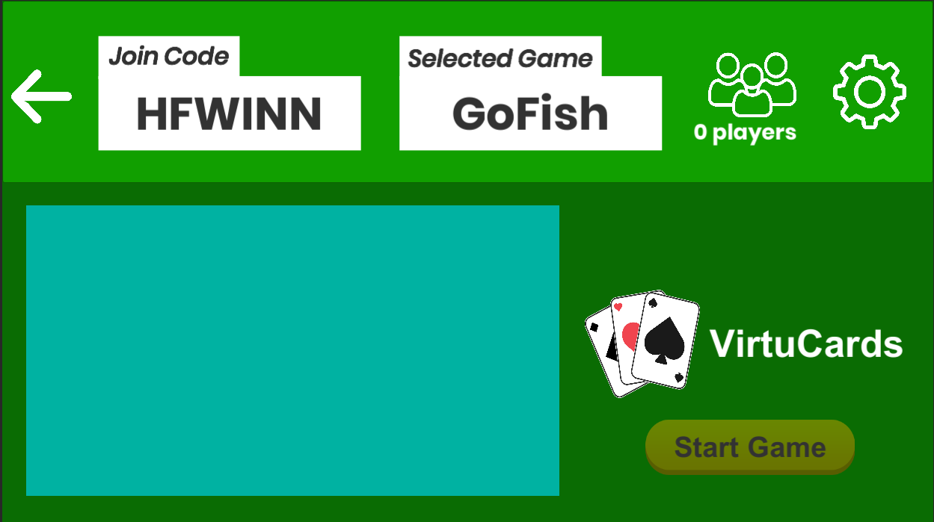

Then selecting War

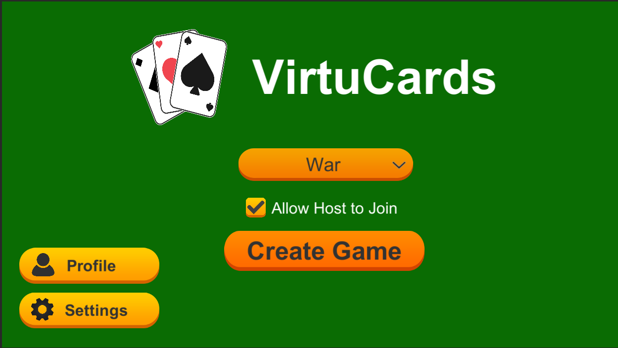

Creating a War Game and then joining the game from the client

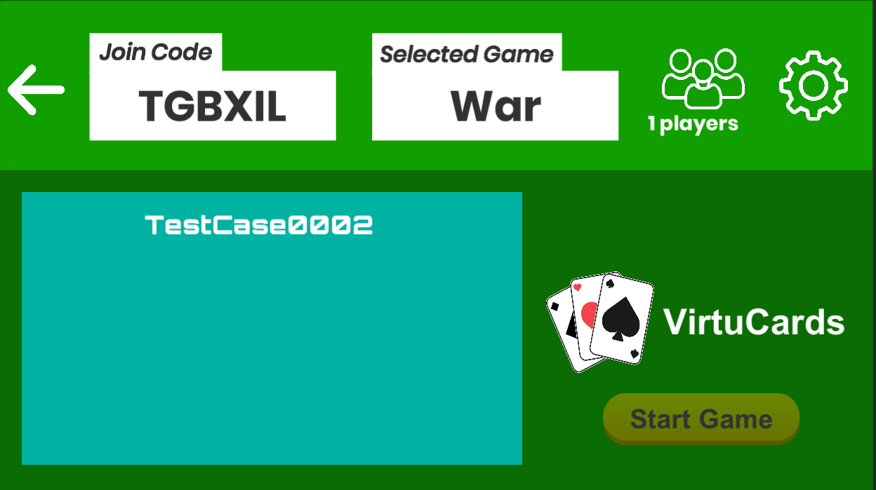

VirtuCard Client:

Client waiting screen

