

FIX Repository

2010 Edition Specification
*** DRAFT – FOR PUBLIC COMMENT ***

June 11, 2010

Document History
Revison | Date | Author | Comments
Draft 1 | March 15, 2010 | Jim Northey, Phil Oliver | Original draft.

DISCLAIMER
THE INFORMATION CONTAINED HEREIN AND THE FINANCIAL INFORMATION EXCHANGE ALGORITHMIC TRADING DEFINITION LANGUAGE (COLLECTIVELY, THE "FIXadtlSM SCHEMA") ARE PROVIDED "AS IS" AND NO PERSON OR ENTITY ASSOCIATED WITH THE FIX PROTOCOL AND/OR THE FIXadtl SCHEMA MAKES ANY REPRESENTATION OR WARRANTY, EXPRESS OR IMPLIED, AS TO THE FIXadtl SCHEMA (OR THE RESULTS TO BE OBTAINED BY THE USE THEREOF) OR ANY OTHER MATTER AND EACH SUCH PERSON AND ENTITY SPECIFICALLY DISCLAIMS ANY WARRANTY IN RELATION TO THE SAME, INCLUDING BUT NOT LIMITED TO ANY WARRANTIES OF ORIGINALITY, FREEDOM FROM INFRINGEMENT, ACCURACY, COMPLETENESS, MERCHANTABILITY, SATISFACTORY QUALITY OR FITNESS FOR A PARTICULAR PURPOSE. SUCH PERSONS AND ENTITIES DO NOT WARRANT THAT THE FIX PROTOCOL AND/OR THE FIXadtl SCHEMA WILL CONFORM TO ANY DESCRIPTION THEREOF OR BE FREE OF ERRORS. THE ENTIRE RISK OF ANY USE OF THE FIX PROTOCOL AND/OR THE FIXadtl SCHEMA IS ASSUMED BY THE USER.
NO PERSON OR ENTITY ASSOCIATED WITH THE FIX PROTOCOL AND/OR FIXadtl SCHEMA SHALL HAVE ANY LIABILITY FOR DAMAGES OF ANY KIND ARISING IN ANY MANNER OUT OF OR IN CONNECTION WITH ANY USER'S USE OF (OR ANY INABILITY TO USE) THE FIXadtl SCHEMA, WHETHER DIRECT, INDIRECT, INCIDENTAL, SPECIAL OR CONSEQUENTIAL (INCLUDING, WITHOUT LIMITATION, LOSS OF DATA, LOSS OF USE, CLAIMS OF THIRD PARTIES OR LOST PROFITS OR REVENUES OR OTHER ECONOMIC LOSS), WHETHER IN TORT (INCLUDING NEGLIGENCE AND STRICT LIABILITY), CONTRACT OR OTHERWISE, WHETHER OR NOT ANY SUCH PERSON OR ENTITY HAS BEEN ADVISED OF, OR OTHERWISE MIGHT HAVE ANTICIPATED THE POSSIBILITY OF, SUCH DAMAGES.
All intellectual property rights vesting in the FIXadtl SCHEMA are strictly reserved to FIX Protocol Limited ("FPL"), its affiliates or its licensors. FIXatdl is a service mark of FPL. You do not acquire any ownership rights in the FIXatdl SCHEMA through your use of it. FPL grants you a non-exclusive right and licence to use the FIXadtl SCHEMA (but excluding the FIXatdl SCHEMA service mark) solely for reasonable internal use within your organisation and/or for the purpose of conducting your organisation's business. You are not permitted to modify or create derivative works of the FIXadtl SCHEMA for any other purpose.
© Copyright 2010 FIX Protocol Limited, all rights reserved
Contents
Introduction to 2010 Edition 5
Purpose 5
What is the repository? 5
What is the basic repository? 5
What is the unified repository? 5
Repository Versioning (Editions) 5
What is an edition? 5
What constitutes a new edition? 5
Extension Pack Releases 5
Service Pack Releases 6
Basic Repository 6
Files within each version FIX.4.0 – FIX.50SPx with files in each directory 6
Abbreviations 7
Categories 7
Components 8
Datatypes 8
Enums 9
Fields 10
Messages 10
MsgContents 11
Sections 11
Manifest 12
Intermediate Repository 12
Unified Repository 12
Tools 13
2009 to 2010 converter 13
2010 to 2009 converter 13
FIXML Schema 13
XML Spy diagrams of Schema for Basic Structure 14
XML Spy diagrams of Unified Repository Schema 31

Introduction to 2010 Edition

Purpose
This document is for users of the published repository files.

What is the repository?
The repository consists of files which are intended to represent parts of the formal FIX specification in a precise machine-readable manner. Currently these are XML files but may also include database files (e.g. Microsoft Access format) in the future.

What is the basic repository?
The basic repository consists of a set of XML files – one set per version of FIX – and one file per entity type, such as Fields.

What is the unified repository?
The unified repository is a single XML file which contains all of the information represented in the union of all of the basic repository files, except for human readable textual descriptive data which reside in separate files. This is intended to facilitate machine processing across all FIX versions, and for internationalization efforts, so that descriptions can eventually be provided for multiple languages without altering the machine readable file.

Repository Versioning (Editions)

What is an edition?
It is a particular format of the FIX repository itself. It is not identical to the specification - it can be considered a machine-readable subset representing a portion of the spec.

What constitutes a new edition?
Editions do not change when new EPs and SPs are issued. A new edition is signified by an updated release date which identifies it (currently, a particular year) and may contain data format changes, including corrections and enhancements.

Extension Pack Releases
An extension pack consists of a set of files which precisely define a change to the repository. These are identified by an ascending globally unique numeric identifier. At a minimum, there is a single file named with the pattern EPnnn.XML, where nnn is the EP identifier. This is typically created and edited with the EP.sps file, which is an Altova Authentic template file, along with the extensionpack.xsd schema file. The EPnnn.XML file is then processed with the EPXSLTCreator.xsl, which in turn creates per-entity XSLT scripts which apply the specified changes (if any exist) to each entity type. Certain attributes are automatically applied to each specifically affected entity by these scripts.
Attribute | Purpose
added | Signify the current FIX version for when-added tracking
addedEP | Signifies the current EP for when-added tracking
deprecated | Signify the current FIX version for when-deprecated tracking
deprecatedEP | Signifies the current EP for when-deprecated tracking
updated | Signify the current FIX version for when-updated tracking
updatedEP | Signifies the current EP for when-updated tracking

Service Pack Releases
Major bundling and packaging of extension packs that includes a specification document update. The service pack is an official released version of the FIX Specification.

Basic Repository

Files within each version FIX.4.0 – FIX.50SPx with files in each directory
This is a high level overview of the basic repository structure. Detailed XML Schemas for each entity are included towards the end of this document.
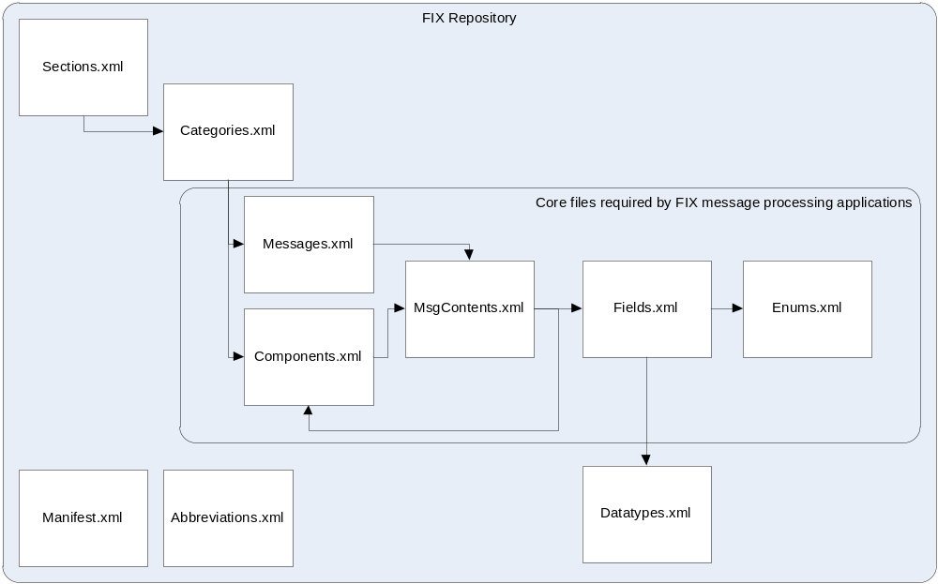
The Basic Repository is contained within nine XML files:
XML file | Purpose
Abbreviations.xml | Standard abbreviations for various FIX related terms.
Categories.xml | The category associated with a particular component or message.
Components.xml | Permitted component types.
Datatypes.xml | The datatypes associated with a particular field.
Enums.xml | The permitted enumerated values for enumerated fields.
Fields.xml | The definition of all defined fields (tags) which comprise the body of components or messages.
Messages.xml | Permitted message types. This is a higher level list of messages; the message bodies are specified by MsgContents.xml.
MsgContents.xml | Specifies the content of Messages and Components.
Sections.xml | The documentation section associated with a particular category.

Abbreviations
Standard abbreviations for various FIX related terms. At a high level this file has the following structure:
<Abbreviations>
<Abbreviation>
[…]
</Abbreviation >
</Abbreviations >
Each Abbreviation element has the following elements in the given order:
Element name | Required? | Datatype | Purpose
Term | Yes | Term_t | Full-length, unabbreviated term
AbbrTerm | Yes | Abbreviation_t | Abbreviated version of 'Term'
Usage | No | Usage_t | Description of usage of Term

Categories
The category associated with a particular component or message. At a high level this file has the following structure:
<Categories>
<Category>
[…]
</Category>
…
</Categories >
Each Category element has the following elements in the given order:
Element name | Required? | Datatype | Purpose
CategoryID | Yes | CategoryID_t | A string uniquely identifying this category
FIXMLFileName | Yes | Name_t | The FIXML file name for a Category
NotReqXML | Yes | BOOL_t | A boolean to indicate if the Category of messages and components is not required in FIXML
GenerateImplFile | Yes | BOOL_t | A boolean used to indicate if an implementation schema file is to be produced for FIXML
ComponentType | Yes | 'Field' | 'Message' | A string specifying the component type associated with this category
SectionID | Yes | SectionID_t | A string specifying the section associated with this category
Volume | Yes | Volume_t | A string specifying the document volume where this category is described
IncludeFile | Yes | 'components' | 'fields' | A string that specifies if the Fields file or components file is to be included within this categories schema file
Description | Yes | Description_t | A string description this category

Components
Permitted component types. At a high level this file has the following structure:
<Components>
<Component>
[…]
</Component >
…
</Components >
Each Component element has the following elements in the given order:
Element name | Required? | Datatype | Purpose
ComponentID | Yes | CompID_t | The unique integer identifier of this component type
ComponentType | Yes | ComponentType_t | A string specifying the type of the component
CategoryID | Yes | CategoryID_t | A string specifying the category of the component
Name | Yes | ComponentName_t | The human readable name of the component
AbbrName | Yes | Name_t | The name for this component when used in an XML context
NotReqXML | Yes | BOOL_t | Whether this component must be used in an XML context
Synopsis | No | Synopsis_t
Description | No | Description_t | Description_t

Datatypes
The datatypes associated with a particular field. At a high level this file has the following structure:
<Datatypes>
<Datatype>
[…]
</Datatype >
…
</Datatypes >
Each Datatype element has the following elements in the given order:
Element name | Required? | Datatype | Purpose
Name | Yes | xs:string | PK: Identifier of the datatype
BaseType | Yes | xs:string | Base type from which this type is derived
Description | Yes | xs:string | Human readable description of this Datatype
Example | Yes | xs:string | A string that contains examples values for a datatype
XML | No |  | FIXML datatype definition for the datatype
XML/BuiltIn | Yes | BOOL_t
XML/Base | Yes | xs:string
XML/MinInclusive | No | xs:unsignedShort
XML/Pattern | No | xs:string

Enums
The permitted enumerated values for enumerated fields. At a high level this file has the following structure:
<Enums>
<Enum>
[…]
</Enum >
…
</Enums>
Each Enum element has the following elements in the given order:
Element name | Required? | Datatype | Purpose
Tag | Yes | Tag_t | Identifies the field containing this enumeration
Value | Yes | Enumeration_t | The actual data value
SymbolicName | Yes | SymbolicName_t | A unique (within the same tag) identifier for this enumeration, suitable for use as a human-readable identifier in computer programs
Group | Yes | Group_t | A string designatiing a group identifier for this enumeration
Sort | Yes | xs:int | An integer indicating the sort position of this enumeration within the set of all enumerations for a given tag
Synopsis | No | Synopsis_t | Short description of this value
Description | No | Description_t | Extended description of this value

Fields
The definition of all defined fields (tags) which comprise the body of components or messages. At a high level this file has the following structure:
<Fields>
<Field>
[…]
</Field >
…
</Fields >
Each Field element has the following elements in the given order:
Element name | Required? | Datatype | Purpose
Tag | Yes | Tag_t | A positive integer representing the unique identifier for this field type
Name | Yes | SymbolicName_t | A human readable string representing the name of the field
Type | Yes | Datatype_t | The datatype of the field
AssociatedDataTag | No | xs:int | The associated data field. If given, this field represents the length of the referenced data field
AbbrName | No | SymbolicName_t | Abbreviated form of the Name, typically to specify the element name when the field is used in an XML message. Can be overridden by BaseCategory / BaseCategoryAbbrName
BaseCategory | No | CategoryID_t | Specifies the base message category when field is used in an XML message
BaseCategoryAbbrName | No | Name_t | If BaseCategory is specified, this is the XML element identifier to use for this field, overriding AbbrName
NotReqXML | Yes | BOOL_t | Indicates whether the field is required in an XML message
EnumDatatype | No | Tag_t | When specified, the value is the tag of the field to use to supply enumeration values for this fiel
UnionDataType | No | UnionDataType_t
Synopsis | No | Synopsis_t
Description | No | Description_t

Messages
Permitted message types. This is a higher level list of messages; the message bodies are specified by MsgContents.xml. At a high level this file has the following structure:
<Messages>
<Message>
[…]
</Message>
…
</Messages>
Each Message element has the following elements in the given order:
Element name | Required? | Datatype | Purpose
ComponentID | Yes | MsgID_t | The unique integer identifier of this message type
MsgType | Yes | MsgType_t | The unique character identiifer of this message type; used literally in FIX messages
Name | Yes | Name_t | The name of this message type
CategoryID | Yes | CategoryID_t | Identifier of the category to which this message belongs
SectionID | Yes | SectionID_t | Identifier of the section to which this message belongs
AbbrName | No | Name_t | The abbreviated name of this message, when used in an XML context
NotReqXML | Yes | BOOL_t | A boolean used to indicate if the message is to be generated as part of FIXML
Synopsis | No | Synopsis_t
Description | No | Description_t

MsgContents
Specifies the content of Messages and Components. At a high level this file has the following structure:
<MsgContents>
<MsgContent>
[…]
</MsgContent>
…
</MsgContents>
Each MsgContent element has the following elements in the given order:
Element name | Required? | Datatype | Purpose
ComponentID | Yes | MsgOrCompID_t | The unique integer identifier of the message
TagText | Yes | TagText_t | A string identifying either a tag number or a ComponentID
Indent | Yes | xs:nonNegativeInteger | The indentation value for display, used by Fiximate 2.0
Position | Yes | xs:decimal | A decimal number representing the position of this tag or component within the message
Reqd | Yes | BOOL_t | A boolean value indicating whether the tag or component is required in the message
Description | No | Description_t | A description of this entity as used within its component or message

Sections
The documentation section associated with a particular category. At a high level this file has the following structure:
<Sections>
<Section>
[…]
</Section>
…
</Sections>
Each Section element has the following elements in the given order:
Element name | Required? | Datatype | Purpose
SectionID | Yes | SectionID_t | A string uniquely identifying this section
Name | Yes | Name_t | The human readable name of this section
DisplayOrder | Yes | xs:int | An integer specifying the sort order of this section when displayed within a list of all sections
Volume | Yes | Volume_t | A string specifying the document volume describing this section
NotReqXML | Yes | BOOL_t | A boolean used to indicate if the section of messages is to be included as part of FIXML
FIXMLFileName | No | Name_t | The name of the FIXML file name for the section
Description | Yes | Description_t | Human readable description of this section

Manifest
The manifest file is used for automated processing of EPs within a version. It also serves a documentation purpose for each EP.

Intermediate Repository
The Intermediate Repository (IR) is a single file within each version which combines all entity types in a simple manner. It has a root element <reposAll>, followed by the contents of each other entity file. This is for those who are not prepared to use the Unified Repository but want to access the basic repository as a single XML document (per version).

Unified Repository
The Unified Repository (UR) was designed to be a compact representation of the data found in the Basic Repository across all versions. A single file, FixRepository.xml, contains all non-descriptive information in the union of all Basic Repository files. Descriptive (human readable text) information is referenced by a unique symbolic identifier, called a textID, when needed.
The advantage of using the textID approach is two-fold. First, it reduces the total file size for a full-version set of repository data when the goal is to support machine processing which does not require human readable text. Second, it permits straightforward internationalization of human readable text. A set of files contain the text, per language/per version. For example: FIX.4.0_en_phrases.xml contains all of the mappings of textID names to English language readable text. Currently only English is available but other languages are expected to eventually be supported based on user demand.
Fiximate 3.0 is built using an FPL internal tool which takes the UR and associated phrase files, and is designed to support runtime selection of multiple languages as they become available.

Tools

2009 to 2010 converter
This is a set of nine XSLT scripts which transform separate Basic repository files in 2009 edition format to the 2010 format. They are located in the tools/Repository folder of the 2009 distribution. The scripts are named with the pattern Translate_ENTITY_2009_to_2010.xsl, where ENTITY corresponds to the particular entity type (and filename) to be converted, one from the following set of names: Abbreviations, Categories, Components, Datatypes, Enums, Fields, MsgContents, MsgType, and Sections.
Each script has an external script dependency, Translate_support.xsl.
The transformation is accomplished simply by feeding a 2009 edition format file as the input to the corresponding script, which then emits 2010 formatted output. With additional programming, this process can easily be automated, for example with Ant and the free Saxon processor.

2010 to 2009 converter
This is a set of nine XSLT scripts which transform separate Basic repository files in 2010 edition format to the 2009 format. They are located in the tools/Repository folder of the 2010 distribution. The scripts are named with the pattern Translate_ENTITY_2010_to_2009.xsl, where ENTITY corresponds to the particular entity type (and filename) to be converted, one from the following set of names: Abbreviations, Categories, Components, Datatypes, Enums, Fields, Messages, MsgContents, and Sections.
Each script has an external script dependency, Translate_support.xsl.
The transformation can be done in two ways. The easiest is to use the supplied build.xml, then building with Ant with a target of '2010to2009' will cause existing Base repository files for each version to be converted into the Build directory, under a generated 2009-from-2010 directory.
Alternatively, the scripts can be used on a per-entity basis. This is accomplished simply by feeding a 2010 edition format file as the input to the corresponding script, which then emits 2009 formatted output. With additional programming, this process can easily be automated, for example with Ant and the free Saxon processor.

FIXML Schema

XML Spy diagrams of Schema for Basic Structure

Abbreviations.xml

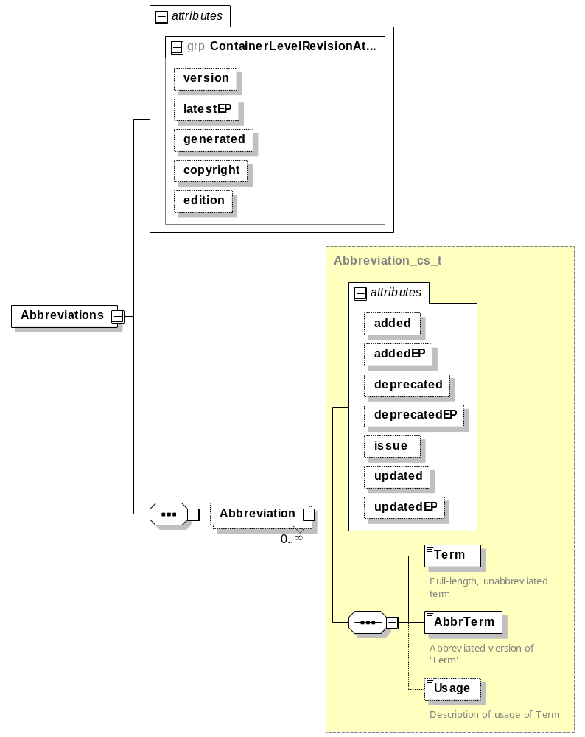

Categories.xml

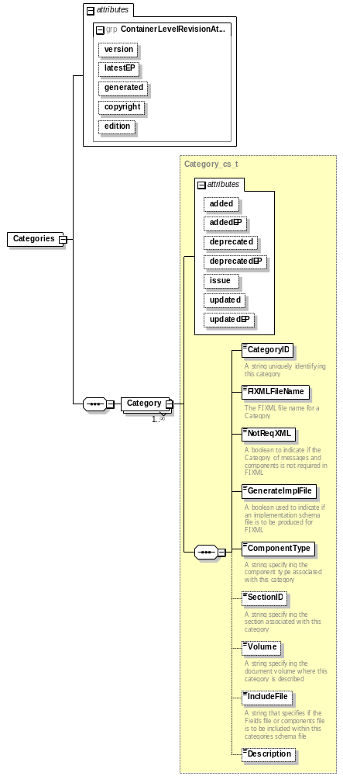

Components.xml

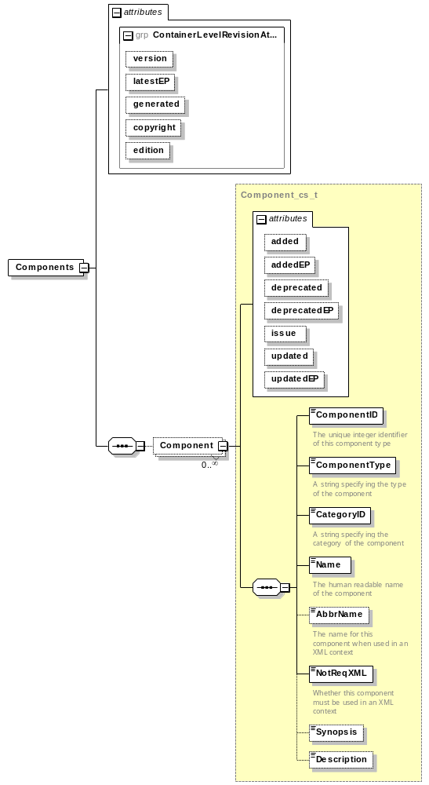

Datatypes.xml

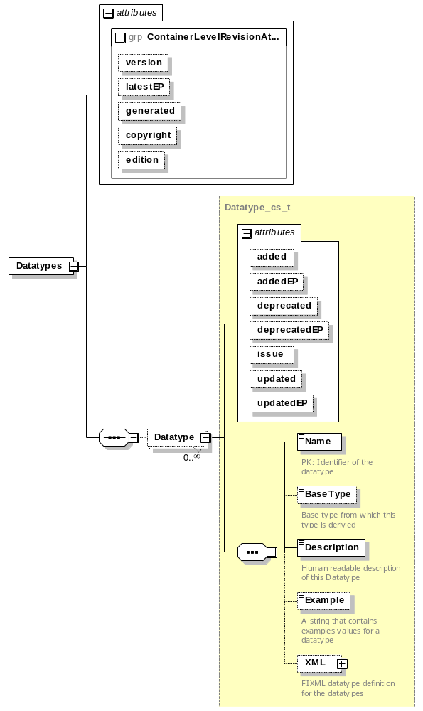

Enums.xml

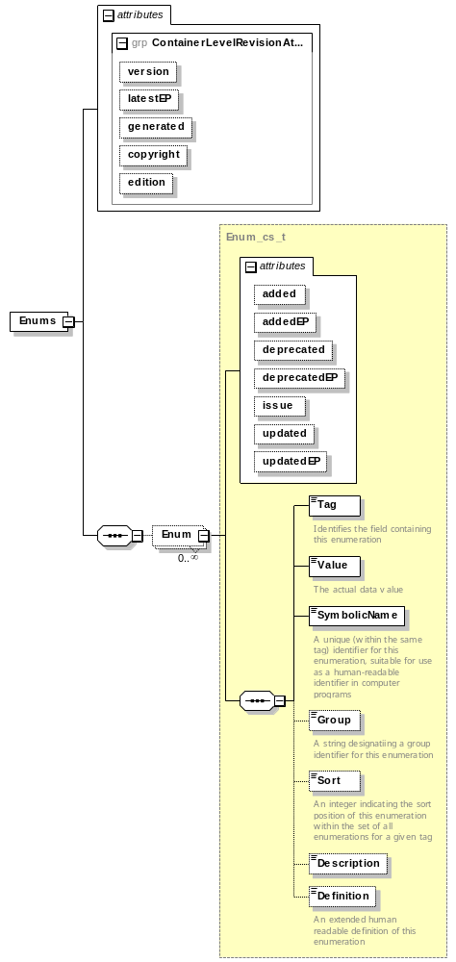

Fields.xml

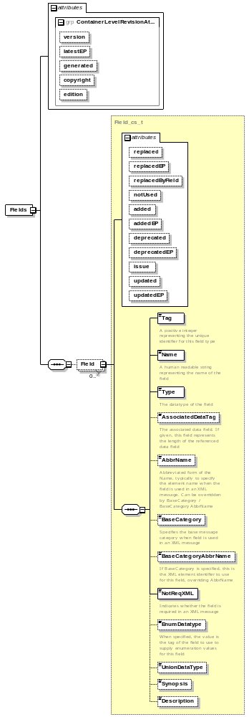

Messages.xml

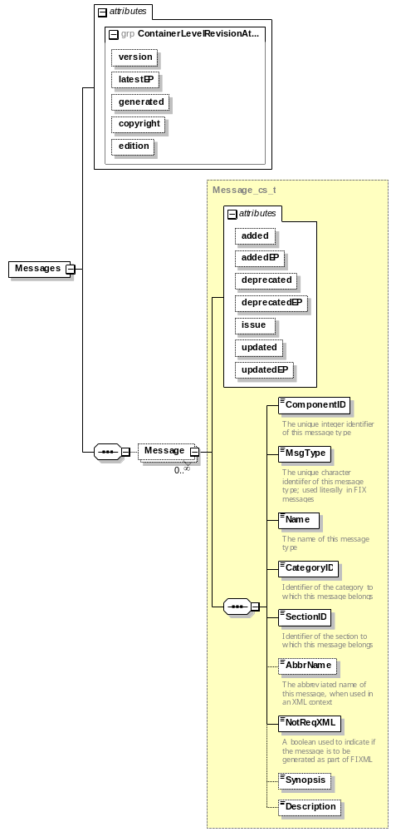

MsgContents.xml

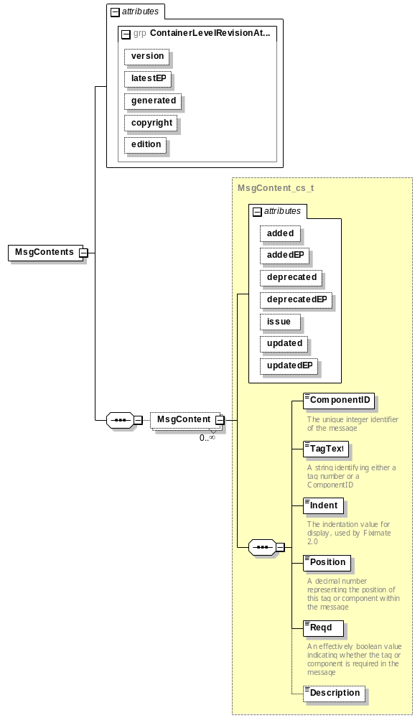

Sections.xml

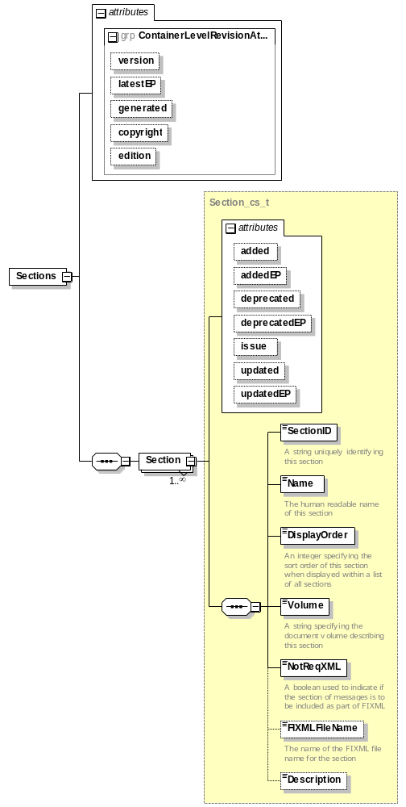

XML Spy diagrams of Unified Repository Schema

Unified Repository High Level Overview

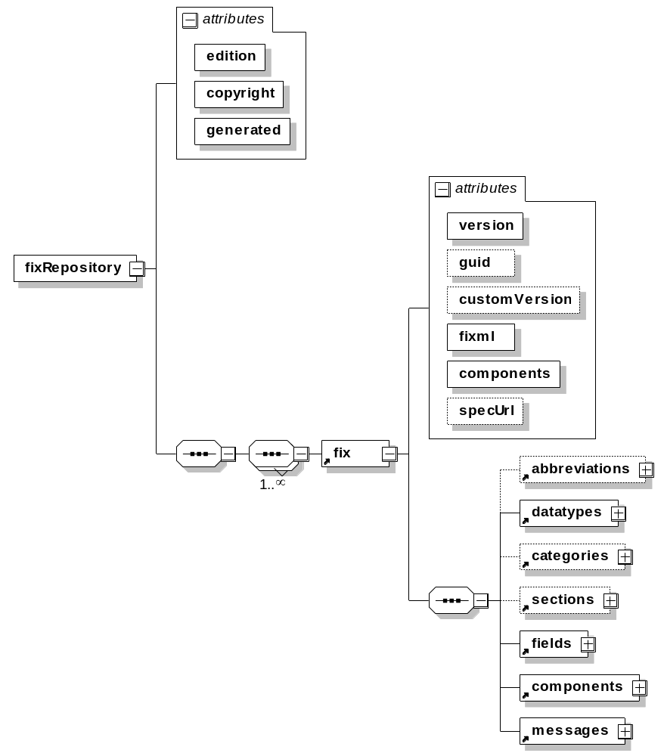

Unified Repository, abbreviations element

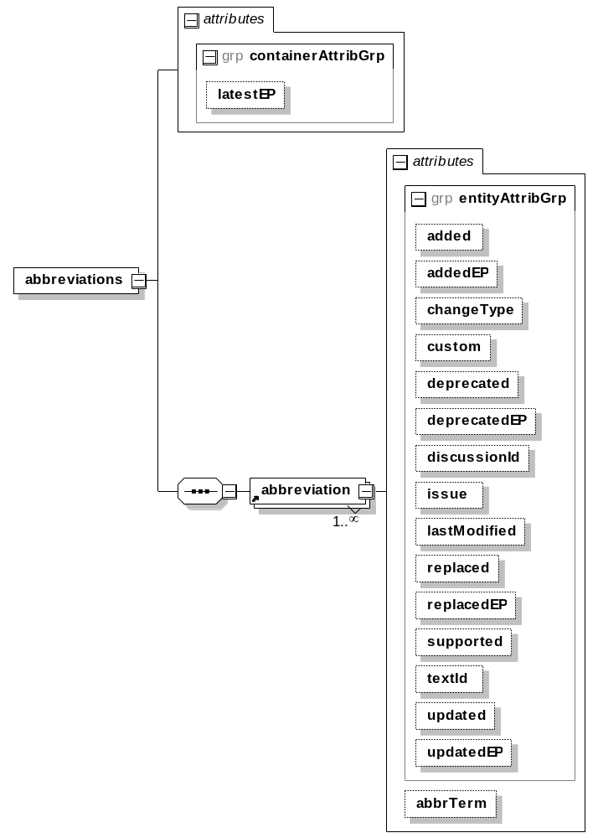

Unified Repository, datatypes element

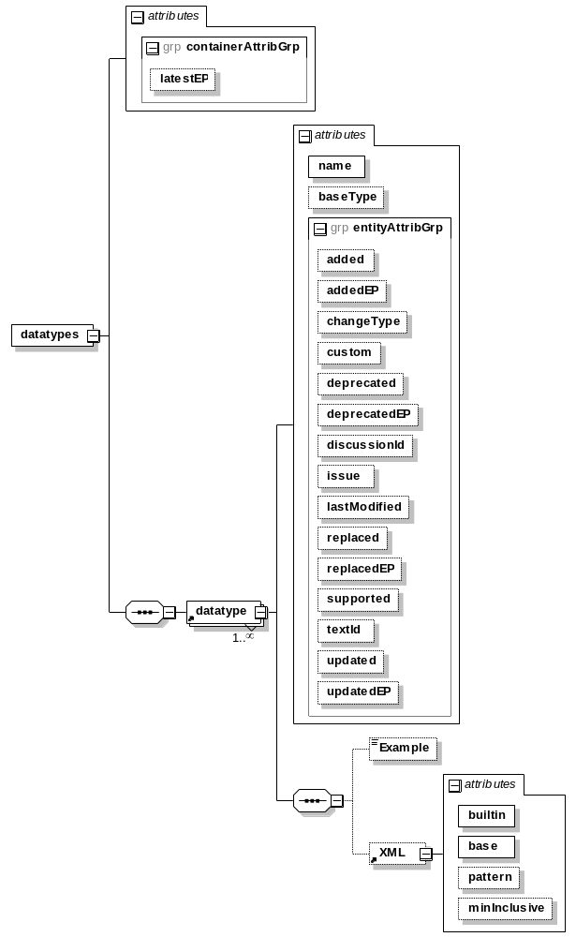

Unified Repository, categories element

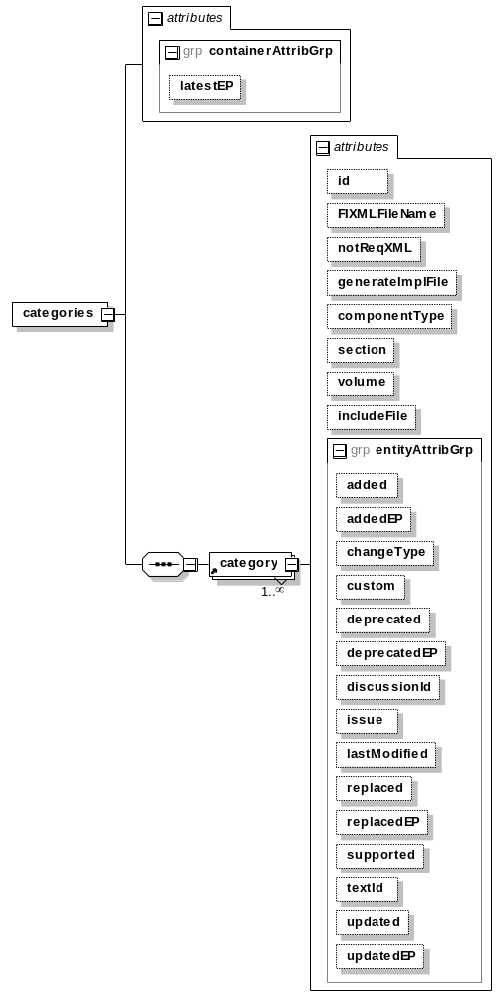

Unified Repository, sections element

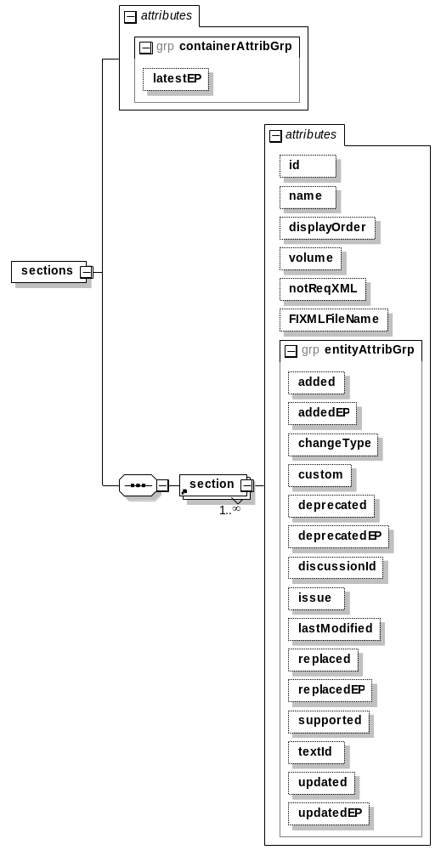

Unified Repository, fields element

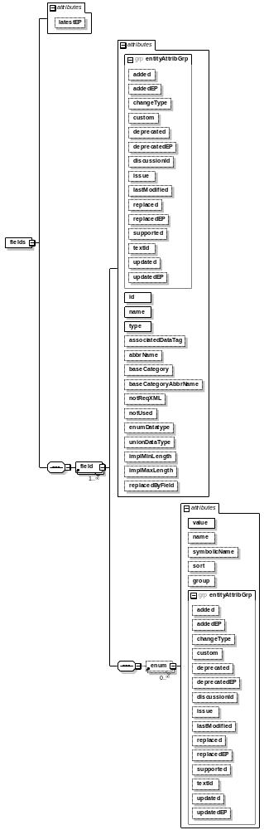

Unified Repository, components element

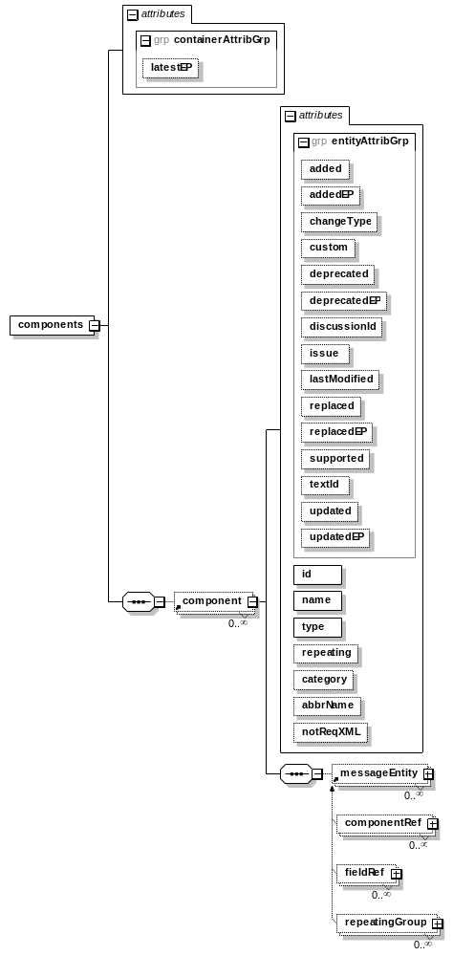

Unified Repository, messages element

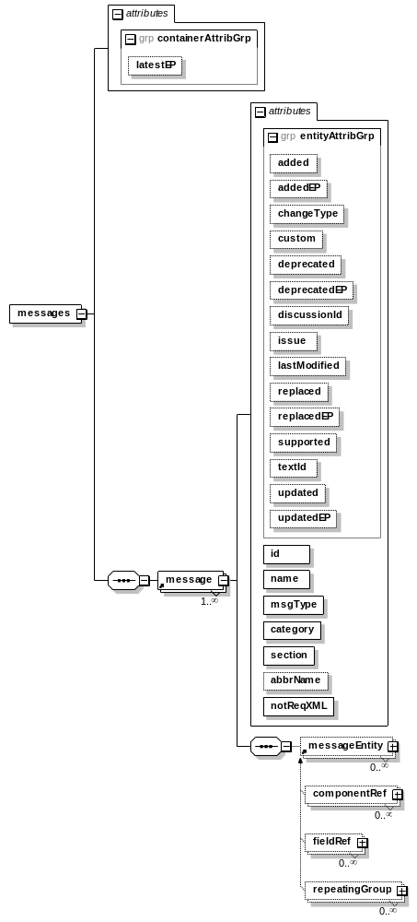

Unified Repository, componentRef element

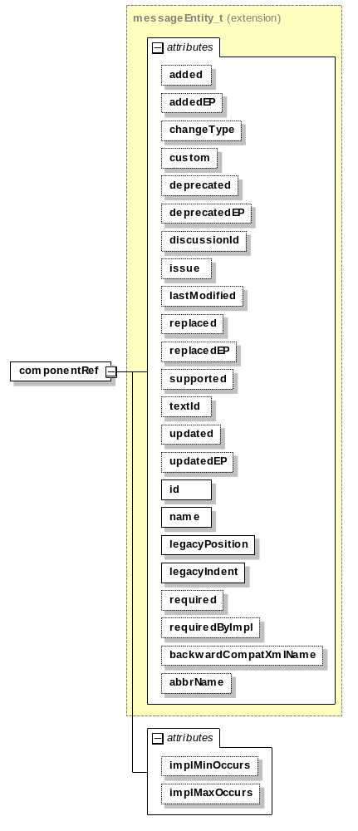

Unified Repository, fieldRef element

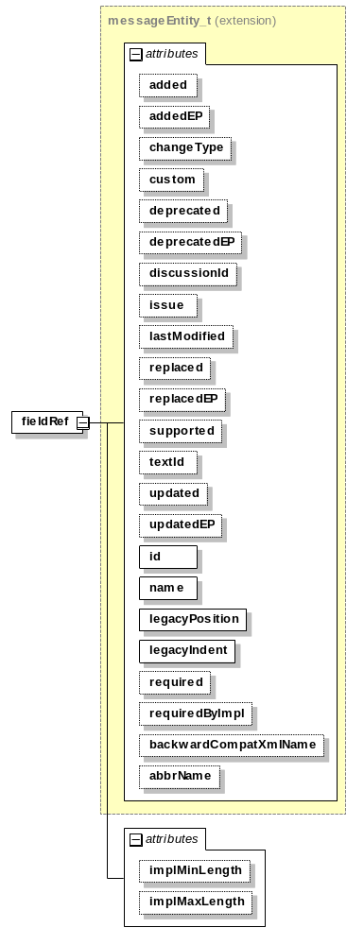

Unified Repository, repeatingGroup element

