CyberSentinel UEBA — Confidential Project Record
Oct 13, 2026 · @Lord
Confidential — internal only. Contains infrastructure detail, credentials handling, known weaknesses and unmitigated risks. Do not circulate outside Virtual Galaxy Infotech.

Executive summary
CyberSentinel UEBA is a behavioural analytics engine that sits on top of CyberSentinel SIEM: it reads already-enriched security events, learns what normal looks like for each user, host and IP, and raises an alert when behaviour deviates from that baseline. It is home-grown, written in Python, and has been in continuous production since early 2026.
It is not a log collector, a correlation engine or a SIEM. It consumes what the SIEM has already normalised and enriched. If a field is not in the incoming event, UEBA cannot see it — a constraint that shapes several of the compliance answers later in this document.
Scale it has run at. Roughly 2 million events per day from 26–38 endpoints, sustaining 41–50 events/second with a measured peak ingest of 208/second. It modelled 543 distinct entities. Alert rate held between 0.04% and 0.09% — about 1,300 alerts a day surviving from 2 million events, after two layers of suppression.
Where it stands today. The production host, box98, was permanently decommissioned in October 2026. The code is safe on GitHub and the critical runtime state — 453 trained models and 204 analyst-taught false-positive patterns — survived as a local copy. A replacement Utho server is pending, and a rebuild runbook is written and ready.
What this document is for. It records how the system came to be shaped the way it is, including the compromises. A reader who only sees the architecture will not understand why several parts look the way they do; the sections on jugaad and on production incidents exist so that whoever maintains this next does not have to rediscover those lessons the expensive way.

Origins
The first commit landed on 30 March 2026. The project exists because a SIEM answers a different question from the one a SOC actually needs answered.
CyberSentinel SIEM detects by rule: a signature matches, a threshold trips, an IoC appears in a feed. That catches what is already known to be bad. It cannot catch an action that is individually unremarkable — a successful login, a file read, an outbound connection — but abnormal for the person doing it. A finance clerk authenticating at 03:00 from a new country breaks no rule. Every event in that sequence is permitted.
UEBA was built to answer the second question: not "is this bad?" but "is this normal for you?"

Why two machines
The split between the SOC box (222) and the engine box (98) was forced by resources, not design preference:
- Training per-entity neural models needs a GPU; the SOC machine had none.
- A 21-day rolling corpus runs to 190 GB; the SOC machine had nowhere to put it.
- The SOC machine was already saturated running the SIEM and its Kafka enrichment.
So the engine runs where the GPU and the disk are, pulls enriched events across an SSH reverse tunnel, and sends only alerts back. One consequence worth stating plainly: UEBA never sees a raw log. It consumes the SIEM's enriched output, so its detection ceiling is set by what the enrichment pipeline chooses to include.

Why these models
The design settled on a hybrid early, and it has survived every revision since:
- A global Isolation Forest answers "is this weird for anyone?" — it works precisely because it pools every entity's data.
- A per-entity autoencoder answers "is this weird for you?" — one small model per user, host or IP.
Neither is sufficient alone. A purely global model cannot see that an ordinary action is unusual for one person; a purely personal model has nothing to say about entities it has never observed. They are fused 50/50, with the threshold at 0.75.

Open question for the record
This section reconstructs intent from the commit history and the code's own comments. The original business driver — whether UEBA began as a competitive requirement, a client commitment, or an internal initiative — is not recorded anywhere in the repository, and should be filled in by whoever was in the room.

Timeline
Seven months, 72 commits in the original repository, four distinct eras: build (Mar–May), make it survive its own data volume (Jun–Jul), make it fast and trustworthy (Aug), make it sellable (Sep). Newest first.
Date | Milestone | Why it mattered
2026-10-13 | box98 decommissioned; rebuild prep | Found 3 silent failures in the install path before they bit
2026-09-30 | Architecture + onboarding guide | First time the system was documented end to end
2026-09-30 | Drilldown payload fix | One endpoint was returning 673 MB / 1.14M rows
2026-09-29 | Pushed to the organisation GitHub | Code left one laptop for the first time — 2 weeks before box98 died
2026-09-29 | Role-based access + local password accounts | UEBA can now run without the SIEM in front of it
2026-09-29 | Watchdog forensics fixed | 57 stall snapshots had captured zero stacks
2026-09-23 | Reporting engine, notifications, search suggest | Closed 11 RFP points in one push
2026-09-21 | Audit trail, XML export, watch lists | Analyst actions became accountable
2026-09-08 | Production sync: SSO, batching, bridge rewrite | Repo caught up with what was actually running
2026-08-29 | Bridge rewrite | ssh was eating the loop's stdin: 20 min → 39 s per chunk
2026-08-27 | Event batching | Throughput 70 → 208 events/sec
2026-08-11 | Retrain corpus poisoning fixed | Re-enrichment was corrupting the training data
2026-07-20 | Autoencoder threshold calibration | Fixed a retrain that flooded the console with alerts
2026-07-13 | Staged retrain + validation gate | A bad model could no longer reach production
2026-07-13 | Race-free alert writes, offset persisted on shutdown | Stopped losing and duplicating alerts across restarts
2026-06-30 | Instant-load dashboard rearchitecture | Load times had become unusable
2026-06-25 | "Calm" re-architecture + 30-day corpus prune | First serious attempt to stop the disk filling
2026-06-22 | FAISS moved to CPU | Freed the shared GPU; dashboard UI had frozen under volume
2026-06-02 | 500k alert cap, lazy-loaded evidence | Payload discipline introduced — the lesson re-learned in September
2026-05-30 | Engine-level FP feedback loop | Analyst corrections began changing detection
2026-05-21 | Weekly retrain wrapper | Models started learning the customer's own users
2026-05-16 | FP auto-suppression patterns | One button suppresses similar alerts — now 204 patterns
2026-05-15 | Vite build, live SSE, analyst workflow | The dashboard became a product rather than a debug view
2026-04-03 | Dashboard moved to port 3026 | Still its port today
2026-03-30 | Initial commit
The shape of it. Roughly half the engineering effort went not into detection but into surviving the data: payload caps, corpus pruning, batching, cache warming, race fixes. The models were working by May. Everything after that was making them usable at 2 million events a day on a shared machine.

Tech stack
Python 3.12 end to end on the backend, vanilla JavaScript on the front. Seventeen Python dependencies, two JavaScript ones. That asymmetry is deliberate and is the single clearest design value in the project: dependencies are a liability on a box you share with other teams and ship to customers.
Layer | Choice | Why this one
Language | Python 3.12 | ML ecosystem; 3.12 for hashlib.scrypt and modern typing
Outlier model | scikit-learn Isolation Forest | Unsupervised, no labels needed, cheap to score in batch
Behavioural model | PyTorch autoencoder | Per-entity baselines; tiny nets (~2k params), GPU only for training
Campaign grouping | HDBSCAN | Finds clusters without being told how many; tolerates noise
Similarity / RAG | FAISS (CPU build) | Retrieves similar past anomalies as alert evidence
Feature store | HDF5 via h5py | Training features; 51 GB at current volume
Numerics | NumPy, pandas
API | Flask + flask-cors | Small, synchronous, no framework ceremony
Auth | PyJWT + cryptography | HS256 SSO tokens; stdlib scrypt for local passwords
JSON | orjson | Measurably faster on the hot parse path
GeoIP | geoip2 (MaxMind GeoLite2) | Powers geo features and the threat map
Identity + sessions | SQLite | Separate DB from behavioural profiles — different blast radius
Alerts | JSONL + zipped archives | Append-only; the weakest link, see Technical debt
Frontend | Vanilla JS modules + Vite | No React. Zero runtime framework
Globe | globe.gl (Three.js) | The one real frontend dependency
Reporting | reportlab, openpyxl, python-docx, python-pptx | PDF / Excel / Word / PowerPoint renderers
Transport | bash + SSH + gzip | No broker; see Jugaad
Process mgmt | systemd + cron | Units for engine, dashboard, bridge, watchdog

Choices worth defending
No React. The dashboard is ten panels of tables and charts over a polling API. A framework would have added a build dependency and a runtime for layout work that innerHTML does adequately. The cost is real — panels re-render by rebuilding HTML strings, which is why role gating had to be done with CSS classes rather than a DOM pass — but it has stayed maintainable.
CPU for inference, GPU only for training. Detection is CPU-only by design. The per-entity autoencoders are ~2,000 parameters; GPU inference would cost more in transfer than it saves in compute. On the reference host an L40S with 46 GB sat at 14 MiB used. A customer does not need a GPU to run UEBA — only to retrain it.
SQLite, not Postgres. Right for one engine and one dashboard on one box. It is also the thing that makes high availability impossible (RFP 32), and it is the first item on the restructure list.
JSONL for alerts. Dead simple, greppable, append-only, and survives a crash mid-write. It also has no index, so every query is a file scan — which is exactly how a single endpoint drilldown came to return 673 MB.

How it works
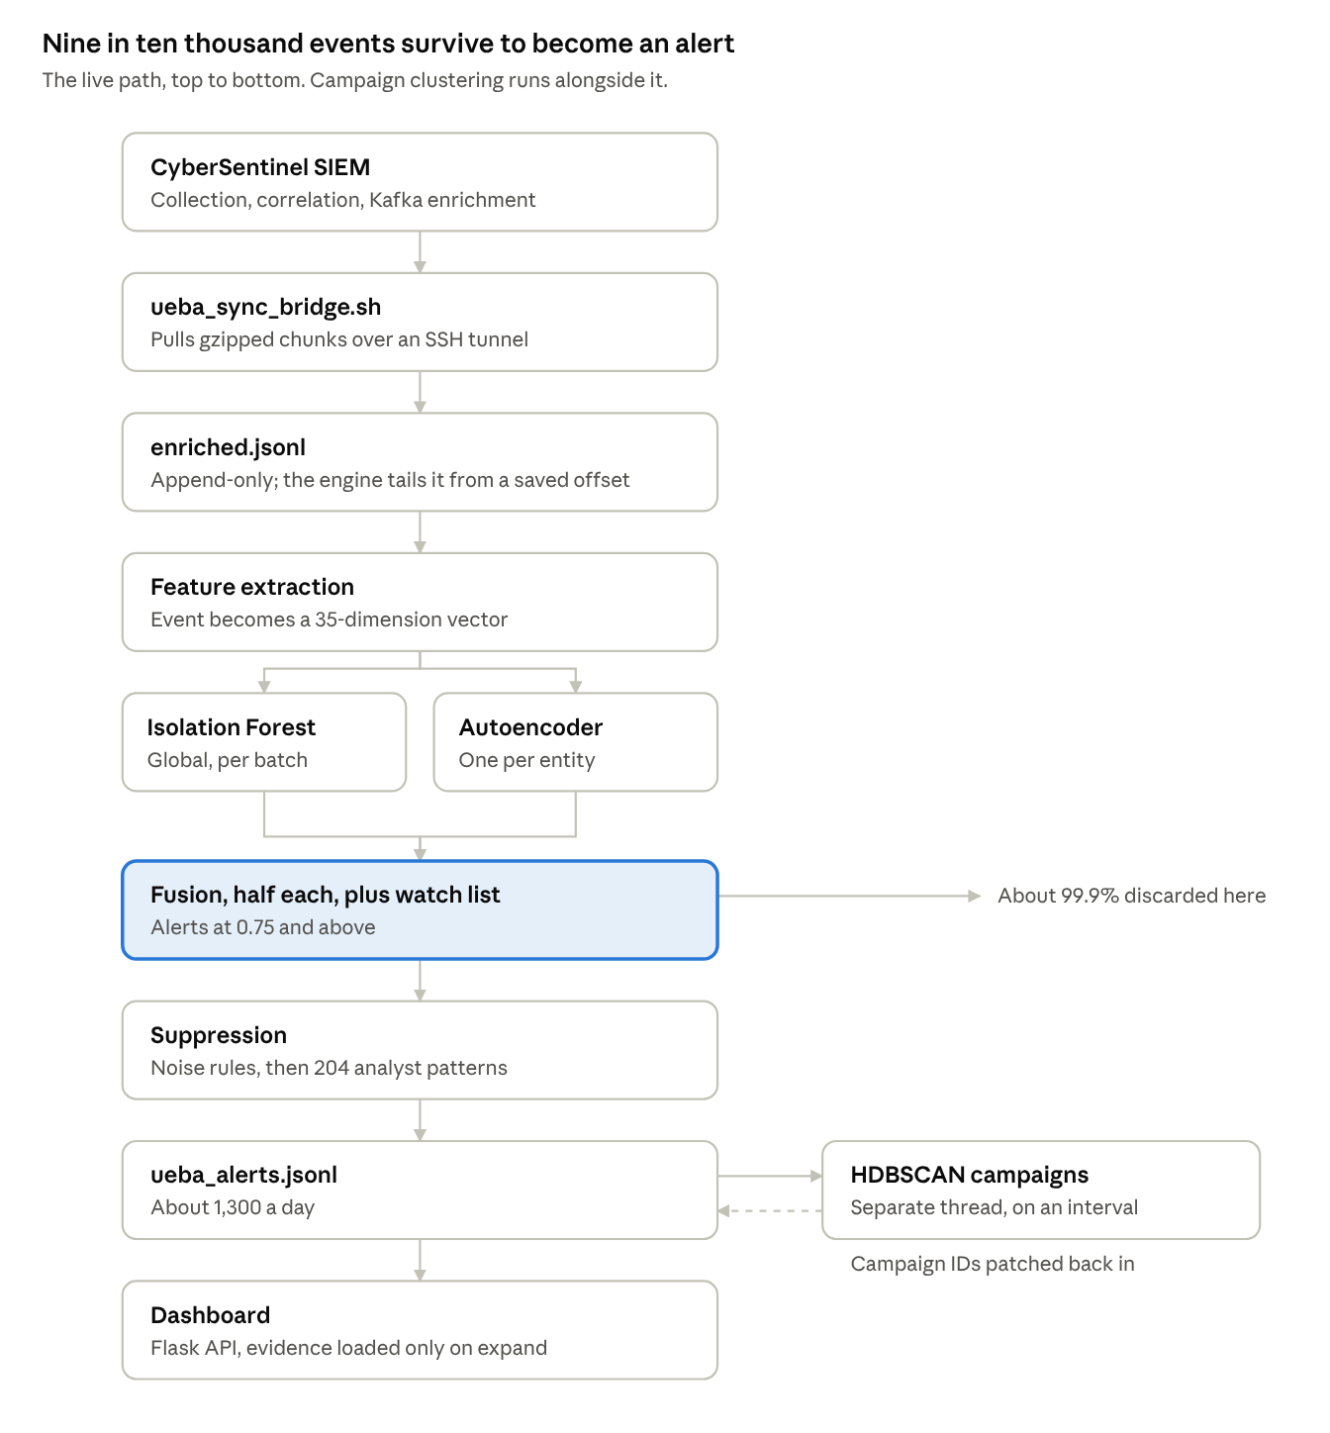
live detection path · 9 stages, 2 models, 2 suppression gates
The decisive step is fusion: an event scoring below 0.75 is discarded and never written anywhere, which is about 99.9% of everything that arrives. Only what survives is enriched with similar past anomalies, buffered for clustering, and passed through the two suppression gates.
Campaign clustering runs on its own thread, not in the scoring path. That is why a fresh alert can show no campaign and gain one minutes later — HDBSCAN runs on an interval over the anomaly buffer and then patches campaign IDs back into the alert file. The main loop has to reopen its file handle afterwards, because the atomic swap replaced the inode underneath it.
Evidence is never shipped with alert rows. The in-memory caches hold slim records with fourteen top-level sections dropped, and the dashboard lazy-loads an alert's full evidence only when an analyst expands that row. This is the discipline that keeps payloads survivable; forgetting it on two endpoints is what produced a 673 MB response.

The models
Four components, none of them large. The sophistication is in how they are combined and suppressed, not in model size — the per-entity networks are about 2,000 parameters each.
Component | Type | Scope | Question it answers
Isolation Forest | sklearn, unsupervised | one global model | Is this weird for anyone?
Autoencoder | PyTorch, 35→24→12→24→35 | one per entity (543 at peak) | Is this weird for you?
HDBSCAN | density clustering | over the anomaly buffer | Are these the same incident?
FP suppressor | analyst-taught patterns | 204 patterns | Have we been told this is noise?

The 35 features
Everything the models see. Nothing outside this vector influences a score.
Group | Count | Features
Temporal | 5 | hour, day of week, is_weekend, is_business_hours, is_night_shift
Event type | 4 | is_auth, is_network, is_file, is_process
Anomaly flags | 9 | brute force, port scan, Tor, malicious IP, impossible travel, lateral movement, data exfiltration, after hours, high frequency
Counters | 4 | src_ip_5m, src_ip_1h, user_1h, host_1h
Behavioural | 3 | unique destinations 1h, unique ports 1h, recent failures 5m
Geo | 3 | distance_km, cross_border, cross_continent
Other | 7 | risk_score, rule level, is_cloud, event category, outcome, traffic direction, user baseline deviation
Worth noticing: nine of the 35 are flags the SIEM already computed. UEBA is not re-deriving "this is a brute force"; it is learning whether this entity normally produces events carrying that flag.

Why the hybrid, and why it stays
A proposal to give every user their own Isolation Forest comes up regularly. It should be refused. The forest works because it pools data across the estate; per-entity forests trained on sparse users produce confident nonsense. There is already a floor — min_events_per_user: 2000 — below which an entity falls back to the global autoencoder rather than getting a badly-fit personal one. More models is not better detection; it is more ways to overfit.

Fusion
combined = 0.5 × IsolationForest + 0.5 × Autoencoder (+ watch-list boost)
Score | Verdict | Confidence
below 0.75 | discarded silently — ~99.9% of all events
0.75 – 0.85 | suspicious | low
0.85 – 0.93 | anomalous | medium
0.93 and above | highly anomalous | high
The watch-list boost is applied before the threshold, deliberately: flagging an entity should lower the bar at which its behaviour becomes visible, not merely relabel alerts that would have fired anyway. The pre-boost model_score is stored alongside, so an analyst reviewing a watched user can always tell whether the models or the watch list produced the alert.

Threshold calibration — a hard-won detail
Autoencoder thresholds are calibrated on a held-out split with a floor, added on 20 July 2026. Before that, a retrain could set thresholds so tight that the console flooded with alerts the morning after. The floor exists because a quiet entity would otherwise get a threshold near zero and alert on everything it did.

The jugaad
Every one of these is load-bearing in production. They are listed because the next person needs to know which parts are deliberate engineering and which are improvised fixes still holding — and because several are the reason the restructure exists.
# | What we did | Why | What it costs
1 | Transport is a file copied over SSH, not a Kafka consumer | The SIEM's Kafka was there; nobody plugged into it | Position state, single reader, half-dead tunnels, disk coupling
2 | ~20% of events suppressed by handwritten rules | Models alone produce more noise than a SOC can read | 414k/day suppressed before the models are even trusted
3 | /dev/shm decompression during retrain | Disk I/O on the shared box was too slow | 82 GB RAM spike; becomes 861 GB at 400 endpoints — a hard wall
4 | fallocate(COLLAPSE_RANGE) in-place corpus prune | No room to copy a 190 GB file to trim it | Block-aligned, unforgiving, no undo
5 | FAISS pinned to CPU | To free the GPU other teams were sharing | Slower retrieval; a resource workaround wearing a design hat
6 | Alert file rewritten in full after each clustering run | Campaign IDs arrive after the alert is written | Main loop must reopen its fd — the inode changed under it
7 | Paths hardcoded to /root/NEW_DRIVE/aditya_ueba | A second disk mounted after the first filled | The name itself is an artifact; 23 places; 2 still broken until October
8 | html { zoom: 0.8 } on the whole UI | Design was done at 80% browser zoom | Splits visual vs layout pixels; caused every hover bug
9 | Identity resolution is a static alias map in YAML | No directory integration | Hand-maintained; silently wrong for anyone not listed
10 | Entity names used as filenames | Simple model lookup | Leaks usernames; needs escaping; why models/ is gitignored
11 | min_events_per_user: 2000 floor + global fallback | Sparse entities produced garbage baselines | ~90 of 543 entities have no personal model
12 | Payload caps rather than pagination | Browser was receiving hundreds of MB | Analysts silently see a truncated list
13 | ai_analyst built, then disabled for customers | Cloud LLM dependency unacceptable on-prem | Dead code behind a flag
14 | Watchdog restarting an engine that recovers on its own | Nobody had checked whether stalls were terminal | ~112 needless restarts, each discarding a warm model cache

The four that matter most
The transport (1). This is the single biggest piece of accidental architecture. The SIEM already runs Kafka; UEBA copies gzipped files over an SSH tunnel and tracks its own read offset in a state file. Every ingestion outage we have had traces to this: the tunnel going half-dead with sockets in CLOSE-WAIT, the bridge's backpressure floor halting on low disk, the offset file disagreeing with reality after a crash. Consuming the Kafka topic directly would delete the bridge, the offset file, and that entire class of failure.
The suppression layers (2). Worth stating plainly because it is easy to misread the alert rate as evidence of good models. Of ~2M daily events, roughly 414,000 are dropped by hand-written noise rules and a further few thousand by analyst-taught patterns, before the 0.09% alert rate is computed. The models are doing real work, but the signal-to-noise figure quoted to clients rests substantially on human curation. Those 204 FP patterns are among the most valuable assets in the system — and the hardest to replace, which is why their survival through the box98 decommission mattered so much.
The zoom (8). A cosmetic decision with a long tail. Because getBoundingClientRect() returns zoomed pixels while offsetWidth and style.left do not, every overlay in the dashboard had to learn the difference. It took three deploys to fix the hover misplacement, and it is also why globe.gl's own hit-testing had to be corrected at the pointer rather than by resizing anything.
The in-place prune (4). Elegant and genuinely clever — FALLOC_FL_COLLAPSE_RANGE removes bytes from the front of a 190 GB file without copying it. It is also the kind of trick that works until someone changes the filesystem, because it requires 4096-byte block alignment and has no dry-run.

Production incidents
Not one of these was a detection failure. Every significant outage was plumbing — transport, disk, payload size or process supervision. That is the clearest signal in the project's history about where the engineering risk actually lives.
Date | Incident | Root cause | Fix
Sep 2026 | 19-hour ingestion outage | Disk filled → bridge backpressure floor halted; SSH reverse tunnel half-dead (ESTABLISHED, all sockets CLOSE-WAIT) blocking rebind | Prune + tunnel rebind; pre-flight space gate
Aug 29 | Bridge 3 days behind and staying there | ssh inside a while read loop inherited the loop's stdin and swallowed the rest — exactly one chunk per cycle regardless of backlog | Loop rewritten: 20 min → 39 s per chunk
Aug 27 | Throughput ceiling at 70 ev/s | Isolation Forest scored one row at a time; ~96% of budget in sklearn's fixed per-call cost | Batch scoring → 208 ev/s
Aug 11 | Training corpus poisoned | Retrain re-ran L1/L2 enrichment over already-enriched events | Bypass re-enrichment; entity junk guard
Jul 20 | Console flooded after a retrain | AE thresholds not calibrated on a held-out split | Held-out calibration + a floor
Jul 13 | Alerts lost and duplicated across restarts | Race on alert writes; read offset not persisted on shutdown | Write lock; offset persisted
Sep 8 | Dashboard "0 tiles", 60-second loads | Four independent causes | Now ~0.7 s
Sep 30 | Endpoint drilldown "failed to load" | No time window and no row cap — 673 MB / 1.14M rows | Capped + windowed
Ongoing | Engine stalls ~2×/day | Unresolved — see below | Mitigated, not fixed

The engine stall — still open
The longest-running unresolved issue, and instructive about method.
The engine pauses for several minutes, then resumes on its own. Confirmed 29 September: frozen 10:45–10:52 with the heartbeat 422 s stale, still running from its 00:05 start hours later, no restart. Signature at the moment of a stall: main thread R (on CPU), all 119 other threads idle, swap 0, 8 open file descriptors, RSS flat. So it is spinning on CPU — not deadlocked, not blocked on I/O, not leaking.
Three hypotheses were disproved by measurement, and should not be re-chased:
- Memory leak — RSS is flat at ~19.7 GB. The apparent growth was a reading taken mid-startup.
- Throughput degradation — the rate field in the Stats line is a lifetime average. A falling number does not mean slowing down.
- _patch_campaign_ids holding the alert write lock — plausible on inspection, since it parses the whole alert file under the lock. Measured: 13 MB, 1,357 lines, 0.1 s. Ruled out.
The diagnostic itself was broken for two months. The watchdog captured 57 stall snapshots containing zero stack traces. Cause: set -euo pipefail combined with for ... done | head -40 over 120 threads — head closes the pipe, the loop takes SIGPIPE, pipefail surfaces 141, and set -e aborts the script before the SIGUSR1 dump, before the log line, and before the restart. So the watchdog had also silently stopped restarting anything after 24 September.
Fixed on 29 September and verified end to end. A confirmation window was added so the watchdog no longer kills an engine that was about to recover. Root cause awaits the next stall.

What the incidents taught
- Silent failures outnumber loud ones. The watchdog capturing nothing, rotation pointed at a dead path, the stale-cache deletion — none announced themselves.
- Measure before fixing. Three stall hypotheses were wrong; each would have produced a confident, useless change.
- Payload size is a recurring class, not an incident. It was fixed in June, re-learned in September. Any endpoint returning per-entity rows needs a window and a cap.

Current state
UEBA is not running. box98 was permanently decommissioned in October 2026. A replacement Utho server is pending; a rebuild runbook is written and the install path has been dry-reviewed.

Performance envelope, as measured on box98
These are the figures to quote, and the baseline the rebuild should be checked against.
Metric | Measured
Events ingested | ~2.0 M/day (1,992,638 over a full day)
Sustained throughput | 41–50 events/sec
Peak ingest | 208 events/sec
Alert rate | 0.04% – 0.09% (~1,300/day)
Suppressed as noise | ~414,000/day
Entities modelled | 543
Endpoints | 26 active / 38 registered
Engine memory | 19.7 GB RSS, 120 threads, flat
Dashboard memory | 4.0 GB
Dashboard load | ~0.7 s
Weekly retrain | 941.7 min total (trainer 852 min)
Reference host | 60 cores, 201 GB RAM, NVIDIA L40S 46 GB, Ubuntu 24.04

What survived the decommission
Asset | Status
All source code | Safe — GitHub, pushed 29 Sep, two weeks before the box died
204 analyst FP patterns | Safe — local copy
false_positives.json (1.7 MB) | Safe
453 autoencoders + IF + scaler + thresholds | Safe, but dated 16 Aug
profiles/user_profiles.db (37 MB) | Safe
Alert history (35 MB), agents.json | Safe
190 GB training corpus | Lost — re-accumulate or seed from SIEM
features.h5 (51 GB), FAISS index (4.3 GB) | Lost — regenerate at first retrain
Alert archive, auth DB | Lost — accepted
Packaged as a 13 MB restore bundle, gitignored because the autoencoder filenames are real usernames.

Two caveats on the restored state
The models are eight weeks stale and cover 453 entities where box98 had 543 after its 27 September retrain. Detection will work from day one rather than being blind, but roughly 90 entities will fall back to the global model until the first retrain. That retrain cannot happen until a corpus accumulates — 21 days from scratch, or days if historical enriched logs can be pulled from the SIEM side.
The restore bundle currently exists on one laptop. Until it reaches the new server, that is the single point of failure for everything the analysts taught this system.

RFP compliance position
Fifteen points were closed between 21 and 29 September 2026, most of them in two concentrated pushes. The live tracker is docs/RFP_COMPLIANCE.md in the repository.

Shipped
# | Requirement | Implementation
1 | Watch lists | ueba_watchlist.py, read by the engine — a watched entity is scored more sensitively within one event
10 / 15 | Device registry, proactive alerting | ueba_notify.py — rules by score, verdict, priority, tactic; email + webhook; mandatory throttling
23 | Role-based dashboards | CAPABILITIES table gates 23 routes; UI hides what the role lacks
28 | Auto-complete / auto-suggest | /api/suggest, vocabulary built per timeline window
34 / 39 | Export Excel / PDF / XML | ueba_report_render.py
35 / 36 / 37 | Out-of-box reports (analyst / admin / audit) | Section-catalogue design
38 / 40 | Custom + scheduled reports | Analyst-chosen section lists; cron-driven delivery
62 | Threat report PDF for a period | Falls out of the reporting engine
65 | Audit log of analyst actions | after_request hook → ueba_audit.jsonl, self-rotating
The design decision that made the reporting cluster tractable: one renderer-agnostic report document, and a report defined as an ordered list of section keys over a shared catalogue. Custom reports then cost nothing extra — they are an analyst-chosen list of the same keys — and every report improves when a section improves.

Buildable, not started
# | Requirement | Gap | Estimate
7 | Device / subnet admin | 3 flat roles, no scoping | 1–2 weeks — extends the RBAC just built
70 | Any field as entity | Entity resolution hardcoded to user/host/IP | 2–3 weeks
48 | Rules scoped to a user set until a condition or time | No temporal rule engine | 2–3 weeks
27 | Natural-language search | Substring match only | Medium — constrained by point 67
29 | Netflow ingestion | No netflow support | 3–4 weeks
60 | App-layer protocol decode | Not implemented | Partial — bounded by what the SIEM sends

Blocked, and why
# | Requirement | Position
21 | Supervised ML | No labelled incident data exists. Depends on analysts labelling — months, and not an engineering problem
44 | Peer-group deviation | Needs cohort definition from AD/HR data we do not have
32 | HA / no single point of failure | SQLite + single Flask process. Needs Postgres + leader election — 2–3 months
46 | Misuse by sequence of actions | Sequence models are a new detection class — months
47 | Data leakage via HTTP parameter manipulation | Wrong product. Belongs to DLP/WAF
69 | Profile all AD users from day 1 | AD import is easy; "day 1 profiling" is physically impossible — baselines need 3–7 days of history. Needs bid language, not code

Standing constraint
Point 67: ai_analyst must remain disabled on customer installations. Any work on natural-language search (27) must therefore avoid a cloud LLM dependency or ship as something the customer explicitly enables.

Known limitations and technical debt
What would not survive a design review, ordered by how much it should worry us.

Severe
No automated tests. No CI. Zero test files in the repository, no .github/, no pipeline. Every change is validated by deploying it and watching the Stats line. This has mostly worked because the feedback loop is fast — a bad change is visible within a minute at 2M events/day — but it means there is no safety net for refactoring, no regression protection, and nothing stopping a change that breaks a path nobody exercises that week. This is the single largest piece of debt in the project.
Single points of failure throughout. One engine process, one Flask process, SQLite for identity. Any of the three dying takes the system down. This is RFP 32 and it is honestly scoped at 2–3 months.
No observability beyond log grep. No metrics endpoint, no Prometheus, no structured monitoring. System health is assessed by reading a Stats line — whose headline rate field is a lifetime average that has already misled us once. Problems are found by noticing, not by alerting.

Significant
RBAC is built and inert. auth.enforce has never been turned on. Roles, gates, capability tables and a login screen all exist and are tested, but in production every visitor had full access. Turning it on requires a local admin to exist first — the guard rails for that are in place, but the switch has not been thrown.
UEBA_SSO_SECRET was never set in the box98 environment, and has been flagged for rotation for weeks. SSO was live but not enforcing, which made the omission invisible.
Feature extraction runs twice — once at ingest for scoring, again during retrain from raw corpus. The vectors are computed and discarded. This is the waste the per-entity feature store removes.
No model registry or rollback. There is a validation gate that refuses to promote a regression, which is good, but no versioned history. If a bad model reaches production the recovery is a retrain, not a revert.
No feature schema versioning. If the SIEM changes its event shape, feature extraction degrades silently — no error, just worse detection. Nothing detects this.

Worth knowing
- ~90 entities have no personal model in the restored set (453 vs 543) and fall back to the global one.
- Identity resolution is a hand-maintained alias map. Anyone not listed is silently treated as a separate entity, splitting their baseline.
- Model filenames are real usernames, which is why models/ can never be committed and why a state bundle needs the same care as a credential.
- Dead config key paths.training_data points nowhere.
- Analysts see truncated lists silently. Payload caps protect the browser but nothing tells the user the list was cut.
- Three older Git repositories still contain the 453 username-named model files, including one on a personal account. A deliberate decision was taken to leave them.

The road ahead
The decommission is an opportunity. Rebuilding from scratch is the cheapest moment this project will ever get to make structural changes — retrofitting a running system is expensive; building it right costs almost nothing extra. But the rebuild's first job is to work, so heavyweight operational changes stay gated.
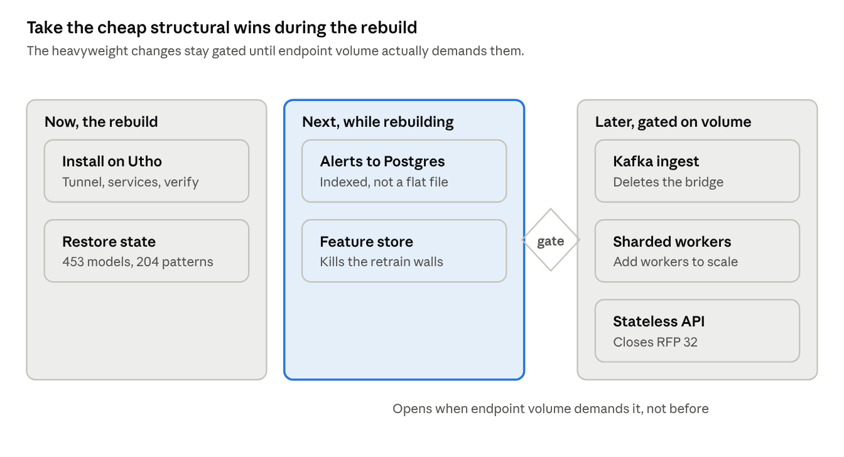
restructure roadmap · 3 phases, 1 volume gate

Why the feature store is the one to take
The engine already computes a 35-dimension vector for every event, scores it, and throws it away. Come Sunday the retrain decompresses 190 GB of raw corpus and recomputes those same vectors. Persisting them at scoring time, partitioned by entity, changes the arithmetic completely:
 | Today | With a feature store
Retrain input | 190 GB | ~8 GB
/dev/shm peak | 82 GB | none
Retrain one entity | part of a 15.7-hour job | seconds
Feature extraction | twice | once
At 400 endpoints | 2 TB · 861 GB shm · 6.2 days | 88 GB · none · hours
It is a write-path addition to the engine — nearly free during a rebuild, expensive to retrofit — and it is what makes drift-triggered incremental retraining possible instead of an architectural project.

Scaling to 400 endpoints
Straight-line extrapolation from the current deployment, which is 10.5× today's endpoint count:
 | Now (38) | At 400
Events/day | 2.0 M | 21 M (243/sec average)
Peak ingest | 208/sec | ~2,200/sec
Training corpus | 190 GB | 2.0 TB
Retrain /dev/shm | 82 GB | 861 GB — impossible
Trainer runtime | 852 min | 6.2 days — breaks the weekly window
Three walls, and none of them yields to a bigger box: the retrain no longer fits in a week, /dev/shm cannot hold the snapshot, and one Python process cannot do 2,200/sec because of the GIL. The fixes are drift-triggered retraining, the feature store, and entity-sharded workers respectively.
Caveat: that is linear extrapolation from one deployment. Event mix matters more than endpoint count — most of this volume is firewall traffic, not endpoint telemetry. Size from events/day once the target SIEM can give that number.

What I would not do yet
Kafka, multi-worker sharding and a stateless API tier are all correct at 400 endpoints and all wrong at 38. Each adds operational weight and new failure modes to a system that currently has no test suite. The gate on the diagram is deliberate.

Operational reference

Sizing
The counter-intuitive part: RAM is driven by the weekly retrain, not by detection. Steady state is ~24 GB across all three services; the retrain decompresses its snapshot into /dev/shm and peaked at 82 GB.
 | Minimum (~500k events/day) | Recommended (~2M events/day)
CPU | 8 cores | 16–24 cores
RAM | 32 GB | 128 GB
/dev/shm | ≥ 24 GB | ≥ 96 GB
Disk | 500 GB SSD | 1 TB NVMe
GPU | none — CPU training | optional, 8 GB (T4/A10 class)
OS | Ubuntu 22.04 / 24.04, Python 3.12 | same
Scaling rules. RAM ≈ 24 GB + (weekly events × 6 KB) for the retrain unpack. Disk ≈ 4.5 GB per million events retained, plus ~120 GB working headroom.
On the GPU: detection is CPU-only. A GPU shortens retraining and does nothing else. Put the budget into RAM and NVMe first.
Use a dedicated host. box98 was shared, and the contention was measurable — deep search ran ~40× slower in-request than standalone, and co-tenant disk pressure caused the 19-hour outage.

Services
Unit | Does
ueba-bridge | Pulls enriched logs from the SOC machine
ueba-engine | The scoring loop
ueba-dashboard | Flask API + SPA
ueba-engine-watchdog.timer | Every 2 min; forensics + conditional restart
cron 00:05 daily | ueba_rotate.sh — rotation and retention
cron 03:30 Sunday | ueba_weekly_retrain.sh

Daily commands
systemctl status ueba-engine ueba-dashboard ueba-bridge
grep "Stats |" logs/ueba_engine.stdout.log | tail -3
cd dashboard && npm run build && systemctl restart ueba-dashboard
./venv/bin/python3 ueba_auth.py list-users
./venv/bin/python3 ueba_auth.py check
Reading the Stats line — rate is a lifetime average, not current throughput. A falling number does not mean the engine is slowing down. Watch processed advancing and errors: 0.

Where everything lives
Repository | Virtual-Galaxy-Infotech-Ltd/CyberSentinel-UEBA-2
Architecture + onboarding | docs/ARCHITECTURE.md
Rebuild procedure | docs/REBUILD_RUNBOOK.md
RFP tracker | docs/RFP_COMPLIANCE.md
Client deliverables | docs/*.docx, docs/*.pptx
Installer | install_ueba.sh — 8 stages, idempotent, has --dry-run
Restore bundle | ueba-state-restore-*.tar.gz — gitignored, contains real usernames

Credentials
Everything comes from the environment, never from ueba_config.yaml — that file was readable by other teams on the shared box. UEBA_SSO_SECRET for SSO, UEBA_SMTP_PASSWORD for report delivery. Local accounts use stdlib scrypt with per-user salts; there are no default credentials and the first admin can only be created from the CLI.

