**V-notch**

Apparatus used:

A channel with V-notch, hook gauge, collecting tank, piezometer, etc

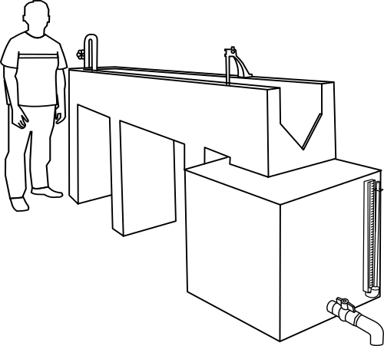

**STEP:➊**Start the pump by pressing start button.

**STEP:❷** Open the inlet valve and allow the water to fill in the channel till crest level.

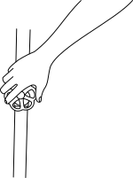

**STEP:➌** Note theoretical discharge by noting the hook gauge reading of the V-notch.

Initial reading (water level till crest) =_____cm

Final reading=_____cm

Head of water=_____ cm

theoretical discharge, Qth=_____cm3/sec

**STEP:➍**Note actual discharge reading of the V-notch from the collecting tank.

Initial reading (water level till crest) =_____cm

Final reading=_____cm

Head of water=_____ cm

Actual discharge, Qact=_____cm3/sec

|  |  |  |  |  |  |  |  |  |  |  |  |
| --- | --- | --- | --- | --- | --- | --- | --- | --- | --- | --- | --- |
| Sr. No. | Hook gauge reading  (cm) | | | Qth  (cm3/sec) | Collecting tank reading | | (cm3/sec) |  | Graphical solution | | |
| I.R | F.R | F.R-I.R | x (cm) | t (sec) | n | k | Cd |
| 1 | 3.15 | 10.04 | 6.89 | 294.37 | 10 | 20 | 1750 | 0.59 | 2.53 | 14 | 0.593 |
| 2 | 3.15 | 9.59 | 6.44 | 248.63 | 10 | 24 | 1458 | 0.58 |
| 3 | 3.15 | 8.85 | 5.7 | 183.25 | 10 | 31.4 | 1114.6 | 0.60 |
| 4 | 3.15 | 8.04 | 4.89 | 124.92 | 10 | 44.6 | 784.7 | 0.62 |
| 5 | 3.15 | 7.12 | 3.97 | 74.19 | 10 | 72 | 486.1 | 0.65 |
| 6 | 3.15 | 5.79 | 2.64 | 26.75 | 10 | 178 | 196.63 | 0.73 |

Observation:

Length of the collecting tank = 70 cm

Breadth of the collecting tank = 50 cm

Result:

Coefficient of discharge, Cd = _____

CALCULATION:

Head at V-notch= F.R-I.R

= _____cm

Theoretical discharge, 

= _____cm3/sec

Actual discharge 

= _____cm3/sec

Coefficient of discharge, 

= _____