**ROCKWELL HARDNESS TEST**

OBJECTIVE:   
To find the Rockwell hardness number of mild steel, cast iron, brass and aluminium, spring steel etc.

Apparatus used:

|  |  |
| --- | --- |
| Rockwell hardness testing machine |  |

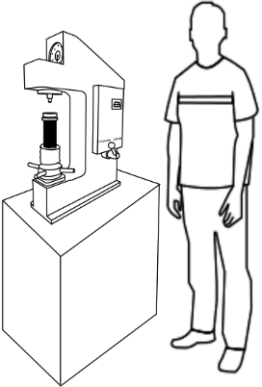

**STEP:➊**  Select a specimen of your choice. (spring steel, cast iron, mild steel, brass, aluminium). Clean the surface of the specimens from dirt, oil and scale and rub with sand paper. Place it on the work table.

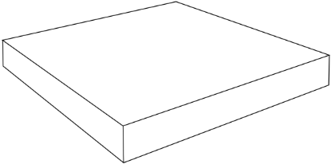 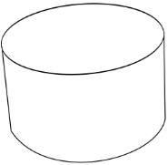 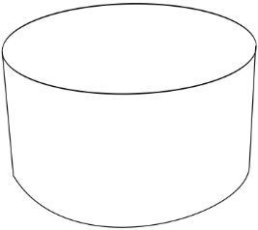 

**STEP:** **➋** The hand wheel is turned until the specimen is in contact with the indenter and the pointer of the smaller dial gauge reaches the **RED DOT** so that minor load of 10kg is applied.

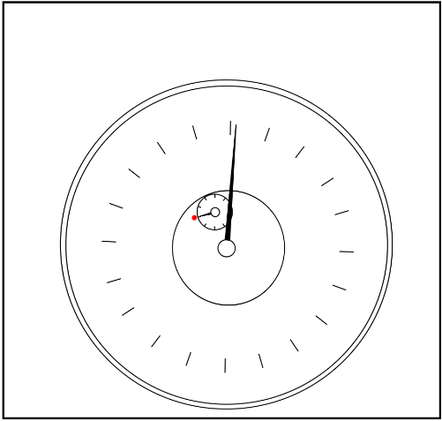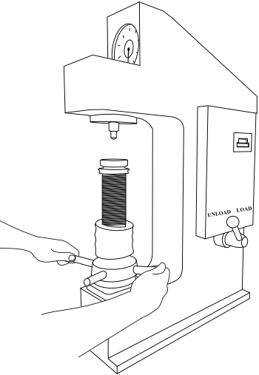

**STEP:** **➌** Based on the material the major load is set (moving the main load dial selector), the type of indentor is selected (ball or cone) is selected (figure of the indentor) & the motor is switched on. The hand lever is pulled to load position the pointer rotates at the anticlockwise direction from zero. After the lever is set back to the unload position the pointer goes back in the opposite direction and the reading is noted down using B-scale or C-scale according to the type of indentor used [i.e. ball(B)/cone(C) indentor] .

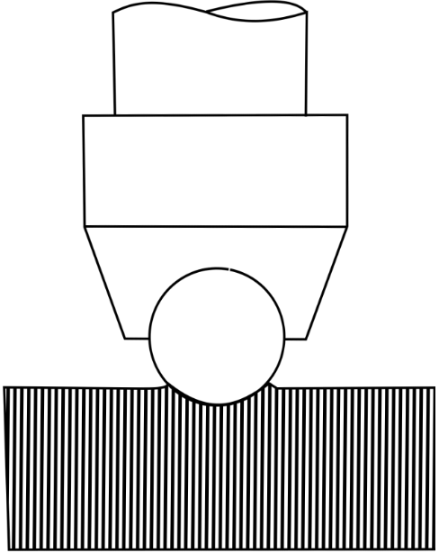

Ball indentor (B) Cone indentor(C)

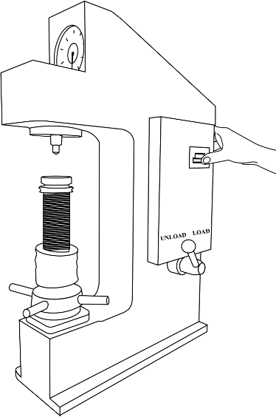   
Major Load selection

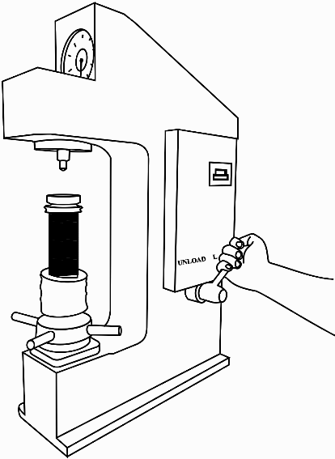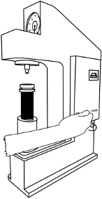

**Loading Unloading**

**STEP:** **➍** Two trials of the rockwell hardness number is noted for all the four specimens and the average is of the two trials gives the final Rockwell Hardness number.

|  |  |  |  |
| --- | --- | --- | --- |
| Material | Load P in (Kg.) | Scale  Used | Rockwell Hardness  number  (RHN) |
|
| Spring steel  [Cast Iron/ Brass/ aluminium/ Mild Steel] |  | C  B |  |