**CHARPY TEST**

OBJECTIVES:  
 To find the impact resistance of mild steel

Apparatus used:

Impact testing machine

|  |
| --- |
|  |

**STEP:➊** Test for friction loss is conducted by adjusting the pointer to 300 Joules and the hammer attached to the pendulum is released by operating the lever without keeping the specimen.

(SEE VIDEO: SHOW ANIMATION)

Average loss of energy due to friction Ef=_____J

**STEP:❷** The Charpy test specimen as per Indian standard IS:1499-1977 is used to conduct the test.

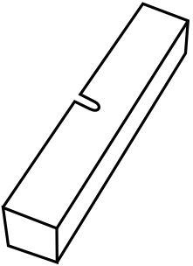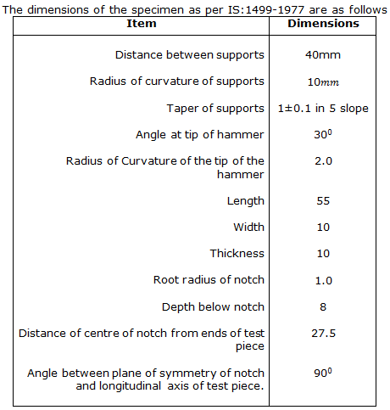

**STEP:** ❸ The Charpy test specimen is placed in position as shown.

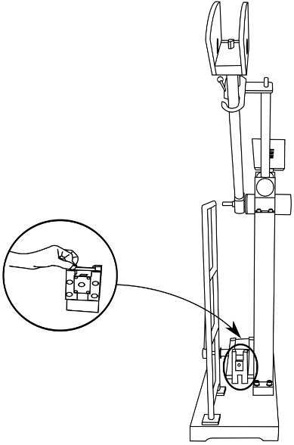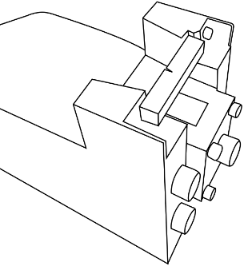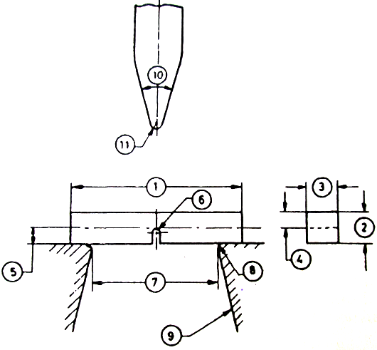

Refer procedure manual, Source: IS:1499-1977

**STEP:** **❺** The pendulum is released operating the lever. The hammer strikes against the specimen, breaks it and swings and the reading is noted down.

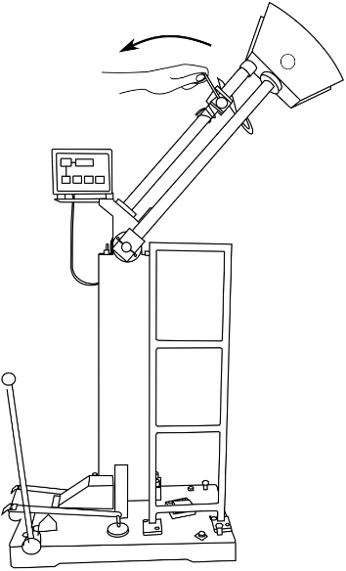

(SEE VIDEO: SHOW ANIMATION)

Total loss of energy during transit of Hammer ET =_____J

Energy for failure of specimen= ET -Ef=_____J