Partitioned Matrix

In many theoretical discussions of matrices, it will be useful to conceive of a matrix as being composed of sub-matrices. When we do this, we will “partition” the matrix symbolically by breaking it down into its components. The components can be either matrices or scalars. By introducing vertical and horizontal lines into a matrix, we can partition it into blocks.

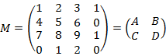
Here 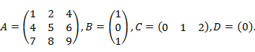
- The blocks of a block matrix must fit together to form a rectangle. So 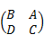 makes sense, but 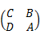 does not.
- There are many ways to cut up an n × n matrix into blocks. Often context or the entries of the matrix will suggest a useful way to divide the matrix into blocks. For example, if there are large blocks of zeros in a matrix, or blocks that look like an identity matrix, it can be useful to partition the matrix accordingly.
Multiplication of Partitioned Matrices

Matrix A and B cannot be multiplied together If the number of columns in A does not equal the number of rows in B. In this case, the multiplication of these two matrices is not defined.

Let
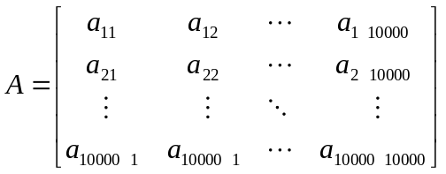 , 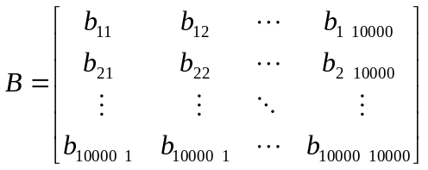
be 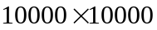 matrices. It might be very time consuming and sometimes impossible to calculate the multiplication of the two matrices since the memory in computer to store the two matrices are very large. To solve this problem, We can partition the matrices A and B in a small block of 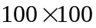 matrices.

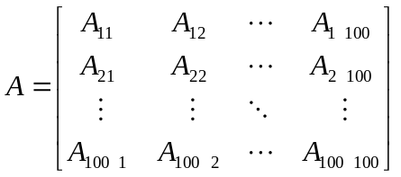, 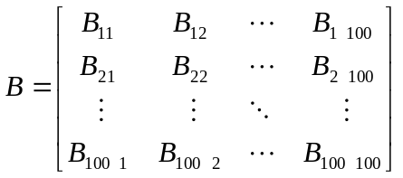,
where 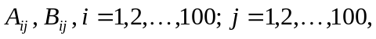 are matrices. Then,
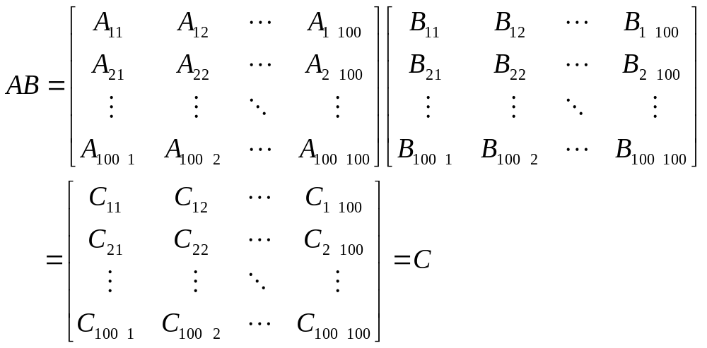
where
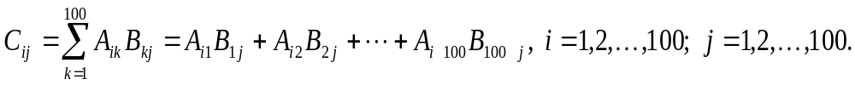
For instance,
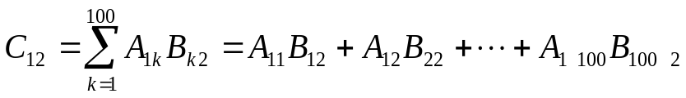.
Thus, we only need to compute the multiplication of the matrices.

General case:
Let
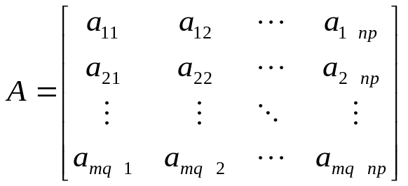
be a 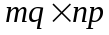 matrix and
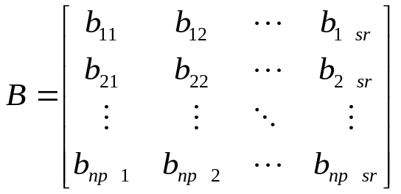
be a 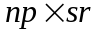 matrix. We can partition the two matrices by
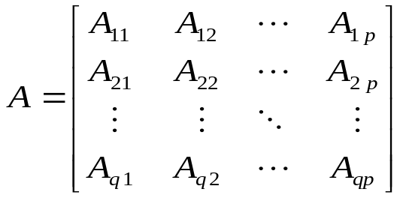
and
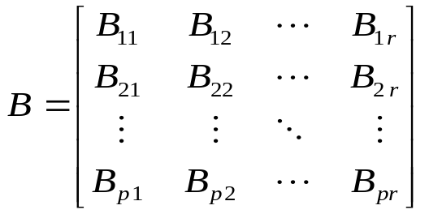,
where 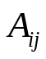 are matrices and 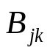 are matrices,

Then,
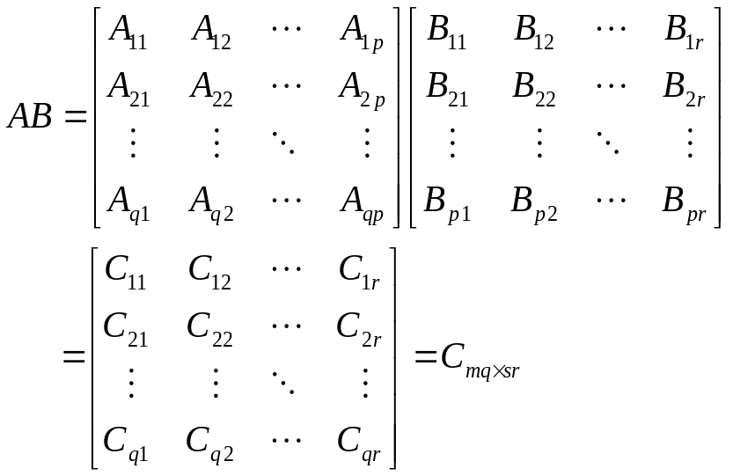
where

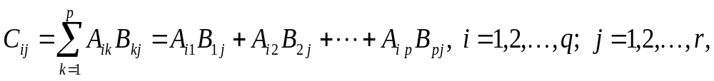
are matrices.

Example:

Let
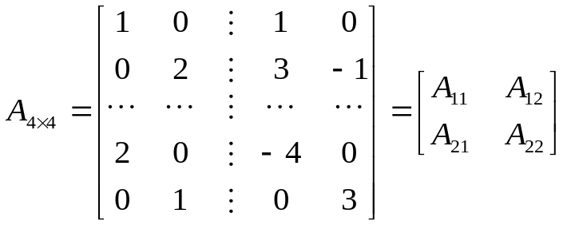
and
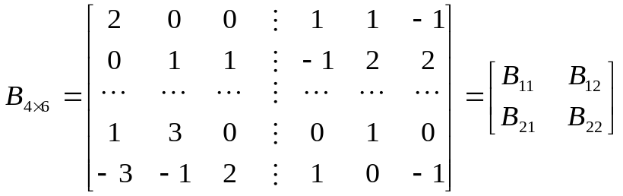.
, where
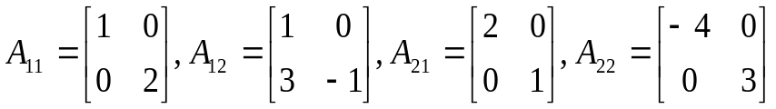

and

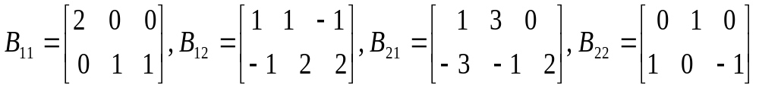.

Then, the multiplication of A and B is
