How to Create a Skype ID
Step 1:- You are required to install a Skype messenger in the beginning. After installing Skype; open it and Click on “Don’t have a Skype name?”
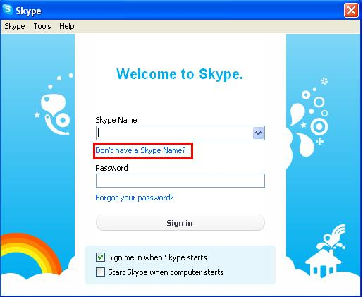
Step 2:- In the next step you would be able to see a blank form like shown below in the snapshot.
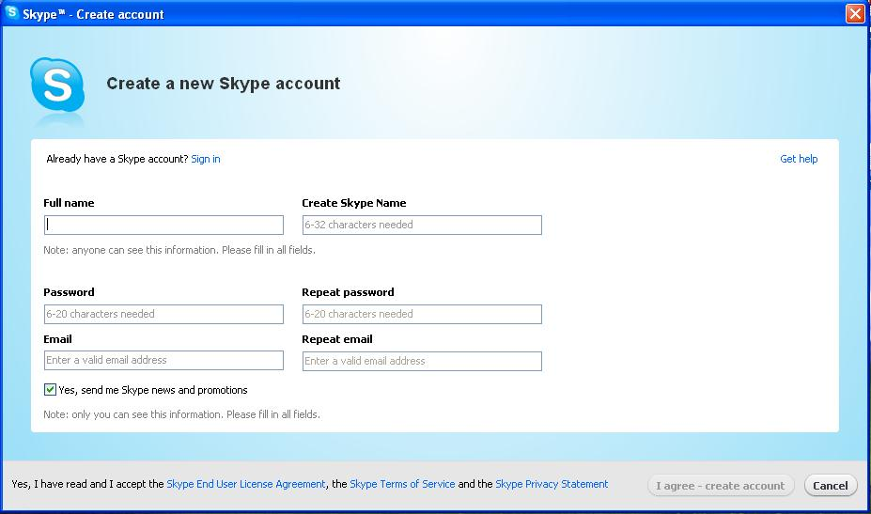
Step3:- Fill the form accordingly like given in the snapshot. You are required to mention your LMS ID in the Skype name like given in the snapshot given below. After filling the form click on “I agree- create account”
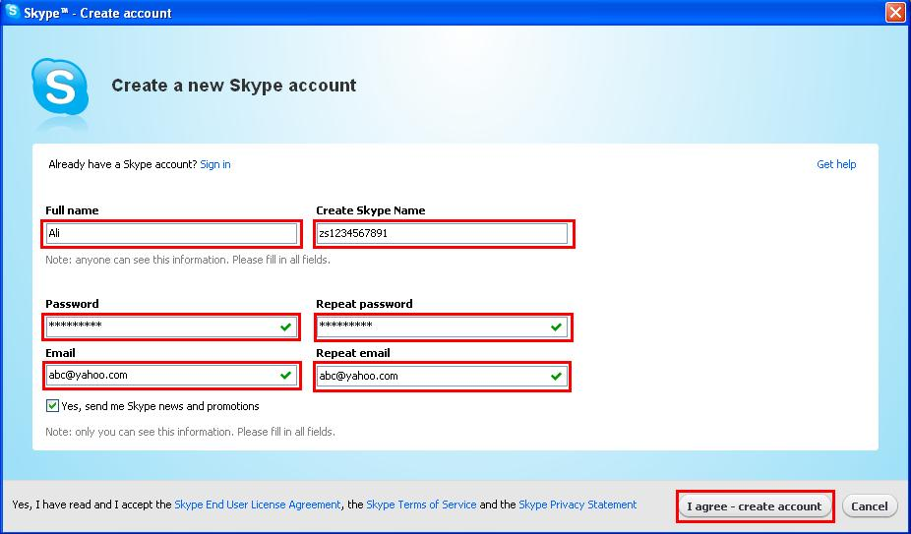

Step 4:- After clicking on create account; Skype will create your new ID and you will see the screen given in the snapshot.
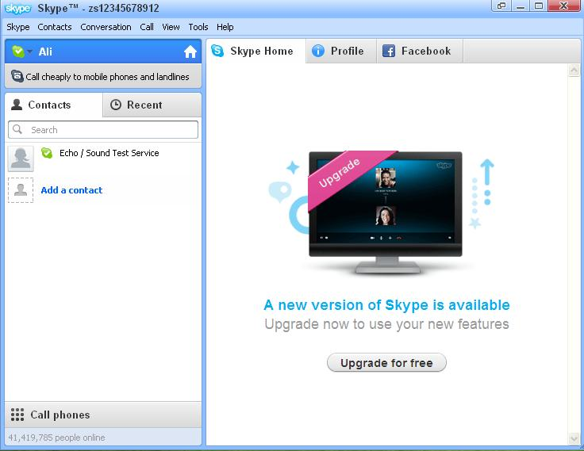

Step5:- Now you can add your respective instructor ID .On menu bar; click on “contacts” than “add a contact” as shown in the snapshot given below.
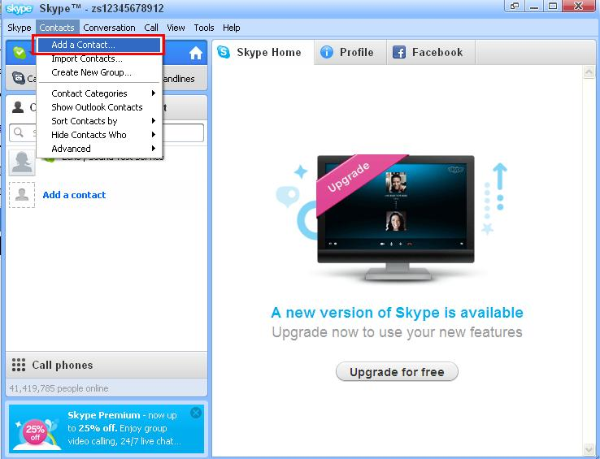

Step6:- Write your respective course ID e.g. for “Business Mathematics and Statistics” write “Instructor.MTH302.name” or “Instructor.MTH302.1” or “Instructor.MTH302” (as announced) in the Skype name text box and click on “add” . You can also mention the email Address, phone number or full name. But it is a good practice to add a person via Skype name.
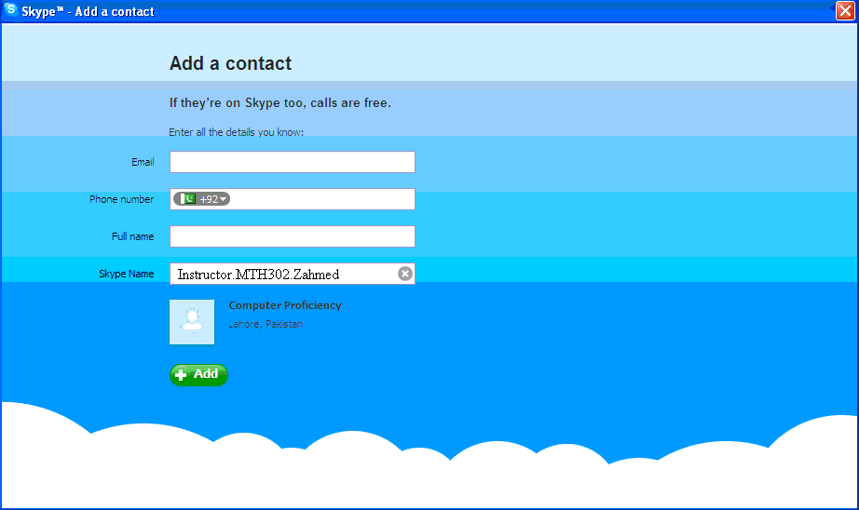
After clicking on “Add” your request will be sent to the course ID you had mentioned.

Note:- you can also create a skype ID via www.skype.com .You will be provided a simple form. After filling the form; your ID will be created.

