Creating a repo

press + NEW “ on the top Right coner “

Type Repository Name " Infra "

Click public

Press Create Repository

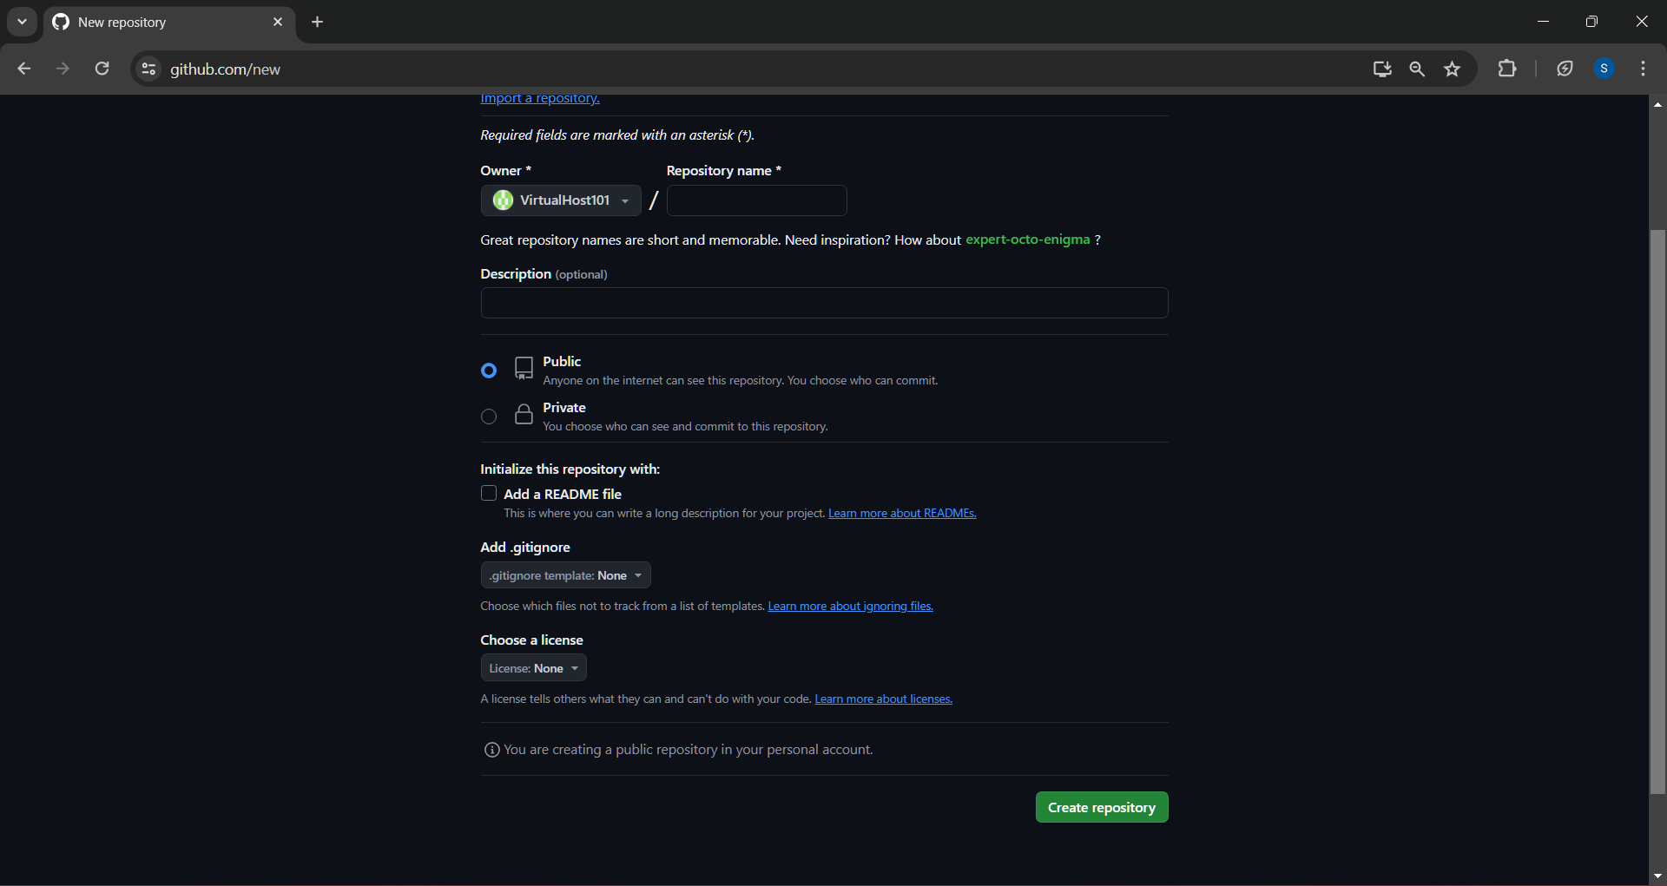

In Local

Go to the project directory

Example “ C:\Users\Satyatej\Desktop\project”

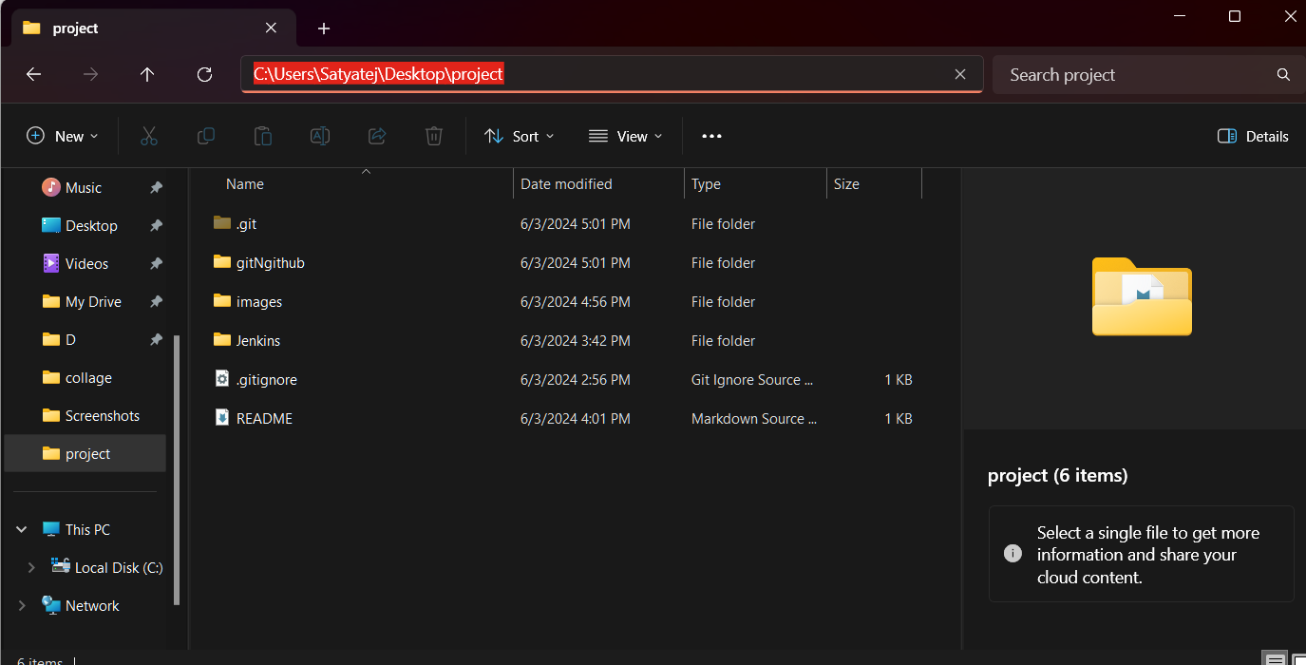

Open VS-Code or any command prompt

git remote add origin https://github.com/VirtualHost101/infra.git

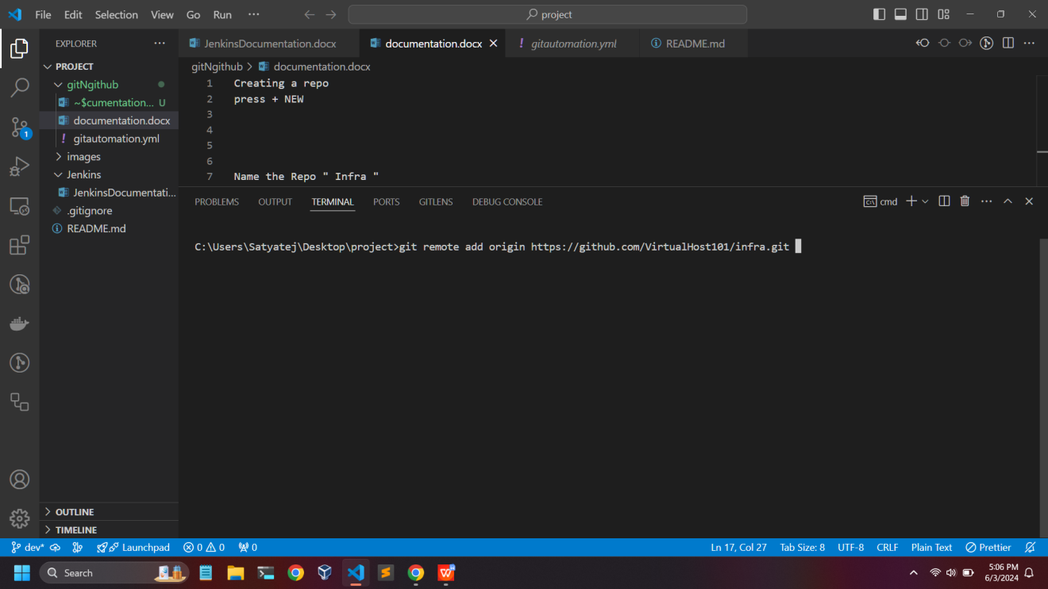

git branch -M master

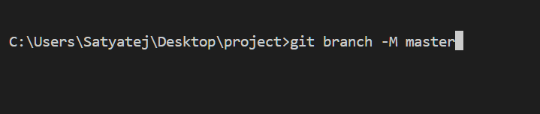

git push -u origin master

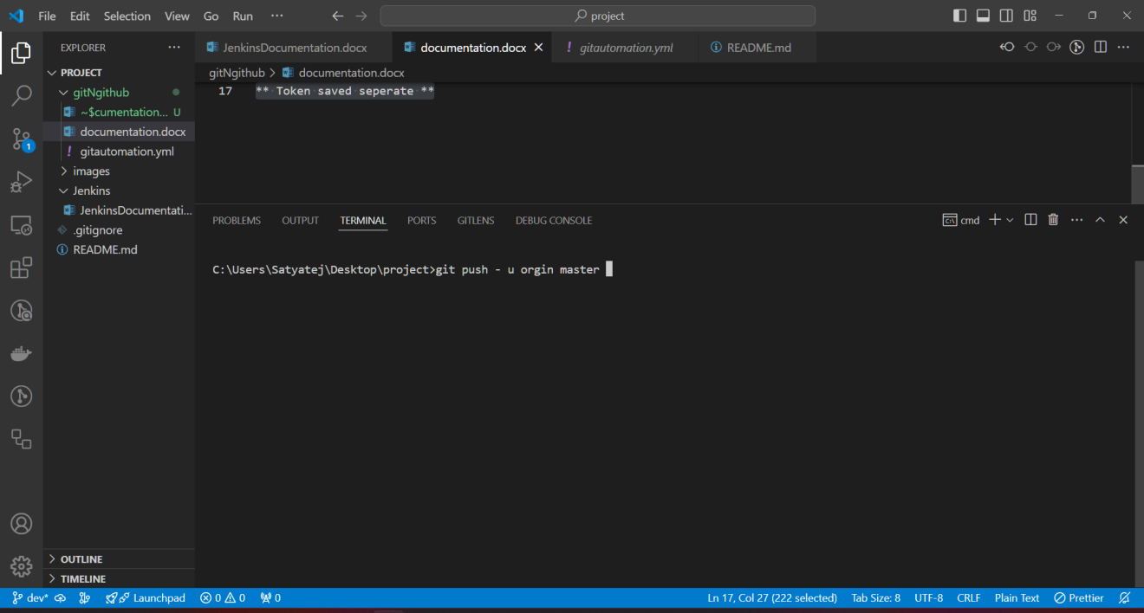

\*\* Token saved seperate \*\*