Data Report

2022-11-22 15:23:16

## Header 2

**12 census tracts in Autauga County, Alabama**

**Factor: Particulate Matter**

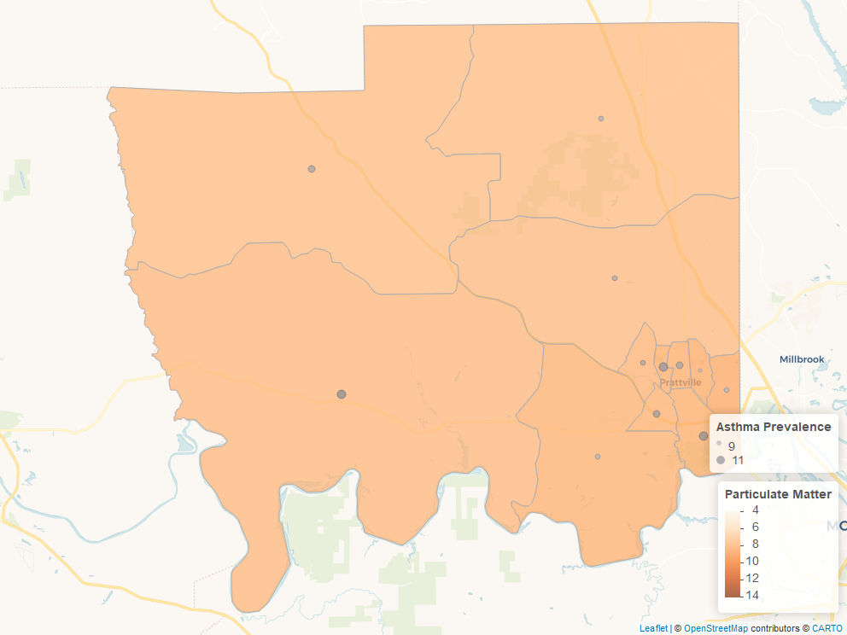

Factor Map

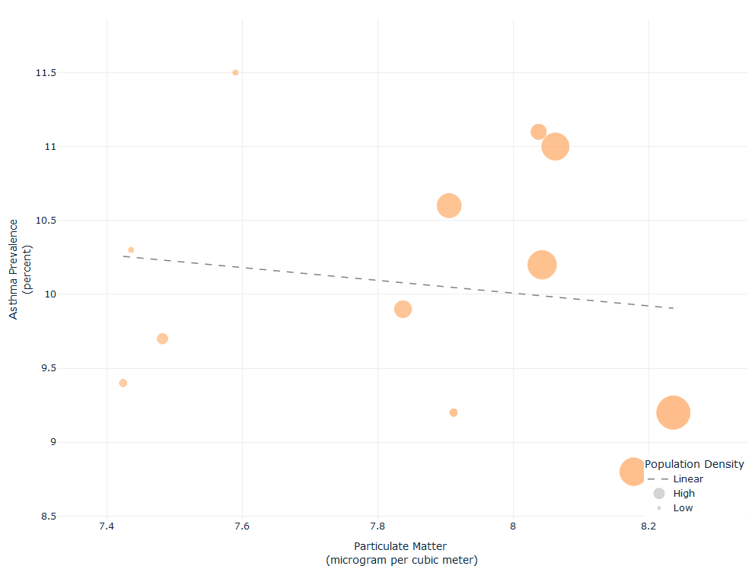

Factor Scatter Plot

| Census Tract | Asthma Prevalence | Particulate Matter |
| --- | --- | --- |
| Census Tract 201, Autauga County, Alabama | 9.9 | 7.837220 |
| Census Tract 202, Autauga County, Alabama | 11.0 | 8.062370 |
| Census Tract 203, Autauga County, Alabama | 10.2 | 8.042672 |
| Census Tract 204, Autauga County, Alabama | 8.8 | 8.177949 |
| Census Tract 205, Autauga County, Alabama | 9.2 | 8.236604 |
| Census Tract 206, Autauga County, Alabama | 10.6 | 7.905288 |
| Census Tract 207, Autauga County, Alabama | 11.1 | 8.037635 |
| Census Tract 208.01, Autauga County, Alabama | 9.2 | 7.912131 |
| Census Tract 208.02, Autauga County, Alabama | 9.7 | 7.482033 |
| Census Tract 209, Autauga County, Alabama | 9.4 | 7.423824 |
| Census Tract 210, Autauga County, Alabama | 10.3 | 7.435640 |
| Census Tract 211, Autauga County, Alabama | 11.5 | 7.589850 |