Solution: A simple daily scaffold that helps you choose only three priorities, start the first step, and get back on track after interruptions—without feeling judged or overwhelmed. The app is designed as a neurodivergent-friendly took to turns goals into smaller doable steps, visually track steps toward a goal, and leverage AI intelligence as a “support” for the user (trained in neurodivergence approaches to managing tasks).

The "Agent Assist"
When a user clicks Start on a task, the AI assistant expands and becomes a guided step-by-step helper (almost like a co-pilot for completing the task). THIS is where ScaffoldAI becomes very differentiated from every task manager on the market (neurodivergent or not).

Draft Mock Screens

Screen 1 - AI Assist Planner Screen 2 - Daily Main Screen

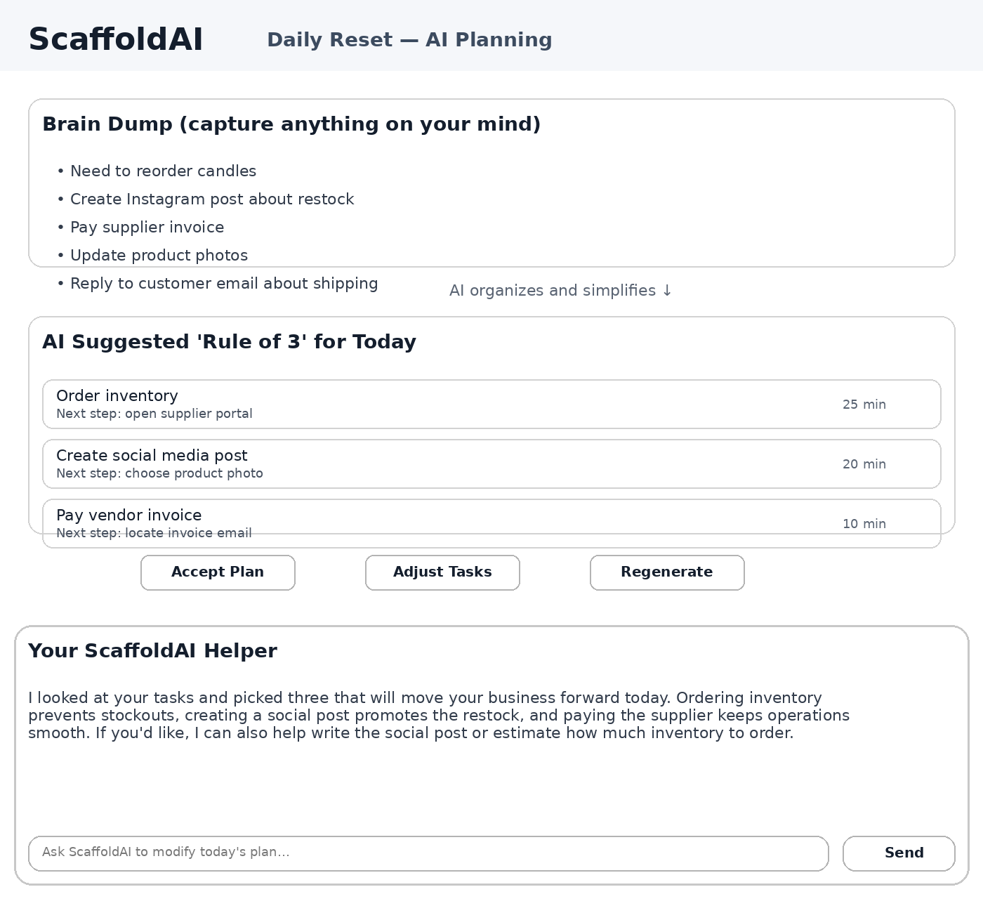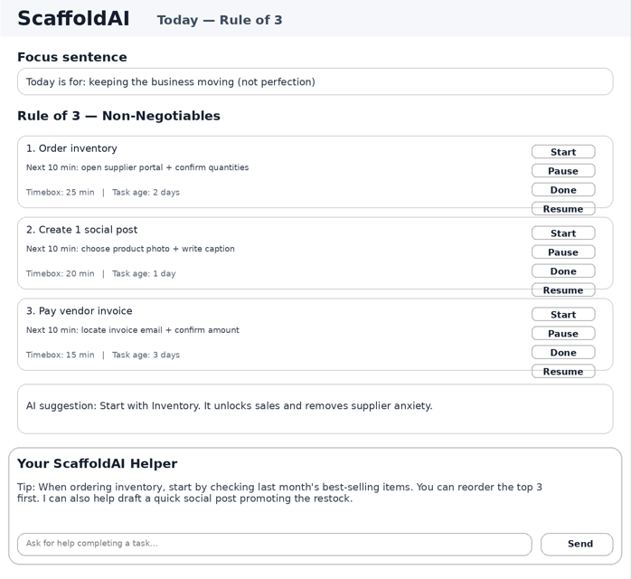

Screen 3 - Task Guide Screen 4 - Recovery
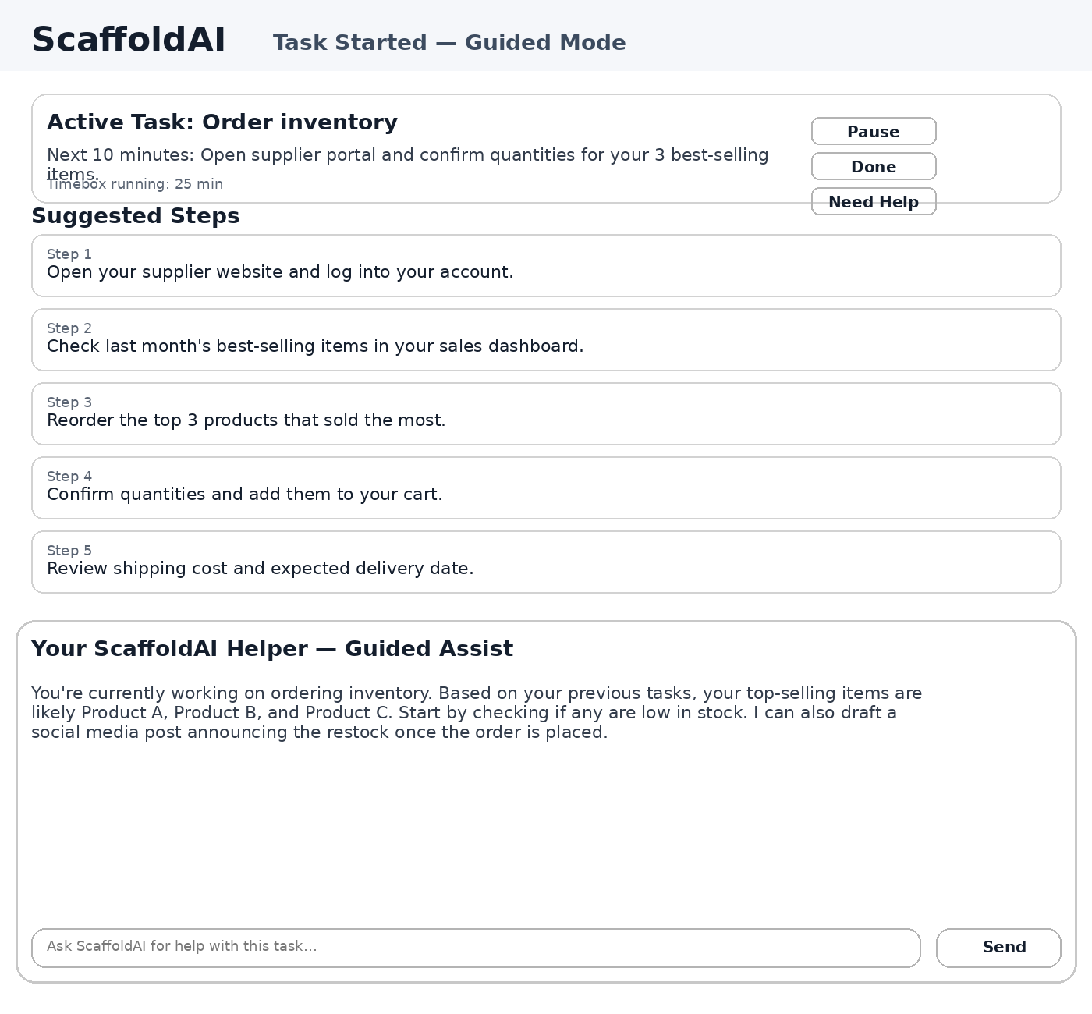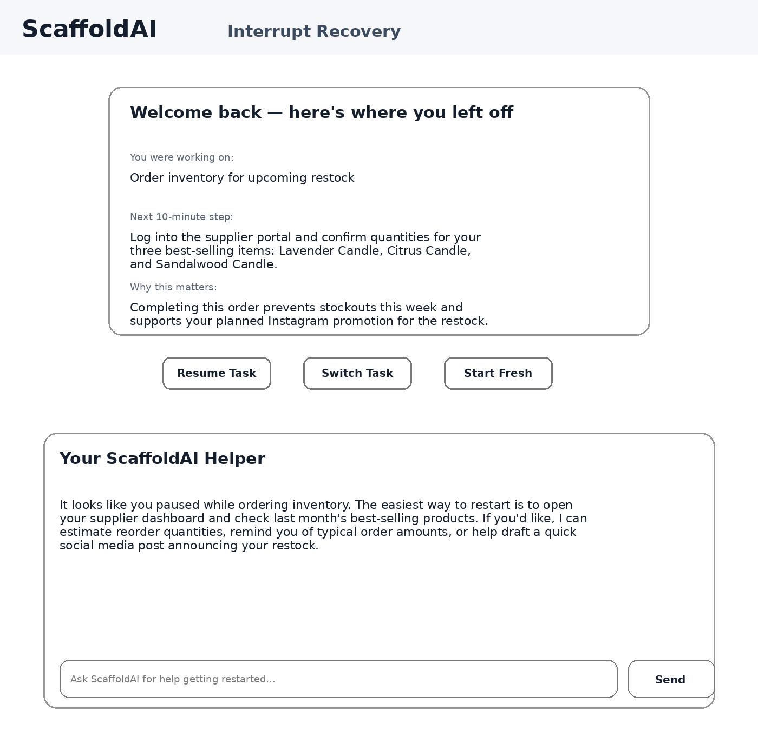

Target Users
• Neurodivergent adults (AuDHD / ADHD) managing small-business and general life goals
• Users who struggle with prioritization, task initiation, and interruption recovery

Core Principles (Non-Negotiables)
• Rule-of-3 constraint everywhere (avoid overload)
• Basic design with embedded intelligence at each step (basic funcitonal design, NOT basic technical design)
• AI proposes; user approves (design in LangGraph agentic framework and LLM API calls.. )
• Local-first prototype (simple storage using my/Matt’s local server; but exportable and scalable if we want)

Other Screens (addition to one above)
Playbooks Repeatable checklists that can instantiate into Today/Week, Starter library (6–10)
Decisions (Decision Clinic) Decision question → 3 assisted options → pick 1

Data Objects (Minimal)
• Task: title, next_action, timebox, status, tags
• DailyPlan: date, focus_sentence, 3 nonnegotiables, now_next
• Outcome(Week): outcome_text, steps(≤3)
• Playbook: name, steps, required_fields
• ResumeCard: what_i_was_doing, next_10, why_it_matters, restart_action

AI/Agentic Flows (Constrained)
1. Break Down: Task --> how to complete --> timebox
2. Plan Today: Inbox/Week --> DailyPlan proposal (diff/preview)
3. Run Playbook: if exists already from past, refernce to create tasks automatically.. help user through
4. Decision Clinic: Generate 3 options → decision record
5. Resume task: Generate resume card on interruption / context switch

