# System Requirements

Users:

VirtualScope users, biology majors, universities, and biology

Functionality, Goals, and Scope

The system shall hook into the [VirtualScope](https://virtualscope.site) system, meaning the users shall be authenticated externally. Ideally the site’s colors and layout shall be visually like VirtualScope’s site. Users will have the option to be redirected to this site with an image attached to their user session, so they do not have to download an image from VirtualScope and upload an image to the VirtualScope Forums to post it. They then shall have the ability to view a project list, add comments, attach images, and submit number count to a main post a teacher or professor creates. The system shall be secured so it is production ready, meaning user input must be sanitized, MySQL injection must be prevented, etc.

Technical Process:

The site shall be developed within the allotted time period. The front-end shall consist of HTML, CSS, Jquery/JavaScript, Bootstrap for the frontend. The backend shall consist of PHP and MySQL. Users shall be authenticated using a PHP Session from the VirtualScope systems.

# Functional Requirements

|  |  |  |  |
| --- | --- | --- | --- |
| Functional Requirement | Description | Section / page | Users |
| Login | The user shall authenticate from an external service |  |  |
|  | 1. Redirected to this website 2. Database creates linking entry identifying the user by the ID provided | Any Page | All |
|  | 1. User is Logged in | Internal Pages/Public Pages | All |
| View Project List | The user shall have a page that displays a list of all **available** projects. |  |  |
|  | 1. The page shows the projects the user can view, private projects at the top and highlighted. | Project List | All |
|  | 1. Project posts are shown. |  |  |
| Make Post | A user with permission should be able to make a new post relating to an experiment or similar. |  | Teachers/Elevated Permission Users |
|  | 1. Navigate to Post Creation page 2. Set Title 3. Upload Image (if any) 4. Set visibility private/public 5. Set password (if private) 6. Assign to Class (if any) | Post Creation Page | Teachers/Elevated Permission Users |
|  | 1. Submit post using submit button. | Post Creation Page | Teachers/Elevated Permission Users |
| Make Comment | Any user with permission (globally) should be able to comment on a project. |  |  |
|  | 1. View projects 2. Select project | Project List | Anyone with global “Post Comment” permission |
|  | 1. Add Title, Text 2. Upload any images | Project Page | Anyone with global “Post Comment” permission |
|  | 1. Submit | Project Page | Anyone with global “Post Comment” permission |
| Upload Image received from External Service | A user should be able to directly upload an image or have the image “follow” the user from the external site. | Post or Comment Creation Page | Anyone with global “Post Comment with Image” permission |
|  | 1. User is redirected to the site or post with an image URL | Any Page | Anyone with global “Post Comment with Image” permission |
|  | 1. User creates post and the image is already available for selection, no upload needed 2. User “submits” image 3. Backend grabs image from server or returns an error 4. User finishes “Create Comment” or “Create Post” and submits | Post Creation Page or Post Page | Anyone with global “Post Comment with Image” permission |

# Domain Diagram

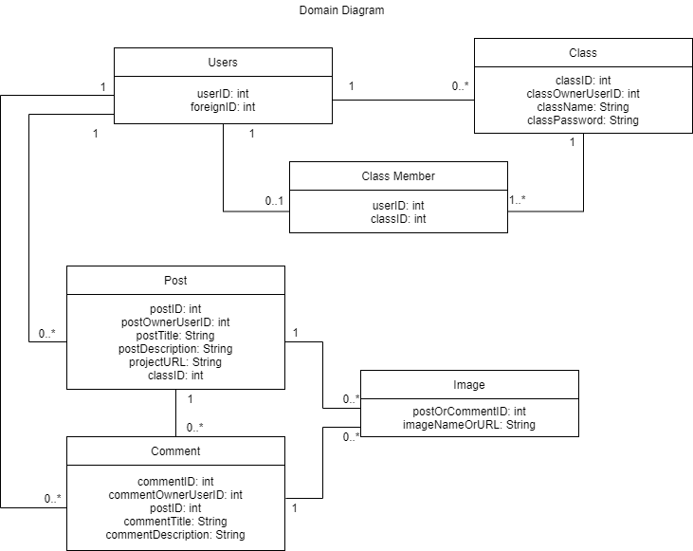

# ERD Diagram

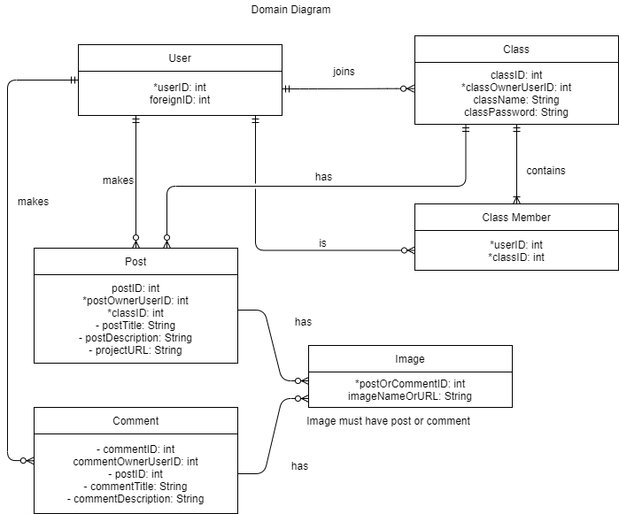

# Mockups

