|  |  |  |
| --- | --- | --- |
| Username | Text | Allowed inputs are: Letters, numbers, “-”, and “_” without the quotes. 3-20 characters. |
| Password | Text | Must be at least 8 characters long, max length is 40. Can contain numbers, letters, and these special characters: (@#$%^&). |

Username / Password (Sign Up / Login):

Create Class:

|  |  |  |
| --- | --- | --- |
| Name | Text | Allowed inputs are: Letters, numbers, “-”, and “_” without the quotes. 3-20 characters. |

Create Forum Post

|  |  |  |
| --- | --- | --- |
| Title | Text | Allowed inputs include Letters, Numbers, Spaces, and “+-!.()” without the quotes. |
| Post | Text | Allowed inputs include Letters, Numbers, Spaces, and “+-!.()” without the quotes. |
| Add to Class | Dropdown of Class Names | Only predetermined class names from the database are allowed. In addition the query must be of Letters, numbers, “-”, and “_” without the quotes and 3-20 characters to proceed looking up in the database. |
| Image Input | Image | Max file size 2MB, must be PNG, JPG, or JPEG. |

Create User Post

|  |  |  |
| --- | --- | --- |
| Title | Text | Allowed inputs include Letters, Numbers, Spaces, and “+-!.()” without the quotes. |
| Post | Text | Allowed inputs include Letters, Numbers, Spaces, and “+-!.()” without the quotes. |
| Image Input | Image | Max file size 2MB, must be PNG, JPG, or JPEG. |

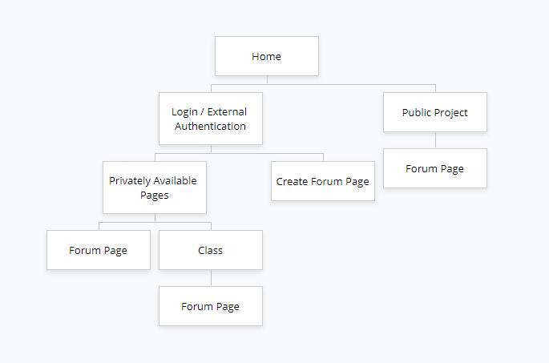

Code:

<https://github.com/VirtualScope/AngryNerds-Master>