Documentation for Project Chronos
A chronological path planning system

1. Project documentation

1.1 Methods
The software is a fusion of different available systems in ROS. The overall goal is to provide a system, which computes travel times for mobile robots on defined jobs. These jobs consist of a goal and a start time. To find out the time a resource needs to reach the goal we need at first a path through the given environment.

1.1.1 Path planning
Path planning is a quite complex topic, when it comes to mobile robots. The environment as well as the robot has to be digitalized to define areas where the robot can move. In this case the whole process is automated by the move_base node in ROS.
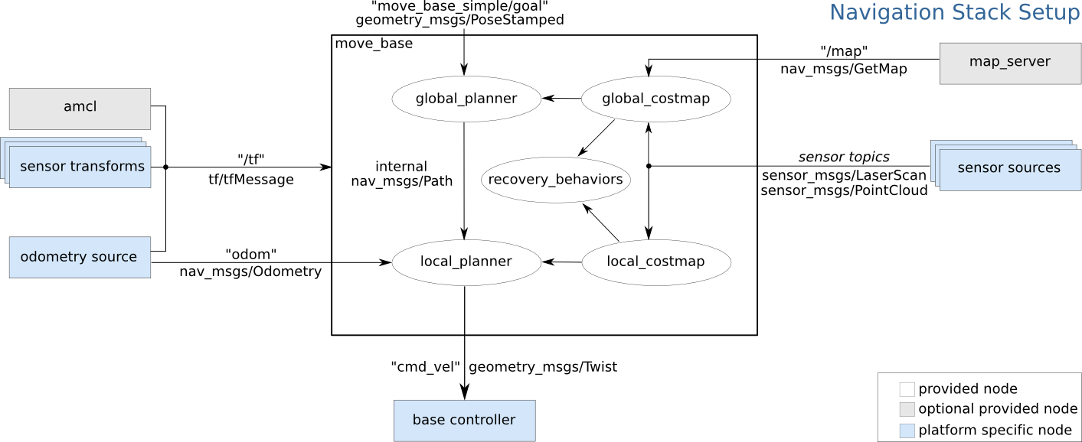
It takes a map from the map_server node and merges it with the information gathered by the robot’s sensors. This process leads to a costmap, which weights smallest zones in the map depending on how likely it is to crash into an obstacle. The next participant is the planner, that builds a path consisting of poses on the optimized in length and the goal not to crash.

1.1.2 Time stamping
Up to this point ROS provides the nodes and enables calculating a path and executing it, but it is not in charge of merging this paths with time information and planning into the future. In order to find a accurate travel time this is necessary as the time when the goal is reached is connected with the start time and the path. The developed time_server is capable of assigning time information to the single poses of the computed path:
start pose → 1 → 2 → … → goal pose
The distance between the start pose and pose 1 is determined and based on the distance with the help of a average velocity the travel time from the start pose to pose 1 is known. Also the start time is given and so the time when the robot reaches pose 1 is now known. The same process can be executed for pose 1 and pose 2 and so on until the last pose namely the goal pose.

1.1.3 Collision checking
The third necessary method in this system is the collision checking as it is crucial for the travel time. So far the travel time of the job depends only on the average velocity of the robot, but does not take in charge possible collisions or if it has to wait to let other robots pass.

1.2 Code
In the this chapter the directory with all the sub folders and files is visualized + a short description of the function. The directory is ordered as followed:

DIRECTORY
├── Main folder
│ ├── Sub folder
│ └── File
├── Cmake files

CHRONOS
├── action
│ ├── planning.action path planning and organization
│ └── PTS.action expects the job (goal, start time) and calculates travel time
├── cfg
│ ├── chronos.rviz configuration for rviz (displayed elements)
│ └── costmap_example.yaml critical for the path_server
├── CMakeLists.txt
├── launch
│ ├── path_server.launch path_server depends on the costmap_example.yaml so a
rosrun path_server is not possible (test)
│ ├── server.launch runs the three server ( path, time and collision)
│ ├── setup.launch runs the setup_gazebo and setup_navigation in this order
│ ├── subsystems
│ │ ├── amcl.launch adaptive monte carlo localization
│ │ ├── move_base.launch enables automated path computation and navigation based on
the configuration of a mobile robot
│ │ ├── setup_gazebo.launch simulates a world and the three turtlebots in gazebo,
runs rviz for visualization and the map_server
│ │ └── setup_navigation.launch launches amcl and move_base for the three turtlebots
│ └── systems.launch TODO
├── maps
│ ├── factory_map.pgm
│ ├── factory_map_polished.pgm ← current implemented map
│ ├── factory_map_polished.yam l updated factory_map depending on collision areas
│ ├── factory_map.yaml map generated by a turtlebot in the factory world
│ ├── house_map.pgm map for the house_world
│ └── house_map.yaml
├── msg
│ ├── plan.msg message format for broadcasting the current overall path plan
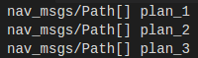
│ └── visualization.msg old message format for visualization (outdated)
├── package.xml
├── params
│ ├── my_base_local_planner_params.yaml (parameters for the move_base
│ ├── my_costmap_common_params_burger.yaml differing on the turtlebot model
│ ├── my_costmap_common_params_waffle_pi.yaml local & global costmaps
│ ├── my_costmap_common_params_waffle.yaml marking and clearing o obstacles)
│ ├── my_dwa_local_planner_params_burger.yaml
│ ├── my_dwa_local_planner_params_waffle_pi.yaml
│ ├── my_dwa_local_planner_params_waffle.yaml
│ ├── my_global_costmap_params.yaml
│ ├── my_local_costmap_params.yaml
│ └── my_move_base_params.yaml
├── src
│ ├── actionserver
│ │ ├── planning_actionserver.cpp organizes the path plan
│ │ └── PTS_actionserver.cpp computes travel times for jobs
│ ├── path_execution.cpp executes the path plan by sending goals to the robots
│ ├── server
│ │ ├── collision_server.cpp checks two paths for collisions chronological and locally
│ │ ├── path_server.cpp computes a plan with the help of navfn and costmap
│ │ └── time_server.cpp time stamps a plan
│ ├── tests TODO which test is outdated
│ │ ├── collision_test.cpp
│ │ ├── path_test.cpp
│ │ ├── planning_test.cpp
│ │ ├── PTS_test.cpp
│ │ └── time_test.cpp
│ └── visualization.cpp visualizes the plan by publishing in rviz topics
├── srv
│ ├── collision_service.srv two paths prioritized → collision yes or no and if the place
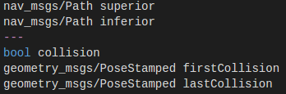
│ ├── path_service.srv start and goal → path
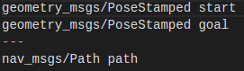
│ └── time_service.srv path, average velocity of robot and start time → path with time
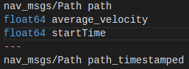
├── urdf
│ ├── common_properties.xacro
│ ├── turtlebot3_burger_for_autorace.gazebo.xacro
│ ├── turtlebot3_burger_for_autorace.urdf.xacro
│ ├── turtlebot3_burger.gazebo.xacro
│ ├── turtlebot3_burger.urdf.xacro
│ ├── turtlebot3_waffle_for_open_manipulator.urdf.xacro
│ ├── turtlebot3_waffle.gazebo.xacro
│ ├── turtlebot3_waffle_pi_for_open_manipulator.urdf.xacro
│ ├── turtlebot3_waffle_pi.gazebo.xacro
│ ├── turtlebot3_waffle_pi.urdf.xacro
│ └── turtlebot3_waffle.urdf.xacro
└── worlds
└── world.world factory world

CHRONOS_RQT
├── CMakeLists.txt
├── package.xml
├── plugin.xml
├── resource
│ ├── ChronosRqt.ui can be opened with QT_creator and shapes the ui
│ └── ScrollableTimelineQT.ui
├── scripts
│ └── chronos_rqt
└── src
└── chronos_rqt
├── __init__.py
├── __init__.pyc
├── timeline_module.py logic of the gui is implemented here
└── timeline_module.pyc

CHRONOS_RVIZ next step is implementing the ui formed in chronos_rqt
in rviz for a more convenient usage

1.3 Requirements

The requirements for this software are containing all the systems, which are not written in this project. The first big thing to mention is the whole turtlebot framework. So first to build a software working with robots, real robots have to be configured or some resources simulated. Afterwards the robot can publish data by his sensors and execute orders. The complex connection of these subsystems happens in the localization and navigation. On the one side on a local level the robot recognizes obstacles and circumnavigate it. Other on the global level the robot computes plans and can go for the transferred goals. Both functions are crucial for the path planning system, as paths can only be generated with the move_base node of a active turtlebot and the same node executes the plan to reach a very goal. So a big part of the code is by the turtlebot3 package (https://github.com/ROBOTIS-GIT/turtlebot3) or only slightly modified.
Further more general requirements is the ROS framework in version kinetic and Ubuntu 16.04 LTS. Whereas it should work on other versions but it is not tested.

2. System documentation

2.1 Usage (Functions? How is it used?)

Functions:
The main function is the calculation of a job time for a given goal at a very time.

System call:
1. launch setup.launch
2. launch server.launch
3. run PTS_actionserver
4. run planning_actionserver

1: setup.launch (starts the required systems for simulation and navigation)
→ setup_gazebo.launch (simulates robots in gazebo and opens rviz)

2.2 Data

The overall goal of the software is to calculate the travel time of a resource as accurate as possible and for this reason the path and time information has to be intertwined. In the following chapter the interaction process of the different systems is described.
At first the standard format of paths has to be introduced to understand the change at every process step.
std_msgs/Header header
uint32 seq
time stamp
string frame_id
geometry_msgs/PoseStamped[] poses
std_msgs/Header header
uint32 seq
time stamp
string frame_id
geometry_msgs/Pose pose
geometry_msgs/Point position
float64 x
float64 y
float64 z
geometry_msgs/Quaternion orientation
float64 x
float64 y
float64 z
float64 w
As well the input/output pattern for services in ROS:
float32 x
float32 y
float32 theta
string name
---
string name

It shows the Spawn service, which spawns a turtle in the simple simulation environment turtlesim. Inputs are the position in coordinates (x and y) with a orientation (theta) and a optional name. The result or the output of the Spawn server is a the name the spawned turtle has. (more information at http://wiki.ros.org/ROS/Tutorials/UnderstandingServicesParams)

Origin of the path/time data flow lies within the path server. With the start and goal information a path is computed with the following content.
geometry_msgs/PoseStamped start
geometry_msgs/PoseStamped goal
---
nav_msgs/Path path
PATH WITHOUT TIMESTAMPS
header: ← header of the path
seq: 18← sequence ID in path header is for the ROS message system
stamp:
secs: 0
nsecs: 0
frame_id: "map"
poses: "<array type: geometry_msgs/PoseStamped, length: 139>"
---
header: ← start pose
seq: 0
stamp:
secs: 840← time point of path creation
nsecs: 536000000
frame_id: "map"
pose:
position:
x: -0.0499998517334
y: -0.0499998517334
z: 0.0
orientation:
x: 0.0
y: 0.0
z: 0.0
w: 1.0

header: ← goal pose
seq: 0
stamp:
secs: 840← time point of path creation
nsecs: 536000000
frame_id: "map"
pose:
position:
x: 3.2
y: 1.35
z: 0.0
orientation:
x: 0.0
y: 0.0
z: 0.0
w: 1.0
Second step is the time stamping executed by the time_server.
nav_msgs/Path path
float64 average_velocity
float64 startTime
---
nav_msgs/Path path_timestamped
TIMESTAMPED PATH
header:
seq: 19
stamp:
secs: 1553
nsecs: 307999999
frame_id: "map"
poses: "<array type: geometry_msgs/PoseStamped, length: 139>"
---
header:
seq: 38
stamp:
secs: 1553← time information of start pose is now the start time
nsecs: 307999999
frame_id: "map"
pose:
position:
x: -0.0499998517334
y: -0.0499998517334
z: 0.0
orientation:
x: 0.0
y: 0.0
z: 0.0
w: 1.0
---
header:
seq: 39
stamp:
Secs: 1560← analogous the end time
nsecs: 498480958
frame_id: "map"
pose:
position:
x: 3.2
y: 1.35
z: 0.0
orientation:
x: 0.0
y: 0.0
z: 0.0
w: 1.0
The last step is the collision checking by the collision_server and adding the necessary time to the end time.
nav_msgs/Path superior
nav_msgs/Path inferior
---
bool collision
geometry_msgs/PoseStamped firstCollision
geometry_msgs/PoseStamped lastCollision
COLLISIONFREE PATH
header:
seq: 22
stamp:
secs: 1553
nsecs: 307999999
frame_id: "map"
poses: "<array type: geometry_msgs/PoseStamped, length: 142>"
---
header:
seq: 44
stamp:
secs: 1553
nsecs: 307999999
frame_id: "map"
pose:
position:
x: -0.0499998517334
y: -0.0499998517334
z: 0.0
orientation:
x: 0.0
y: 0.0
z: 0.0
w: 1.0
---
header:
seq: 45
stamp:
secs: 1562← path is longer and therefore needs more time
nsecs: 341298405
frame_id: "map"
pose:
position:
x: 3.2
y: 1.35
z: 0.0
orientation:
x: 0.0
y: 0.0
z: 0.0
w: 1.0

2.3 Tests/ Verification

Path_test
Path test works with the call
rosrun chronos path_test startX(int) startY(int) goalX(int) goalY(int)
and publishes the result into /path_test

Time_test
called by
rosrun chronos time_test args
whereas the args are integers:
1. number of positions of an auto generated path
2. distance in x direction between the positions in the path
3. distance in y direction between the positions in the path
4. average velocity – pre comma
5. average velocity – post comma
6. start time

2.4 Further development

Time calculation system

