|  |
| --- |
| Welcome to |
| **Camp Ocean Explorer-Bali** |
| **Summer Outbound Programme 2018 for 13-18 year olds** |



|  |
| --- |
| **User**  **[Pick the date]** |

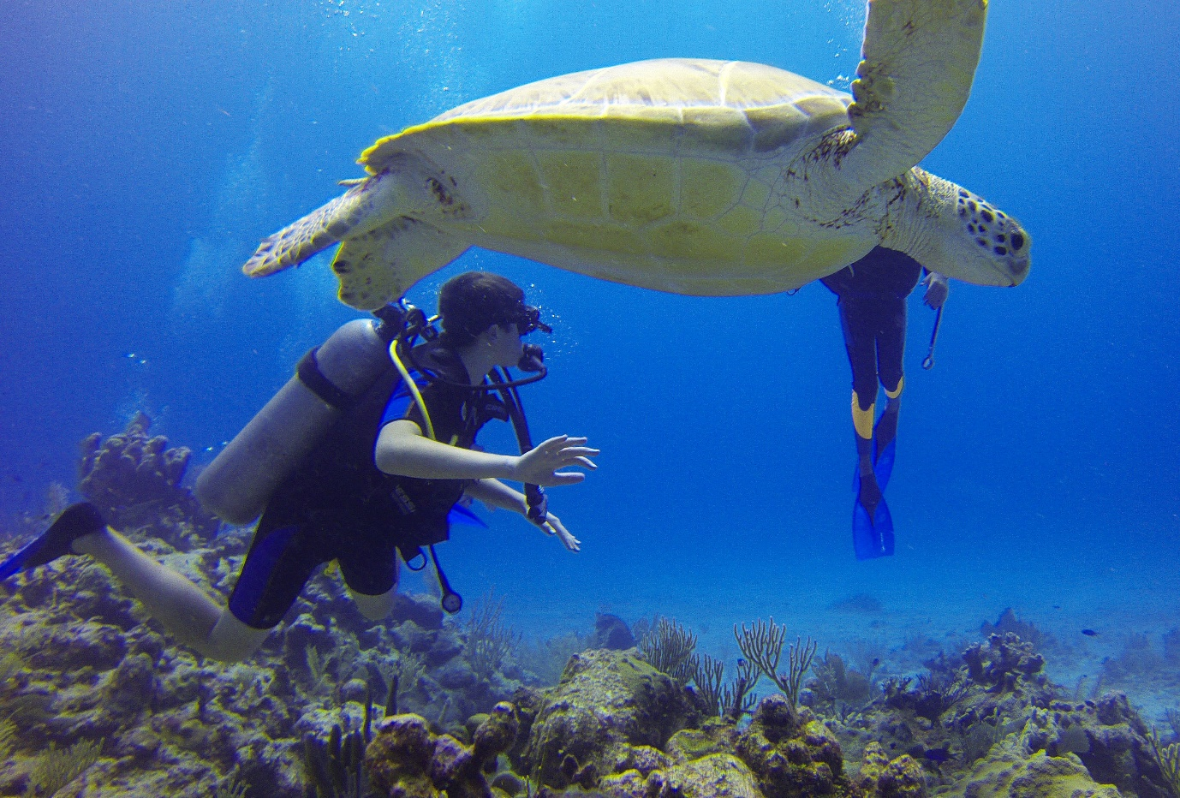

**Trailblazers Adventure Travel Pvt. Ltd, Mumbai**

504, India Bulls Mint, Manpada, Thane West – 400 610

Email: [camps@trailblazersindia.com](mailto:camps@trailblazersindia.com) Phone: 022-21 73 97 32/37

Web: [www.trailblazersindia.com](http://www.trailblazersindia.com)

[](https://www.linkedin.com/company-beta/3801286/) [cid:image001.png@01D1FECC.B8F3BD60](https://www.facebook.com/Trailblazers.TheOutdoorSchool) [](http://www.instagram.com/trailblazers.india) [cid:image005.png@01D1FE57.2413EAF0](https://twitter.com/Trailblazers_In) [](http://thetrailblogger15.blogspot.in/) [ECOTRAIL](http://trailblazersindia.com/ecotrail/ecotrail.htm)

# **About Trailblazers**

Trailblazers is a 23 year old private enterprise doing pro active outbound environment education in India through eco-camps, wildlife, heritage, trekking and adventure programmes. We have worked with 1,00,000+ campers since 1994. The programmes are interactive, carved out with meticulous planning and research and aim to provide children and adults with fun experiences that enable them to discover the world and themselves, while making them more sensitive to nature & environment.

To know more about us please visit [www.trailblazersindia.com](http://www.trailblazersindia.com).

# **Programme Invitation**

Dear Parent,

Trailblazers Adventure Travel Pvt. Ltd, Mumbai invites your child to be a part of our Camp Ocean Exlporer.

Trailblazer’s Summer Outbound Programmes are designed to offer your child an unforgettable summer in the month of May/June 2018. Your child will be away from his regular routine exploring new skills, developing leadership qualities, taking up various challenges, discovering closeness to mother nature, increasing self belief and independence of thought all in a fun way with the help of friendly, well trained and expert professionals from Trailblazers.

Trailblazers Summer Camps & Expedition are all about you. Camps and Expeditions means fun, meeting new people, means doing new things, means learning a skill, means doing more than you think you can do.

Summer camps are enablers. They enable you to explore different facets of self, Enables you to see how much is possible, Enables you to explore the country, people and make new friends, Enables you to reach your potential, Enables you to have clean fun, good food, new friends increasing your Face book circle, Enables you to do things you can’t or would not have done, Enables you to be healthy and learn a lot of new skills and lastly it Enables you to be the Global person you really are. The world is flat and it’s yours to see and seek. Trailblazer’s Camp Ocean Explorer enables you to succeed.

Regards,

Ranjan Biswas

Managing Director

Email: [ranjan@trailblazersindia.com](mailto:ranjan@trailblazersindia.com)

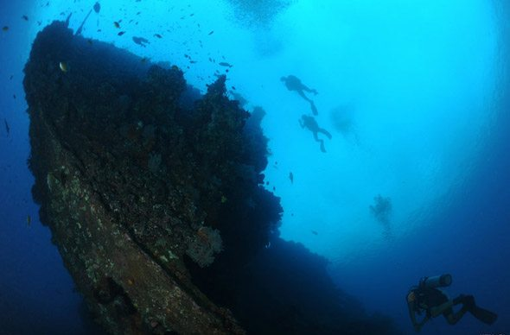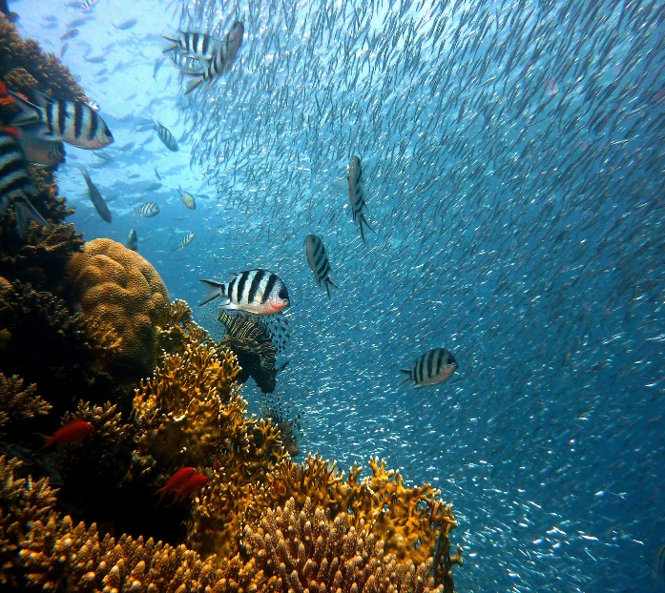

**Sample Itinerary**

|  |  |
| --- | --- |
| **Day 1** | Meet at Mumbai Airport and board flight to Bali. Arrive in Bali and drive to hotel, check in, lunch and relax. **Experience sunset at a Balinese sea temple perched on the edge of an ocean cliff**. Enjoy the **traditional Kecak dance performances in the open air**. Dinner and sleep in early to be fresh to start the dive course tomorrow. |
| **Day 2** | Wake up fresh to start dive course at 730am. **Learn basics of diving theory and practice basic skills over swimming pool sessions**. Finish around 5-6pm. Evening at leisure followed by dinner. Retire early to be fresh for first ocean dive. |
| **Day 3** | Wake up early to start an exciting day at 730am. **It's time for your first dive in the ocean.** Practice skills learnt yesterday in the open water over 2 ocean dives. **Enjoy the feeling of flying underwater, while experiencing a completely different world underwater of exquisite corals and marine life.** Lunch. Finish theory if incomplete. Evening at leisure followed by dinner. Sleep in early for the next day's dive. |
| **Day 4** | Wake up early to start an exciting day at 730am. Enjoy a drive through the Balinese countryside to reach a World War 2 ship wreck site! **Practice skills learnt over 2 ocean dives.** **Enjoy the experience of exploring an underwater ship wreck from World War 2.** Final exam. Return by evening to the hotel. **Celebrate becoming a licensed scuba diver over a special dinner.** Retire for a well-deserved good night's sleep. |
| **Day 5** | Wake up at leisure. After breakfast, start out for a **Bali countryside cycling trip through rice terraces of Bali**. Stop at a **Balinese herb, spices, fruit, coffee & tea plantation** to learn and taste about some tropical delights. **Learn how Kopi Luwak- the world's most expensive coffee is made**, have a taste and maybe buy a pouch for home. **Enjoy a 20km mostly downhill ride, with cultural stops to learn about Balinese life, traditions & culture. Enjoy a traditional Balinese meal.** Transfer back to hotel and evening at leisure. Enjoy last night in Bali by reflecting over experiences over dinner. Retire for the night. |
| **Day 6** | Wake up fresh and check out. **Visit the famous Green Bali School**- an international school in Bali, Indonesia, famous for its spectacular bamboo architecture and **innovative green school concept.** Experience this school without walls, a campus which ignites the senses and the natural curiosity, where innovation, creativity and learning flourish, a community which has come together from all corners of the globe to share new experiences. Lunch. Get ready to depart for India with a backpack full of memories and your newly acquired diver's licence. |

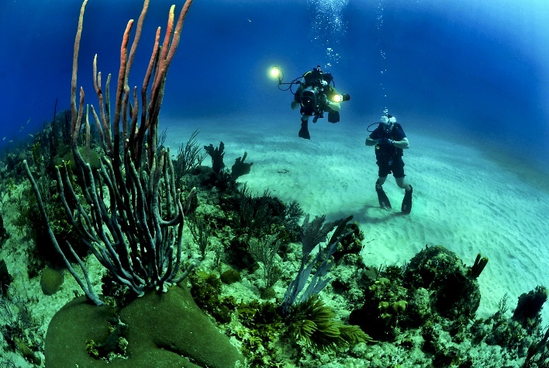 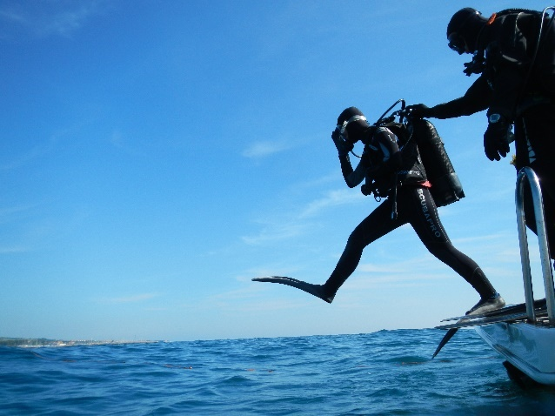

**The programme content is conceptualized, designed and solely the intellectual property of Trailblazers Adventure Travel Pvt Ltd. Copyright and other intellectual property laws protect these materials. Reproduction or retransmission of the materials, in whole or in part, in any manner, without the prior written consent of the copyright holder, is a violation of copyright law. Users may not distribute such copies to others, whether or not in electronic form, whether or not for a charge or other consideration, without prior written consent of the copyright holder of the materials.**

**Programme Cost**

**Cost per participant: INR**

**Non – refundable registration amount: INR 7,500/- per participant**

***Early bird discount of INR ... if registered by.... For more discount schemes, refer the FAQ section.***

**Cost Includes:**

# Content: Course material, PADI certification fee, all dive equipment, dive insurance, instructor fee, park entrances, boat charges, dive log book. Additionally, an Advanced Diver will accompany participants from Mumbai and participate in all dives with them. Cost also includes a min. 21 gear mountain bike with safety equipment and instructor for the cycling tour.

# Accommodation: Accommodation on twin/ triple sharing basis in a 3 star or equivalent hotel in Bali.

# Food: Vegetarian and Non-vegetarian breakfast, lunch and dinner starting from Mumbai airport to Mumbai airport. Meals will be a mix of Indian and International cuisines.

# Safety: First aid kit with trained, certified staff from Trailblazers.

# Travel: Internal travel for all the visits.

# Insurance

# Visa for Indian/ US passport holders

# Cost excludes:

1. **Optional expenses:** Additional activities opted during the visits.
2. **Others:** Aerated drinks, Extra bottled water, Extra meals other than the meal plan, shopping, telephone calls or Porter services, camera, video charges at parks/ monuments. Tips and gratuities.

**Eligibility:**The participant needs to be a strong swimmer able to swim 200 metres/yards (or 300 metres/yards in mask, fins and snorkel). There is no time limit for this and you can use any swimming style. You should also be able to float and tread water for 10 minutes using any methods you want.  
For medical eligibility, please refer to PADI guidelines given below.

**Safety:**

* Trailblazers experts are first aid certified and always carry a fully equipped first aid kit.
* Trailblazers experts follow Strict Child Protection Policy to ensure child safety during our domestic and International programmes.
* Swimming without supervision and overnight road journeys are strictly not allowed in any of Trailblazers programmes.
* We provide a wholesome child-friendly menu to the participants which can be customized according their requirement.

**Please Note:**

* Trailblazers representative will meet the group at Mumbai International Airport
* We will send you all the details regarding the trip at a later stage to help you prepare.
* Welcome kit and Parents Information Sheet will sent to the parents after registration.

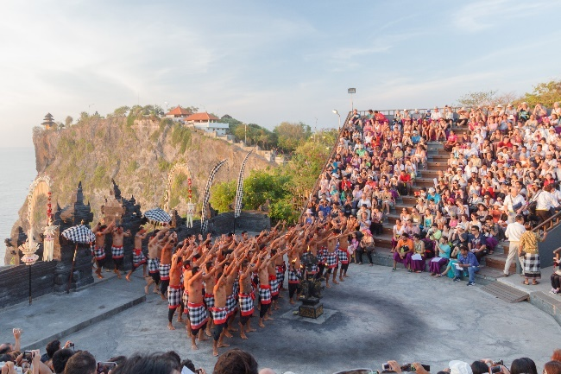 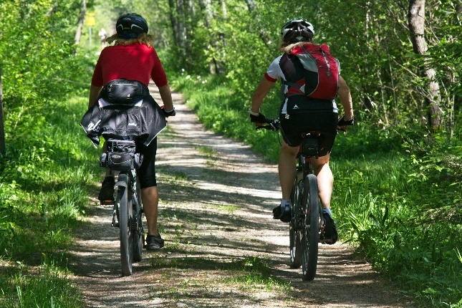

**How to register?**

**Step 1:**

Option 1 -Complete the payment and registration process on the website by clicking on ‘Book Now’.

Option 2- Alternatively, after online registration you can pay through cash/ cheque using the following details:

Cheque to be drawn in the favour of ‘Trailblazers Adventure Travel Pvt. Ltd’ or Cash to be deposited at your nearest branch using the following bank details-

ACCOUNT NAME: TRAILBLAZERS ADVENTURE TRAVEL PVT.LTD.

BANK NAME: IDBI BANK LTD.

ACCOUNT NUMBER: 0753102000001328

BRANCH: VASANT VIHAR.THANE (W), MAHARASHTRA

**Step 2:**

We will send you a confirmation through your registered email address in the next 2-3 working days.

**Step 3:**

Discount cash back (if applicable) will be credited into your bank account before the commencement of the trip.

We will be happy to help if you need any additional information regarding the programme and/ or the registration process. Please contact us on 022- 2173 9732/37 or at [camps@trailblazersindia.com](mailto:camps@trailblazersindia.com)

**Discount schemes?**

**Things to carry?**

* We would recommend 2 bags - Main luggage in a rucksack/medium sized suitcase & a small knapsack for day excursions.
* The knapsack which would also be a hand-luggage with a light jacket and a small freshen-up kit.
* We also would advise the parents to ask the child to pack his/her own luggage so that it is easy for them to locate their things.
* You should discuss with your child the importance of caring for his / her personal property. TRAILBLAZERS will not be responsible for items lost or stolen, although every effort will be made to see that this does not take place.

**A suggested list of items which we recommend as a guide of what to pack on our activity courses is as follows. You can add or minimize the number of clothes based on personal requirement:**

* Valid Passport (min. 6 months), 3 photocopies of passport, 3 passport sized photographs
* Comfortable trousers/ shorts for general activities (2)
* MCj03579310000[1]T-Shirts (6)
* Swimsuit
* One light jacket
* Undergarments (5) + Night wear
* Rainwear
* All purpose shoes for cycling and activities -1 pair
* ****Waterproof Sandals with straps –1 pair (No Flip flops please)
* Wash-kit (toothbrush, toothpaste, soap, shampoo, etc)
* Bath towel (easy to dry)
* Plastic bags for soiled, wet clothes
* Sunglasses + Cap + Waterproof sunscreen (SPF 25+) and lip balm
* Moisturizing cream/body cream/mosquito or insect repellent
* Water bottle (1 litre capacity)

Rucksack

Knapsack

* Binoculars (optional)
* Participants wearing lenses / spectacles to get an extra pair for safety.
* Pocket money not more than IDR 500.000/-
* Personal log book, pen/ pencil

*We allow electronic gadgets to be carried but the responsibility rests with the participants.*

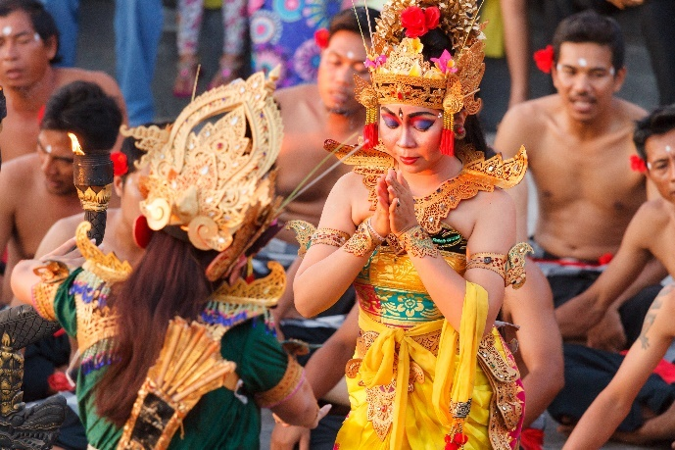 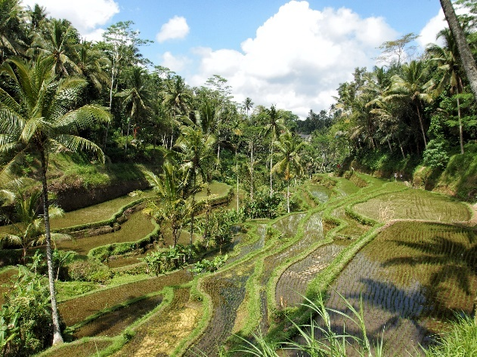

**Frequently Asked Questions**

1. **What is PADI?**

The Professional Association of Diving Instructors is the world's largest recreational diving membership and diver training organization.

1. **What is the PADI Open Water Course?**

The PADI Open Water diver course is the world’s most popular diving certification course. Learning to dive in Bali is a great way to invest your vacation time. It’s a lot of fun, you’ll get your PADI and you’ll see some amazing things.   
There is so much to explore underwater wherever you travel. After you learn to dive your vacations will never be the same again. The PADI Open Water course will teach you the skills to dive safely and independently anywhere in the world.

1. **Who can join the PADI Open Water diver course?**ThePADI Open Water course allows complete beginners to become certified scuba divers. You need to be at least 10 years old. There is no upper age limit to learn to dive as long as you are fit and healthy.
2. **Will I receive a certificate card after course completion?**Yes you will. You’ll receive a temporary certificate (and a handshake or high-five) on the day you finish the course. Your permanent diving licence will be mailed to your address. You can slip it in your wallet just like a credit card and show it whenever you want to dive worldwide. Your diving licence never expires. It’s your ticket to a lifetime of diving adventures.  
   Participants below age xx will receive a Junior Open Water card, which will automatically convert to an Open Water licence on their xx birthday.
3. **How many dives will I do?**  
   Five dives in the pool and then four great ocean dives.
4. **How deep will I dive?**  
   The maximum depth will be 18metres (60 feet).
5. **What will I see?**The great thing about taking your PADI Open Water diver course in Bali is that there is so much marine life. You’ll be blown away by the number and variety of fish you see and you’ll be amazed at how close they come. You’ll also get the unbelievable opportunity to dive at a World War Two shipwreck!
6. **Where will I dive?**  
   In Sanur and in Tulamben. After each dive you and your Instructor will complete your dive log-book with names of some of the amazing marine life you saw on your dives. Be warned! There are 400 species of fish living on the wreck so you may need some time to learn all their names.
7. **I wear spectacles/ lenses. Can I dive?**Even if a mask could seal over spectacles, the pressure of the scuba mask on the nose piece and the lenses of a diver's glasses could cause them to grind uncomfortably into the diver's face. Instead of spectacles, divers can opt for contact lenses.   
   Participants are to inform the dive instructors if they are wearing contact lenses.
8. **What’s the weather like?**May and June are dry months in Bali. The average temperature in May is 28°C, while the average low is 23°C, and the average high is 33°C.The average temperature in June is 27°C, while the average low is 22°C, and the average high comes in at 31°C.  
   Note, these are weather forecasts and not guaranteed weather conditions.
9. **What are the safety provisions?**Trailblazers experts follow Strict Child Protection Policy to ensure child safety during our domestic and International programmes.The team follows a comprehensive Standard Operation Procedure during the camp.Swimming without supervision and overnight road journeys are strictly not allowed in any of Trailblazers programmes. **Adult supervision** during all activities, visits and all other times.  
   All participants will be insured with a dive insurance and a travel insurance.
10. **What are the medical facilities available?**Trailblazers team members are certified first- aiders from St. John’s, Mumbai. Besides, the nearest hospital is informed about the camp and a doctor on call is available through out.
11. **What are the qualifications of the instructor?**The lead instructors are minimum Post Graduates with specialization in fields of Ornithology, Bio-diversity, Botany, Psychology or Mountaineering. The team holds experience of working with students from Indian and International schools. Instructors are also PADI certified divers and first aid certified.  
    All dive instructors will be PADI certified trainers.
12. **What is the staff- child ratio?**For safety reasons, we have a maximum of 4 divers per dive instructor. Additionally, there will be two camp leaders for a group of maximum 24 participants.
13. **How are the food allergies and dietary requirements taken care of?**Our team will study the medical allergies/ dietary requirements of the child before the camp and will make adequate provisions for the same. They will get in touch with the parent in case if they have any additional queries.
14. **What type of food will be served?**  
    We serve child friendly menu during our camps and ensure all meals are hygienic and wholesome with a wide range of cuisines to accommodate as many preferences as possible.
15. **What is the cancellation policy?**Please refer to our detailed cancellation policy on the website.
16. **Can parents visit when the camp is in progress?**  
    We don’t allow parents to visit the camp since we want the participant to learn to be independent away from home.
17. **How much pocket money should the participant carry?**

All expenses are paid for and the participant will not have to spend at any point. However, participants may carry a maximum of IDR 500.000 for personal expenses.

1. **Are mobile phones allowed during this programme?**  
   Yes. However, they will be permitted to use only during specified hours.
2. **How do I get access of the photographs from the camp?**We will update the pictures frequently on our Facebook page [www.facebook.com/Trailblazers.TheOutdoorSchool/](http://www.facebook.com/Trailblazers.TheOutdoorSchool/) and Instagram page <https://www.instagram.com/trailblazers.theoutdoorschool/> . Please note that uploading photographs will depend on internet connectivity and may or may not feature your child. The purpose of the photograph will be to showcase happenings during the camp.
3. **How do I communicate with my child during the programme?**We will send you daily update through SMS/ personal WhatsApp message about the activities of the day.

**\*\*Attach PADI Medical Form**