|  |
| --- |
| *Welcome to* |
| **Camp Voyager- China** |
| Summer Outbound 2018 for 12-16 year olds |



|  |
| --- |
| User  [Pick the date] |



**Trailblazers Adventure Travel Pvt. Ltd, Mumbai**

504, India Bulls Mint, Manpada, Thane West – 400 610

Email: [camps@trailblazersindia.com](mailto:camps@trailblazersindia.com) Phone: 022-21 73 97 32/37

Web: [www.trailblazersindia.com](http://www.trailblazersindia.com)

[](https://www.linkedin.com/company-beta/3801286/) [cid:image001.png@01D1FECC.B8F3BD60](https://www.facebook.com/Trailblazers.TheOutdoorSchool) [](http://www.instagram.com/trailblazers.india) [cid:image005.png@01D1FE57.2413EAF0](https://twitter.com/Trailblazers_In) [](http://thetrailblogger15.blogspot.in/) [ECOTRAIL](http://trailblazersindia.com/ecotrail/ecotrail.htm)

# **About Trailblazers**

Trailblazers is a 23 year old private enterprise doing pro active outbound environment education in India through eco-camps, wildlife, heritage, trekking and adventure programmes. We have worked with 1,00,000+ campers since 1994. The programmes are interactive, carved out with meticulous planning and research and aim to provide children and adults with fun experiences that enable them to discover the world and themselves, while making them more sensitive to nature & environment.

To know more about us please visit [www.trailblazersindia.com](http://www.trailblazersindia.com).

# **Programme Invitation**

Dear parent,

Trailblazers Adventure Travel Pvt. Ltd, Mumbai invites your child to be a part of our Camp Footloose.

Trailblazer’s Summer Camps are designed to offer your child an unforgettable summer in the month of May 2017. Your child will be away from his regular routine exploring new skills, developing leadership qualities, taking up various challenges, discovering closeness to mother nature, increasing self belief and independence of thought all in a fun way with the help of friendly, well trained and expert professionals from Trailblazers.

Trailblazers Summer Camps & Expedition are all about you. Camps and Expeditions means fun, meeting new people, means doing new things, means learning a skill, means doing more than you think you can do.

Summer camps are enabler’s. They enable you to explore different facets of self, Enables you to see how much is possible, Enables you to explore the country, people and make new friends, Enables you to reach your potential, Enables you to have clean fun, good food, new friends increasing your Face book circle, Enables you to do things you can’t or would not have done, Enables you to be healthy and learn a lot of new skills and lastly it Enables you to be the Global person you really are. The world is flat and it’s yours to see and seek. Trailblazer’s Summer Camp Footloose enables you to succeed.

Regards,

Ranjan Biswas

Managing Director

Email: [ranjan@trailblazersindia.com](mailto:ranjan@trailblazersindia.com)



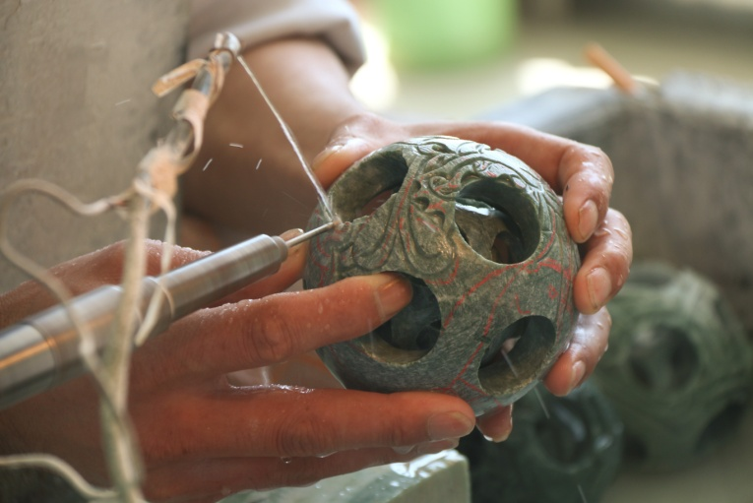

**Sample Itinerary**

|  |  |
| --- | --- |
| **Day 1** | Arrive in Beijing and drive to the hotel.  Dinner, orientation to the programme and overnight stay in the hotel. |
| **Day 2** | Breakfast and drive to the spectacular **Great Wall at Juyong pass**, **photo stop at Bird’s Nest**,  **shop at the Jade factory** and visit **Huiyuan Beverage Co. Ltd** with lunch enroute.  Return to the hotel, dinner and lights out. |
| **Day 3** | Post breakfast; visit **the Tiananmen square** and UNESCO **World Heritage site of Forbidden city**.  Afternoon visit the imperial complex of religious buildings - **Temple of Heaven** and then have a session on the ancient Chinese martial art – **Tai chi** and explore its health benefits and uses in self-defence.  Dinner and overnight stay in Beijing. |
| **Day 4** | Breakfast, check out and drive to the railway station.  Travel by **high speed train to X’ian**. Arrive and check in to hotel. Learn **dumpling making** along with an **introductory session on Chinese dumplings**, explore **city wall photo shop, big wild goose pagoda with fountain show.** Dinner and lights out. |
| **Day 5** | Post breakfast, visit **Terra cotta** and **crockery factory** and then drive to the railway station for high speed train to Chengdu. Arrive; check in, dinner and overnight stay in Chengdu. |
| **Day 6** | Breakfast and **discover the world of pandas** at the Panda Breeding Base. Head to Beijing and board flight to India. |



**The programme content is conceptualized, designed and solely the intellectual property of Trailblazers Adventure Travel Pvt Ltd. Copyright and other intellectual property laws protect these materials. Reproduction or retransmission of the materials, in whole or in part, in any manner, without the prior written consent of the copyright holder, is a violation of copyright law. Users may not distribute such copies to others, whether or not in electronic form, whether or not for a charge or other consideration, without prior written consent of the copyright holder of the materials.**

**Programme Cost**

**Cost per participant: INR**

**Non – refundable registration amount: INR 5,000/- per participant**

***Early bird discount of INR ... if registered by.... For more discount schemes, refer the FAQ section.***

**Cost Includes:**

# Content: The content covers workshops, expert guidance and activities by professionals during the programme.

# Accommodation: Accommodation on triple sharing basis in minimum 3 star hotels in Beijing, X’ian and Chengdu.

# Food: Vegetarian and Non vegetarian breakfast, lunch and dinner starting from …. . Meals will be a mix of Chinese, Indian and International.

# Safety: First aid kit with trained, certified staff from Trailblazers.

# Travel: Internal travel for all the visits.

# Insurance

# Cost excludes:

1. **Visa:**
2. **Optional expenses:** Additional activities opted during the visits.
3. **Others:** Aerated drinks, Extra bottled water, Extra meals other than the meal plan, shopping, telephone calls or Porter services, camera, video charges at monuments. Tips and gratuities.

**Safety:**

* Trailblazers experts are first aid certified and always carry a fully equipped first aid kit.
* Trailblazers experts follow Strict Child Protection Policy to ensure child safety during our domestic and International programmes.
* Swimming and overnight road journeys are strictly not allowed in any of Trailblazers programmes.
* We provide exclusive child menu to the participants which can be customized according their requirement.

**Please Note:**

* Trailblazers representative will meet the group at Mumbai/ Delhi International Airport
* We will send you all the details regarding the trip at a later stage to help you prepare.
* Welcome kit and Parents Information Sheet with all trip related information will be sent to the parents after registration.

**How to register?**

**Step 1:**

Option 1 -Complete the payment and registration process on the website by clicking on ‘Book Now’.

Option 2- Alternatively, after online registration you can pay through cash/ cheque using the following details:

Cheque to be drawn in the favour of ‘Trailblazers Adventure Travel Pvt. Ltd’ or Cash to be deposited at your nearest branch using the following bank details-

ACCOUNT NAME: TRAILBLAZERS ADVENTURE TRAVEL PVT.LTD.

BANK NAME: IDBI BANK LTD.

ACCOUNT NUMBER: 0753102000001328

BRANCH: VASANT VIHAR.THANE (W), MAHARASHTRA

**Step 2:**

We will send you a confirmation through your registered email address in the next 2-3 working days.

**Step 3:**

Discount cash back (if applicable) will be credited into your bank account before the commencement of the trip.

We will be happy to help if you need any additional information regarding the programme and/ or the registration process. Please contact us on 022- 2173 9732/37 or at [camps@trailblazersindia.com](mailto:camps@trailblazersindia.com)

**Discount schemes?**

**Things to carry?**

* We would recommend 2 bags - Main luggage in a rucksack/medium sized suitcase & a small knapsack for day excursions.
* The knapsack which would also be a hand-luggage should be packed with a warm jacket, one pair of clothes and a small freshen-up kit.
* We also would advise the parents to ask the child to pack his/her own luggage so that it is easy for them to locate their things.
* You should discuss with your child the importance of caring for his / her personal property. TRAILBLAZERS will not be responsible for items lost or stolen, although every effort will be made to see that this does not take place.

**A suggested list of items which we recommend as a guide of what to pack on our activity courses is as follows. You can add or minimize the number of clothes based on personal requirement:**

* Comfortable trousers for general activities(2)
* MCj03579310000[1]T-Shirts(5)
* One warm jacket
* Undergarments (4) + Night wear
* Rainwear
* All purpose shoes for trekking and activities -1 pair
* ****Waterproof Sandals with straps –1 pair (No Flip flops please)
* Wash-kit (toothbrush, toothpaste, soap, shampoo, etc)
* Bath towel (easy to dry)
* Plastic bags for soiled, wet clothes
* Sunglasses + Waterproof sunscreen (SPF 25+) and lip balm
* Moisturizing cream/body cream/mosquito or insect repellent
* Water bottle (1 litre capacity)

Rucksack

Knapsack

* Binoculars (optional)
* Participants wearing lenses / spectacles to get an extra pair for safety.
* Flashlight(torch) with extra batteries
* Pocket money not more than Rs.500/-
* Personal log book, pen/ pencil and ID card

*We will allow electronic gadgets but the responsibility rests with the students.*

**Frequently Asked Questions**

1. **What are the safety provisions?**
2. Trailblazers experts follow Strict Child Protection Policy to ensure child safety during our domestic and International programmes.

The team follows a comprehensive Standard Operation Procedure during the camp.

Swimming and overnight road journeys are strictly not allowed in any of Trailblazers programmes.

**Adult supervision** will be carried during all the activities, visits and all other times.

1. **What are the medical facilities available?**
2. Trailblazers team members are certified first- aiders from St. John’s, Mumbai. Besides, the nearest hospital is informed about the camp and a doctor on call is available through out.
3. **What are the qualifications of the instructor?**
4. The lead instructors are minimum Post Graduates with specialization in fields of Ornithology, Bio-diversity, Botany, Psychology or Mountaineering. The team holds experience of working with students from Indian and International schools.
5. **What is the staff- child ratio?**
6. **How are the food allergies and dietary requirement taken care of?**
7. Our team will study the medical allergies/ dietary requirements of the child before the camp and will make adequate provisions for the same. They will get in touch with the parent in case if they have any additional queries.
8. **What type of food will be served?**
9. We serve child friendly menu during our camps and ensure all meals are hygienic and wholesome with a wide range of cuisines to accommodate as many preferences as possible. Meals will be mostly in buffet style.
10. **What is the cancellation policy?**
11. Please refer to our detailed cancellation policy on the website.
12. **Can parents visit when the camp is in progress?**
13. We don’t allow parents to visit the camp since we want the child to learn to be independent away from home.
14. **How much pocket money should the child carry?**
15. **Are mobile phones allowed during this programme?**
16. Yes. However, they will be permitted to use only during specified hours.
17. **What’s the weather like?**
18. **How do I get access of the photographs from the camp?**
19. We will update the pictures frequently on our Facebook [www.facebook.com/Trailblazers.TheOutdoorSchool/](http://www.facebook.com/Trailblazers.TheOutdoorSchool/) and Instagram page <https://www.instagram.com/trailblazers.theoutdoorschool/> . Please note that uploading photographs will depend on internet connectivity and may or may not feature your child. The purpose of the photograph will be to showcase happenings during the camp.
20. **How do I communicate with my child during the programme?**
21. We will send you daily update through SMS/ personal WhatsApp message about the activities of the day.