**Technical Design Document**

**Flash Starling framework**



Copyright: Virtuos Games 2012

# Table of Contents

Table of Contents ii

1. Terms and Definitions 1

2. Products and Development Overview 2

2.1 Summary Product Description 2

2.2 Development Staff 2

Programming Staff 2

2.3 Reviewing System 2

2.4 Development Environment 4

Development Software 4

Using ActionScript Build Path 4

Version Control Methodology 6

Project Management Methodology 6

Backup Methodology 7

3. System Resources Allocation 8

3.1 Platform Specification 8

CPU 8

Main Memory 8

VRAM 8

LCD 8

Network 8

Controller 8

3.2 CPU Budget 8

3.3 Memory Budget 8

3.4 Texture Benchmark 9

3.5 Geometry Benchmark 9

4. Data Pipeline and Tools 9

4.1 Texture Pipeline and Tools 9

4.2 ANI&VSA 12

4.3 Audio Pipeline and Tools 14

4.4 Font Pipeline and Tools 14

4.5 Resource Editor 16

5. Programming Conversions 18

5.1 Coding Style 18

Coding Style 18

5.2 Sprint Planning Meeting 18

5.3 Code Review 18

5.4 TDDs 18

1. Terms and Definitions

To list words or phrases used in this document to describe the game and technology.

**TRC –** Technical Requirements Checklist, which must be followed for all games.

2. Products and Development Overview

2.1 Summary Product Description

2.2 Development Staff

### Programming Staff

Ian Sweeny Director

Zhang Chi Lead Programmer

Xiao Yu Ting Director Programmer

Wang Peng He Programmer

Bao Ke Hang Programmer

Yu Ya Ling Programmer

2.3 Reviewing System

In order to maintaining our code perform better and preventing the hard coding. We need a reviewing system.

In this system we encourage the team-members to strengthen reviewing code for each other.

The reviewing structure can be defined as:

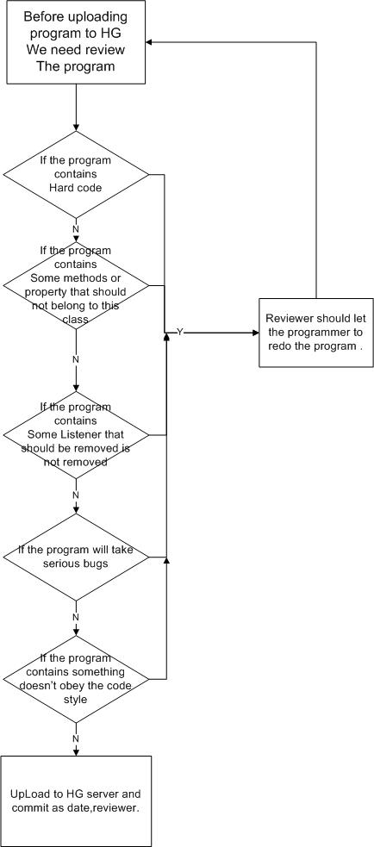

The different meetings taking place are: (Virtuos Default)

* Sprint Planning : Monday every 2 weeks, Leads + Directors + Producer + Scrum Master
* Daily Meeting : every day, Scrum Team
* Sprint Review (demo) : Friday every 2 weeks, Leads + Directors + Producer + Scrum Master
* Sprint Retrospective : Scrum Team + Producer
* Ad-hoc Product Backlog review meetings: Leads + Directors + Producer + Scrum Master

2.4 Development Environment

### Development Software

* Windows Operating System

*Microsoft Windows XP SP3*

* Flash Builder 4.5+
* AIR3.3 SDK
* Starling 1.1 framework.

### Using ActionScript Build Path

Using the flash-builder mechanism to import a SWC or Lib into project instead of putting them into the project folder directly.

* The way to import lib using flash-builder mechanism

Right click the project. And then choose the properties.

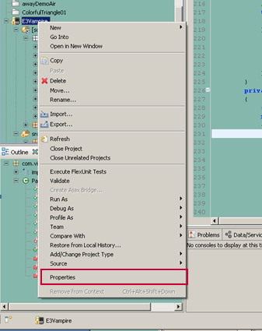

Then choose the ActionScript Build Path Source path Tab and click Add Folder button.

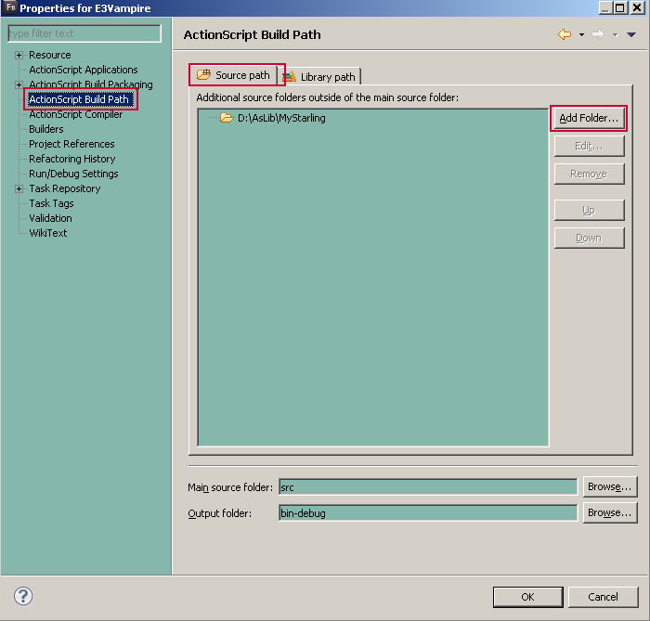

Click Browse button and choose the Lib folder to import the lib outside the project.

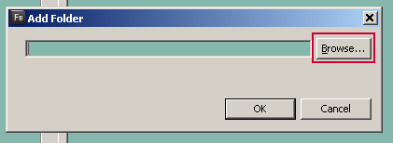

So the lib will appear in the project tree. And we can also edit them directly.

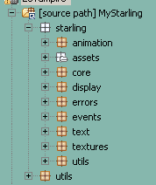

### Version Control Methodology

* HG

We used HG for version control. We use weak locking control methodology, one can edit files at his own computer and confirm to server, you need to update your work copy before confirm your work, if there is a conflict you should solve it. We don’t advise to create a branch.

* TeamCity

It’s for continuous integration.

### Project Management Methodology

* Scrum
  + Agile Development
  + Scrum will be used for project management
  + Backlog
  + 2-week Sprint
  + Sprint meeting
  + Task dissemination process

The team breaks down each story into tasks during each sprint planning meeting, each task is estimated in story points. Once a task is claimed by someone, it moves from the Todo list to the WIP(work in progress) list. We update the status for all tasks in the daily scrum meetings to reevaluate the remaining work until it is finished. A task deemed finished is then moved to the Verify list until a team leader check it and confirm if it’s done or not. Excel is used for task tracking

* Virtuos.net

Virtuos.net is an internal web site to share and manage project documents.

### Backup Methodology

A separated HG server will perform automatic backup every day.

3. System Resources Allocation

3.1 Platform Specification

### CPU

System controller includes:

* Ipad Apple A4 1GHZ

### Main Memory

* 256M

### VRAM

### LCD

* 1024*768 ipad.

### Network

* WIFI ,3G

### Controller

* Home button

3.2 CPU Budget

3.3 Memory Budget

3.4 Texture Benchmark

3.5 Geometry Benchmark

4. Data Pipeline and Tools

4.1 Texture Pipeline and Tools

In the art resources, we cannot use the Shape, Button or Static text. All Shape should be converted to bitmap and be named properly. All Button should be converted to 3-keyframe movie clip. All static text fields should be converted to dynamic text fields and also need to be named properly. Avoid the usage of Chinese name.

Then we can export the texture by choosing all of bitmaps and generating them to a big texture. Remember, the texture size should not bigger than 2048*2048.

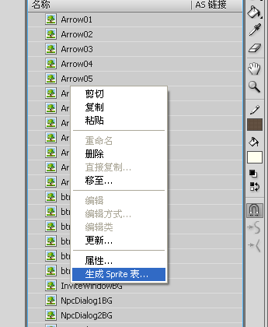

Named the texture properly and choose the data format as Starling.

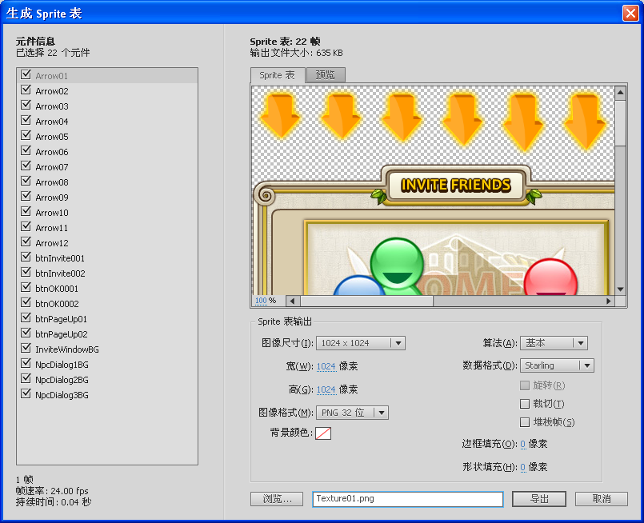

Then we can get one PNG file and one XML file.



Finally, you should export the main XML file which includes all movie clip information.

Click ‘command’ button than choose ‘Export VFF XML’.

PS: There are 2 kinds of assets we have right now that is ANI and VSA

The ANI is exported by “Export ANI XML.jsfl”

The VSA is exported by “Export VFF (Virtuos Flash Format) XML.jsfl”

Note: You can put the .jsfl file to

Windows XP:

C:\Documents and Settings\user_name\Local Settings\Application Data\Adobe\Flash CS6\zh_CN\Configuration\Commands

Windows® 7™：

C:\Users\user_name \AppData\Local\Adobe\Flash CS6\langurage\Configuration\Commands

Mac:

Macintosh HD/Users/ user_name /Library/Application Support/Adobe/Flash CS6/langurage/Configuration/Commands

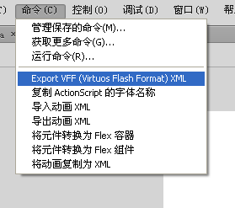

***Art Tools***

* Adobe Photoshop CS2+
* Flash CS6+

4.2 ANI&VSA

Firstly ,you should have your .xml and .png together in a folder

Using VirtuosStatlingEdit to package .ani file which is the animation format .

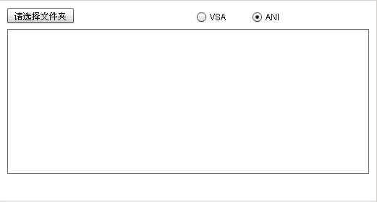

Press the button and then choose the folder that contains both the xml&png files.

PS：you can choose the file type ANI is the animation which is lighter than VSA.

VSA is the UI or HUD assets which has the layer property.

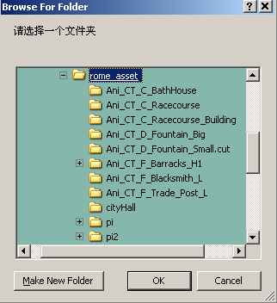

Click “ok” to make the animation file.note: the file name is according to the sub folder’s name.

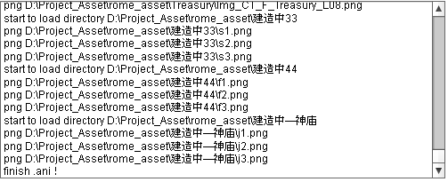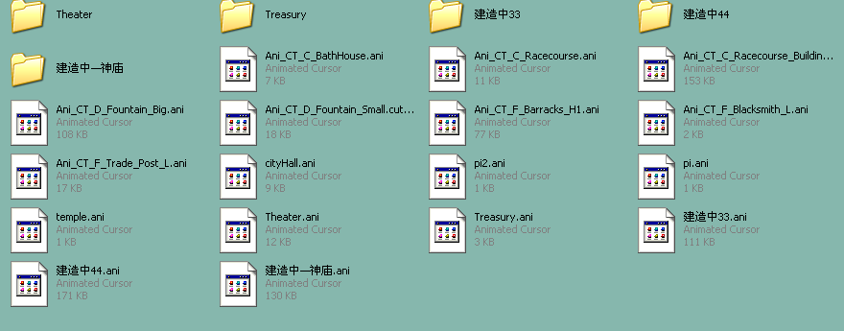

4.3 Audio Pipeline and Tools

4.4 Font Pipeline and Tools

Before we use the font, we need export all the font we need to a SWC file first.

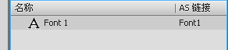

Choose SWC in publish setting than publish.

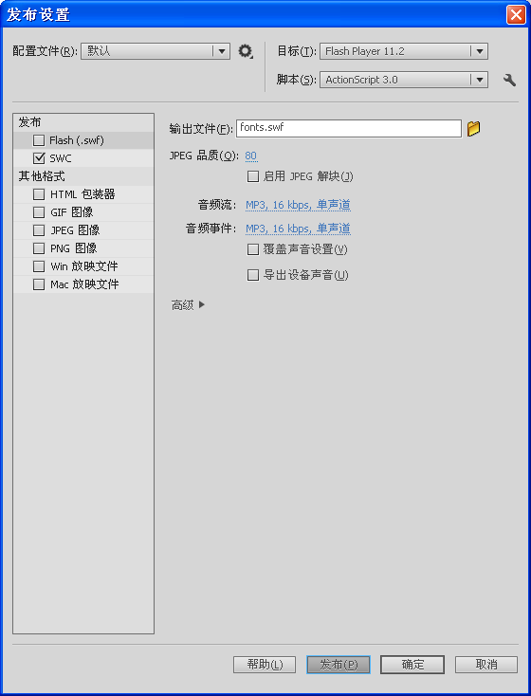

Use the following code to register font.

**import** flash.text.Font;

private function configFonts():void

{

Font.registerFont(Font1);

Font.registerFont(Font2);

…

}

Import our text field class before we need to modified text field:

**import** com.virtuos.display.text.TextField;

We can announce the text field instance like:

private var myText: TextField = new TextField ();

myText.text = ‘Hollow World!’;

addChild(myText);

4.5 Resource Editor

This is a resource manager and xml-config exporter which can export starling-xml easily.

Export XMLs resources from this application

Import XML resources into this application

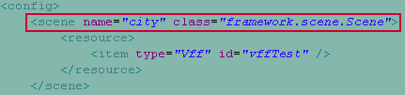

In scene-config.xml

Resource console

Different type of resources info that have been imported

Resources in current scene

remove the scene label

label

Add the scene

label

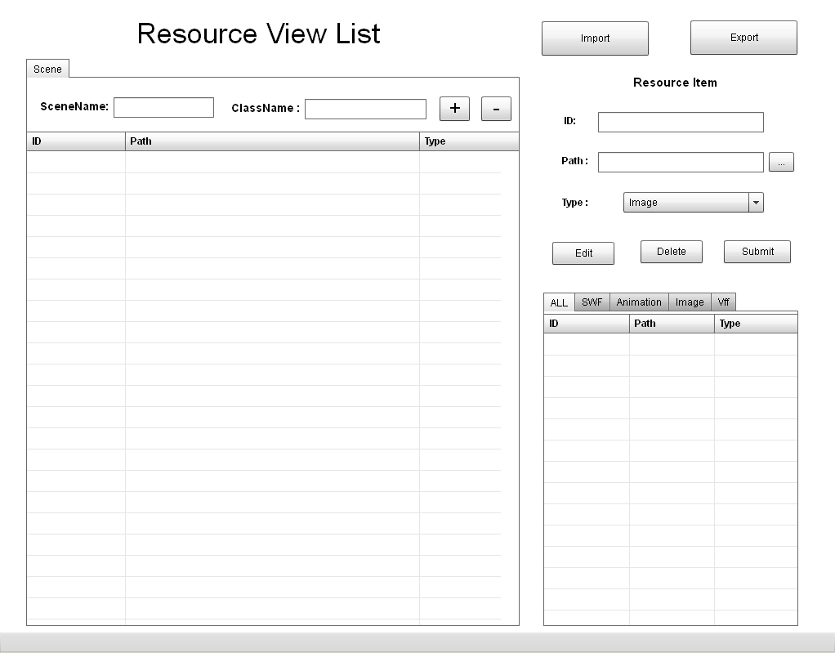

5. Programming Conversions

5.1 Coding Style

### Coding Style

Please follow the document “代码规范白皮书.docx” as your programming rules.

5.2 Sprint Planning Meeting

At the beginning of each sprint, all team members will have a sprint planning meeting. During the meeting, all sprint backlog items will be discussed and estimated. Through this, every team member and programmer in particular will be clearly kept aware of the sprint’s goals and the associated tasks road-map.

The sprint planning meeting is important and acts as a powerful driver to reduce risk.

5.3 Code Review

Another programmer will be asked to perform a code review for each sprint.

At the beginning of project,.

5.4 TDDs

In principle, TDDs are required for all tasks.

For simple tasks, it is acceptable not to have a TDD. However, TDDs are mandatory for the important and complex ones.