VAM_porting_DEV_EXP |  | 2012  July
By: Zhang Chi | EXP Share Document

Overview
This is a prototype of ios social game. The player is a vampire and you should survival in the game with lots of famer and vampire-Hunter spawning into the level.
The most challenge feature in game is the path-finding AI of enemy.

Requirements
- Vampire ‘s dash movement.
- Enemy’s AI.

Dependencies
- Flash builder4.5
- Flash stage3D API
- Flash player11 or higher

Vampire’s Dash
The player’s movement is a new feature we haven’t done before , so I think it is important to share it here.
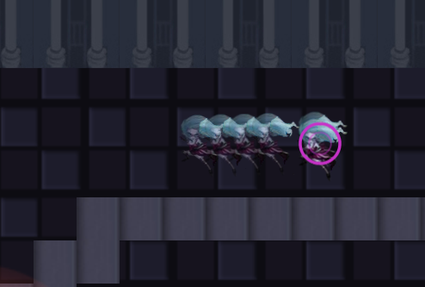
Because the gameplay of the game is screen scrolling. So the player is always at the center of the map, so the movement I think should belong to the mylevel class.
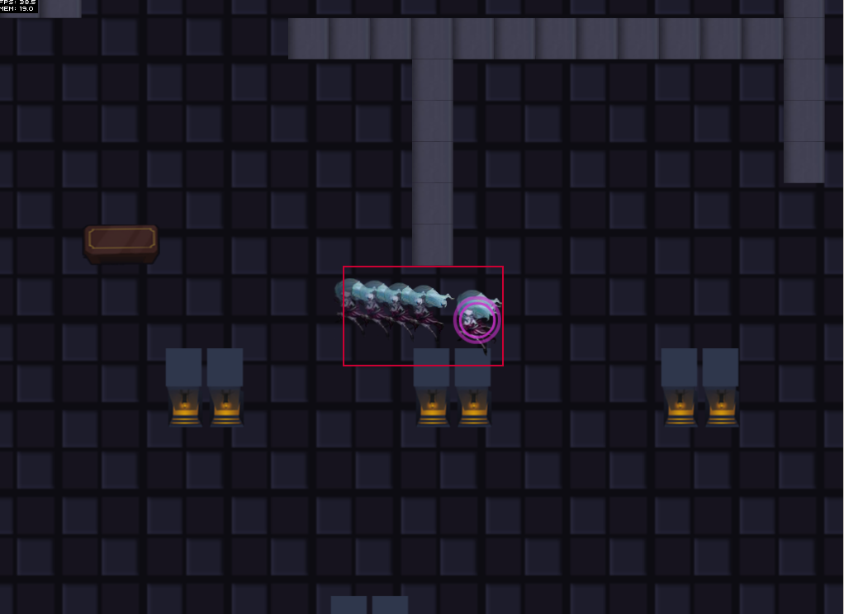
Firstly we should implement a touchEvent which is the input event to tell the player where to go.
//触碰地图传坐标
this.addEventListener(TouchEvent.TOUCH,onTouch);
…
//the constant position that is the center of the map.
private const _tempOrgX:uint=497
private const _tempOrgY:uint=359
private function onTouch(e:TouchEvent):void
{

var curTouch:Touch = e.getTouch(this);
if (curTouch)
{
if (curTouch.phase == "began")
{
//if the player isn’t feed the enemy.
if(!DataManager._playerFeeding){
_targetPoint=new Point(curTouch.globalX-25,curTouch.globalY-25);
/***确定player移动的位置坐标**/
if(_len==0){
tempVec[0]=_tempOrgX-_targetPoint.x;
tempVec[1]=_tempOrgY-_targetPoint.y; dis=Math.sqrt(tempVec[0]*tempVec[0]+tempVec[1]*tempVec[1])
tempVec[2]=tempVec[0]/dis
tempVec[3]=tempVec[1]/dis //get the player’s position in the map
DataManager._playerPoint=new Point(_tempOrgX-this.x,_tempOrgY-this.y) _destinyArray[0]=tempVec
}
}
if(!this.hasEventListener(Event.ENTER_FRAME)){
this.addEventListener(Event.ENTER_FRAME,onEnterFrame);
}
}else if(curTouch.phase == "hover"){

}
}
}
The following is the movement of the player in the level. Actually the player is not move but the map.
private var cumulateX:Number=0;
private var cumulateY:Number=0;
//dash模拟增量
private var cumulateDashX:Number=0;
private var cumulateDashY:Number=0;
private var _dashSpeed:Number;
private var _playerDisX:Number;
private var _playerDisY:Number;
private var temp0:Number;
private var temp1:Number;
private var temp2:Number;
private var temp3:Number;
//x分量的速度
private var _plusX:Number;
//y分量的速度
private var _plusY:Number;
//x分量的dash速度
private var _plusDashX:Number;
//y分量的dash速度
private var _plusDashY:Number;
//dash delay
private var _dashDely:uint=0;
//距离
private var _distance:Number;

private function onEnterFrame(e:Event):void{
var _len:uint=_destinyArray.length;
DataManager._playerPoint=new Point(_tempOrgX-this.x,_tempOrgY-this.y);
if(_destinyArray.length==0){
this.addEventListener(Event.ENTER_FRAME, this.removeShadow);
return
}
//temp0:x偏量，temp1:y偏量；
temp0=_destinyArray[0][0];
temp1=_destinyArray[0][1];
temp2=_destinyArray[0][2];
temp3=_destinyArray[0][3];
_distance=Math.sqrt(temp0*temp0+temp1*temp1);

DataManager._dashSpeed=_dashSpeed=_distance/DataManager._dashDuration;
//collision
if(OBJCollision.playerCollisions(temp2,temp3,_dashSpeed)){
this.removeEventListener(Event.ENTER_FRAME,removeShadow);
_destinyArray.shift();
cumulateX=0;
cumulateY=0;
cumulateDashX=cumulateDashY=0;
Player.getInstance().x=0;
Player.getInstance().y=0;
DataManager._playerMoving=false;
return
}
//x分量的速度
_plusX=_dashSpeed*temp2;
//y分量的速度
_plusY=_dashSpeed*temp3;
//x分量dash的速度
_plusDashX=_dashSpeed*temp2;
//y分量dash的速度
_plusDashY=_dashSpeed*temp3;
//camera reach point
if(cumulateDashX>=Math.abs(temp0)-Math.abs(_plusDashX)||cumulateDashY>=Math.abs(temp1)-Math.abs(_plusDashY)){
_plusDashX=_plusDashY=0;
DataManager._playerMoving=false;
} if(cumulateX>=Math.abs(temp0)||cumulateY>=Math.abs(temp1)){
cumulateX=0;
cumulateY=0;
cumulateDashX=cumulateDashY=0;
_dashDely=0;
Player.getInstance().x=0;
Player.getInstance().y=0;
_destinyArray.shift();
return
}
/****
* amortize,缓冲
* */
if(_dashDely<4){
_dashDely++
if(DataManager._playerMoving){
cumulateDashX+=Math.abs(_plusDashX);
cumulateDashY+=Math.abs(_plusDashY);

Player.getInstance().x-=_plusDashX;
Player.getInstance().y-=_plusDashY;

}else{
Player.getInstance().x+=_plusX;
Player.getInstance().y+=_plusY;
}
}else{
cumulateX+=Math.abs(_plusX);
cumulateY+=Math.abs(_plusY);

this.x+=_plusX;
this.y+=_plusY;
if(DataManager._playerMoving){
if(cumulateDashX>=Math.abs(temp0)-Math.abs(2*_plusDashX)||cumulateDashY>=Math.abs(temp1)-Math.abs(2*_plusDashY)){
Player.getInstance().x-=_plusDashX;
Player.getInstance().y-=_plusDashY;
}else{
Player.getInstance().x-=_plusDashX/100;
Player.getInstance().y-=_plusDashY/100;
}
cumulateDashX+=Math.abs(_plusDashX);
cumulateDashY+=Math.abs(_plusDashY);
}else if(!DataManager._playerMoving){
Player.getInstance().x+=_plusX;
Player.getInstance().y+=_plusY;
}
}
DataManager._playerPoint=new Point(_tempOrgX-this.x+Player.getInstance().x,_tempOrgY-this.y+Player.getInstance().y)
}
//end
That will have the player moving with some offset which looks like the player move first and the camera follow it.
pretty cool
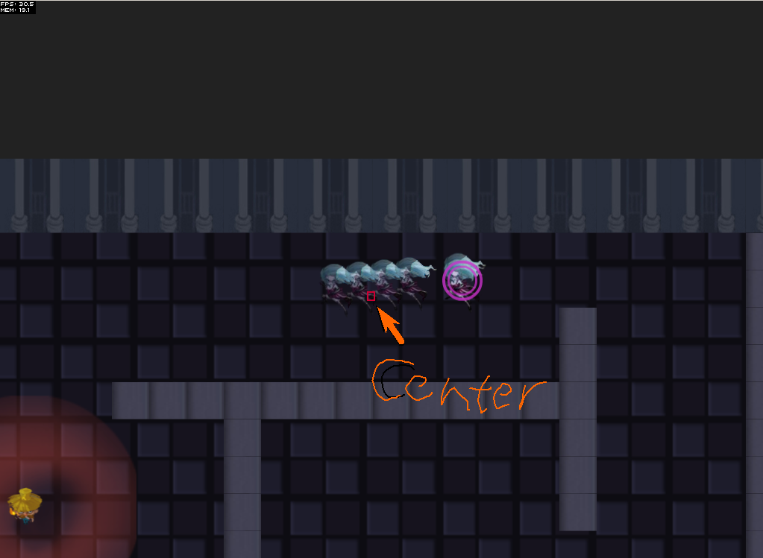

AI
The AI in-game includes path-finding , collision, etc. in this DOC I will talk the path-finding which use the a* algorithm.

Firstly we have a PathFinder class which package the whole AI logic inside.
It have 6 parameters and returns a vector.
findPath(map:Array,sX:uint=7,sY:uint=1,eX:uint=5,eY:uint=1,$enemy:BaseEnemy=null):Vector
map: the whole map informations include the path, the collisions.
sX,sY, start Position.
eX,eY,end Position.
$enemy enemy .

Secondly we have a object that contains the x,y,counter info.
Soon every grid of the map will have these infos.
Var finishObject={i:_endX,j:_endY,counter:0};
This means the finish Point Grid ‘s positions and the counter means the cost to reach there.

Then we have a queue to push every grid we search.
_queue = new Vector.<Object>();
_queue.push(finishObject);
Lastly we have a recursion method checkQueue() which include 3 parameters.
checkQueue(startIndex:int, counter:int, enemyType:String):void

var lastQueueLength:int = _queue.length;
var i:int= startIndex;
for (; i < lastQueueLength; i++)
{
var coordinate:Object;
//check top
if (_queue[i].j != 0 &&isPath(_map[_queue[i].i][_queue[i].j - 1]))
{
coordinate = {i: _queue[i].i, j: _queue[i].j - 1, counter:counter};
//if this coordinate is the start finish algorothm as
//the shortest path was just found
if (coordinate.i==_startX&&coordinate.j ==_startY)
return;
//if a coordinate already exists in the queue
//and has higher coordinate it won't be added
//but if it has lower coordinate it will replace the one in the queue
if (canBeAddedToQueue(coordinate))
_queue.push(coordinate);
}
//check right
if (_queue[i].i != _map.length - 1 &&isPath(_map[_queue[i].i + 1][_queue[i].j]))
{
coordinate = {i: _queue[i].i + 1, j: _queue[i].j, counter:counter};
if (coordinate.i==_startX&&coordinate.j == _startY)
return;
if (canBeAddedToQueue(coordinate))
_queue.push(coordinate);
}
//check bottom
if (_queue[i].j != _map[_queue[i].i].length - 1 &&isPath(_map[_queue[i].i][_queue[i].j + 1]))
{
coordinate = {i: _queue[i].i, j: _queue[i].j + 1, counter:counter};
if (coordinate.i==_startX&&coordinate.j == _startY)
return;
if (canBeAddedToQueue(coordinate))
_queue.push(coordinate);
}
//check left
if (_queue[i].i != 0 &&isPath(_map[_queue[i].i-1][_queue[i].j]))
{
coordinate = {i: _queue[i].i - 1, j: _queue[i].j, counter:counter};
if (coordinate.i==_startX&&coordinate.j == _startY)
return;
if (canBeAddedToQueue(coordinate))
_queue.push(coordinate);
}
}
checkQueue(lastQueueLength, counter + 1,enemyType);
}

Additionally there are another 2 method
If the grid’s counter we check now is lower than the queue return true.
private static function canBeAddedToQueue(coordinate:Object):Boolean
{
var i:int=_queue.length - 1
for (; i >= 0 ; i--)
{
if (coordinate.i == _queue[i].i && coordinate.j == _queue[i].j)
{
if (coordinate.counter >= _queue[i].counter)
{
return false;
}
else
{
_queue.splice(i, 1);
return true;
}
}
}
return true;
}
private static function isPath($pathPoint:uint):Boolean{
if($pathPoint==0||$pathPoint==7||$pathPoint==8){
return true;
}else{
return false;
}
}

And that will take the whole map counter informations.
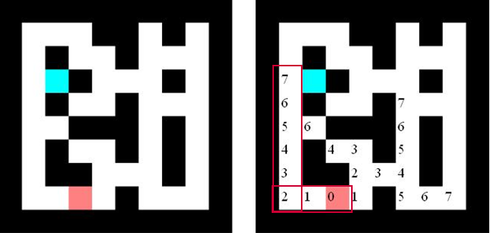
So the last thing is simple . we can collect the path info from the end of the queue Vector ,and compare their counter . we can have a path vector. So the AI knows where he should go.
