Flash_3D_DEV_Conclusion |  | 2012  March
By: Zhang Chi | EXP Share Document

Overview
This project is a 3d flash project which costs us about 2 and half month including Loading assets a level with normal material and 3 animate characters with normal, specular, diffuse material . the player has 2 kinds of weapon which can be switched by the player, the enemy has simple AI which make them follow the player attack the player. And we can have a combat in the demo which means the demo also include the life property , GUI, pop-up menu,and start Menu.
The whole size of the project is 49MB when I am doing this doc. But we are still try to reduce it since we need to put it onto the server.
We use flashplayer11.2 stage3d API to make it come true. It is a GPU acceleration tech of flashplayer after flashplayer11.
We use alternativa3d 8.27.0 as the 3d engine to load the model exports from maya and arrange the texture onto the model. This engine support diffuse material, normal material, specular material, light material etc. the a3d 8.27 has the new feature which is the directlight shadow which can let the user add shadow into the game.

Requirements
- Importing Maya files into flash and move it in the game.
- Good performance of the game.
- Making 1 level of the game including enemy’s AI.
- 2 months limitation of the schedule including designing , researching and coding.

Dependencies
- Flash builder4.5
- Flash stage3D API
- Flash player11 or higher

The performance of the Demo
Firstly let’s focus on some chart of the Demo to show the relationship between fps , surface and 3dobject.
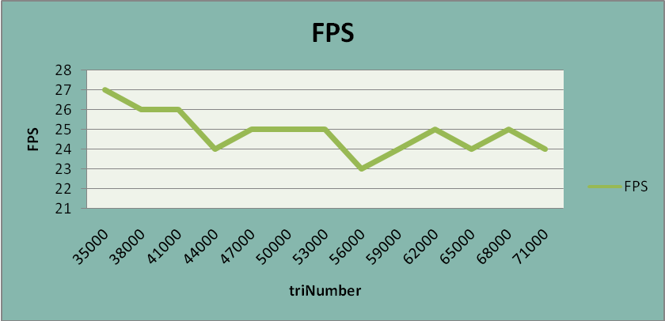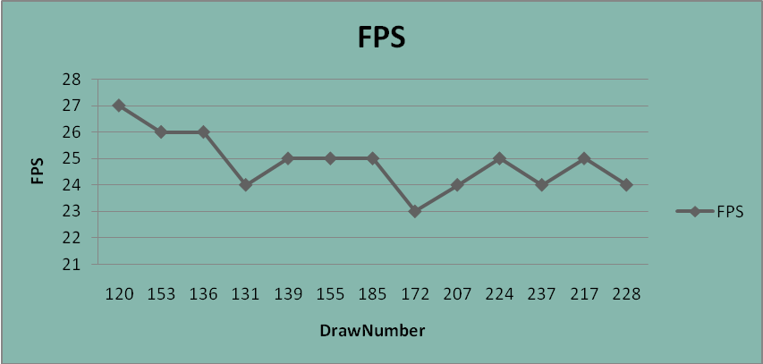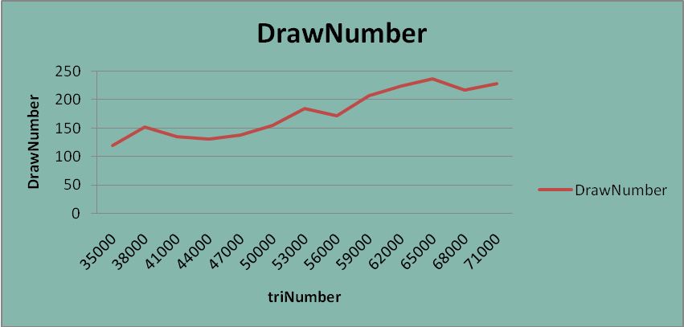
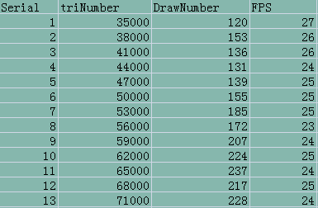
As we can see the performance is pretty good,even the max number of face reaches 70000.

Optimize the Demo

5.1 Optimize The standard material.
The standard material include 5 parameters .2 of them are essential ,that is diffuseMap and normalMap, which means we should have at least 2 materials to show each models. That will double the number of the assets if all the model needs 2 kinds of material.
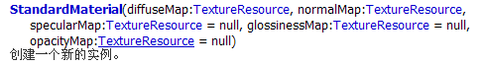
In order to solve this problem. We use the BitmapTextureResource as the normal TextureResource of the normalMap which is set as “0x7F80FF”,just the background color of normal material. We set it to some model that is not very important like the level ground.
var _normal:BitmapTextureResource = new BitmapTextureResource(new BitmapData(1, 1, false, 0x7F80FF));
surface.material=new StandardMaterial(diffuse,_normal);
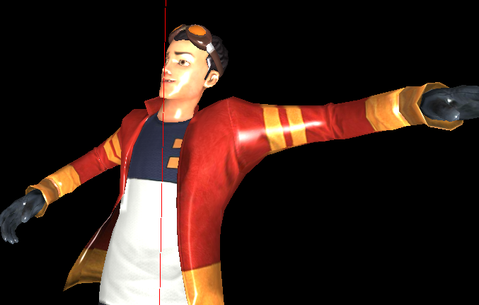
Use blue color as normal material.

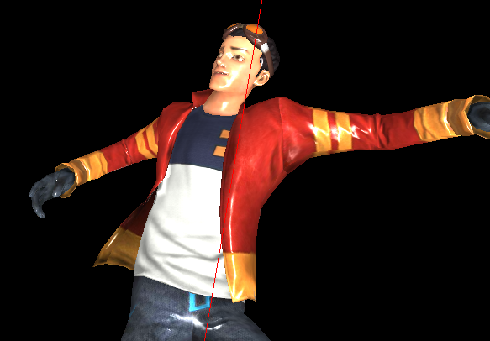
Use normal texture as normal material.
The effect is just fine as U can see, and it is also similar to the original.

5.2 Optimize the size of DAE.
We use the dae file which is an opencollada tech in the project. This format can support animation , Joint Mesh info. Even the normal material and the lightmap material.
But the problem occurs if we want to make such a good kinds of effect of each model it will be such a large assets, almost double the size of the normal DAE.
So there is the solution: we export 1 DAE file each character with normal material info. Another DAE file we just export the joint and animation info.
Since the 3d engine just need the joint info in different animations,and it’s just read the material info once when the model is imported. So we don’t need to export all the animation dae file with normal material supported.
So that we have reduced the size of model , and the loading period is also reduced by 1/3.
But actually ,since our project is not supported by the 3d art or animator well. We export each character at least 5 times. That is idle, run, be hit, attack, death. But the model we need is just 1 file with all animations inside the file .And we can export it once, that is the official recommended method.

5.3 Optimize the level
As we mentioned in 5.1. Since the shadow effect is needed in the game, the level ground need to have the standard material. So we divide all the level model to 2 part.1 is the ground which support normal material, and the other is the architectures around which don’t support the normal material. So the level has been divided to 2 file that will be 4MB in all . but according to our test if we export all the level to DAE that has the normal material info . it will be larger than 7MB.
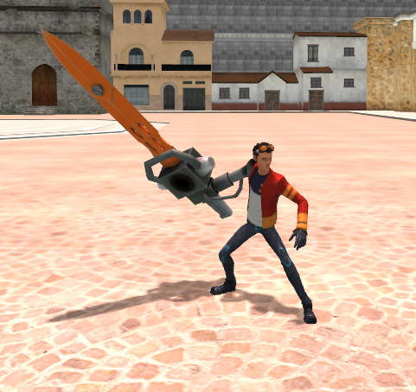
If you want to have shadow the object must have the standard material.

