January:

byte january1_1[8] = {0x00,0x02,0xFB,0x36,0xAB,0x9B,0xF6,0x00};

byte january1_2[8] = {0x00,0x00,0xFF,0x29,0xA5,0x6F,0xA1,0xD4};

byte january1_3[8] = {0x0E,0x51,0x7F,0xD3,0x55,0x53,0x55,0x00};

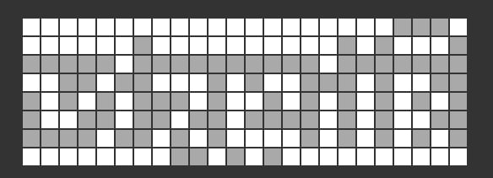

February:

byte february1_1[8] = {0x00,0x00,0xFF,0x66,0x95,0xA5,0x5E,0x01};

byte february1_2[8] = {0x00,0x00,0xFF,0x69,0xA5,0x6F,0x55,0xE8};

byte february1_3[8] = {0x0E,0x51,0x7F,0xD3,0x55,0x53,0x55,0x00};

March:

byte march1_1[8] = {0x00,0x00,0x07,0x02,0x01,0x03,0x03,0x00};

byte march1_2[8] = {0x00,0x11,0xDF,0x74,0x57,0xD4,0x57,0x00};

byte march1_3[8] = {0x80,0x00,0xC0,0x00,0x80,0x80,0x00,0x00};

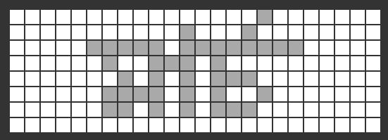

April:

byte april1_1[8] = {0x00,0x00,0x0D,0x0A,0x02,0x26,0x1A,0x00};

byte april1_2[8] = {0x78,0x86,0xDB,0xA6,0x9A,0x92,0xC6,0x3A};

byte april1_3[8] = {0x00,0x00,0xFC,0x08,0x58,0xA8,0x88,0x00};

May:

byte may1_1[8] = {0x00,0x00,0x00,0x00,0x00,0x00,0x00,0x00};

byte may1_2[8] = {0x00,0x00,0xFF,0x52,0x8A,0x9E,0x5A,0x00};

byte may1_3[8] = {0x00,0x00,0x00,0x00,0x00,0x00,0x00,0x00};

June:

byte june1_1[8] = {0x00,0x00,0x0F,0x01,0x05,0x04,0x07,0x00};

byte june1_2[8] = {0x00,0x00,0xFF,0xC0,0x27,0xA4,0xD6,0x68};

byte june1_3[8] = {0x00,0x00,0xE0,0x40,0x40,0xC0,0x40,0x00};

July:

byte july1_1[8] = {0x00,0x00,0x3F,0x0E,0x29,0x25,0x3E,0x03};

byte july1_2[8] = {0x00,0x01,0xFD,0x07,0x2D,0x55,0x85,0x40};

byte july1_3[8] = {0xE0,0x10,0xFC,0x60,0x10,0x60,0x38,0x00};

August:

byte august1_1[8] = {0x00,0x00,0xFE,0x1B,0x56,0x46,0x3A,0x00};

byte august1_2[8] = {0x00,0x82,0xDB,0xA6,0x92,0xB2,0x82,0x00};

byte august1_3[8] = {0x98,0x64,0xFF,0x90,0x76,0x92,0x0C,0x00};

September:

byte september1_1[8] = {0x00,0x00,0xFF,0x52,0x8B,0x8F,0x5A,0x00};

byte september1_2[8] = {0x98,0x64,0xEF,0xD8,0x68,0x0A,0x8E,0x00};

byte september1_3[8] = {0x00,0x00,0xFF,0x53,0xF5,0x73,0x55,0x30};

October:

byte october1_1[8] = {0x00,0x00,0xFF,0x34,0xAD,0x8D,0x74,0x00};

byte october1_2[8] = {0x90,0x69,0xFD,0xBF,0x55,0x33,0x9D,0x00};

byte october1_3[8] = {0x00,0x00,0xFF,0x33,0x55,0x53,0x35,0x00};

November:

byte november1_1[8] = {0x00,0x00,0xFF,0x04,0x75,0x4D,0x64,0x00};

byte november1_2[8] = {0x00,0x00,0xFF,0x98,0x51,0x4C,0xB8,0x00};

byte november1_3[8] = {0x00,0x00,0xFF,0xA7,0xE9,0xE5,0xAB,0x60};

December:

byte december1_1[8] = {0x78,0x84,0xFF,0x88,0xAD,0xA5,0x9C,0x00};

byte december1_2[8] = {0x00,0x00,0xFF,0xA4,0x15,0x1C,0xB4,0x00};

byte december1_3[8] = {0x00,0x00,0xFF,0xA7,0xE9,0xE5,0xAB,0x60};

Muharram:

byte muharram1_1[8] = {0x00,0x00,0xFF,0x44,0x24,0x7C,0x6A,0x0D};

byte muharram1_2[8] = {0x00,0x00,0xFF,0xC6,0x2A,0xC6,0x6A,0x00};

byte muharram1_3[8] = {0x00,0x00,0xFF,0x69,0xA5,0x6F,0xAD,0x00};

Sofor:

byte sofor1_1[8] = {0x00,0x00,0x1F,0x09,0x05,0x07,0x0D,0x00};

byte sofor1_2[8] = {0x00,0x00,0xFF,0x4C,0x2A,0x4A,0x38,0x00};

byte sofor1_3[8] = {0x00,0x00,0xF8,0x70,0x90,0x50,0xB0,0x00};

Robiul Aual:

byte robiul_aual1_1[8] = {0x00,0x00,0xFC,0x38,0x48,0x28,0x5A,0x00};

byte robiul_aual1_2[8] = {0x00,0x00,0xFE,0x1B,0x56,0x46,0x3A,0x00};

byte robiul_aual1_3[8] = {0x38,0x84,0xFE,0x88,0xAC,0xA4,0x9D,0x00};

Robius Sani:

byte robius_sani1_1[8] = {0x00,0x00,0xFD,0x38,0x48,0x28,0x5A,0x00};

byte robius_sani1_2[8] = {0x00,0x05,0xF7,0x9D,0x55,0x75,0xD5,0x00};

byte robius_sani1_3[8] = {0xF8,0x04,0xFE,0x04,0x74,0x4C,0x65,0x00};

Jomadiul Aual:

byte joma_aual1_1[8] = {0x00,0x00,0xFE,0x1C,0x52,0x4A,0x7A,0x00};

byte joma_aual1_2[8] = {0x00,0x00,0x7F,0x0D,0x2B,0x23,0x9D,0x00};

byte joma_aual1_3[8] = {0x1C,0x42,0x7F,0xC4,0x56,0x52,0x4E,0x00};

Jomadius Sani:

byte joma_sani1_1[8] = {0x00,0x00,0xFD,0x38,0xA4,0x94,0xF6,0x00};

byte joma_sani1_2[8] = {0x00,0x05,0xF7,0x9D,0x55,0x75,0xD5,0x00};

byte joma_sani1_3[8] = {0xF8,0x04,0xFE,0x04,0x74,0x4C,0x65,0x00};

Rojob:

byte rojob1_1[8] = {0x00,0x00,0x1F,0x07,0x09,0x05,0x0B,0x00};

byte rojob1_2[8] = {0x00,0x00,0xFF,0x1C,0x52,0x4A,0x7A,0x00};

byte rojob1_3[8] = {0x00,0x00,0xF8,0x70,0x90,0xD0,0x30,0x00};

Shaban:

byte shaban1_1[8] = {0x00,0x02,0x6E,0x13,0x3A,0x2A,0x02,0x00};

byte shaban1_2[8] = {0x00,0x81,0xFD,0x9F,0xA5,0xB5,0x8D,0x00};

byte shaban1_3[8] = {0x00,0x00,0xFE,0x04,0x74,0x4C,0x64,0x00};

Romjan:

byte romjan1_1[8] = {0x00,0x00,0xFF,0x74,0x92,0x57,0xB6,0x00};

byte romjan1_2[8] = {0x00,0x00,0xFF,0x8E,0xA9,0xA5,0xBD,0x00};

byte romjan1_3[8] = {0x00,0x40,0x7F,0xC1,0x5D,0x53,0x59,0x00};

Shaoal:

byte shaoal1_1[8] = {0x00,0x0A,0xBA,0x4F,0xEA,0xAB,0x0A,0x00};

byte shaoal1_2[8] = {0x00,0x00,0xDF,0x29,0x45,0x2F,0xE1,0x04};

byte shaoal1_3[8] = {0x00,0x40,0x7F,0xC1,0x4B,0x55,0x51,0x00};

Jilkad:

byte jilkad1_1[8] = {0x78,0x84,0xFF,0x9C,0xD2,0xCB,0xBD,0x03};

byte jilkad1_2[8] = {0x00,0x00,0xFF,0x09,0x5A,0xAA,0x09,0x00};

byte jilkad1_3[8] = {0x00,0x00,0xFF,0xC8,0xAB,0xAD,0x89,0x00};

Jilhajj:

byte jilhajj1_1[8] = {0x78,0x84,0xFF,0x9C,0xD2,0xCB,0xBD,0x03};

byte jilhajj1_2[8] = {0x00,0x00,0xFF,0x0B,0x58,0xAB,0x09,0x00};

byte jilhajj1_3[8] = {0x00,0x00,0xFF,0x0C,0xAA,0x25,0x9B,0x0D};

Boishakh:

byte boishakh1_1[8] = {0x60,0x10,0xFF,0x27,0x49,0x4D,0x23,0x00};

byte boishakh1_2[8] = {0x00,0x05,0xDD,0x27,0x55,0x05,0x05,0x00};

byte boishakh1_3[8] = {0x00,0x02,0xEB,0x7A,0x0A,0x32,0x0E,0x00};

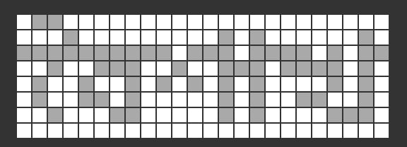

joishtho:

byte joishtho1_1[8] = {0x30,0x08,0x7F,0x11,0x25,0x24,0x13,0x00};

byte joishtho1_2[8] = {0x00,0x00,0xFF,0xC5,0x28,0xA4,0xA8,0x00};

byte joishtho1_3[8] = {0x1C,0x20,0xFE,0x38,0xE4,0xA4,0x78,0x00};

Ashar:

byte ashar1_1[8] = {0x00,0x00,0xFE,0x1B,0x56,0x46,0x3A,0x00};

byte ashar1_2[8] = {0x00,0x81,0xFD,0xA7,0x95,0xAD,0x9D,0x00};

byte ashar1_3[8] = {0x00,0x00,0xFE,0x40,0x4C,0x44,0x38,0x10};

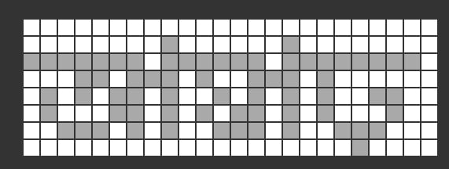

srabon:

byte srabon1_1[8] = {0x00,0x01,0x37,0x09,0x15,0x01,0x23,0x1D};

byte srabon1_2[8] = {0x00,0x40,0x7F,0xCE,0x52,0x5A,0x46,0x00};

byte srabon1_3[8] = {0x00,0x08,0x6C,0x98,0xC8,0x08,0x08,0x00};

Bhadro:

byte bhadro1_1[8] = {0x00,0x00,0x0F,0x00,0x04,0x02,0x01,0x00};

byte bhadro1_2[8] = {0x00,0x08,0xEF,0x59,0x89,0x69,0xCA,0x01};

byte bhadro1_3[8] = {0x00,0x00,0xF0,0x00,0x20,0xD0,0x90,0x60};

ashin:

byte ashin1_1[8] = {0x00,0x00,0xFE,0x1B,0x56,0x46,0x3A,0x00};

byte ashin1_2[8] = {0x1E,0xA1,0xFB,0xA4,0xAA,0xA1,0xA2,0x01};

byte ashin1_3[8] = {0x00,0x80,0xFF,0x82,0xBA,0xA6,0xB2,0x80};

kartik:

byte kartik1_1[8] = {0x00,0x00,0xFE,0x3D,0x4A,0x6A,0x18,0x00};

byte kartik1_2[8] = {0x1C,0xA3,0xFF,0xA3,0xAA,0xA8,0xA7,0x00};

byte kartik1_3[8] = {0x80,0x00,0xFF,0x1E,0xA5,0xB5,0x0C,0x00};

ogrohayon:

byte ogrohayon1_1[8] = {0x00,0x00,0x1F,0x03,0x0A,0x08,0x07,0x00};

byte ogrohayon1_2[8] = {0x00,0x00,0xF6,0x49,0xC4,0xCC,0x51,0x0E};

byte ogrohayon1_3[8] = {0x00,0x80,0xD8,0x98,0x80,0x98,0x98,0x00};

poush:

byte poush1_1[8] = {0x00,0x00,0x0E,0x05,0x08,0x08,0x04,0x00};

byte poush1_2[8] = {0xB8,0x54,0xDF,0x35,0xD4,0x95,0x14,0x00};

byte poush1_3[8] = {0x00,0x00,0xF0,0x20,0xA0,0x60,0xE0,0x00};

magh:

byte magh1_1[8] = {0x00,0x00,0x07,0x02,0x01,0x03,0x03,0x00};

byte magh1_2[8] = {0x00,0x10,0xDF,0x74,0x55,0xD2,0x53,0x00};

byte magh1_3[8] = {0x00,0x00,0xE0,0x40,0x40,0x40,0xC0,0x00};

falgun:

byte falgun1_1[8] = {0x00,0x00,0xFE,0x4D,0x2A,0x4A,0x38,0x00};

byte falgun1_2[8] = {0x00,0x80,0xF8,0x86,0xA9,0xD4,0x8D,0x01};

byte falgun1_3[8] = {0x00,0x80,0xFF,0x81,0x9D,0x93,0x59,0xA0};

choitro:

byte choitro1_1[8] = {0x06,0x01,0x0F,0x02,0x04,0x04,0x02,0x00};

byte choitro1_2[8] = {0x00,0x00,0xFF,0x81,0xF1,0x94,0xE3,0x00};

byte choitro1_3[8] = {0x00,0x00,0xF0,0xC0,0x20,0x60,0xA0,0x00};

