Raat

byte raat1_1[8] = {0x00,0x01,0xFD,0x3B,0x49,0x29,0x59,0x00};

byte raat1_2[8] = {0x00,0x00,0xFE,0x18,0x54,0x44,0x38,0x00};

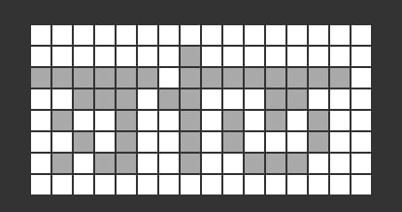

Purbanno

byte purbanno1_1[8] = {0x00,0x11,0xDF,0xB3,0x54,0x36,0x21,0x18};

byte purbanno1_2[8] = {0x80,0x20,0xBF,0xEC,0xA3,0xAD,0xA6,0x00};

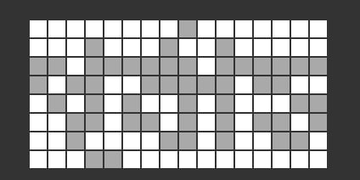

Modhhanno

byte modhhanno1_1[8] = {0x04,0x08,0xFB,0x96,0x5B,0xF6,0xD3,0x00};

byte modhhanno1_2[8] = {0x00,0x20,0xBF,0xEC,0x23,0xAD,0x26,0x00};

Sayanno:

byte sayanno1_1[8] = {0x00,0x08,0xEF,0xBA,0x69,0x6B,0xA8,0x01};

byte sayanno1_2[8] = {0x00,0x10,0xDF,0x76,0x53,0x55,0xD6,0x00};

Usha:

byte usha1_1[8] = {0x44,0x3A,0xFF,0x08,0xAE,0x62,0x1C,0x00};

byte usha1_2[8] = {0x00,0x04,0xF7,0x9C,0x74,0x94,0x74,0x00};

Oporanno:

byte oporanno1_1[8] = {0x00,0x00,0x0F,0x02,0x09,0x09,0x06,0x00};

byte oporanno1_2[8] = {0x00,0x08,0xEF,0xD9,0xAA,0x89,0x8A,0x00};

byte oporanno1_3[8] = {0x00,0x20,0xBF,0xEC,0xA3,0xAD,0xA6,0x00};

Shonibar:

byte shonibar1_1[8] = {0x00,0x05,0xDF,0x25,0x55,0x05,0x05,0x00};

byte shonibar1_2[8] = {0xF0,0x08,0xFE,0x08,0x68,0x58,0x08,0x00};

Robibar:

byte robibar1_1[8] = {0x01,0x02,0xFF,0x3A,0x4A,0x2A,0x5A,0x00};

byte robibar1_2[8] = {0xE0,0x10,0xFC,0x70,0x90,0x90,0x70,0x00};

Shombar:

byte shombar1_1[8] = {0x00,0x00,0xFF,0x29,0x45,0x47,0x2D,0x00};

byte shombar1_2[8] = {0x00,0x40,0x7F,0xD2,0x4A,0x5E,0x5A,0x00};

Mongolbar

byte mongol1_1[8] = {0x04,0x03,0xFA,0x99,0x56,0xF1,0xD3,0x00};

byte mongol1_2[8] = {0x00,0x40,0x7F,0xC1,0x4B,0x55,0x51,0x00};

Budhbar:

byte budhbar1_1[8] = {0x01,0x02,0xFE,0x39,0x4A,0x39,0x14,0x0A};

byte budhbar1_2[8] = {0x00,0x00,0xF0,0x40,0x40,0xC0,0x40,0x00};

Brihoshpotibar:

byte briho1_1[8] = {0x00,0x00,0xD8,0x18,0x80,0x18,0xD8,0x00};

byte briho1_2[8] = {0x00,0x00,0xFF,0x3B,0x48,0x3B,0x11,0x1C};

Shukrobar:

byte shukro1_1[8] = {0x00,0x02,0xDB,0x26,0x52,0x06,0x0A,0x05};

byte shukro1_2[8] = {0x00,0x00,0xFF,0x3C,0x4A,0x3A,0x98,0x68};

